Guidelines for implementation

laboratory work No. 1 on the course " Web technologies"

"HTML Language. Layout Techniques"

**Objective of the work** : familiarization with the HTML markup language , working with basic tags.

**Rules for assessing works**

Completion of the basic task is estimated at a maximum of 6 points. To receive 10 points for the work, you must complete all the points from the "Extended Task" section. The extended task is completed after the basic one.

Points will be deducted from the maximum possible grade in the following situations:

1. **Deadline.** The report is posted in the personal account after the deadline - minus 1 point every 2 weeks from the date recorded in the personal account. The defense date can be any;
2. **Defense.** "Gaps" in knowledge during the oral defense of the work: grade "good" - minus 1 point, grade "satisfactory" - minus 2 points;
3. **Report.** The report contains minor violations of requirements - minus 1 point, several report items are missing - minus 2 points or more;
4. **Work.** The completed task lacks minor elements - minus 1 point, several points of the task are missing - minus 2 points or more. Repetition of information; titles do not correspond to the content; elements that do not reveal the topic of the site, small volume - minus points at the discretion of the teacher.

Protection of work is possible only if there is a report in the personal account.

**Basic task**

Develop three website pages on the topic determined by the option (Table 2 “Website Topics”):

--- one page must be laid out using only HTML 4 ( div tag ),

--- another page – only by means of HTML 5 (it is necessary to use at least 5 of the tags header , footer , article , section , aside , main , nav , aside ),

--- One page should contain links to sites that were used in preparation (page title: "Sources Used").

No duplicate content is allowed. Each page must have different content. Each page must have its own title that reflects the content.

Within a student group, repetition of the topic is not allowed. The topic can be selected independently from the existing list. Also, a student can propose his own topic, close in content to the topics from table 2.

The topic is maintained for all laboratory semesters. Each element of the site must correspond to the topic. The text of the site must describe the state of the subject area from the 1990s to the present.

The text, list and table must contain different information. The text volume on each page except for the list of sources is at least 500 words. Repeating information anywhere on the site is not allowed. Elements on the page should be arranged from top to bottom. Use only tag attributes for design.

Each page should contain: a "header" with the site name, site logo; menu; page name; "footer". Page names and the site name should reflect the information they contain.

Required website elements:

1. Site header at the top of each page (site name, page name, logo)
2. Menu with hyperlinks for switching between pages on each page. Pages prepared during each subsequent work should be built into the main site. Scheme of the full menu (after all work is completed): 1.. main page, 2.. second page, 3.. sources, 4.. lr3 ( javascript script ), 5.. questionnaire ( lr 5 with form), 6.. tables from the database. The names of the menu items should reflect the information content of the site.
3. Table with structure according to the variant. Design the table using the attributes of its tags.
4. Two-level list (type – numbered or bulleted – specifies the variant). If a list of definitions is specified, two separate single-level lists of definitions should be made, and each should contain at least three items. It is prohibited to make a list of one item. The list should contain structured information on the topic of the site. A list of sources cannot be presented as this information. For design, use tag attributes ( type , start , value ) of the list. The list size should not be less than the following scheme:

* point 1
  + clause 1.1
  + item 1.2
* point 2
  + 2.1 point 2.1
  + 2.2 point 2.2
* point 3
  + 3.1 point 3.1
  + 3.2 point 3.2

1. Set of pictures
2. Several horizontal lines ( hr tag ) to highlight page sections
3. "footer" at the bottom of the page

**Extended Task**

1.. Extended use of the meta tag (except encoding).

2.. Using structural formatting tags: abbr , cite , code , dfn , em , kbd , mark , samp , strong , var , q , blockquote . At least 5 different ones.

3.. Using additional table tags: th , caption , thead , tfoot , tbody , colgroup , col .

4.. Application tags audio, video, embed, address, picture, time.

5.. In the main part of one of the pages, select two or three columns in accordance with the task. Use the layout method specified by the option and the CSS rules .

**Requirements for report design**

Listings must be presented as texts, in black font size 12 on a white background. Screenshots for demonstrating fragments of documents are prohibited.

Within the listings, text fragments with task completion must be highlighted in color and provided with comments.

All graphic elements (screenshots, etc.) must be numbered and signed.

**Contents of the report**

1. Front page
2. Contents of the report with page numbers
3. Variants of tasks from tables 1 and 2
4. Names of the tools used to complete the work (editor, browser, etc.)
5. A verbal description of the completed points of the basic task with links to drawings with screenshots and to the page numbers of the report where the corresponding listing is located.
6. Verbal description of completed points of the extended task with links to pictures with screenshots and to the page numbers of the report where the corresponding listing is located (if any). Explanation of the capabilities of the applied tags.
7. HTML 5 tags with links to images with screenshots and to the page numbers of the report where the corresponding listing is located.
8. Screenshots of web pages with captions and figure numbers
9. HTML document texts with file names

**Brief information about the html language**

HTML – HyperText Markup Language – hypertext markup language.

Used to describe web pages using tags.

*Tags* define the structure of the page (describe a paragraph, list, table, block, etc.). Most tags are paired - have two parts. Inside the tag (between the opening and closing parts) is the content (text). The tag name and the list of attributes are enclosed in angle brackets:

< tag name>content </tag name>

There are also single tags. For example, < img > – image output (< img src =”my.jpg”>) and < br > - line break.

Tags can follow each other or be nested. Paired tags cannot cross.

*Attributes* define the properties of the tag. They are written in the opening part. The attribute value is placed in double or single quotes. The notation is: attribute_name = "value". For example, < img src =”my.jpg” >, where src is an attribute containing the name of the graphic file.

Each tag has its own fixed set of attributes. Attributes are applied as needed. They are written in any order. Many attributes can be used in almost all tags. There are also attributes that apply only to a specific tag.

If we group attributes by their role, we can distinguish the following categories:

- defining the appearance of an element: align , color , width , height , etc. It is not recommended to use these attributes now. CSS rules should be used instead .

- specifying the file name: src , href (from English hyper reference - hyperlink), name , action .

- tag naming: id , class , name .

- events used in scenarios: onclick , ondblclick , onkeydown , onkeypress , onkeyup , onmousedown , onmousemove , onmouseout , onmouseover , onmouseup , onload (end of document loading), onselect (element selection).

For most tags, you can use the style attribute to set individual styling for the element.

**HTML document structure**

Any web page has two sections: <head> – contains service information (page title, information for search engines and browsers, styles, scripts, links to included files) and <body> – contains the actual web page markup. These sections are united by the <html> tag , which begins and ends the document. Tags head section : meta, title, base, link, style, script.

<head>

<title>Название вкладки со страницей</title>

<meta http-equiv="Content-Type" content="text/html; charset=utf-8">

<link rel="stylesheet" type="text/css" href="style.css">

<style>

body {background: #FFF; color: #000; font-size: 14px;} </style>

<script type= "text/javascript">

prompt (' This is dialogic prompt window .', '') </script> </head>

body section contains all the elements displayed in the browser window. One of the most important elements is the <a> hyperlink, which is used to navigate between pages of the site.

<a href =”http://google.ru ”> Open Google search engine </a>

You can also link to positions within the current page. This is done using an anchor - a hyperlink tag that specifies the name attribute :

<a name = “ name anchors "> Text </a>

The transition to the anchor is done using a link of the following type:

< a href ="anchorname"> Text </a>

<div> and <span> tags are universal containers. You can insert anything into them and format them any way you want using CSS . By default, they have no graphic display. These tags are used to form the document structure.

<body> section tags are divided into two types - block and in - line . In a normal flow, block elements are displayed one above the other from top to bottom, and in-line elements are displayed next to each other in one line. Block elements include, for example, the tags div , h1 … h6 , p , and in-line elements include img , a , span .

**Table**

The table is formed as a set of rows (tag < tr >) from cells (tags < th > or < td >).

Table tag - this is the starting tag of the table, inside which all other tags related to the table will be used.

Tag thead - a row with table column headings, usually the first one. This tag can be omitted. To add cells inside the thead tag , use the th tag . Table headings are bold by default.

By default, a table must have a <tbody> tag , but if it doesn't, the browser adds <tbody> to the DOM tree itself. Inside the tbody tag, the rows with the main content of the table are placed.

tfoot tag is the "footer" or table footer, the last row. This tag is optional.

To expand a table cell across multiple rows and/or columns, use the colspan and rowspan cell attributes .

**Lists**

in HTML : numbered, bulleted, and definition lists. Items in a numbered or bulleted list are marked with the <li> tag and placed in a <ol> or <ul> container , respectively . For definition lists, the following tags are used: <dl> - container, <dt> - defined term, <dd> - definition itself.

< ol > < li > December </ li >

< li > January </ li >

< li > февраля </ li > </ ol >

< ul > < li > December </ li >

< li > January </ li >

< li > February </ li > </ ul >

< dl > < dt >item 1 </ dt >

< dd > first definition of item 1</ dd >

< dd > second definition of point 1</ dd >

< dt >item 2 </ dt >

< dd > first definition of point 2</ dd >< / dl >

**Layout methods**

To structure a page, to place elements in an arbitrary place, special techniques of page organization are used, called layout. Three methods will be considered below: table, block and semantic layout.

When using *table layout,* website elements are placed in cells of an invisible table (border width is zero). Often, another table is located inside the cell for more precise element positioning. Table layout is not used now because the page will be displayed only after the table is fully loaded, which slows down the work. Listing 1 shows an example of table layout. The "Menu" and "Page Content" sections are located in a table nested in the main table cell. The cell borders are highlighted for clarity.

**Listing 1. Table layout**

< html >

< head > < title > Table layout </ title > </ head >

<body>

<table width="500" border="0" align="center" height="300">

<tr> <td valign ="top" height="80" style=" border:# 6699FF solid 5px">

Cap site </ td> < /tr>

<tr> <td height="20" style="border:#6699FF solid 5px"> </td> </tr>

<tr> <td>

<table width="100%" height="100%" style="border:#6699FF solid 8px">

<tr> <td valign="top" width="150" style="border:#0000FF solid 5px"> Меню

<ul> <li><a href="../../html_step.php"> HTML по шагам</a></li>

<li><a href="../../html_tag.php"> Теги HTML</a></li>

<li><a href="../../css_step.php"> CSS по шагам</a></li> </ul> </td>

<td valign="top" style="border:#0000FF solid 5px"> Контент страницы </td>

</tr></table> </td> </tr>

<tr> < td height ="35px" style="border:#0000FF solid 5px"> Footer </td> </tr>

</table> </body> </html>​​​​​

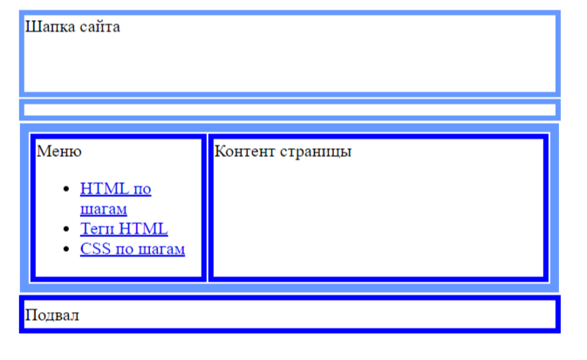Fig. 2. Example of table layout

*Block layout* is built on the basis of named div tags , which are given the desired position on the page using CSS rules . In Listing 2, each div tag has an id attribute . The float property allows you to align elements to the right or left, disrupting the normal flow.

**Rule # clear { clear :both ; }** prevents the element from being floated on the left and right. If you remove it, the layout will "go" and the bottom of the site will no longer be displayed correctly.

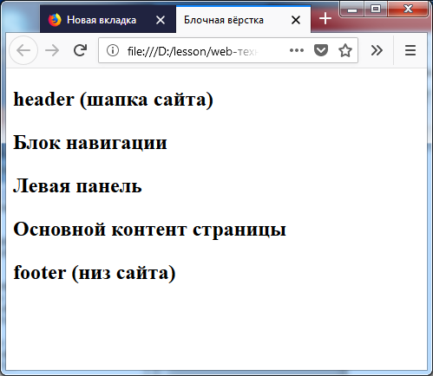

Fig. 3. Page view without CSS

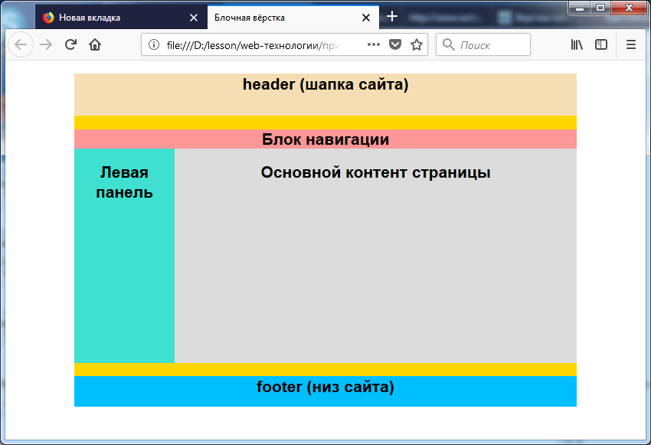

Fig. 4. Page after applying css

**Listing 2. Block layout**

< html > < head > < title >Block layout</ title >

<link rel="stylesheet" type="text/css" href="style.css"> </head>

<body>

<div id="container">

<div id="header"> <h2>header (шапка сайта)</h2> </div>

<div id="navigation"> <h2>Блок навигации</h2> </div>

< div id =" sidebar "> < h 2>Left panel</ h 2> </ div >

< div id =" content "> < h 2> Main content of the page</ h 2> </ div >

<div id="clear"> </div>

<div id="footer"> <h2>footer (низ сайта)</h2> </div>

</div></body></html>

**Листинг 3. Файл style.css для листинга 2**

body {background: #FFF; color: #000; font-family: Arial, sans-serif; font-size: 14px;}

#header {background: #F5DEB3; width: 100%;height: 55px;}

#container {background: #FFD700; margin: auto auto; text-align: center; width: 80%; height: 400px; }

#navigation {background: #FE9798; width: 100%; height: 25px;}

#sidebar {background: #40E0D0; float: left; width: 20%; height: 280px;}

#content {background: #DCDCDC; float: right; width: 80%; height: 280px;}

#clear {clear: both;}

#footer {background: #00BFFF; width: 100%; height: 40px;}

*Semantic layout* uses tags that appeared in the html 5 version, structuring the constructive elements of the page (header, navigation panel, sidebar, section, footer). These tags are: < header >, < nav >, < aside >, < section >, < footer >, etc. The location of the blocks is set through css rules .

**Listing 4. Semantic markup**

<html><head><title>Семантическая верстка</title>

<link rel="stylesheet" type="text/css" href="style5.css"> </head>

<body>

<div id="container">

<header> <h2>header (шапка сайта)</h2> </header>

< nav > < h 2>Navigation Block </ h 2></ nav >

< aside > < h 2>Left panel</ h 2> </ aside >

< section > < h 2>Main content of the page</ h 2></ section >

<div id="clear"> </div>

<footer> <h2>footer ( hoax )</h2> </footer>

</div> </body> </html>

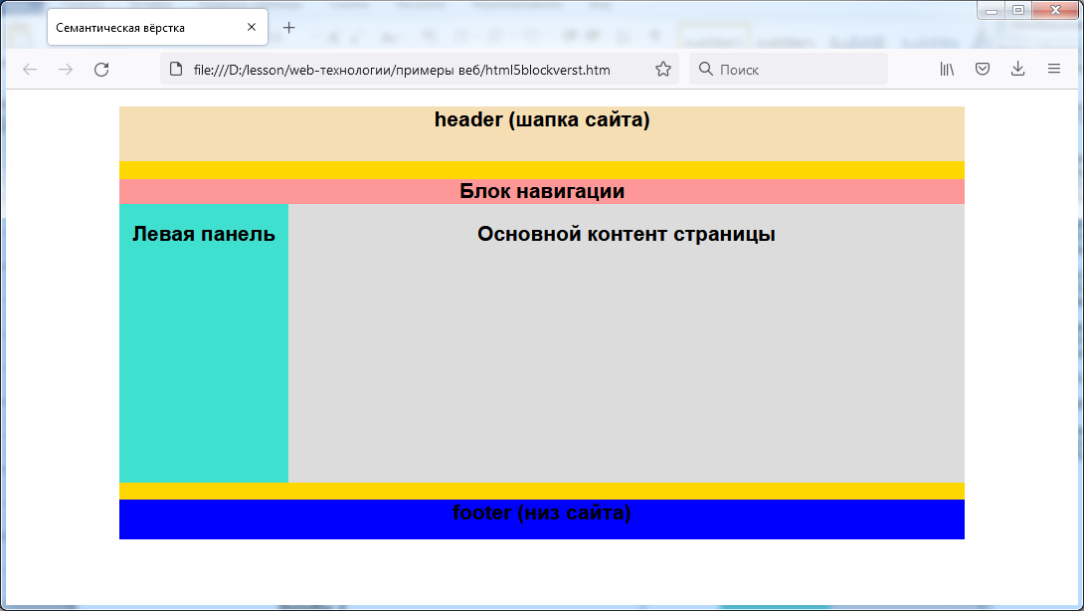

Lynx. 5. Semantic framework

**Style file 5. css for listing 4**

body {background: #FFF; color: #000; font-family: Arial, sans-serif; font-size: 14px;}

header {background: #F5DEB3; width: 100%; height: 55px;}

#container {background: #FFD700; margin: auto auto ; text-align: center; width: 80%; height: 400px;}

nav {background: #FE9798; width: 100%; height: 25px;}

aside {background: #40E0D0; float: left; width: 20%; height: 280px;}

section {background: #DCDCDC; float: right; width: 80%; height: 280px;}

#clear {clear: both;}

footer {background: #0000FF; width: 100%; height: 40px;}

**Example website**

***HTML document listing***

<!DOCTYPE HTML>

<html> <head>

<meta http- equiv ="Content-Type" content="text/html; charset=windows-1251" />

<title> Basic HTML</title></head>

<body>

<h1> Title website < /h1>

<a href = "ff.htm"> Block navigation </a>

<p>Example of a two-level list with a combination of numbers and bullets</p>

< ol > < li > winter

< ul > < li > December </ li >

< li > January </ li >

< li > February </ li >

</ul> < /li>

<li> spring </li>

<li> summer </li> </ ol >

<table border =2>

< caption >Table without merged cells</ caption >

<tr> < th > column 1</ th > < th > column 2</ th > < th > column 3</ th ></tr>

<tr> <td> cell 1 </td> <td> cell 2 </td><td> cell 3</td></tr>

<tr> <td> cell 4 </td> <td> cell 5 </td><td> cell 6</td></tr>

<tr> <td> cell 7 </td> <td> cell 8 </td><td> cell 9</td></tr>

</table> < br >

<table border =2>

<caption> Unification lines </caption>

<tr> < th > column 1</ th > < th > column 2</ th > < th > column 3</ th ></tr>

<tr> <td> cell 1 </td> <td> cell 2 </td><td> cell 3</td></tr>

<tr> <td> cell 4 </td> <td> cell 5 </td><td rowspan = 2> cell 6</td></tr>

<tr> <td> cell 7 </td> <td> cell 8 </td></tr>

</table> <br>​

<table border =2>

<caption> Unification columns </caption>

<tr> < th > column 1</ th > < th > column 2</ th > < th > column 3</ th ></tr>

<tr> <td> cell 1 </td> <td> cell 2 </td><td> cell 3</td></tr>

<tr> <td colspan = 2> cell 4 </td> <td> cell 6</td></tr>

<tr> <td> cell 7 </td> <td> cell 8 </td><td> cell 9</td></tr>

</table> <br>​

<table border =2 > <caption> Union lines And columns </caption>

<tr> < th > column 1</ th > < th > column 2</ th > < th > column 3</ th ></tr>

<tr> <td> cell 1 </td> <td> cell 2 </td><td> cell 3</td></tr>

<tr> <td colspan = 2 rowspan = 2> cell 4 </td> <td> cell 6</td></tr>

<tr> <td> cell 9</td></tr>

</ table > < / body > </ html >

***Displaying a page in a browser***

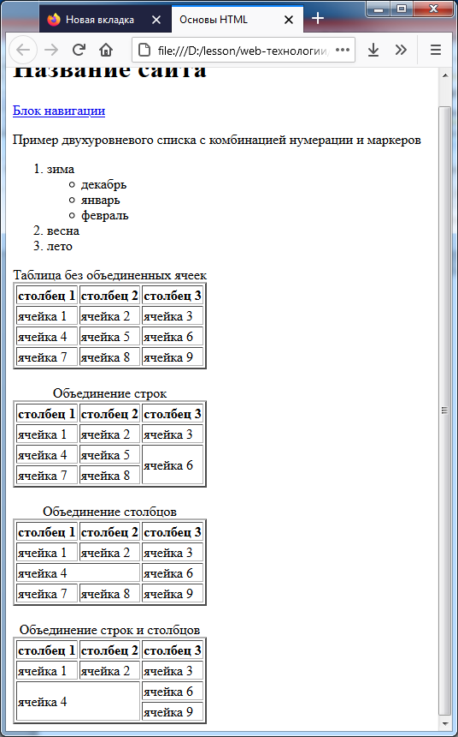

**Control questions**

1. List the tags that were introduced in HTML 5.
2. Name at least 10 attributes and explain how each is used.
3. What attributes are used to name elements?
4. List the table tags and explain their use.
5. What types of lists can be used in html ? How are they created?
6. What tags can be placed in the head section ?
7. How is semantic layout implemented?

**Task options**

Table 1. Table and list view

|  |  |  |  |  |
| --- | --- | --- | --- | --- |
| No. | Table view | List view | Layout method | Number of columns in the main part of the page |
| 1 | Merge columns | numbered | Block | 2 |
| 2 | Merge columns | marked | Block | 3 |
| 3 | Concatenation of strings | numbered | Block | 2 |
| 4 | Concatenation of strings | marked | Block | 3 |
| 5 | Merging Rows and Columns | marked | Block | 2 |
| 6 | Merging Rows and Columns | numbered | Block | 3 |
| 7 | Merge columns | Definitions (tags dl , dt , dd ) | Block | 2 |
| 8 | Concatenation of strings | Definitions (tags dl , dt , dd ) | Block | 3 |
| 9 | Merging Rows and Columns | Definitions (tags dl , dt , dd ) | Semantic | 2 |
| 10 | Merge columns | numbered | Semantic | 3 |
| 11 | Merge columns | marked | Semantic | 2 |
| 12 | Concatenation of strings | numbered | Semantic | 3 |
| 13 | Concatenation of strings | marked | Semantic | 2 |
| 14 | Merging Rows and Columns | marked | Semantic | 3 |
| 15 | Merging Rows and Columns | numbered | Semantic | 2 |
| 16 | Merge columns | Definitions (tags dl , dt , dd ) | Semantic | 3 |
| 17 | Concatenation of strings | Definitions (tags dl , dt , dd ) | Block | 2 |
| 18 | Merging Rows and Columns | Definitions (tags dl , dt , dd ) | Block | 3 |
| 19 | Merge columns | numbered | Block | 2 |
| 20 | Merge columns | marked | Block | 3 |
| 21 | Concatenation of strings | numbered | Block | 2 |
| 22 | Concatenation of strings | marked | Block | 3 |
| 23 | Merging Rows and Columns | marked | Block | 2 |
| 24 | Merging Rows and Columns | numbered | Block | 3 |
| 25 | Merge columns | Definitions (tags dl , dt , dd ) | Semantic | 2 |
| 26 | Concatenation of strings | Definitions (tags dl , dt , dd ) | Semantic | 3 |
| 27 | Merging Rows and Columns | Definitions (tags dl , dt , dd ) | Semantic | 2 |
| 28 | Merge columns | numbered | Semantic | 3 |
| 29 | Merge columns | marked | Semantic | 2 |
| 30 | Concatenation of strings | numbered | Semantic | 3 |

Table 2. Site topics

|  |  |
| --- | --- |
| Option No. | Topic |
| 1 | Kotlin language |
| 2 | Graphic file formats |
| 3 | Holograms |
| 4 | Antivirus programs |
| 5 | Python language |
| 6 | Parallel computing |
| 7 | Supercomputers |
| 8 | Modern element base |
| 9 | Electronic cards |
| 10 | Tablets |
| 11 | Computer graphics |
| 12 | Browser Competition |
| 13 | Social networks and messengers |
| 14 | Big data |
| 15 | Augmented reality |
| 16 | Computer technology of Russia |
| 17 | Sound processing and reproduction |
| 18 | Neural networks |
| 19 | Artificial intelligence |
| 20 | Computer games |
| 21 | Industrial robots |
| 22 | Robot toys |
| 23 | Animation studios |
| 24 | Sound Storage Formats |
| 25 | Bioinformatics |
| 26 | Chatbots with artificial intelligence |
| 27 | Metaverses |
| 28 | Classification of programming languages |
| 29 | Golang language |
|  |  |

Distribution of options for laboratory work 1 in the course "Web technologies"

spring 2025

|  |  |  |
| --- | --- | --- |
| Variant of table, list, layout | Gr 4231 | Site theme |
| 1 | Alekseev Leonid Alekseevich |  |
| 2 | Alin Daniil Sergeevich |  |
| 3 | Beldenko Sofia Eniseevna |  |
| 4 | Vasiliev Svyatoslav Sergeevich |  |
| 5 | Gavrilov Dmitry Vasilievich |  |
| 6 | Ermakov Vyacheslav Andreevich |  |
| 7 | Efremov Andrey Sergeevich |  |
| 8 | Ilyin Fyodor Aleksandrovich |  |
| 9 | Kashkolda Roman Sergeevich |  |
| 10 | Kirillov Ruslan Yurevich |  |
| 11 | Kozlov Artem Borisovich |  |
| 12 | Kozyrev Nikita Aleksandrovich |  |
| 13 | Kondratyev Kirill Vadimovich |  |
| 14 | Kochemirov Maksim Alekseevich |  |
| 15 | Ovchinnikova Liliya Nikolaevna |  |
| 16 | Potapov Sergey Antonovich |  |
| 17 | Prourzin Pavel Sergeevich |  |
| 18 | Timofeev Aleksandr Vyacheslavovich |  |
| 19 | Tkachev Ivan Aleksandrovich |  |
| 20 | Ushakov Daniil Pavlovich |  |
| 21 | Cheverda Ilya Aleksandrovich |  |
| 22 | Chernykh Daria Yuryevna |  |
| 23 | Chistyakova Kristina Alexandrovna |  |
| 24 | Shalya Vladislav Yurievich |  |
| 25 | Shvedov Egor Alexandrovich |  |
| 26 | El- Heiba Denis Fadi Abdallaevich |  |
| 27 | Belchikov Nikita Andreevich |  |
| 28 | Saidov Sadi Tolibovich |  |
| 29 |  |  |
| 30 |  |  |
|  |  |  |
|  |  |  |

|  |  |  |
| --- | --- | --- |
| Table, list, layout option | Gr 4232 | Website Theme |
| 1 | Baranov Daniil Grigorievich |  |
| 2 | Kozlov Anton Vyacheslavovich |  |
| 3 | Konovalova Anastasia Vasilevna |  |
| 4 | Kostylev Vladimir Antonovich |  |
| 5 | Krikovtsov Yuriy Alekseevich |  |
| 6 | Kuznetsov Stepan Dmitrievich |  |
| 7 | Kulagina Polina Andreevna |  |
| 8 | Kurish Mikhail Viktorovich |  |
| 9 | Lavrov Svyatoslav Aleksandrovich |  |
| 10 | Lapin Yaroslav Anatolievich |  |
| 11 | Mayorov Arseniy Andreevich |  |
| 12 | Andrey Vladimirovich Matveev |  |
| 13 | Grigory Petrovich Matyushkov |  |
| 14 | Makhmudova Milena Ilyasovna |  |
| 15 | Melnik Matvey Ilyich |  |
| 16 | Mikhailov Daniil Igorevich |  |
| 17 | Nefediev Ilya Innokentievich |  |
| 18 | Ostrovsky Maksim Borisovich |  |
| 19 | Porokhnyak Mikhail Dmitrievich |  |
| 20 | Saveliev Vladislav Maksimovich |  |
| 21 | Salaev Nikita Leonidovich |  |
| 22 | Semenov Aleksandr Alekseevich |  |
| 23 | Sotov Vadim Sergeevich |  |
| 24 | Spitsov Andrey Nikolaevich |  |
| 25 | Utkina Ekaterina Alekseevna |  |
| 26 | Dmitry Andreevich Tsybin |  |
| 27 | Yuzvenko Alina Dmitrievna |  |
| 28 | Yuragin Nikita Valerevich |  |
| 29 |  |  |
| 30 |  |  |
|  |  |  |
|  |  |  |

|  |  |  |
| --- | --- | --- |
| Table, list, layout option | Gr 4233 | Website Theme |
| 1 | Anufriev Maksim Antonovich |  |
| 2 | Bukaev Sergey Artemovich |  |
| 3 | Gozhev Dmitry Sergeevich |  |
| 4 | Golanova Sofia Vladimirovna |  |
| 5 | Grigoriev Danila Alekseevich |  |
| 6 | Dalibaeva Alina Jamalidinovna |  |
| 7 | Erygin Daniil Yurevich |  |
| 8 | Zorikhin Kirill Nikolaevich |  |
| 9 | Zubkov Ilya Yaroslavovich |  |
| 10 | Zuev Ruslan Dmitrievich |  |
| 11 | Kostash Renat Vadimovich |  |
| 12 | Kotkov Vladislav Vladimirovich |  |
| 13 | Kuznetsov Vladislav Dmitrievich |  |
| 14 | Larionovsky Roman Eduardovich |  |
| 15 | Larchenkova Anna Alexandrovna |  |
| 16 | Luzanov Nikita Alekseevich |  |
| 17 | Magerov Anton Sergeevich |  |
| 18 | Osinkin Evgeny Antonovich |  |
| 19 | Pavlov Sergey Romanovich |  |
| 20 | Patrukhin Alexey Ilyich |  |
| 21 | Romanovsky Kirill Arkadievich |  |
| 22 | Sadriev Amir Radimovich |  |
| 23 | Simonov Dmitry Alekseevich |  |
| 24 | Smirnov Vladislav Dmitrievich |  |
| 25 | Tipeeva Adelina Rinatovna |  |
| 26 | Chavychalov Maksim Evgenevich |  |
| 27 | Stadnik Evgeniy Petrovich |  |
| 28 | Erkinov Donior Bakhtior Ugli |  |
| 29 |  |  |
| 30 |  |  |
|  |  |  |
|  |  |  |

|  |  |  |
| --- | --- | --- |
| Table, list, layout option | Gr 4236 | Website Theme |
| 1 | Atyutsky Nikita Mikhailovich |  |
| 2 | Batin Vladislav Sergeevich |  |
| 3 | Borsch Nikita Sergeevich |  |
| 4 | Zhukovsky Sergey Aleksandrovich |  |
| 5 | Zavgorodny Aleksandr Romanovich |  |
| 6 | Zaitsev Andrey Viktorovich |  |
| 7 | Karpova Maria Evgenevna |  |
| 8 | Kelbina Ksenia Anatolievna |  |
| 9 | Kolesnikova Larisa Eduardovna |  |
| 10 | Kudryashov Roman Sergeevich |  |
| 11 | Litvinova Anastasia Mikhailovna |  |
| 12 | Lukina Anastasia Andreevna |  |
| 13 | Lulakov Daniil Feliksovich |  |
| 14 | Machulsky Daniil Romanovich |  |
| 15 | Nikolaev Artyom Aleksandrovich |  |
| 16 | Panin Arthur Konstantinovich |  |
| 17 | Polpudnikov Vladislav Olegovich |  |
| 18 | Suprunenko Georgy Alexandrovich |  |
| 19 | Shchukin Anton Alexandrovich |  |
| 20 | Yuriev Roman Andreevich |  |
| 21 | Mwale Lison |  |
| 22 | Panchenko Andrey Viktorovich |  |
| 23 |  |  |
| 24 |  |  |
| 25 |  |  |
| 26 |  |  |
| 27 |  |  |
| 28 |  |  |
| 29 |  |  |
| 30 |  |  |
|  |  |  |
|  |  |  |

|  |  |  |
| --- | --- | --- |
| Variant of table, list, layout | Gr 4331 | Site theme |
| 1 | Basavin Igor Vladimirovich |  |
| 2 | Berditsky Dmitry Igorevich |  |
| 3 | Vartanyan David Eduardovich |  |
| 4 | Goldashevsky Nikita Stepanovich |  |
| 5 | Denisov Erofey Pavlovich |  |
| 6 | Zinoviev Daniil Artemovich |  |
| 7 | Karlov Vsevolod Grigorievich |  |
| 8 | Kostin Maxim Yuryevich |  |
| 9 | Kumpel Artyom Gennadievich |  |
| 10 | Kushigina Anastasia Antonovna |  |
| 11 | Lambrecht Mikhail Olegovich |  |
| 12 | Lekomtseva Yulia Maksimovna |  |
| 13 | Malenkov Mikhail Sergeevich |  |
| 14 | Mikadze Victoria Valerevna |  |
| 15 | Novitsky Roman Aleksandrovich |  |
| 16 | Orlov Bogdan Ivanovich |  |
| 17 | Presnyakov Egor Stepanovich |  |
| 18 | Sergeeva Elena Aleksandrovna |  |
| 19 | Smirnov Konstantin Alekseevich |  |
| 20 | Trubnikov Aleksandr Vyacheslavovich |  |
| 21 | Khaziev Renat Ramazanovich |  |
| 22 | Chernov Dmitry Andreevich |  |
| 23 |  |  |
| 24 |  |  |
| 25 |  |  |
| 26 |  |  |
| 27 |  |  |
| 28 |  |  |
| 29 |  |  |
| 30 |  |  |
|  |  |  |
|  |  |  |

|  |  |  |
| --- | --- | --- |
| Table, list, layout option | Gr 4332 | Website Theme |
| 1 | Artikulenko Vladimir Alekseevich |  |
| 2 | Besedin Roman Mikhailovich |  |
| 3 | Boldakova Alexandra Evgenevna |  |
| 4 | Budkovoy Ilya Pavlovich |  |
| 5 | Artem Olegovich Vasiliev |  |
| 6 | Vereshchagin Nikita Borisovich |  |
| 7 | Tar Roman Ivanovich |  |
| 8 | Dobrynin Sergey Dmitrievich |  |
| 9 | Vladislav Katashov - |  |
| 10 | Kononenko Svyatoslav Vadimovich |  |
| 11 | Korzhavin Konstantin Sergeevich |  |
| 12 | Krapivka Sergey Igorevich |  |
| 13 | Lyutov Artem Alexandrovich |  |
| 14 | Martynov Alexander Alexandrovich |  |
| 15 | Migunov Maxim Sergeevich |  |
| 16 | Nikulina Yulia Eduardovna |  |
| 17 | Panaev Vladimir Vladimirovich |  |
| 18 | Ponushkov Alexander Alekseevich |  |
| 19 | Saitkulov Dmitry Igorevich |  |
| 20 | Toporina Anna Vladimirovna |  |
| 21 | Chubar Dmitry Vasilievich |  |
| 22 |  |  |
| 23 |  |  |
| 24 |  |  |
| 25 |  |  |
| 26 |  |  |
| 27 |  |  |
| 28 |  |  |
| 29 |  |  |
| 30 |  |  |
|  |  |  |
|  |  |  |

|  |  |  |
| --- | --- | --- |
| Table, list, layout option | Gr 4333 | Website Theme |
| 1 | Argunov Artem Nikitich |  |
| 2 | Bykov Aleksandr Sergeevich |  |
| 3 | Vlasiuk Anastasia Nikolaevna |  |
| 4 | Volodin Gleb Vladimirovich |  |
| 5 | Yevgeny Yuryevich Volokytin |  |
| 6 | Daniil Nikolaevich Voroshilov |  |
| 7 | Garshina Angelina Elizbarovna |  |
| 8 | Gerasimov Sergey Andreevich |  |
| 9 | Dorofeev Aleksandr Vyacheslavovich |  |
| 10 | Yehor Olegovich Enychev |  |
| 11 | Evgeniya Denisovna Kichkina |  |
| 12 | Kolomeitsev Sergey Alekseevich |  |
| 13 | Korda Alexander Evgenievich |  |
| 14 | Lobanov Artem Olegovich |  |
| 15 | Migunova Natalia Denisovna |  |
| 16 | Mogilatov Semyon Igorevich |  |
| 17 | Dream Edward Sergeevich |  |
| 18 | Suleimanov Radzhab Ruslanovich |  |
| 19 | Syrov Daniel Andrzejevich |  |
| 20 | Khatkevich Alexander Evgenievich |  |
| 21 |  |  |
| 22 |  |  |
| 23 |  |  |
| 24 |  |  |
| 25 |  |  |
| 26 |  |  |
| 27 |  |  |
| 28 |  |  |
| 29 |  |  |
| 30 |  |  |
|  |  |  |
|  |  |  |