Covert Communication Application

final project – User manual

Danny Lieu

2018

Table of Contents

Requirements 2

Configuration 2

Usage 4

Attacker 4

Backdoor 5

# Requirements

In order to run the Covert Communication Application, the machine need to meet these following requirements:

* Python 2.7.x installed (prefer 2.7.14)
* Pip installed
* Root privilege to run the script

All modules needed to run the application properly are included in the preparation script which are:

* Scapy
* Netifaces
* Setproctitle
* Pycryto
* Watchdog
* Pynput

The preparation script can be found in ../Listings/ . After that, make the script executable by entering the following command:

chmod +x preparation.sh

Finally, run the script to install all necessary module for the application:

./preparation.sh

# Configuration

A sample of configuration as below:

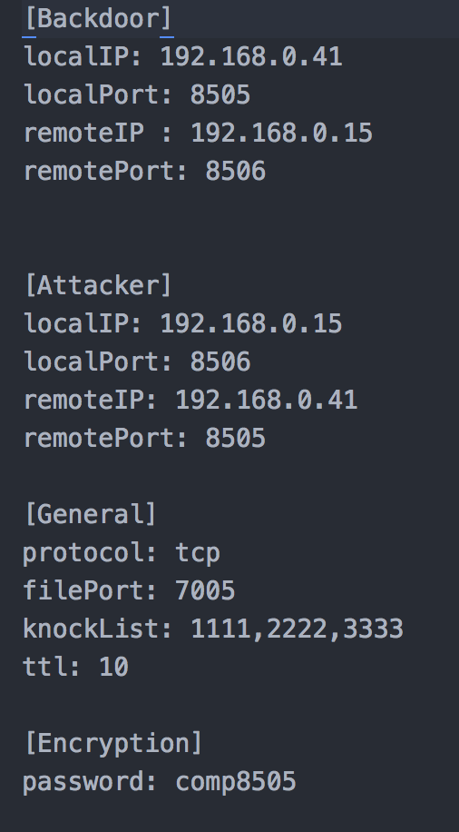

The configuration file is divided into 4 sections:

1. Backdoor

* localIP: the IP address of the machine that the backdoor was installed
* localPort: the port that the backdoor will listen for commands
* remoteIP: the IP address of the attacker machine
* remotePort: the port that the backdoor will knock for file exfiltration

1. Attacker

* localIP: the IP address of the attacker machine
* localPort: the port that will listen for knocking from the backdoor
* remoteIP: the IP address of the machine that the backdoor was installed
* remotePort: the port that all commands will be sent to

1. General
   * Protocol: the protocol for sending and receive packets
   * filePort: the port that will handle the actually file transfer
   * knockList: the sequence of port for port knocking
   * ttl: the time for the firewall to remain opening for file transfer
2. Encryption

* Password: the password to encrypt or decrypt the data

# Usage

## Attacker

To run the attacker script, run the following command:

python attackerMain.py

Once the script is running, the user can start entering the command for the backdoor to execute. The available commands are:

* GET: get the specified file from the victim machine and send to the attacker machine.
* KEYON: start the keylogger
* KEYOFF: stop the keylogger
* WATCH: add a watch for a file or directory
* RMWATCH: remove the watch for a file or directory
* CLOSE: send CLOSE command to the backdoor application and close itself
* Other shell commands: cd, ls, ps, pwd, ifconfig, etc.

## Backdoor

To run the backdoor script, run the following command:

python backdoorMain.py

Once the script is running, the backdoor will start to listen for commands. The available commands for the backdoor are:

* GET: extract the name of the file and start sending to the attacker machine
* KEYON: start the keylogger
* KEYOFF: stop the keylogger
* WATCH: add a watch to a file or directory
* RMWATCH: remove the watch to a file or directory
* CLOSE: close the backdoor application
* Other shell commands: cd, ls, ps, pwd, ifconfig, etc.