*Danny Lieu*

*A00831407 | MAY 22, 2018*

*Packet-sniffing backdoor*

Design Work

Table of Contents

Attacker 2

Diagram 2

Pseudocode 2

Backdoor 3

Diagram 3

Pseudocode 3

# Attacker

## Diagram

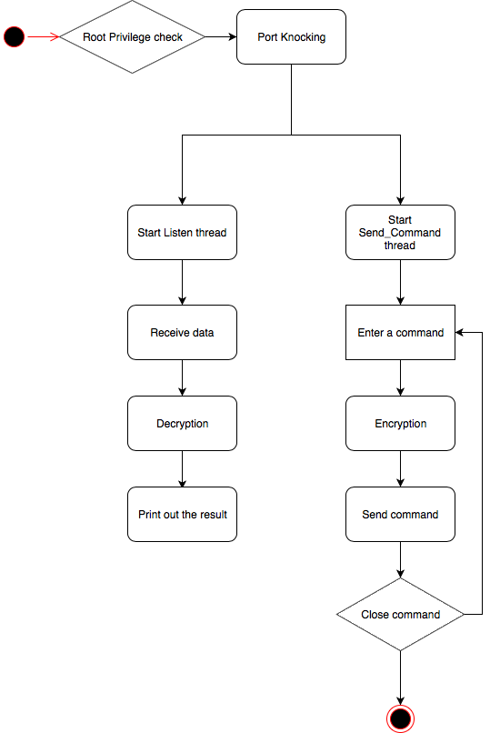

## Pseudocode

*attacker.py*

*main()*

*If user != ‘root’:*

*print(“This application have to run with root access. Try again”)*

*exit()*

*For each port in portList:*

*sendPacket(sport=port)*

*sleep(1)*

*while True*

*cmd = input(“Enter a command: “)*

*sendCommand(encryption(cmd))*

*if cmd == ‘close’:*

*exit()*

*while listenForResult*

*print(decryption(result))*

# Backdoor

## Diagram

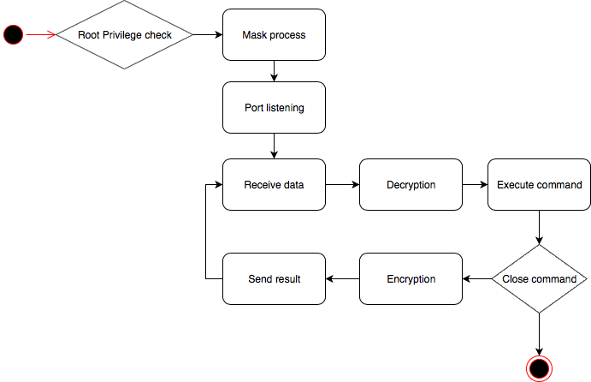

## Pseudocode

*Backdoor.py*

*Main()*

*If user != ‘root’:*

*print(“This application have to run with root access. Try again”)*

*exit()*

*while receivePacket(packet)*

*if packet.sport in portList*

*code += 1*

*if code == 3*

*break*

*while listenForCommand()*

*data = receivePacket()*

*cmd = decryption(data)*

*result = executeCommand(cmd)*

*if cmd == ‘close’*

*exit()*

*payload = encryption(result)*

*sendPacket(payload)*