Port Forwarder

COMP 8005 – Final Project - Design Work

**Danny Lieu**

**Mike Zobac**

**Mar 27, 2018**

# Diagram

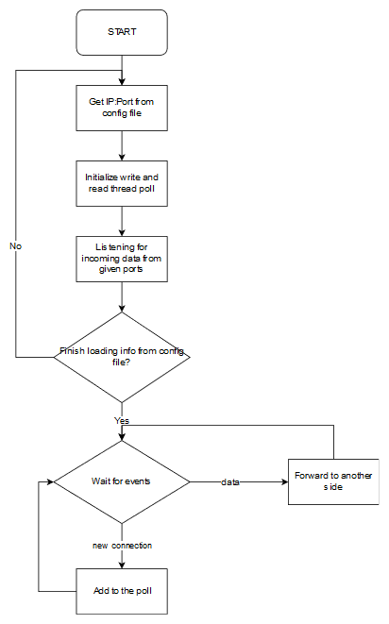

# Pseudocode

int main(void) {

for each port/ip pair in config file {

fork new process

create pool of read threads

create pool of write threads

bind listen socket to port

connect to endpoint at ip on port with forwardFD

set non-blocking

add listen socket to epoll

loop forever{

epoll_wait

for socket in epoll{

If socket == listen socket {

Accept

Set not-blocking

Add to epoll

}

else if EPOLLIN {

add to read queue

}

Else if EPOLLOUT {

Add to write queue

}

}

}

}

}

Read thread {

Get accept socket from listen queue

Read from accept socket into forward socket

Close if closed by client

}

Write thread {

Get accept socket from listen queue

Read from forward socket into accept socket

Close if closed by client

}