
Course Code | : | AIT205
Course Name | : | Matrix Analysis and Application
Lecturer | : | Goh Sim Kuan
Academic Session | : | 2023/09
Assessment Title | : | Assignment
Submission Due Date | : | 29/12/2023
Prepared by
 | : | Student ID | Student Name
 |  | AIT2209607 | Leong Ting Yi
 |  | AIT2209608 | Liew Cheah Ming
 |  | AIT2209941 | Leonard Tye Zi Yang
 |  | AIT2209954 | Tay Re Zen
 |  | AIT2104137 | Wong Zhan Song
Date Received | :
Feedback from Lecturer:

Mark:

Own Work Declaration

I/We hereby understand my/our work would be checked for plagiarism or other misconduct, and the softcopy would be saved for future comparison(s).

I/We hereby confirm that all the references or sources of citations have been correctly listed or presented and I/we clearly understand the serious consequence caused by any intentional or unintentional misconduct.

This work is not made on any work of other students (past or present), and it has not been submitted to any other courses or institutions before.

Signature: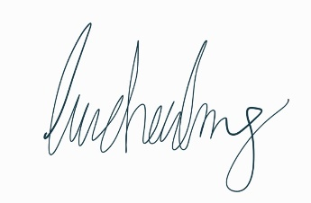
Zen
Ting yi
Leo
ZHanS

Date:29/12/2023

