LVMH Competitor Analysis Report
Generated on: 3/1/2025, 6:44:13 PM
Number of images analyzed: 12

Recommendations & Analysis
Recommendations & Analysis
- **Top 3 Most Attractive Incentives**
- **Acqua Di Parma’s $250.00 cash per bottle** for select high-end fragrances (e.g., ICOLONIAEDCSOML, ESSENZAEDC). This is exceptionally lucrative for staff.
- **Diptyque’s $5.00 cash per item sold** across all SKUs, including diffusers, candles, and sets. Consistent and easy to earn.
- **Hermès Fragrance T4’s $50.00 voucher for every 10 bottles sold** (85ml/100ml), capped at $10,000. High reward for bulk sales.

- **Top 3 Strategies to Compete**
- **Tiered cash incentives**: Offer escalating cash rewards (e.g., $300 for ultra-premium SKUs, $10–$50 for core products) to outpace Acqua Di Parma’s $250.
- **Simplified bulk-sale bonuses**: Introduce “$10 cash per bottle” universally (like Cartier’s $5 but higher) to incentivize volume over competitors’ complex structures.
- **Hybrid rewards**: Combine cash + exclusive product testers (e.g., “$15 cash + tester for every 3 bottles sold”) to counter Diptyque’s cash-only model.

- **Ensuring Clarity for Sales Staff**
- Use **flat-rate cash incentives** (e.g., “$10 per bottle, no caps”) to avoid confusion from tiered thresholds.
- Highlight **immediate payouts** (cash over vouchers) to emphasize instant value.
- Train staff with **product-specific cheat sheets** (e.g., “Sell Product X, earn $Y”) to simplify targeting.

---

Competitor Incentive Analysis Table

Competitor Data Table
Brand | Location of Promotion | Eligible Staff | Incentive Type | Incentive Description | Relevant SKUs/Products
Acqua Di Parma | All terminals | Shilla Payroll | Cash | $2.50–$250.00 cash per bottle sold, varying by SKU. | ICOLONIAEDCSOML. (8028713000089), ICOLONIAESSENZAEDCSOML. (8028713220012), SIG.QUERCIAEDP20ml. (8028713810800), SIG.MAGNOLIAINFINITAEDP20ML (8028713813320), COLONIAEDC100ML (8028713000036), + 25 others
Burberry, Guccicos | All terminals | GS BA | Voucher | $10.00 voucher for every 2 focus SKUs sold. | BURBERRYMAKEBVOLUMEMASCARA01BLACK, GUCCICOSMAKEEYEPLLE244FESTIGLOW, BURBERRYMAKEKMLS24NEWLENUDELE24, + 8 others
Cartier | All terminals | Shilla Payroll | Cash | $5.00 cash per bottle of any Cartier perfume sold. | All Cartier perfumes
Chloe | Wing, Arrival | GS BA | Voucher | $30.00 voucher for every $1,500.00 Chloe products sold. | Chloe-XM24-EDP50BL100 (3616305258502), Flora-Gentle Magnolia-XM24-EDP100 (3616305447654)
CK | Wing, Arrival | GS BA | Voucher | $30.00 voucher for every $1,200.00 CK products sold. | CKOne-XM24-EDT200EDT50 (3616305433770), CKDefy-XM24-EDP50SG100 (3616305433671), + others
Diptyque | All stores | Shilla Payroll | Cash | $5.00 cash per item sold; applies to bags and all listed SKUs. | DIPTYQUEPFMDiffuserRoses (3700431432483), DIPTYQUEPFMNEWHOURGLASS2.0BAIES (3700431445988), DIPTYQUEBODYLEauPapierHairMist30ml (3700431496607), + 25 others
Drunk Elephant | Terminal 1,2,3 | Shiseido Group BAs | Voucher | $10.00 voucher for every $600.00 sales or 5 sets of Lippe Balm sold. | LIPPEBALMREFORM (42801673101)
Hermès (Beauty) | All terminals | GS BA | Voucher, Product | $30.00 voucher + 1 tester for every 6 Eye/Lip products sold (capped at $120.00). | Eye Pencils, Lip Liners, Eyeshadow Palettes
Hermès (Fragrance) | Terminals 1-4 | GS BA | Voucher, Product | $15–$50.00 voucher + testers for bulk sales of Xmas sets/Twilly/Barenia fragrances. | Barenia 30ml/60ml/100ml, Twilly Collection 50ml/85ml, Xmas Sets
Kylie | Wing, Arrival | GS BA | Voucher | $10.00 voucher for every 3 Kylie Cosmic Fragrance bottles sold. | Kylie Cosmic Fragrance
Lancaster | All stores | Shilla Payroll | Voucher | $10.00 voucher for every 4 SKUs sold. | LANCASTESKINSRDAAGESPF30100ML21IV (088210000012), LANCASTESKINDMOIST30MLSPF5018IV (088210000013), + 11 others
Nars | All terminals | GS BA | Voucher | Tiered vouchers: $10/$50/$80 for $1,000/$3,000/$5,000 sales. | All Nars products
Assumptions:
- “Terminal” and “Wing/Arrival” locations inferred from Shilla’s typical duty-free zoning.
- “Shilla Payroll” eligibility assumed for brands without explicit staff criteria.
- SKUs abbreviated for brevity; full EAN/REF codes available in raw data.

Appendix: Analyzed Images

Feb 2025.jpeg
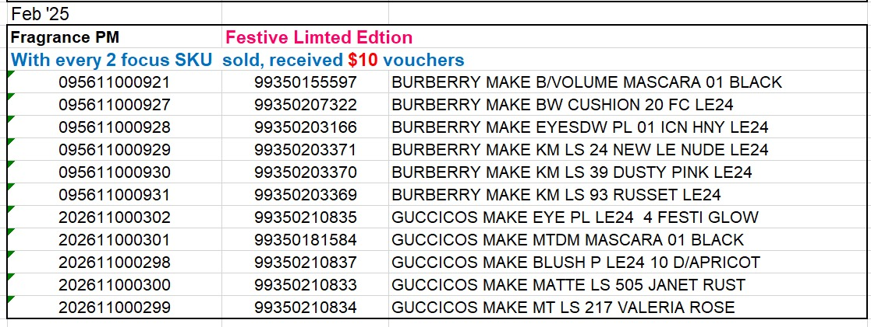

Feb 2025.jpeg
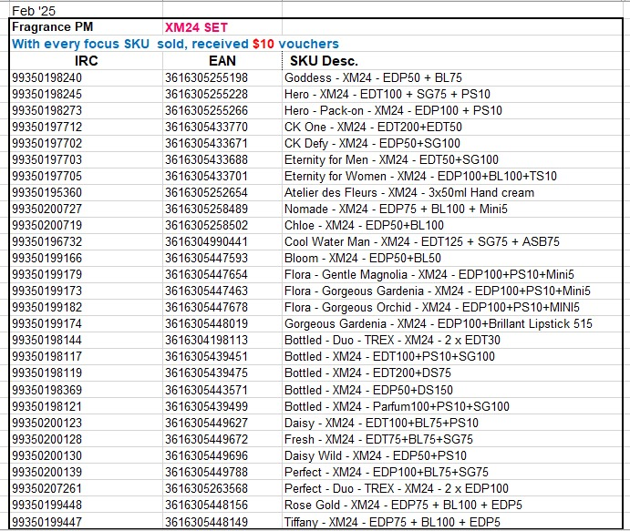

Feb 2025.jpeg
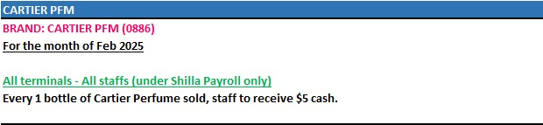

Feb 2025.jpeg
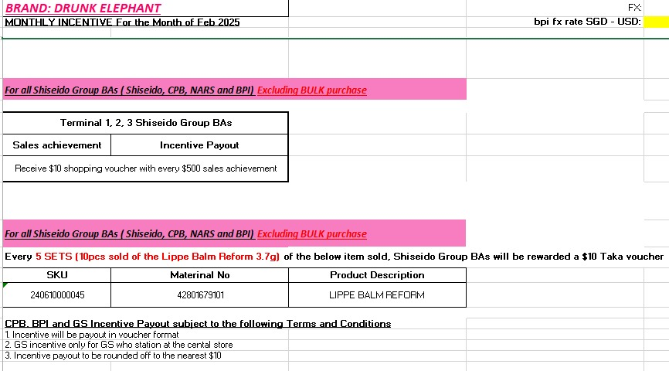

Feb 2025.jpeg
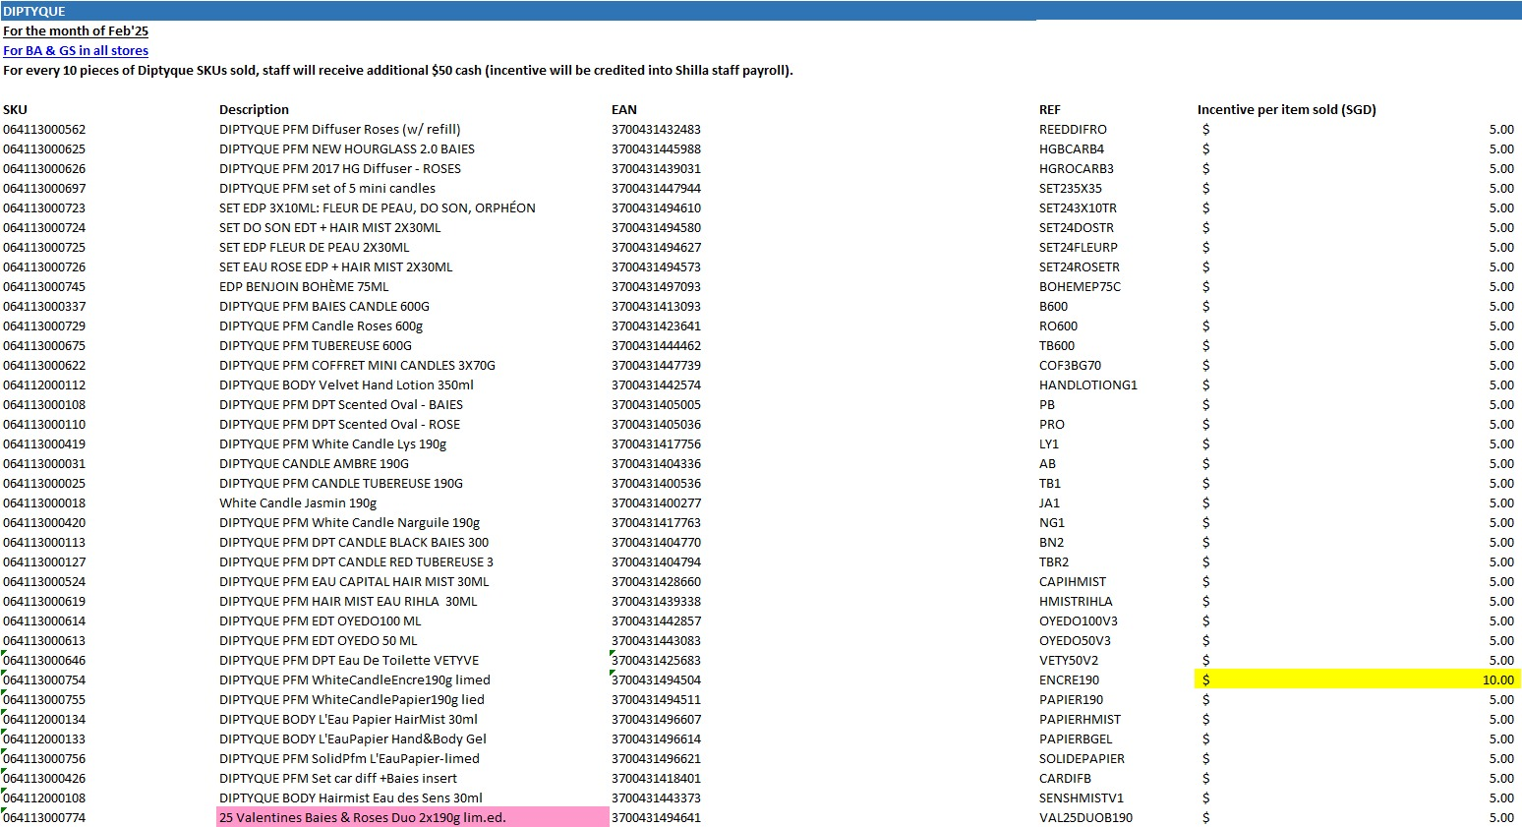

Feb 2025.jpeg
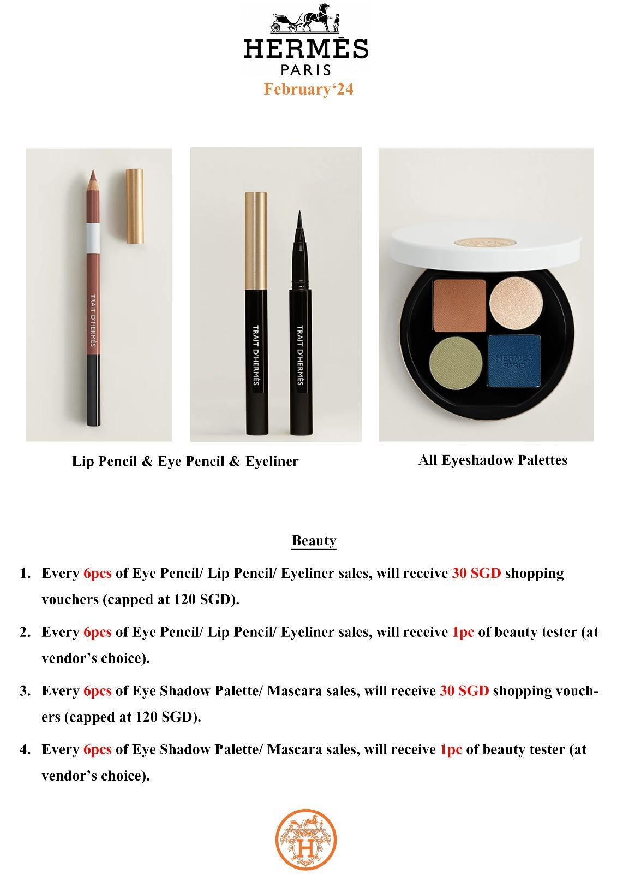

Feb 2025.jpeg
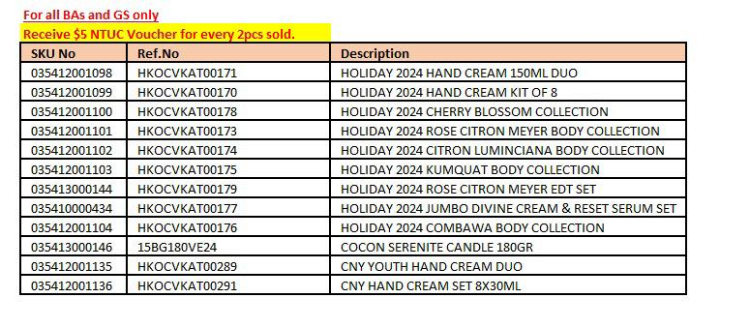

Feb 2025.jpeg
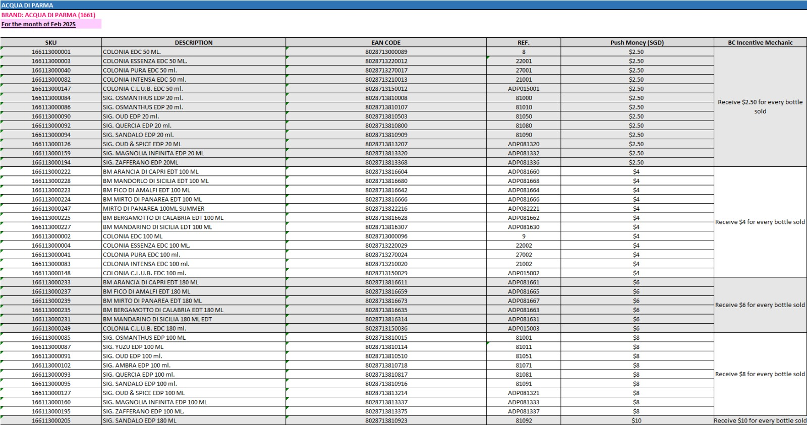

Feb 2025.jpeg
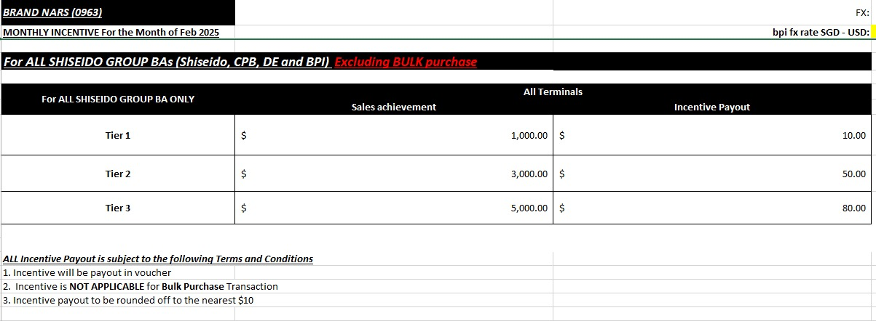

Feb 2025.jpeg
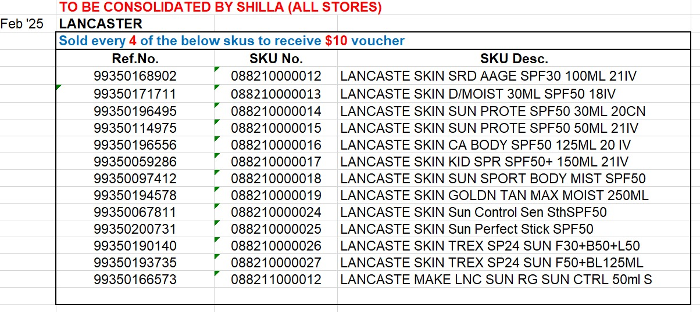

Feb 2025.jpeg
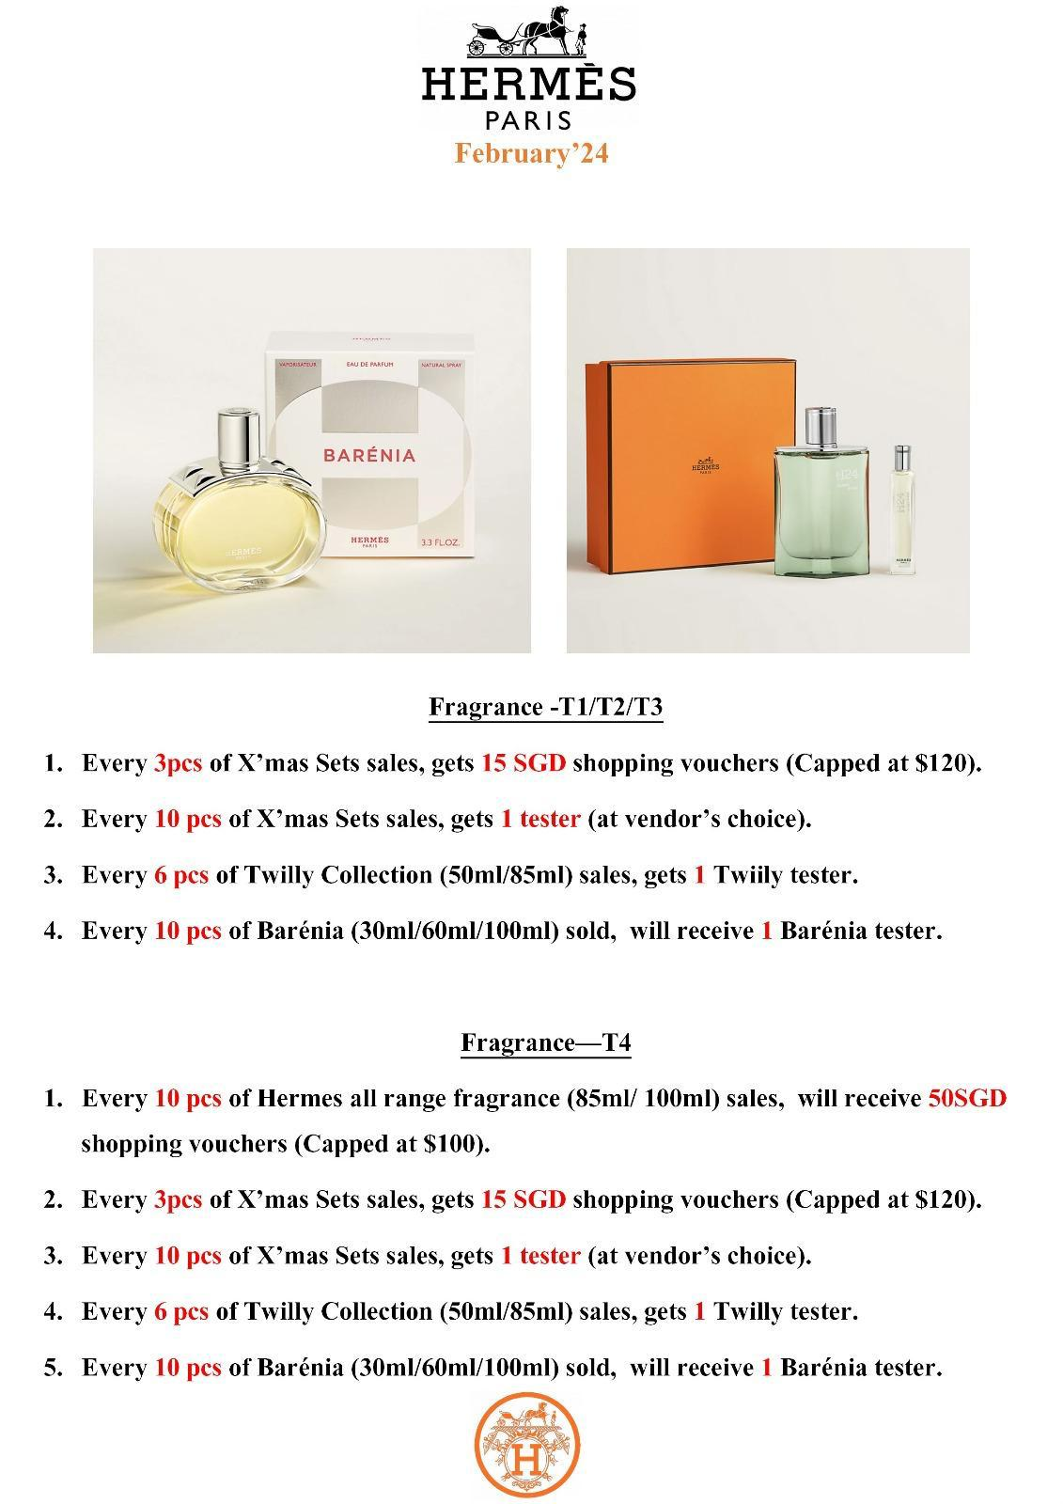

Feb 2025.jpeg
