LVMH Competitor Analysis
Generated on 3/1/2025 6:54:13 PM | 12 images analyzed

Recommendations & Analysis
1. Top 3 Most Attractive Incentives:
- Acqua Di Parma: High cash incentives ($250/SKU for select fragrances) drive urgency for premium products.
- Hermes (T4): $50 vouchers for high-margin 85ml/100ml fragrances incentivize upselling.
- Cartier: Simple $5 cash per bottle sold is easy to understand and universally motivating.
2. Top 3 Strategies to Compete:
- Tiered Cash Bonuses: Offer escalating cash rewards (e.g., $10/$20/$30 per bottle) for LVMH fragrances exceeding price thresholds (e.g., $300+).
- Bundle Incentives: Reward staff with higher payouts for selling complementary products (e.g., perfume + leather accessory sets).
- Exclusive Tester Access: Provide limited-edition testers for top sellers (e.g., Louis Vuitton travel sprays) to create exclusivity and drive loyalty.
3. Simplifying Strategies for Staff:
- Use clear, visual incentive charts (e.g., "Sell 2 Dior perfumes = $25 cash") to eliminate confusion.
- Align incentives with product training (e.g., "Focus on Guerlain Orchidée Impériale for triple rewards").
- Highlight time-limited perks (e.g., "Double vouchers for Chanel No. 5 sales this week") to create urgency.

Detailed Analysis Table
Brand | Location of Promotion | Eligible Staff | Incentive Type | Incentive Description | Relevant SKUs/Products
Acqua Di Parma | All terminals (assumed) | Shilla Payroll | Cash | $2.50–$250.00 per bottle sold, depending on SKU | ICOLONIAEDCSOML., ICOLONIAESSENZAEDCSOML., COLONIAPURAEDC50ml., SIG.OSMANTHUSEDP20ml., SIG.OUDEDP20ml., SIG.QUERCIAEDP20ml., SIG.SANDALOEDP20ml., IBMARANCIADICAPRIEDT100ML, IBMMANDORLODISICILIAEDT100ML, etc.
Burberry/Guccicos | All terminals (assumed) | Shilla Payroll | Voucher | $10.00 voucher for every 2 focus SKUs sold (makeup/fragrance) | BURBERRYMAKEBVOLUMEMASCARA01BLACK, GUCCICOSMAKEEYEPLLE244FESTIGLOW, GUCCICOSMAKEMTDMMASCARA01BLACK, etc.
Cartier | All terminals | Shilla Payroll | Cash | $5.00 cash per bottle of Cartier perfume sold | All Cartier perfumes
Chloe | GSBAA (Wing/Arrival) | Shilla Payroll | Voucher | $30.00 voucher for every $1,500.00 Chloe products sold | Chloe fragrances (inferred)
CK | GSBAA (Wing/Arrival) | Shilla Payroll | Voucher | $30.00 voucher for every $1,200.00 CK products sold | CKOne-XM24-EDT200EDT50, CKDefy-XM24-EDP50SG100, etc.
Diptyque | All stores (BAGs) | Shilla Payroll | Cash | $5.00 cash per Diptyque SKU sold (10+ pieces required for payout) | Diffuser Roses, NEW HOURGLASS 2.0 Baies, Candles (Baies/Roses/Tubéreuse), Hair Mist Eau Rose, etc.
Drunk Elephant | Terminals 1-3 | Shiseido Group BAs | Voucher | $10.00 voucher for every $600.00 sales or 5 sets of Lippe Balm Reform sold | Lippe Balm Reform 3.7g
Fragrance Multibrand | All terminals (assumed) | Shilla Payroll | Voucher | $10.00 voucher per focus SKU sold (XM24SET) | CKOne-XM24-EDT200EDT50, Hero-XM24-EDT100SG75PS10, Nomade-XM24-EDP75BL100Mini5, etc.
Hermes (T1-T3) | Terminals 1-3 | Shilla Payroll | Voucher/Product | $15 voucher (capped at $12,000) + testers for Xmas Sets; testers for Twilly/Barenia | Xmas Sets, Twilly Collection (50ml/85ml), Barenia (30ml/60ml/100ml)
Hermes (T4) | Terminal 4 | Shilla Payroll | Voucher/Product | $50 voucher (capped at $10,000) + testers for Hermès 85ml/100ml fragrances | Hermès 85ml/100ml fragrances
Hermes Beauty | All terminals (assumed) | Shilla Payroll | Voucher/Product | $30 voucher (capped at $120) + testers for Eye/Lip products or Eyeshadow/Mascara | Lip Pencils, Eye Pencils, Eyeliners, Eyeshadow Palettes, Mascara
Kylie | GSBAA (Wing/Arrival) | Shilla Payroll | Voucher | $10.00 voucher for every 3 bottles of Kylie Cosmic Fragrance sold | Kylie Cosmic Fragrance (inferred)
Lancaster | All stores | Shilla Payroll | Voucher | $10.00 voucher for every 4 SKUs sold (sun care products) | LANCASTERSKINSUNPROTESPF5030ML, LANCASTERSKINCABODYSPF50125ML, LANCASTERSUNPERFECTSTICKSPF50, etc.
Nars | Terminals 1-3 (assumed) | Shiseido Group BAs | Voucher | Tiered vouchers: $10/$50/$80 for $1,000/$3,000/$5,000 sales | All Nars products
---

Image Appendix

Feb 2025.jpeg
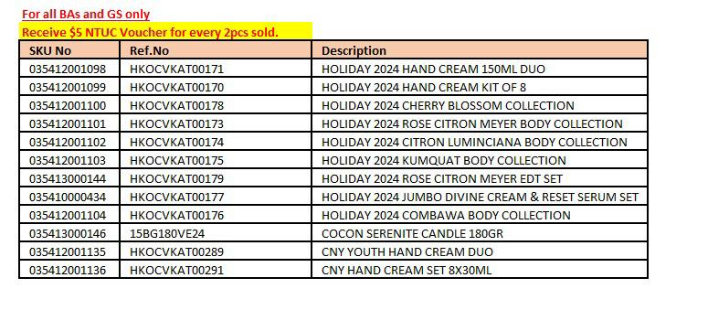

Feb 2025.jpeg
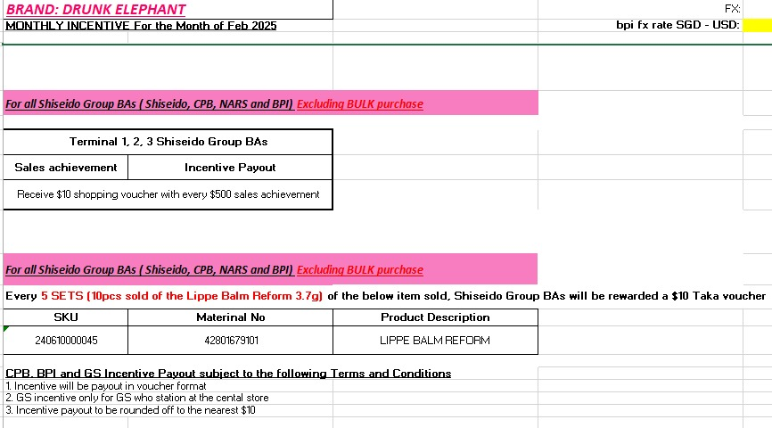

Feb 2025.jpeg
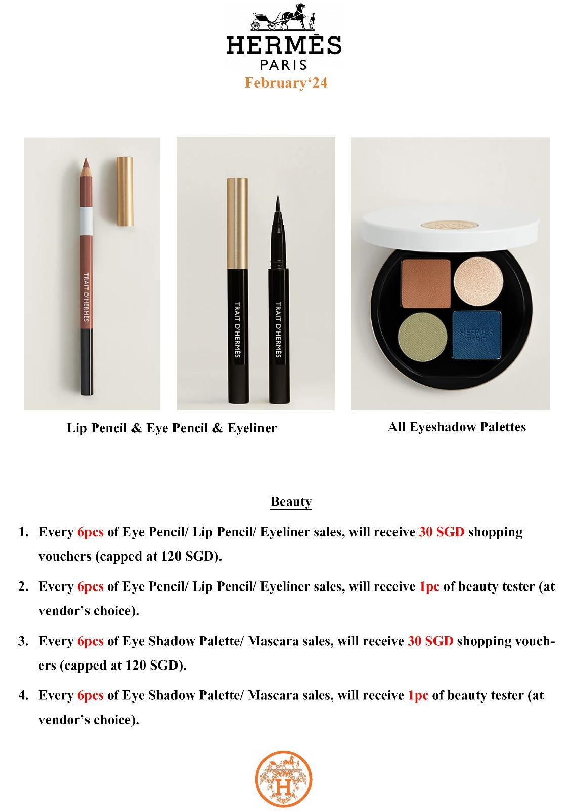

Feb 2025.jpeg
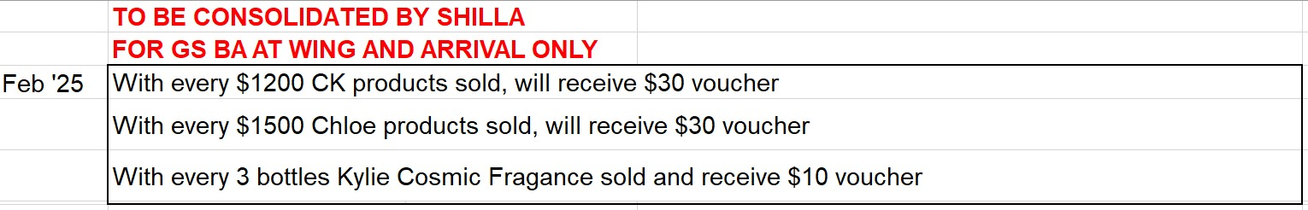

Feb 2025.jpeg
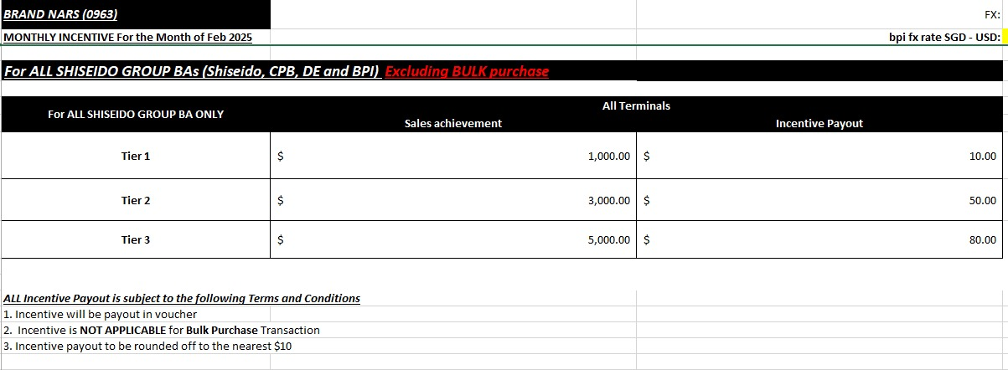

Feb 2025.jpeg
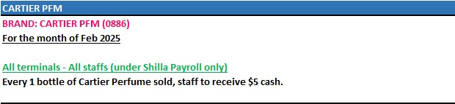

Feb 2025.jpeg
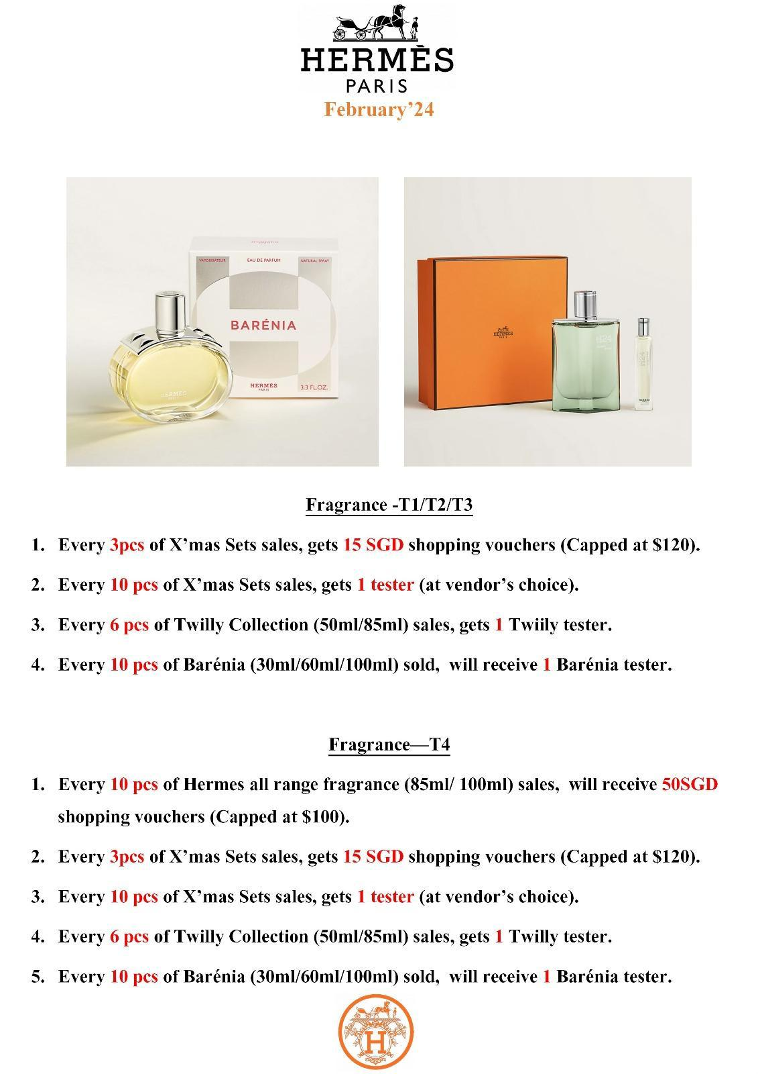

Feb 2025.jpeg
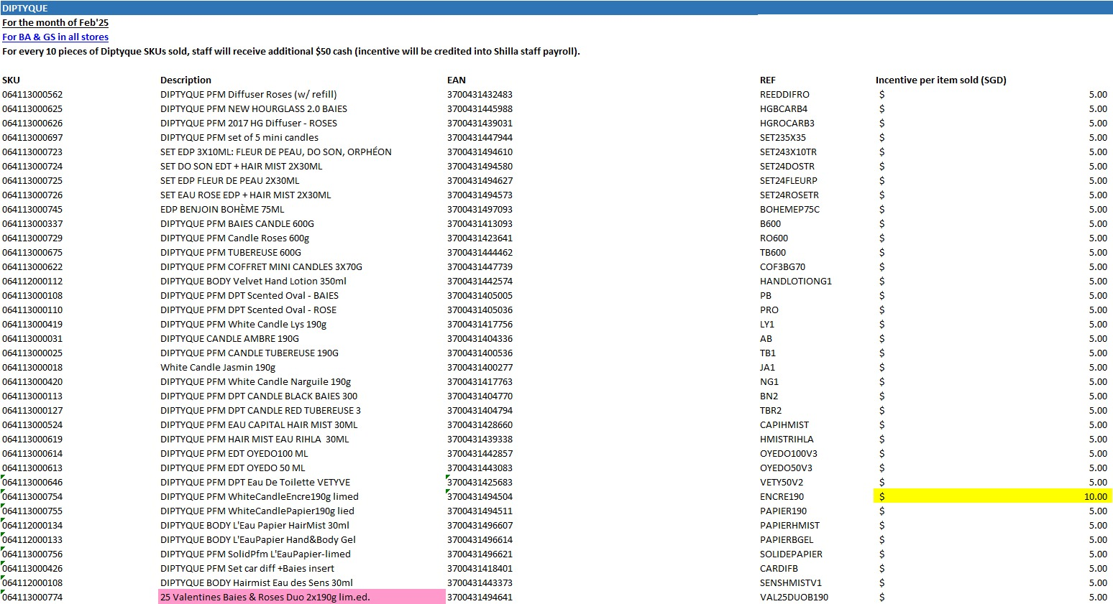

Feb 2025.jpeg
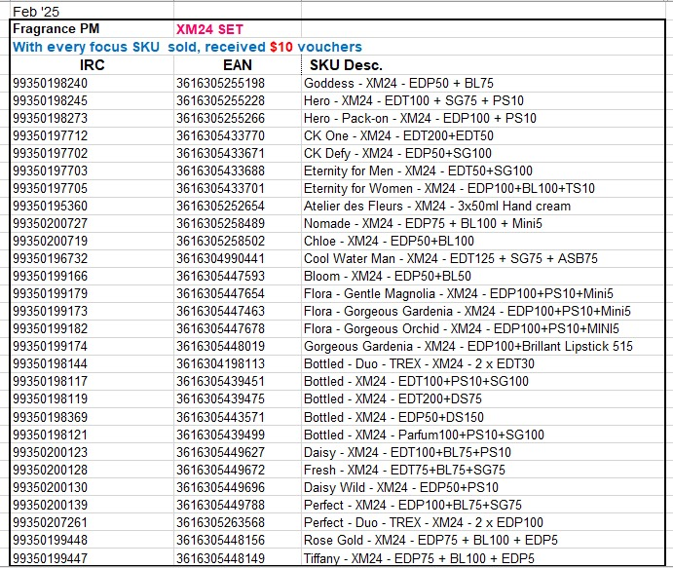

Feb 2025.jpeg
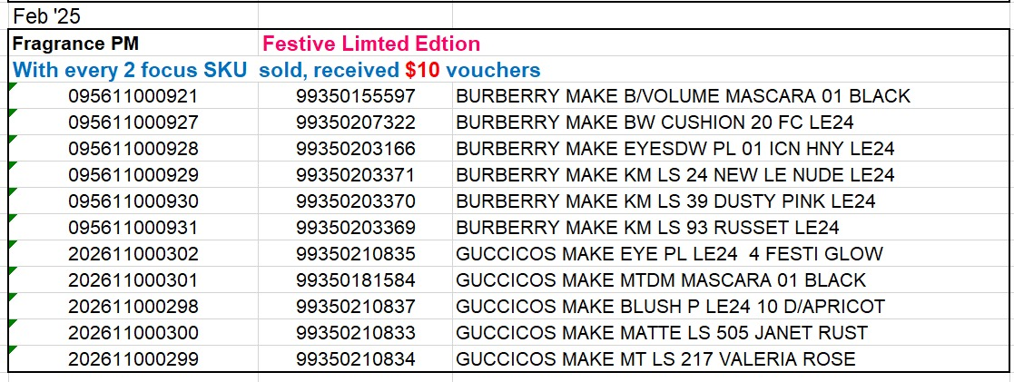

Feb 2025.jpeg
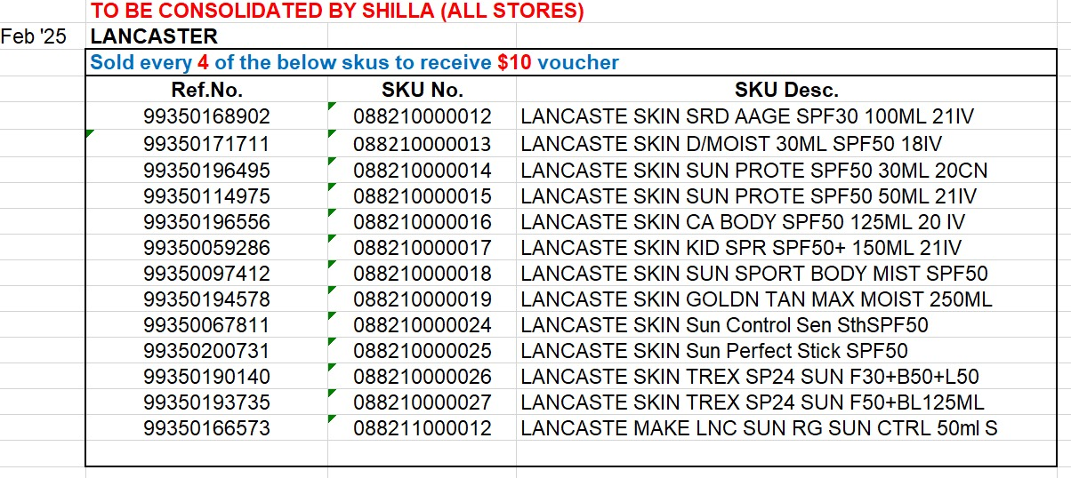

Feb 2025.jpeg
