LVMH Competitor Analysis
Generated on 3/1/2025 7:04:57 PM | 12 images analyzed

Detailed Analysis Table
Brand | Location | Eligible Staff | Incentive Type | Incentive Description | SKUs/Products
Acqua Di Parma | All terminals | Shilla payroll | Cash | Receive $2.50–$10 cash per bottle sold (varies by SKU; e.g., $2.50 for 50ml EDCs, $10 for 180ml EDPs). | All listed SKUs (e.g., COLONIAPURAEDC50ml, SIG.SANDALOEDP180ML, IBMARANCIADICAPRIEDT180ML).
Burberry | Fragrance counters | GS BA | Voucher | $10 voucher for every 2 focus SKUs sold. | Makeup SKUs (e.g., BURBERRYMAKEBVOLUMEMASCARA01BLACK, BURBERRYMAKEKMLS24NEWLENUDELE24).
Cartier | All terminals | Shilla payroll only | Cash | $5 cash per bottle of perfume sold. | All Cartier perfumes.
Chloe | TWING & Arrival | GS BA | Voucher | $30 voucher for every $1,500 in sales. | All Chloe products (inferred).
Diptyque | All stores | BAGs | Cash | $5 cash per item sold when 10 SKUs are sold. | Diffusers, candles, sets (e.g., DIPTYQUEPFMDiffuserRoses, DIPTYQUEPFMNEWHOURGLASS2.0BAIES).
Drunk Elephant | Terminals 1–3 | Shiseido Group BAs | Voucher | $10 voucher per $600 sales or per 5 sets of Lippe Balm Reform 3.7g sold. | Lippe Balm Reform 3.7g sets.
Gucci Cosmetics | Fragrance counters | GS BA | Voucher | $10 voucher for every 2 focus SKUs sold. | GUCCICOSMAKEEYEPLLE244FESTIGLOW, GUCCICOSMAKEMATTELS505JANETRUST.
Hermes (T1–T3) | Terminals 1–3 | GS BA | Voucher | $15 voucher per 3 Xmas sets sold (capped at $120). | Xmas sets (unspecified).
Hermes (T1–T3) | Terminals 1–3 | GS BA | Product | 1 tester per 10 Xmas sets sold. | Xmas sets (unspecified).
Hermes (T4) | Terminal 4 | GS BA | Voucher | $50 voucher per 10pc of 85ml/100ml fragrances sold (capped at $100). | 85ml/100ml fragrances (unspecified).
Hermes Beauty | All terminals | GS BA | Voucher | $30 voucher per 6 Eye/Lip products sold (capped at $120). | Eye pencils, lip pencils, eyeliners.
Kylie Cosmetics | TWING & Arrival | GS BA | Voucher | $10 voucher per 3 bottles sold. | Kylie Cosmic Fragrance (unspecified).
Lancaster | All stores | Shilla payroll | Voucher | $10 voucher per 4 SKUs sold. | Sun care products (e.g., LANCASTESKINSRDAAGESPF30100ML, LANCASTESKINSUNPROTESPF5030ML).
Nars | All terminals | GS BA | Voucher | Tiered vouchers: $10 for $1,000 sales, $50 for $3,000, $80 for $5,000. | All Nars products (unspecified).
Multibrand Fragrance | Fragrance counters | GS BA | Voucher | $10 voucher per focus SKU sold. | CK One, Chloe Nomade, Davidoff Cool Water, Gucci Flora, Marc Jacobs Daisy.
---
1. Top 3 most attractive incentives:
- Acqua Di Parma’s cash incentives (up to $10 per bottle) offer immediate, high-value rewards for volume sales.
- Hermes Terminal 4’s $50 voucher per 10 high-margin fragrances provides a lucrative payout with a reasonable cap.
- Diptyque’s $5 cash per item (when selling 10 SKUs) combines volume-driven earnings with straightforward targets.
2. Top 3 strategies to compete:
- Introduce tiered cash incentives for LVMH hero products (e.g., $15 cash for every Louis Vuitton fragrance sold, scaling with units).
- Bundle vouchers with exclusive product testers (e.g., $20 voucher + a Dior tester for every $1,000 sold) to add perceived value.
- Simplify incentive structures (e.g., flat $8 cash per bottle across all SKUs) to eliminate confusion and drive focus on high-margin items.
3. Ensuring staff adoption:
- Use visual comparison charts to show LVMH incentives outperform competitors (e.g., higher per-unit payouts than Acqua Di Parma).
- Provide real-time tracking tools for staff to monitor earnings, emphasizing instant payouts over vouchers with caps.
- Train staff to position LVMH incentives as “guaranteed rewards” (cash vs. conditional vouchers) to build trust and motivation.

Image Appendix

Feb 2025.jpeg
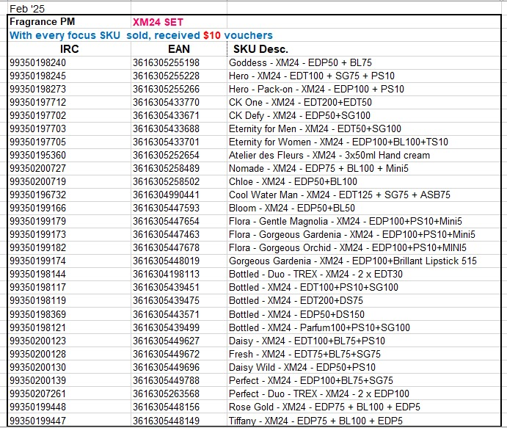

Feb 2025.jpeg
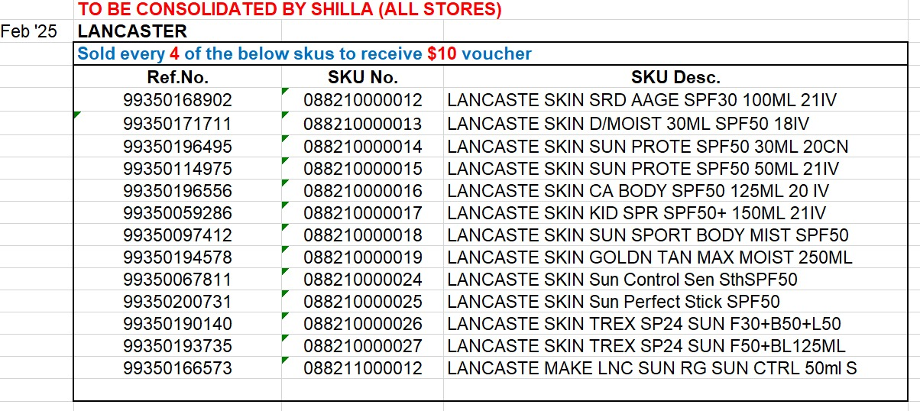

Feb 2025.jpeg
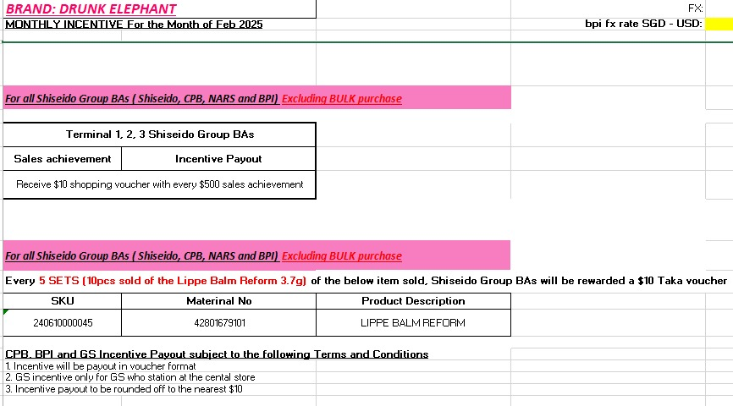

Feb 2025.jpeg
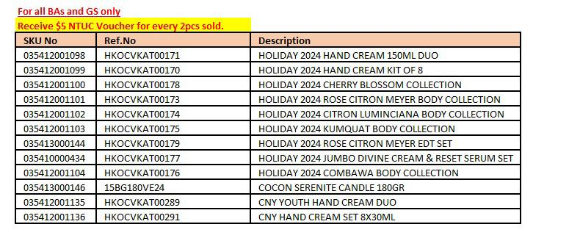

Feb 2025.jpeg
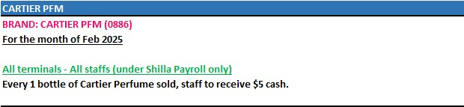

Feb 2025.jpeg
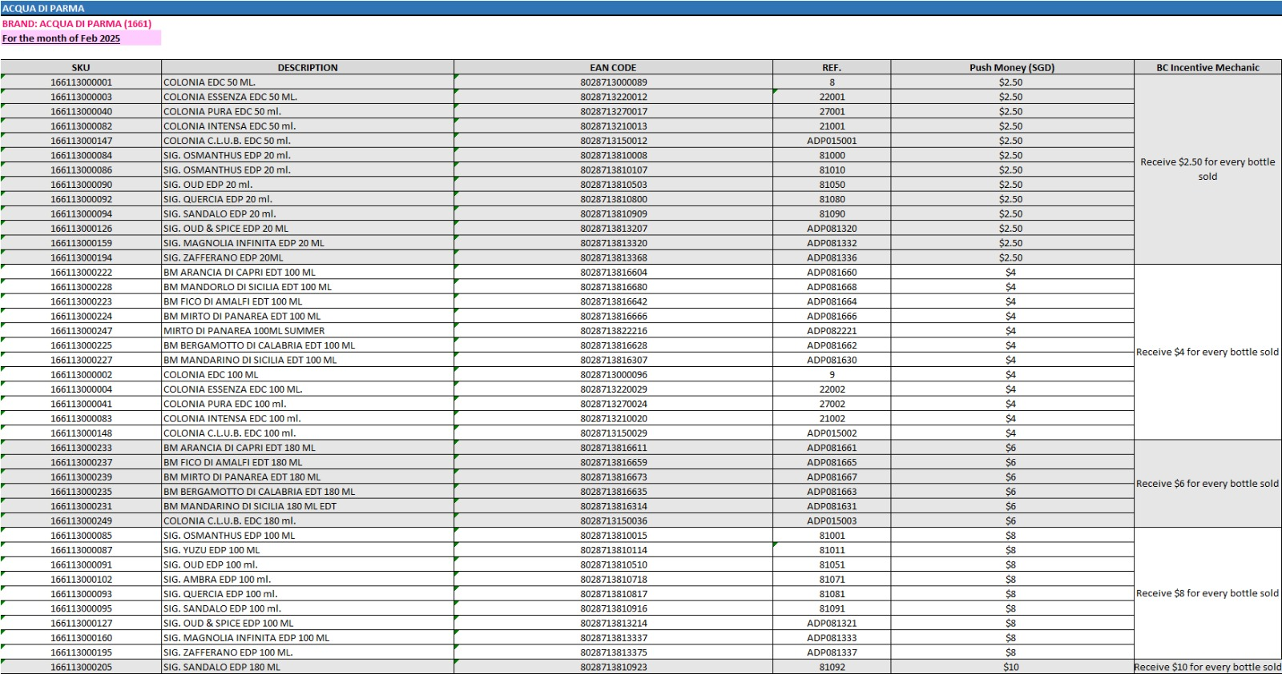

Feb 2025.jpeg
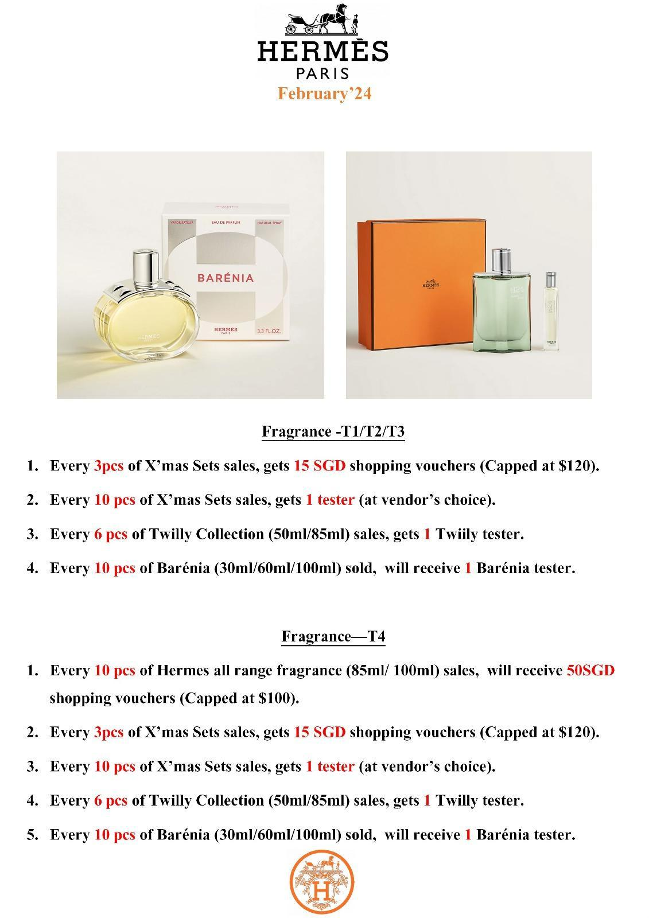

Feb 2025.jpeg
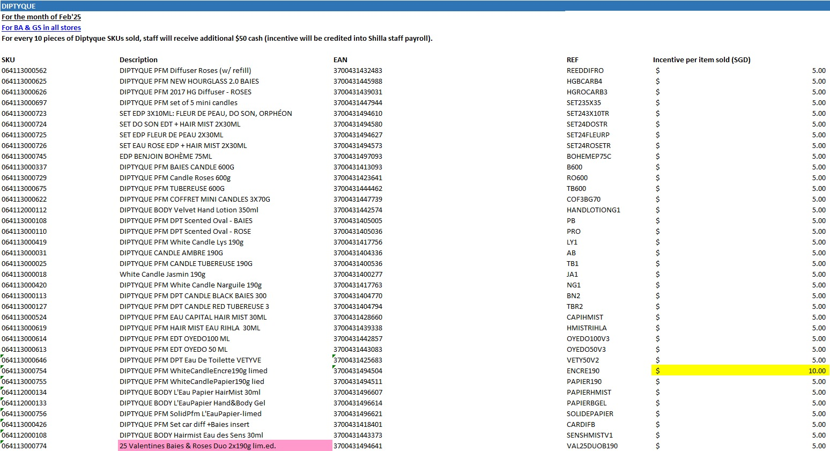

Feb 2025.jpeg
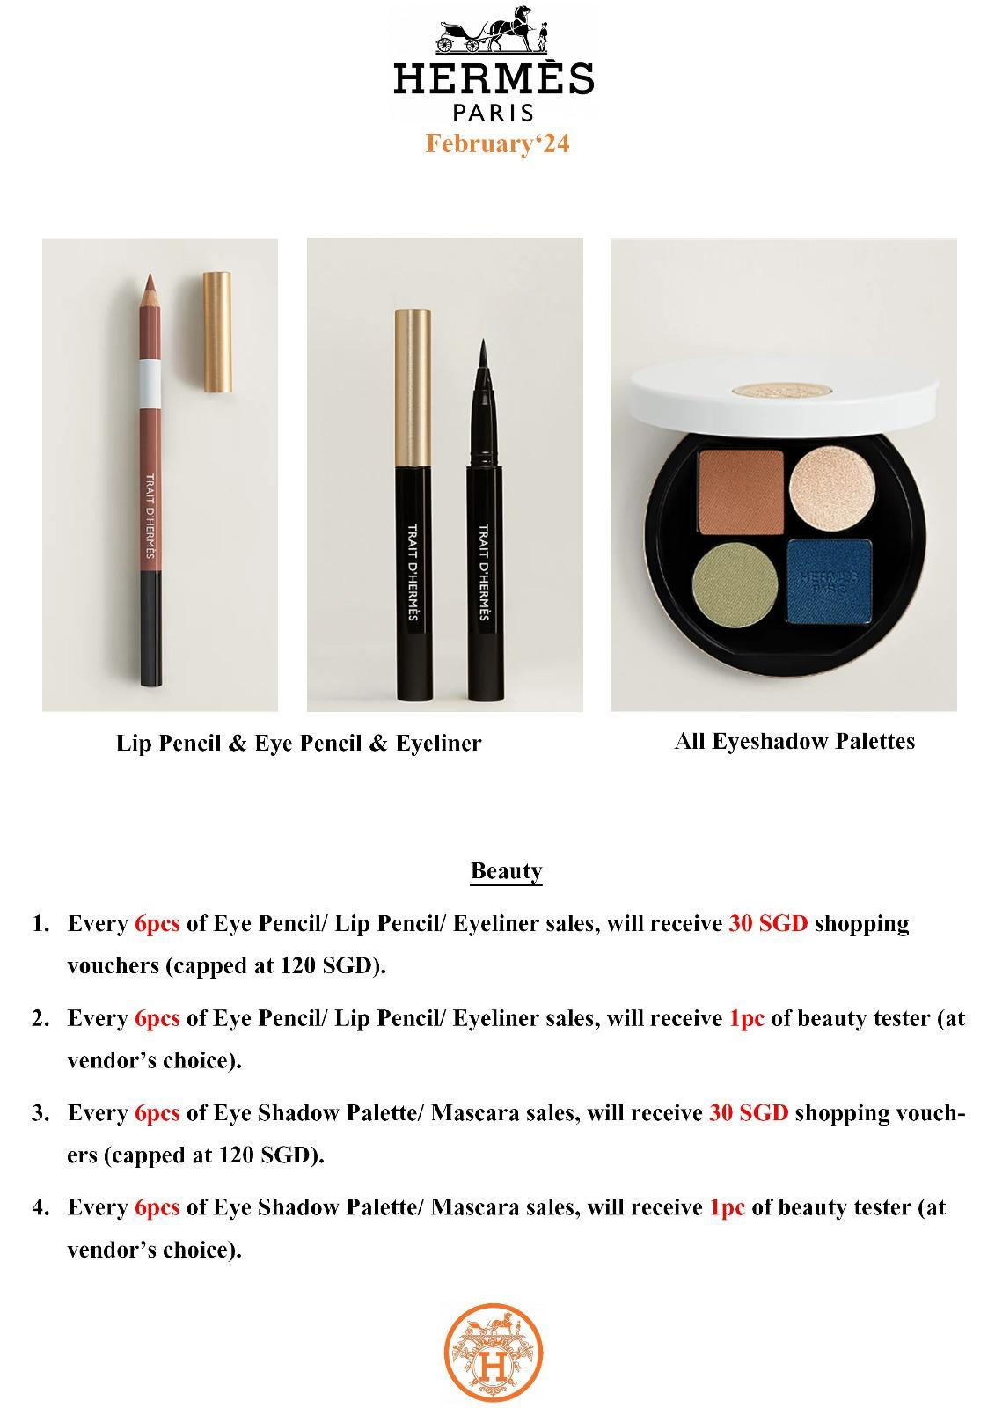

Feb 2025.jpeg
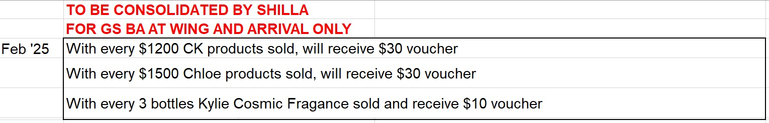

Feb 2025.jpeg
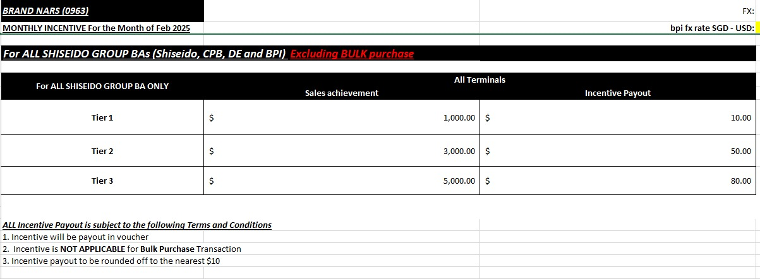

Feb 2025.jpeg
