
IT342-G4
SYSTEMS INTEGRATION AND ARCHITECTURE 1

FUNCTIONAL REQUIREMENTS SPECIFICATION (FRS)

Project Title: User Authentication and Profile Management System
Prepared By: Ybañez, Liezel, A.
Date of Submission: February 02, 2026
Version: 1.0

Table of Contents
1. Introduction 3
1.1. Purpose 3
1.2. Scope 3
1.3. Definitions, Acronyms, and Abbreviations 3
2. Overall Description 3
2.1. System Perspective 3
2.2. User Classes and Characteristics 3
2.3. Operating Environment 3
2.4. Assumptions and Dependencies 3
3. System Features and Functional Requirements 4
3.1. Feature 1: 4
3.2. Feature 2: 4
4. Non-Functional Requirements 4
5. System Models (Diagrams) 4
5.1. ERD 5
5.2. Use Case Diagram 5
5.3. Activity Diagram 6
5.4. Class Diagram 7
5.5. Sequence Diagram 8
6. Appendices 8

Introduction

Purpose
This document specifies the functional requirements for a User Authentication System that handles registration, login, profile viewing, and logout functionalities. The intended audience includes developers, testers, and stakeholders involved in the system implementation.

Scope
The system will provide secure user authentication with the following capabilities:
- User registration with validation
- Secure login with session management
- Profile/dashboard viewing for authenticated users
- Logout functionality
- Protection of routes from unauthorized access

Definitions, Acronyms, and Abbreviations
- ERD: Entity Relationship Diagram
- JWT: JSON Web Token
- API: Application Programming Interface
- UI: User Interface
- DTO: Data Transfer Object

Overall Description

System Perspective
The authentication system integrates with a larger web application, serving as the gateway for user access to protected resources. It follows a client-server architecture with React frontend and Spring Boot backend.

User Classes and Characteristics
- Guest User: Unauthenticated user who can only register or login
- Authenticated User: Logged-in user who can view profile and logout

Operating Environment
- Frontend: React.js with modern browser support
- Backend: Spring Boot 3.x with Java 17+
- Database: MySQL/PostgreSQL
- Tools: Maven/Gradle, Node.js

Assumptions and Dependencies
- Users have valid email addresses
- System uses HTTPS for secure communication
- JWT tokens for session management
- Password encryption using BCrypt

System Features and Functional Requirements
Describe each major feature of the system and its functional requirements.

Feature 1: User Registration
Description: Allows new users to create an account
Functional Requirements:
- User can fill registration form with username, email, password
- System validates email format and password strength
- System checks for duplicate email/username
- Successful registration creates user record and redirects to login

Feature 2: User Authentication
Description: Handles login and logout operations
Functional Requirements:
- User can login with email/username and password
- System validates credentials against database
- Successful login generates JWT token and session
- User can logout, destroying session/token
- Protected routes check authentication status

Non-Functional Requirements
- Performance: Login response < 2 seconds
- Security: Passwords stored as hashes, JWT token expiration
- Usability: Intuitive UI with clear error messages
- Reliability: 99.9% uptime for authentication services
- Scalability: Support for 10,000 concurrent users

System Models (Diagrams)
Insert the necessary diagrams for the system:

ERD
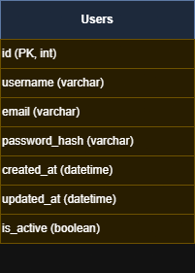

Use Case Diagram
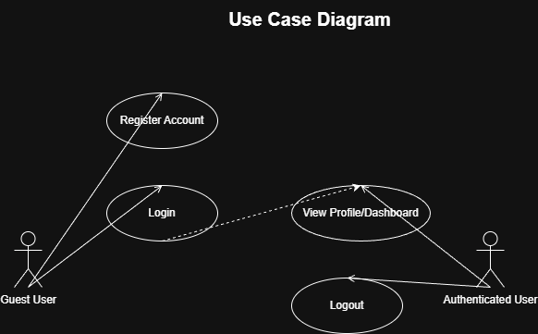

Activity Diagram
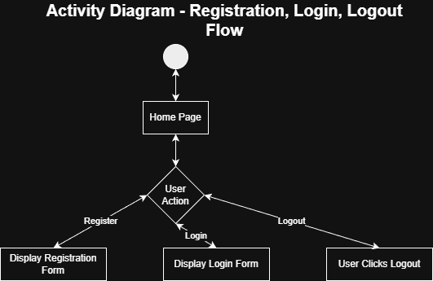

Class Diagram
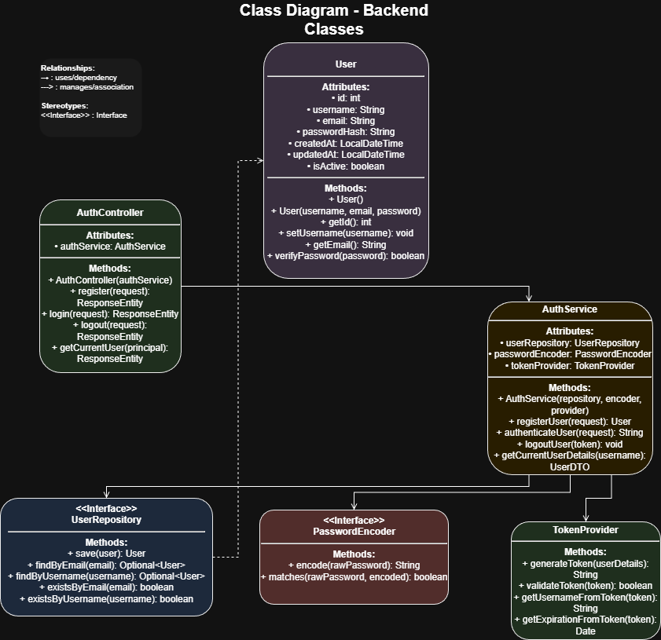

Sequence Diagram
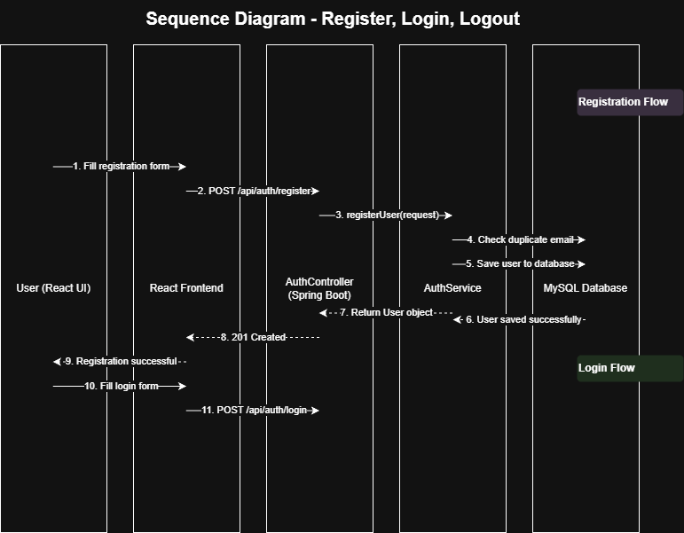

Appendices
- References: Spring Security Documentation, JWT RFC 7519
- Tools Used: Draw.io for diagram creation

Login UI
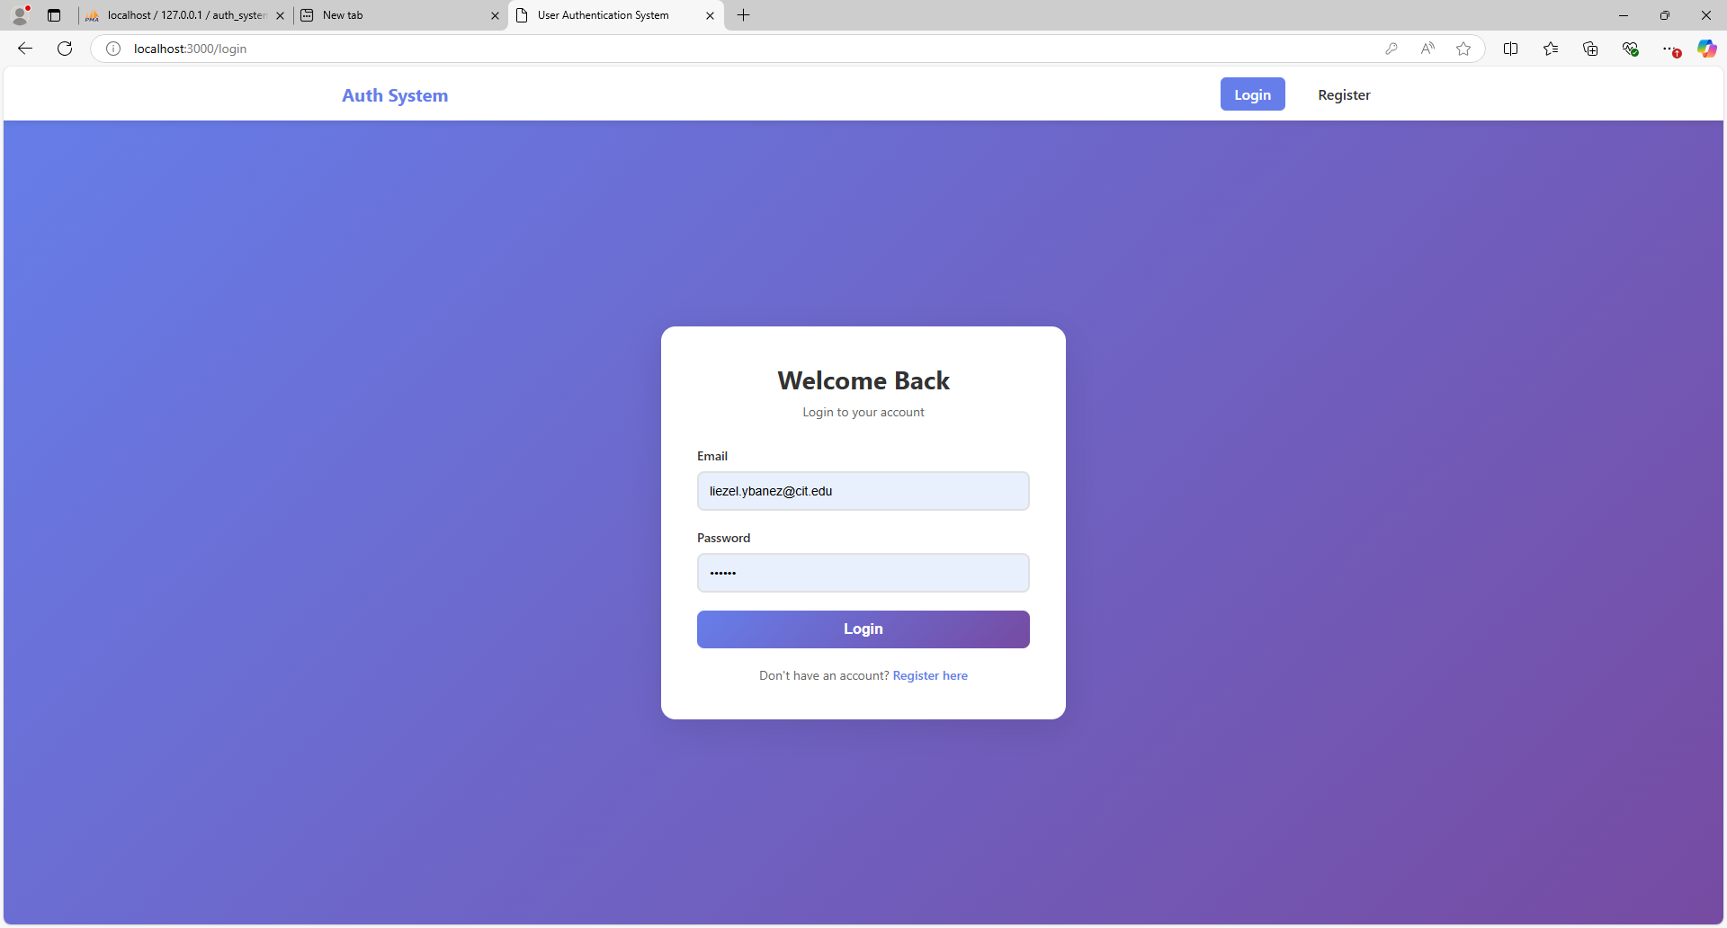
Registration UI
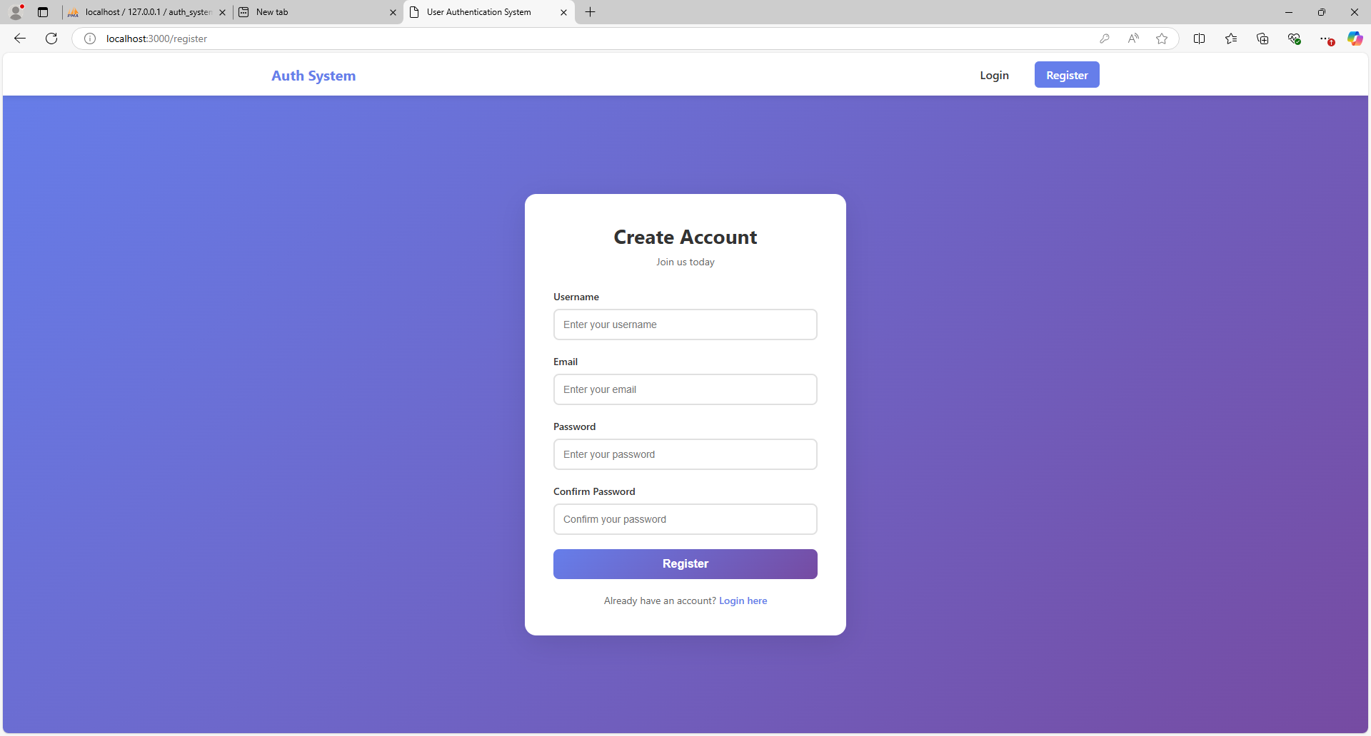

DashBoard and Profile UI
