**DiffraLab Hands-On Teaching Design**

**X-ray and Neutron Diffraction Analysis Simulation Teaching Module**

*— Using the DiffraLab Teaching Platform —*

Li-Fang Chen1, 2  Yu-Lim Chen1, 3

1Department of Physics, National Taiwan Normal University, Taipei, Taiwan

2National Atomic Research Institute (NARI), Taoyuan, Taiwan

3School of Teacher Education, National Taiwan Normal University, Taipei, Taiwan

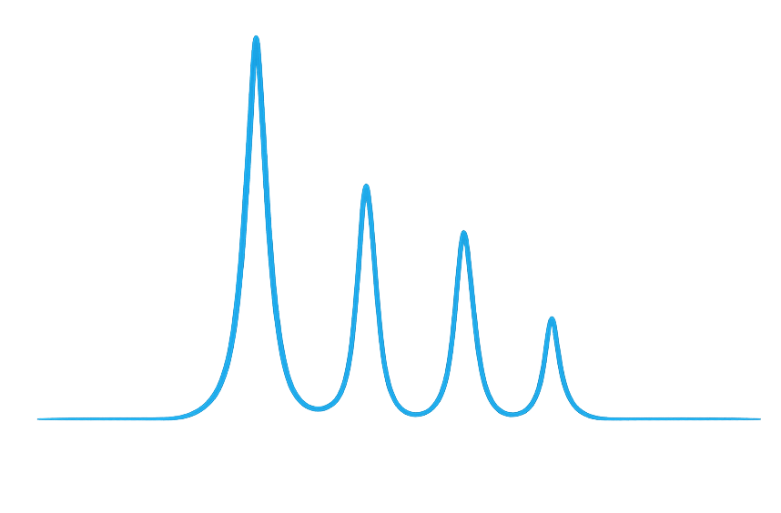

**Teaching Materials and Source Code:**  
<https://github.com/lifangchen2021/DiffraLab>

Version Date: July 31, 2025

*EssayNo.1*

*— A Poetic Prelude to the Educational Spirit —*

*“The mind is not a vessel that needs filling, but a fire to be kindled.”*

*— Plutarch*

Yes,  
perhaps we can consider all human interactions  
as a part of education.  
That is why I am who I am.

I sincerely hope to offer even the slightest contribution,  
to let others feel the beauty of science,  
to understand that the continuity of knowledge transcends time and space—  
just like at night, if you are willing to lift your eyes and gaze upon the distant stars,  
what you see is the unimaginable, spanning thousands of light-years.

So let us try to reinterpret  
the Zen kōan of the moving wind and the fluttering banner—  
It is the wind that moves,  
it is the banner that moves,  
but more so, it is the heart of the observer that moves.  
It depends on which frame of reference you use to explain it.  
It depends on whether you view it from a humanistic or scientific perspective.  
But science and the humanities have never been a binary opposition;  
they are a system of mutual electromagnetic induction.  
And the coil that enables such induction to occur—  
is education.

In my lifetime,  
I wish to ignite the inner flame in others,  
so they may feel—  
that science is a beauty happening all around us, all the time.

*Lifang Chen**2025.07.31*

Table of Contents

*EssayNo.1— A Poetic Prelude to the Educational Spirit —* 0

1. Teaching Philosophy and Course Overview 1

2. Target Audience 4

3. Learning Objectives 4

BraggIt: 4

ResoFox: 5

4. Tools: DiffraLab Teaching Platform (Python GUI Program) 5

5. Suggested Course Schedule (2 hours) 6

6. Instructor Introduction: Diffraction Principles and Bragg's Law 7

6.1 Learning Objectives 7

6.2 Discussion Questions 7

6.3 Supplementary Materials (Optional) 8

7. Introduction and Installation of DiffraLab 8

7.1 **BraggIt** 8

7.2 **ResoFox** 10

8. BraggIt Demonstration and Practice 13

9. Unit Assignment (Example, with partial solutions in blue text and accompanying figures) 16

*Essay No. 2— A Narrative Prelude on Light and the Hope of Science —* 20

10. Teacher's Introduction: Neutron Sources, Neutron Diffractometer Structure, and Similarities & Differences Between Neutron and X-ray Diffraction 21

10.1 Learning Objectives 21

10.2 Guided Questions and Discussion 21

10.3 Supplementary Materials 23

11. ResoFox Operation Demonstration and Practice 23

12. Unit Assignment 26

Teacher Extension 29

13. Report Assignment (For advanced-level courses — to be used as a midterm or final project; choose one of the following topics): 33

14. Reference 33

**DiffraLab Hands-On Teaching Design**

**Teaching Module for X-ray and Neutron Diffraction Resolution Simulation — Using the DiffraLab Platform**

### 1. Teaching Philosophy and Course Overview

This course is designed based on the teaching philosophy of **"Observation → Simulation → Mathematical Modeling → Reflection,"** a cycle that mirrors the authentic process of scientific inquiry, utilizing the **DiffraLab platform** (with *BraggIt* and *ResoFox* modules) to guide students in hands-on exploration of diffraction phenomena. Through observing graphical changes, students will develop an understanding of the importance of Bragg's Law and instrument resolution analysis, emphasizing **"seeing the changes"** rather than simply providing answers.   
  
This approach is explicitly framed within the Nature of Science (NOS) educational framework. The course aims to help students understand not only the content of diffraction (e.g., Bragg's Law) but also the process of how scientific knowledge in this field is constructed and validated. Key NOS tenets are woven throughout the course, including:

* The Role of Models in Science: Students will learn that both Monte Carlo simulations (BraggIt) and analytical theories (ResoFox) are models—simplified representations of reality—each with its own strengths, assumptions, and limitations.
* The Interplay Between Theory and Evidence: Students will be constantly challenged to compare theoretical predictions (from equations and the Caglioti model) with simulated evidence (from the GUI outputs), reinforcing that scientific claims are validated by their correspondence with empirical data.
* The Tentative and Creative Nature of Science: By manipulating instrument parameters and observing their effects, students will see how scientific tools and knowledge are iteratively developed and refined. They will also appreciate the creativity required to design an instrument that balances competing factors like resolution and intensity.
* Experimental Science Process Skills:   
  1. Observation and Phenomenon Analysis

(1)Observe changes in diffraction patterns (peak position, width) by manipulating parameters (crystal structure: FCC/BCC, wavelength spread, etc.)

(2)Identify how instrument parameters (collimator angles, mosaic spread) affect diffraction resolution (ResoFox module exercises).

2. Model Construction and Validation

(1)Understand differences/complementarity between Monte Carlo simulations (BraggIt) and analytical theory (ResoFox) as scientific models.  
(2)Validate Bragg’s Law and the Caglioti model by comparing simulation results with theoretical predictions (e.g., FWHM calculations).  
(3)Evaluate model accuracy through data fitting (e.g., Gaussian fitting with G-Fitter, Page 17).

3. Variable Control and Experimental Design

(1)Systematically manipulate single variables (e.g., wavelength error, collimator angles) to analyze their impact on diffraction outcomes (Pages 15, 24–26).  
(2) Design parameter optimization strategies (e.g., "*How to improve resolution? What trade-offs are required?*" – Page 7 discussion).

4. Quantitative Analysis and Data Processing

(1)Calculate diffraction peak full width at half maximum (FWHM) and derive angular resolution–wavelength spread relationships (Page 16 equations).  
(2) Process exported data (e.g., via Excel) to compare theoretical values

() with simulations (Page 20 tables).

5. Error Analysis and Critical Thinking  
(1)Evaluate the effect of simulated particle count on result precision (Page 6, Objective 3).  
(2)Identify error sources (wavelength uncertainty, instrument limitations) and analyze questions like "Does increasing experiment duration always enhance accuracy?" (Page 21, Q2).

6. Cross-Model Reasoning

(1)Contrast X-ray/neutron diffraction differences (source properties, wavelength error origins) to explain phenomena (e.g., broader neutron peaks – Pages 6–7).

(2)Relate physical mechanisms to instrument design (e.g., neutron source selection’s impact on resolution – Pages 22–23).

7. Understanding the Nature of Science (NOS)  
(1)Recognize the tentative nature of scientific knowledge (e.g., iterative parameter refinement – Page 5).  
(2)Acknowledge model limitations (e.g., Monte Carlo simulations omitting thermal vibrations – Page 9, Q1).  
(3)Examine theory-evidence interplay (Bragg’s Law predictions vs. simulated data – Page 9, Q2).

8. Engineering Thinking and Optimization  
(1)Balance trade-offs between resolution and intensity (collimator optimization exercises – Page 27).  
(2)Design diffractometer parameter schemes (Report Assignment 1 – Page 34).  
  
Key Pedagogical Implementation

1. Inquiry Cycle Design: Rigorously follow the "Observation → Simulation → Modeling → Reflection" framework (Page 5) to reinforce scientific practice.

2. Higher-Order Thinking: Foster hypothesis testing through open-ended questions (e.g., "What would anomalous peaks imply for existing theory?" – Page 9).

3. Real-World Context: Apply skills to authentic problems (e.g., neutron diffraction in magnetic structure/water molecule studies – Page 23).

Through this guided-inquiry process, students will develop a robust understanding of diffraction principles and a deeper appreciation for the nature of scientific work itself and experimental science process skills.

### 2. **Target Audience**

1. Junior and senior undergraduate students in physics or materials science who are taking *Introduction to Solid-State Physics* or *Introduction to Materials Analysis*.
2. Junior and senior undergraduate students in physics who are taking *Modern Physics Laboratory* courses.
3. **Anyone interested in neutron diffraction and instrument simulation for self-learning and practice may also use this software for study and hands-on exercises.**

### 3. Learning Objectives

Students will use the **GUI simulation tools** to observe and operate, allowing them to understand the following physical phenomena:

**BraggIt:**

1. By operating simulations with different crystal structures (such as FCC and BCC), students will observe differences in diffraction patterns, develop a basic understanding of constructive and destructive interference, and recognize how conditions such as destructive interference and sample characteristics affect diffraction patterns compared to powder samples.
2. Explore the impact of wavelength spread on diffraction peak width, and understand the relationship between Bragg’s Law and the broadening of diffraction peaks due to wavelength distribution.
3. Discuss the similarities and differences between Monte Carlo simulations and actual experiments, gain an appreciation of the relationship between simulation time and the number of particles, and understand the advantages and limitations of experimental physics versus computational simulations, as well as the modeling process in physics.
4. Understand the origins of wavelength spread, differences in the characteristics of X-rays and neutrons, and methods of producing neutrons, guiding students to think about why neutron diffraction patterns are broader than X-ray diffraction patterns.

**ResoFox:**

1. Operate simulation tools to observe how **instrumental parameters** (such as slit angles and mosaic spread) affect the width of diffraction peaks, and understand how **instrument parameters** influence the selection of neutron wavelength and the propagation of wavelength spread and errors.
2. Understand how beam divergence affects the analysis of diffraction patterns, and guide students to consider methods for improving resolution.
3. Guide students to recognize the concepts of **crystal structure analysis resolution and diffraction angle resolution**, and understand the physical quantities that need to be measured experimentally to interpret diffraction results.
4. Further compare theoretical calculations, Monte Carlo simulations, and actual experiments to understand the differences, and appreciate the process of observation, simulation, and mathematical modeling in physics.

### 4. Tools: DiffraLab Teaching Platform (Python GUI Program)

The platform includes the following modules:

**BraggIt:**  
A diffraction pattern generator based on **Monte Carlo simulation**, allowing users to input crystal constants and wavelength spread to observe powder diffraction patterns.

**ResoFox:**  
A resolution simulation module based on **analytical theory (Caglioti 1958)**, providing resolution analysis tools for instruments with input parameters for **collimators and monochromators**, and outputs for diffraction intensity profiles.

**G-Fitter:**  
A tool for fitting Monte Carlo simulation results to facilitate comparison with theoretical calculations.

### 5. Suggested Course Schedule (2 hours)

|  |  |  |  |
| --- | --- | --- | --- |
| **Time** | **Activity** | **Learning Objectives** | **Module Used** |
| 0:00–0:20 | Instructor introduces the principles of diffraction and Bragg's Law. Demonstration of **DiffraLab** installation and basic operation. | 1 | None |
| 0:20–0:40 | **BraggIt** demonstration and hands-on practice:  (1) FCC vs. BCC structures  (2) Wavelength spread and diffraction peak broadening | 1, 2, 3, 4 | BraggIt |
| 0:40–1:00 | In-class exercise: Using data generated from the **BraggIt** module, fit the peak profiles using a Gaussian model to obtain FWHM values and compare them with theoretical predictions. | 2 | BraggIt |
| 1:00–1:20 | Instructor explains neutron sources, neutron diffraction instrument structures, and the differences in target goals between neutron and X-ray diffraction. | 4 | None |
| 1:20–1:40 | **ResoFox** demonstration and hands-on practice:  (1) Observe the effects of **instrumental parameters** (slit angles, mosaic spread) on diffraction results.  (2) Observe the effects of **beam divergence parameters** on diffraction results.  In-class exercise: Modify and record how parameters affect the diffraction profiles. | 5, 6 | ResoFox |
| 1:40–2:00 | Instructor-led summary and discussion:  (1) Using diffraction peak analysis to guide students to understand crystal structure analysis.  (2) Reflect on how observation and modeling guide students’ understanding of the physical world and their appreciation of the modeling process. | 7, 8 | ResoFox |

### 6. Instructor Introduction: Diffraction Principles and Bragg's Law

6.1 Learning Objectives

1. Guide students to understand the concept of **“diffraction”** as an interference phenomenon arising from the **interaction between waves and crystal lattices**.
2. Introduce **Bragg's Law** as a fundamental tool for predicting diffraction angles and understanding their relationship with crystal lattice parameters.
3. Provide a brief overview of crystal structures, including the seven crystal systems and typical materials, crystal orientations, and lattice constants.
4. Introduce the basic principles and structure of **powder diffraction instruments**.

6.2 Discussion Questions

1. Are the diffraction patterns of single crystals the same as those of powder diffraction patterns?
2. If a powder diffraction instrument could collect diffraction signals over the entire 4π solid angle, what kind of pattern would be observed?
3. Scaffolding Questions for Deeper Thinking of BraggIt Demonstration and Practice:

(1) On Scientific Models: "You just created two diffraction patterns using the BraggIt simulator. In what ways is this simulation a 'model' of a real experiment? What aspects of reality do you think are simplified or left out in this simulation?"  
(2) On Theory and Evidence: "The positions of the peaks you see are predicted by Bragg's Law. How does the visual evidence on your screen confirm the theoretical predictions? If a new, unknown material produced peaks at completely different angles, what would that tell you about the existing theory or your understanding of the material?"  
(3) On Observation and Inference: "You observed that a larger wavelength uncertainty leads to broader peaks. What does this imply about the 'quality' of our neutron or X-ray source? If you were an instrument scientist, what would you creatively do to make the peaks sharper? What might be the trade-off of doing so?"  
(4) How did using two different types of models deepen your understanding of diffraction?  
(5) Describe one moment in this course where you felt you were 'thinking like a scientist.' What did you do, and what did it teach you about how science works?"

6.3 Supplementary Materials (Optional)

1. An introduction to **reciprocal space, reciprocal lattice, and diffraction patterns**, and their interrelations.

### 7. Introduction and Installation of DiffraLab

**DiffraLab** is a Python-based graphical teaching tool that allows users to simulate and interact with **XRD and neutron diffractometer designs** without requiring additional installation. The software supports **Monte Carlo simulations of cubic crystal systems**, theoretical display of diffraction patterns, and enables users to adjust parameters to observe and reconstruct diffraction patterns under various conditions. The platform includes the following modules:

7.1 **BraggIt**

**BraggIt** utilizes Monte Carlo simulations to generate diffraction patterns. As shown in Figure 1 (not included here), the left panel serves as the parameter input area, where users can set **sample name, lattice constants, crystal type, wavelength, wavelength error, and particle number**. The software simulates conditions commonly encountered in powder samples and typical **XRD wavelengths**.

The right panel is the plotting area. After setting the parameters, users can press **Start Simulation** to immediately observe the simulated changes in diffraction patterns in real-time (as shown in Figure 2). There is also a button below the plot area that allows users to export the diffraction intensity distribution data for further analysis and numerical processing.

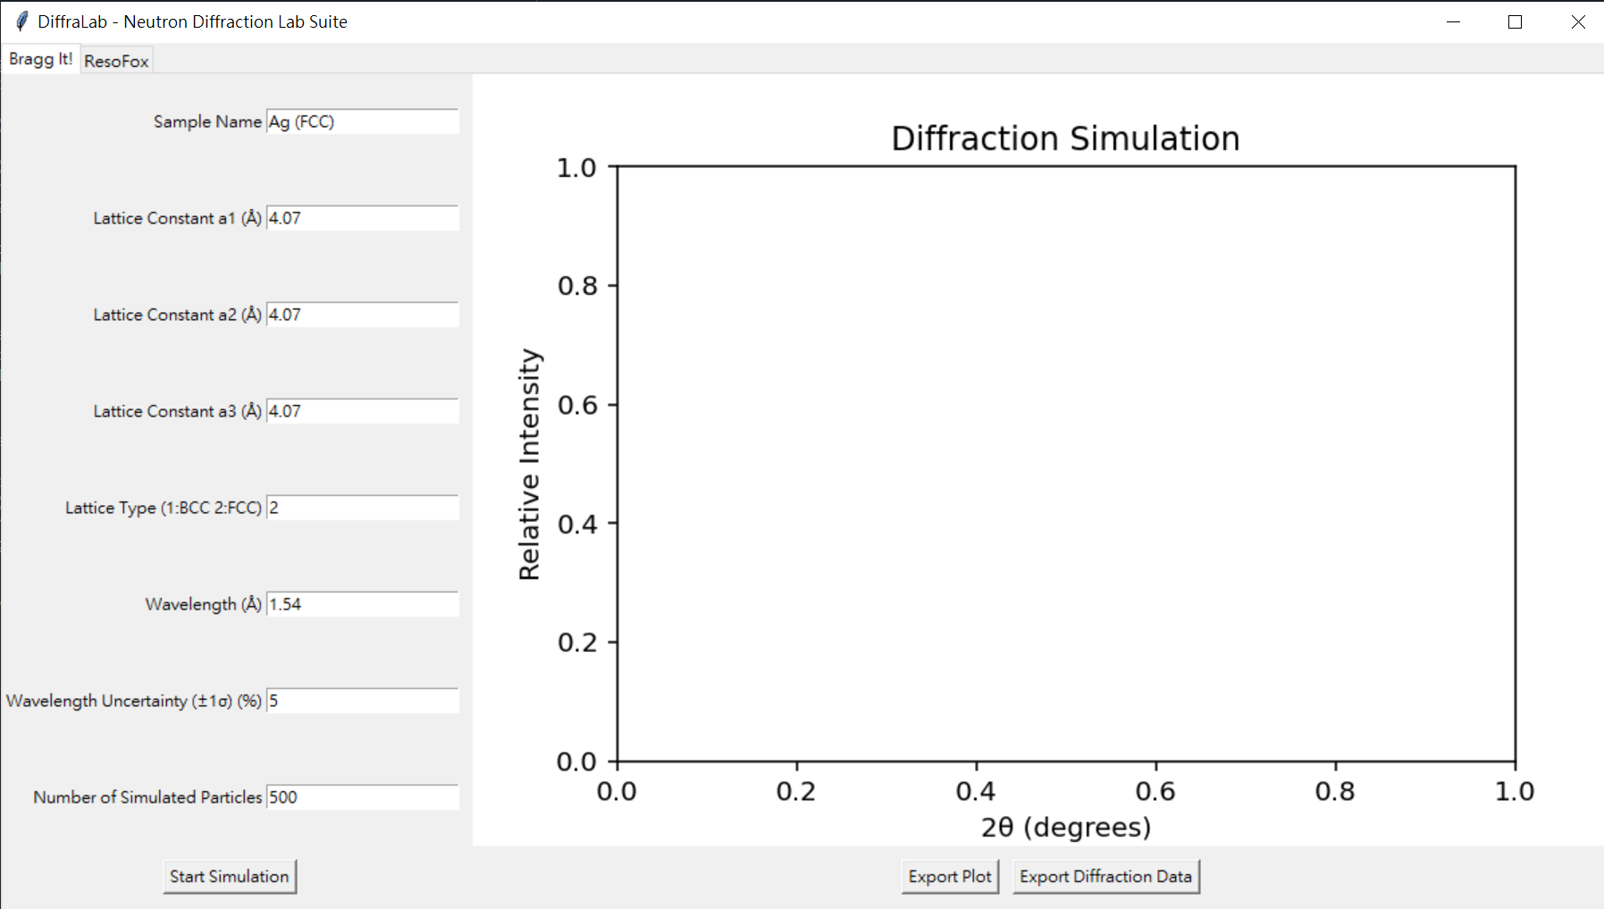

Figure 1. BraggIt Operation Interface

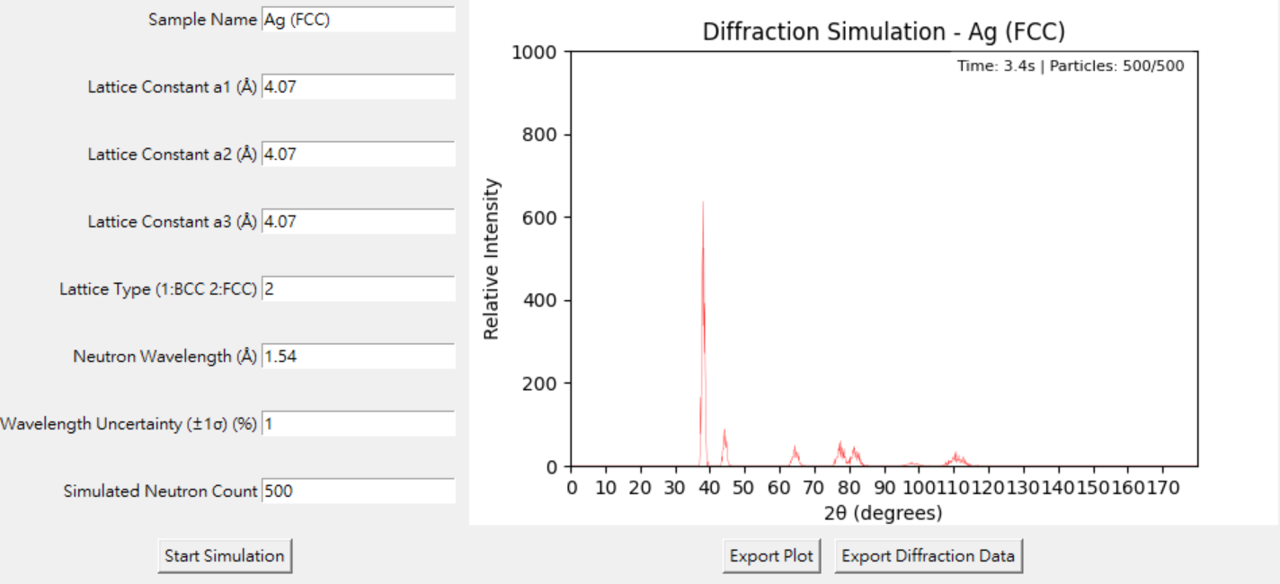

Figure 2. Diffraction Pattern Output Based on Monte Carlo Simulation

7.2 **ResoFox**

**ResoFox** is a Python-based graphical user interface (GUI) tool designed for analyzing the **resolution of neutron powder diffractometers**, using the classic **Caglioti model** as its theoretical foundation. It can calculate **full width at half maximum (FWHM)**, angular resolution, and relative intensity under various optical configurations, and simulates diffraction patterns for **face-centered cubic (FCC)** and **body-centered cubic (BCC)** structures. Users can adjust input parameters directly through the interface and obtain visualized output results in real time.

As shown in **Figure 3** (not included here), the upper section of the ResoFox interface displays the schematic positions of the diffractometer components and key optical elements, while the lower section is for inputting various parameters, including **Collimator’s divergence, monochromator’s Bragg angle, crystal mosaic spread, crystal spacing, and sample parameters**. After setting the desired parameters, users can press **Start Calculation** to compute and display the diffraction pattern and relative intensity profile using analytical methods, as shown in **Figure 2**.

The program allows users to recalculate with different parameter sets without clearing the previous plot by default, but users may press **Clear Plot** to remove previous results if desired. The **Export Data** button enables users to export the **angle versus diffraction intensity data**, which can then be used for comparison with other simulation software (e.g., **McStas**).

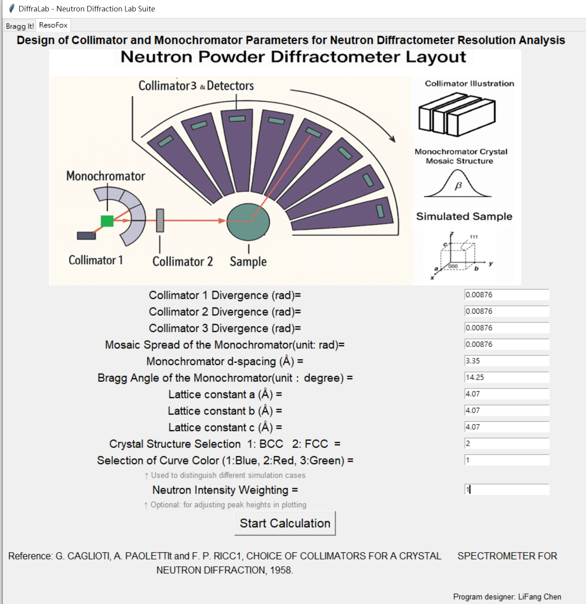

Figure 3. ResoFox Program Input Interface

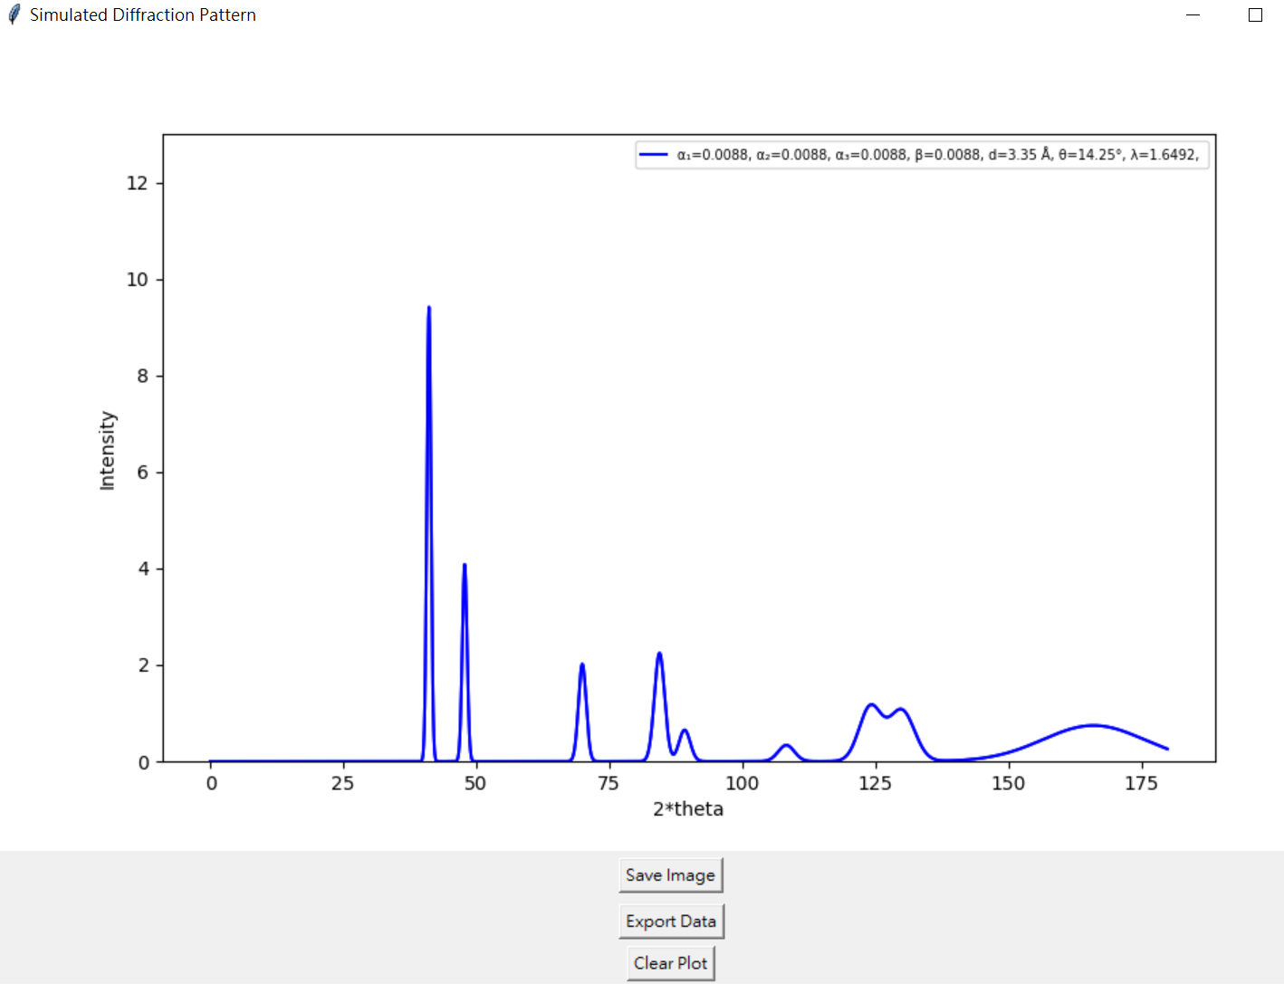

Figure 4. ResoFox Program Output Interface

During execution, the program will display information on the control panel such as the **full width at half maximum (FWHM)** of diffraction peaks, angular resolution, and crystal structure resolution, as shown in **Figure 5**, which can be used for more advanced teaching scenarios.

**It also displays how the neutron beam relative intensity varies with the position of the sample stage, allowing users to consider the effects of beam profile, sample alignment, and geometrical setup on the relative intensity of the diffraction signal.**

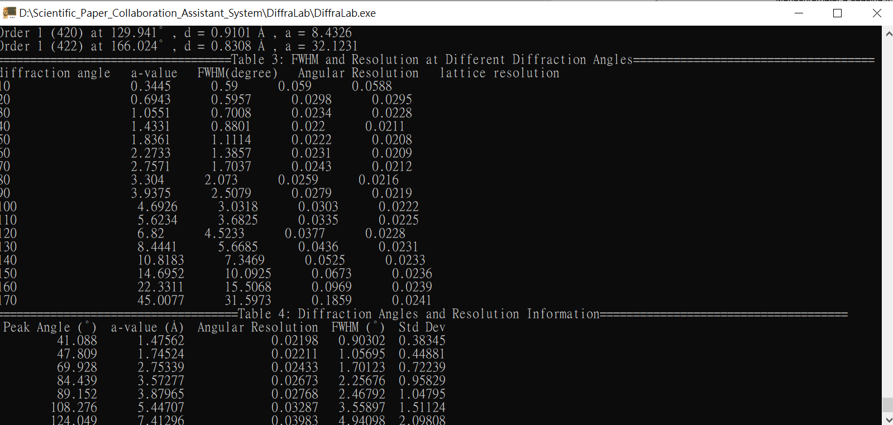

Figure 5. ResoFox Control Panel Output

### 8. BraggIt Demonstration and Practice

(1) Reconstruct the Powder Diffraction Pattern of Silver

Ask students to input the following values to **reconstruct the diffraction pattern of Ag**:

|  |  |  |  |  |
| --- | --- | --- | --- | --- |
| **Parameter** | **Sample Name** | **Lattice**  **Constant a1** | **Lattice**  **Constant a2** | **Lattice**  **Constant a3** |
| Value | Ag(FCC) | 4.07 | 4.07 | 4.07 |
| **Parameter** | **Lattice Type** | **Wavelength** | **Wavelength Uncertainty(%)** | **Number of Simulated Particles** |
| Value | 2 | 1.54 | 0.1 | 500 |

(2) Reconstruct the Powder Diffraction Pattern of Chromium

Ask students to input the following values to **reconstruct the diffraction pattern of Cr**:

|  |  |  |  |  |
| --- | --- | --- | --- | --- |
| **Parameter** | **Sample Name** | **Lattice**  **Constant a1** | **Lattice**  **Constant a2** | **Lattice**  **Constant a3** |
| Value | Cr(BCC) | 2.88 | 2.88 | 2.88 |
| **Parameter** | **Lattice Type** | **Wavelength** | **Wavelength Uncertainty(%)** | **Number of Simulated Particles** |
| Value | 1 | 1.54 | 0.1 | 500 |

(3)

Increase the wavelength uncertainty of Ag and Cr powder by 1% and **observe how the diffraction patterns change**.

(4)

Using the diffraction data of Ag and Cr powder, **ask students to calculate the FWHM of three diffraction peaks**.

(5)

The instructor should guide students to understand that **the methods of generating X-rays and neutrons differ, leading to differences in wavelength uncertainty** between X-rays and neutrons. Explain how **Bragg’s Law and the Debye-Scherrer equation** can be used to derive the relationship between **angular resolution and wavelength spread** :

After differentiation, rearrange the original equation to isolate the terms:

The diffraction angle θ' is twice the Bragg angle. By substituting θ' for θ in the above equation:

Δθ' represents the full width at half maximum (FWHM). Here, it will be substituted with the standard deviation in the above equation:

Similarly, Δλ will be replaced with the standard deviation in the above equation:

Taking the **first diffraction peak of silver powder** as an example, when the standard deviation of wavelength uncertainty is 1%, using calculations performed in an Excel spreadsheet, the diffraction peak is located at **38.1 degrees**:

Using experimental data (Excel):

consistent with the calculation based on wavelength uncertainty:

Ask students to use the **BraggIt** module to simulate the diffraction results of **silver powder and chromium powder**, and compare how the **FWHM obtained from Gaussian fitting** of the simulated results differs from the **theoretical FWHM calculated analytically** under different numbers of simulated particles. This helps students understand **the sources of errors and accuracy in experimental physics**.

**Optional Material:**  
The **DiffraLab** platform provides the **G-Fitter** tool, which can directly select and use the Excel files exported from **BraggIt** to perform **Gaussian fitting of diffraction peaks**. The program allows users to set the minimum peak distance between two peaks for fitting. In the example below, since the data interval in Excel is 0.1° per entry, the minimum distance between two peaks is calculated as 20×0.1=2∘.

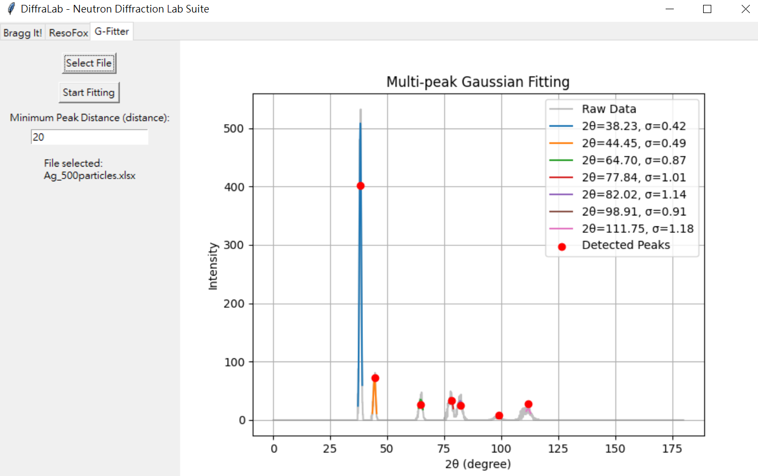

Instructors can adjust according to actual teaching needs. It is recommended that students first calculate and understand the definition of **FWHM** before using this program.

### 9. Unit Assignment (Example, with partial solutions in blue text and accompanying figures)

|  |  |  |  |  |  |  |  |  |  |  |  |  |  |  |  |  |  |  |  |  |  |  |  |  |  |  |  |  |  |  |  |  |  |  |  |  |  |  |  |  |  |  |  |  |  |  |  |  |  |  |  |  |  |  |  |  |  |  |  |  |  |  |  |  |  |  |  |  |  |  |  |  |  |  |  |  |  |  |  |  |  |  |
| --- | --- | --- | --- | --- | --- | --- | --- | --- | --- | --- | --- | --- | --- | --- | --- | --- | --- | --- | --- | --- | --- | --- | --- | --- | --- | --- | --- | --- | --- | --- | --- | --- | --- | --- | --- | --- | --- | --- | --- | --- | --- | --- | --- | --- | --- | --- | --- | --- | --- | --- | --- | --- | --- | --- | --- | --- | --- | --- | --- | --- | --- | --- | --- | --- | --- | --- | --- | --- | --- | --- | --- | --- | --- | --- | --- | --- | --- | --- | --- | --- | --- | --- |
| Course Unit: DiffraLab Practice 1: BraggIt  Student Name:  Student ID:  Date:   1. Please paste the **diffraction pattern** of silver powder and its **related parameters** in the box below:  |  | | --- | |  |  1. Please paste the diffraction pattern of Cr powder and its related parameters in the box below:  |  | | --- | |  |  1. Calculate the first three **diffraction peaks** for silver powder, their **full width at half maximum (FWHM)**, and then use the derived formula to calculate the FWHM from the **wavelength error**. Compare this with the FWHM obtained via the **Monte Carlo method** to see if they match.   *Note: Theoretical diffraction peaks can be obtained from the program console, while simulated diffraction peaks are obtained by Gaussian fitting.*   |  |  |  |  | | --- | --- | --- | --- | | Sample Name: Ag  Relative Standard Deviation of Wavelength: 1%  Number of Simulated Particles: 500 | | | | | diffraction peak | (1 1 1) | (2 0 0 ) | (2 2 0) | | Angle (degrees)  Theoretical / Simulated | 38.257/38.23 | 44.467/44.45 | 64.702/64.7 | | Monte Carlo Simulated FWHM (radians) | 0.0173 | 0.0201 | 0.0358 | | Theoretically Calculated FWHM (radians) | 0.0163 | 0.0193 | 0.0298 |  |  |  |  |  | | --- | --- | --- | --- | | Sample Name: Ag  Relative Standard Deviation of Wavelength: 1%  Number of Simulated Particles: 5000 | | | | | diffraction peak | (1 1 1) | (2 0 0 ) | (2 2 0) | | Angle (degrees)  Theoretical / Simulated | 38.257/38.2 | 44.467/44.4 | 64.702/64.64 | | Monte Carlo Simulated FWHM (radians) | 0.0164 | 0.0193 | 0.0308 | | Theoretically Calculated FWHM (radians) | 0.0163 | 0.0193 | 0.0298 |  1. Calculate the first three diffraction peaks for Cr powder, their full width at half maximum (FWHM), and then use the derived formula to calculate the FWHM from the wavelength error. Compare this with the FWHM obtained via the Monte Carlo method to see if they match.  |  |  |  |  | | --- | --- | --- | --- | | Sample Name: Cr  Relative Standard Deviation of Wavelength: 1%  Number of Simulated Particles: 500 | | | | | diffraction peak | (1 1 0) | (2 0 0 ) | (2 1 1) | | Angle (degrees)  Theoretical / Simulated | 44.433/ | 64.650/ | 81.824/ | | Monte Carlo Simulated FWHM (radians) |  |  |  | | Theoretically Calculated FWHM (radians) |  |  |  |  |  |  |  |  | | --- | --- | --- | --- | | Sample Name: Cr  Relative Standard Deviation of Wavelength: 1%  Number of Simulated Particles: 5000 | | | | | diffraction peak | (1 1 0) | (2 0 0 ) | (2 1 1) | | Angle (degrees)  Theoretical / Simulated | 44.433/ | 64.650/ | 81.824/ | | Monte Carlo Simulated FWHM (radians) |  |  |  | | Theoretically Calculated FWHM (radians) |  |  |  |  1. Questions and Discussion    1. What is the origin of wavelength error? Is it related to the X-ray or neutron source used for detection?    2. Can increasing experiment time improve the accuracy of the results? Are there any situations where increasing experiment time would not improve result accuracy?    3. Is there a relationship between lattice size and the choice of detection wavelength? Taking a silver lattice as an example, if the lattice constant doubles, what wavelength would you choose to use? Would it be longer or shorter than 1.54Å?    4. Following up on the previous question, if you were given a continuous spectrum today, could you use the physical laws you know to select the wavelength you need? 2. Reflections and Insights |

*Essay No. 2*

*— A Narrative Prelude on Light and the Hope of Science —*

*“Concern for man himself and his fate*

*must always form the chief interest of all technical endeavors”*

*—* ***Albert Einstein***

In a fury, the king decreed

that each dawn he would marry a new bride,

only to let none survive past morning,

for he did not believe in science.

He did not believe

that science could solve famine,

ensure the safety of his people,

or gather energy as if by magic.

If the world truly ran

in graceful accordance with natural laws,

why then was his soul so hollow, so broken?

So **Shahryar**

told the king the story of **Fritz Haber**,

who drew fertilizer from the air,

and the tale of **Archimedes**,

who held off invaders with sunlight curved by mirrors.

Shh… listen closely.

She was just about to explain

how Archimedes’ method of focusing sunlight

relates to the selection of neutron wavelengths.

a gentle narrator of time,

is about to tell you

a story of science—

a tale from *the Thousand and One Nights*...

**Lifang Chen**

*August 7, 2025*

### 10. Teacher's Introduction: Neutron Sources, Neutron Diffractometer Structure, and Similarities & Differences Between Neutron and X-ray Diffraction

10.1 Learning Objectives

1. Understand neutron sources, differentiating between reactor-based and accelerator-based neutron sources in terms of neutron production methods, neutron energy spectra, and neutron flux.
2. Grasp the purpose and performance differences between X-ray and neutron diffraction for structural analysis.
3. Learn which scientific problems neutron diffraction helps solve.
4. Develop a general understanding of the basic structure of a neutron diffractometer.

10.2 Guided Questions and Discussion

This section uses problem-based learning to help students understand the differences between neutrons and X-rays in structural analysis. This will lead to an understanding of the scientific problems that different probes can solve. The following questions will serve as the core for guiding discussion and concept building.

* 1. Where do neutrons come from?
* The instructor can guide students to consider that neutrons cannot be generated directly through conventional methods. This leads to an introduction of the two main types of neutron sources:
  + 1. Reactor-based neutron sources: These produce neutrons through nuclear fission reactions (e.g., U-235) and are continuous neutron sources.
    2. Accelerator-based neutron sources (e.g., spallation sources~~)~~: High-energy protons strike a metal target, exciting and ejecting neutrons. These are continuous／pulsed neutron sources.
* Students will learn that:
  1. Neutron sources are not easily accessible, requiring large facilities and specialized maintenance.
  2. Different neutron sources have significant differences in energy spectra and temporal structure.
  3. The production principles of neutrons and X-rays are completely different, meaning wavelength selection is necessary for neutron experiments, and errors can be larger.
  4. What are the differences between X-ray diffraction and neutron diffraction?

The instructor can pose a critical thinking question: "If you want to observe the internal atomic structure of hydrogen-containing materials, are X-rays sufficient?"

This can be used to explain that:

* + 1. X-ray diffraction relies on electron clouds, making it sensitive to heavy elements but insensitive to light elements like hydrogen.
    2. Neutron diffraction relies on nuclear force scattering, making it capable of "seeing" light elements such as hydrogen, lithium, and boron.
    3. Neutrons possess a magnetic moment, making them useful for magnetic materials research.
    4. However, neutron diffraction equipment is typically expensive and requires queuing for access.
  1. What scientific problems has neutron diffraction helped solve?
     1. Analysis of internal magnetic structures in magnetic superconductors.
     2. Studies on the location of water molecules within polymers or proteins (using neutron scattering).
  2. Basic Structure of a Neutron Diffractometer
     1. Neutron Source: Provides thermal or cold neutrons, such as a reactor or spallation source.
     2. Collimator: Filters neutron directions to produce a parallel beam.
     3. Monocrystal Monochromator: Selects a specific wavelength (utilizing Bragg reflection).
     4. Sample Stage: Holds the sample to be tested; allows adjustment of angle and environmental parameters (temperature, pressure).
     5. Detector: Detects the angular and intensity distribution of diffracted neutrons (possibly 2D).

10.3 Supplementary Materials

1. It is recommended that instructors visit the following URL for an interactive tour of a neutron diffractometer: <https://www.ill.eu/for-ill-users/instruments/instrument-map>
2. Video explaining the principles of neutron diffraction, provided by the Institut Laue-Langevin (ILL) laboratory in France: <https://www.youtube.com/watch?v=g1WdPmHobLI>

### 11. ResoFox Operation Demonstration and Practice

**Learning Objective:** Guide students to explore the physical mechanisms by which instrument parameters affect diffraction results.

1. Observe how changes in the primary collimator parameters influence the diffraction pattern.

Students are instructed to input the following parameters:

|  |  |  |  |  |
| --- | --- | --- | --- | --- |
| Collimator 1 | Collimator 2 | Collimator 3 | Mosaic Spread | d-spacing |
| 0.0087 | 0.0087 | 0.0087 | 0.0087 | 3.35 |

|  |  |  |  |  |
| --- | --- | --- | --- | --- |
| Bragg Angle  (Monochromator) | Lattice constant  A、b、c | Crystal Structure | Color | Weighting |
| 14.25 | 4.07 | 2 | 1 | 1 |

This simulation is based on the condition where both the divergence angle of the collimator and the monochromator mosaic spread are set to 0.5°. The selected monochromator is Highly Oriented Pyrolytic Graphite (HOPG) with the (002) reflection, and the take-off angle (twice the monochromator Bragg angle) is set to 28.5°. The diffraction pattern of silver powder is generated under these conditions.

After plotting is completed, ask the students to modify **Collimator 1** to **half of its original value**, change **Color** to **2**, and re-calculate.  
Students should compare the two results, observe the differences in the diffraction patterns, and explain the underlying physical reasons for the changes.

1. Observe how changes in the second collimator parameters influence the diffraction results.

Students are instructed to input the following parameters:

|  |  |  |  |  |
| --- | --- | --- | --- | --- |
| Collimator 1 | Collimator 2 | Collimator 3 | Mosaic Spread | d-spacing |
| 0.0087 | 0.0087 | 0.0087 | 0.0087 | 3.35 |

|  |  |  |  |  |
| --- | --- | --- | --- | --- |
| Bragg Angle  (Monochromator) | Lattice constant  A、b、c | Crystal Structure | Color | Weighting |
| 14.25 | 4.07 | 2 | 1 | 1 |

After plotting is completed, ask the students to modify Collimator 2 to half of its original value, change Color to 2, and re-calculate.

Students should compare the two results, observe the differences in the diffraction patterns, and identify the physical reason behind the changes.

1. Observe how changes in the third collimator parameters influence the diffraction results.

Students are instructed to input the following parameters：

|  |  |  |  |  |
| --- | --- | --- | --- | --- |
| Collimator 1 | Collimator 2 | Collimator 3 | Mosaic Spread | d-spacing |
| 0.0087 | 0.0087 | 0.0012 | 0.0087 | 3.35 |

|  |  |  |  |  |
| --- | --- | --- | --- | --- |
| Bragg Angle  (Monochromator) | Lattice constant  A、b、c | Crystal Structure | Color | Weighting |
| 14.25 | 4.07 | 2 | 1 | 1 |

After plotting is completed, ask the students to modify Collimator 3 to 0.012, change Color to 2, and re-calculate.

Then, modify Collimator 3 to 0.12, change Color to 3, and re-calculate once more.

Students should compare the three diffraction patterns, observe the differences, and identify the underlying physical reasons.

1. Observe how changes in the monochromator mosaic spread affect the diffraction results.

Students are instructed to input the following parameters:

|  |  |  |  |  |
| --- | --- | --- | --- | --- |
| Collimator 1 | Collimator 2 | Collimator 3 | Mosaic Spread | d-spacing |
| 0.0087 | 0.0087 | 0.0087 | 0.0087 | 3.35 |

|  |  |  |  |  |
| --- | --- | --- | --- | --- |
| Bragg Angle  (Monochromator) | Lattice constant  A、b、c | Crystal Structure | Color | Weighting |
| 14.25 | 4.07 | 2 | 1 | 1 |

After plotting is completed, ask the students to modify the Mosaic Spread to half of its original value, change Color to 2, and re-calculate.

Students should compare the two diffraction patterns, observe the differences, and explain the physical reasons behind the changes.

1. Observe how changes in the Bragg angle affect the diffraction results.

Students are instructed to input the following parameters:

|  |  |  |  |  |
| --- | --- | --- | --- | --- |
| Collimator 1 | Collimator 2 | Collimator 3 | Mosaic Spread | d-spacing |
| 0.0087 | 0.0087 | 0.0087 | 0.0087 | 3.35 |

|  |  |  |  |  |
| --- | --- | --- | --- | --- |
| Bragg Angle  (Monochromator) | Lattice constant  A、b、c | Crystal Structure | Color | Weighting |
| 14.25 | 4.07 | 2 | 1 | 1 |

After plotting is completed, ask the students to modify the Bragg angle to twice its original value, change Color to 2, and re-calculate.

Students should compare the two diffraction patterns, observe the differences, and identify the physical reason behind the changes.

### 12. Unit Assignment

(Example with partial answers provided; refer to blue text and attached figures.)

|  |  |  |  |  |  |
| --- | --- | --- | --- | --- | --- |
| **Course Module Title:** DiffraLab Practice 1: ResoFox **Student Name:** **Student ID:** **Date:**   1. **Please paste the diffraction plot after modifying Collimator 1 into the box below:**  |  | | --- | |  |   Did the neutron intensity of the diffraction pattern change?  (Please check Table 1 in the console)  2.6883272401532514e-07  1.4212280841079272e-07  Did the diffraction resolution () improve or worsen?  Think about it: What is the underlying physical mechanism behind this change?   1. Please paste the diffraction plot after modifying Collimator 2 into the box below:  |  | | --- | |  |   Did the neutron intensity of the diffraction pattern change?  (Please check Table 1 in the console)  2.6883272401532514e-07  1.4212280841079272e-07  Did the diffraction resolution () improve or worsen?  Think about it: What is the underlying physical mechanism behind this change?   1. Please paste the diffraction plot after modifying Collimator 3 into the box below:  |  | | --- | |  |   Did the neutron intensity of the diffraction pattern change?  (Please check Table 1 in the console)  8.064981720459755e-08  8.064981720459756e-07  8.064981720459756e-06  Did the diffraction resolution () improve or worsen?  Think about it: What is the underlying physical mechanism behind this change?  **Student Version – Suggested Answer:** The divergence of the third collimator is linearly related to the neutron intensity. However, as the value of Collimator 3 decreases, the resolution of the diffraction pattern appears to reach a plateau, showing no significant improvement. This suggests that, under the condition where all other parameters are held constant, there exists a minimum achievable resolution. Once this minimum is reached, further reducing the divergence of Collimator 3 does not lead to better resolution.  **Teacher Extension**  **How to derive the relationship between wavelength (λ), Collimator 1, monochromator Bragg angle (θₘ), and mosaic spread:**  **Effect of Collimator 1 on Wavelength Distribution**  From Bragg’s Law, taking the differential of both sides and dividing by the original equation gives:  Here, θm​ is the Bragg angle of the monochromator. Since Δθ is provided by the divergence angle of **Collimator 1**, this can be rewritten as:  **Effect of Monochromator Mosaic Spread on Wavelength Distribution**  Using the same derivation from Bragg’s Law:  Here, Δθ comes from the **mosaic spread (β)** of the monochromator. So:  **Combined Effect of Collimator 1 and Mosaic Spread:**  **Example Calculation:**   1. Please paste the diffraction plot after modifying the Mosaic Spread into the box below:  |  | | --- | |  |   Did the neutron intensity of the diffraction pattern change?  (Please check Table 1 in the console)  2.6883272401532514e-07  1.8862839456850558e-07  Did the diffraction resolution () improve or worsen?  Think about it: What is the underlying physical mechanism behind this change?  Student Version – Suggested Answer:  Changes in the mosaic spread appear to have little effect on the resolution of the diffraction peaks, but the neutron intensity shows a linear correlation.  This suggests that increasing the mosaic spread can enhance the neutron flux.  Teacher Extension:  By comparing the previous parameter changes, we can infer the function of each optical component as follows:  Collimator 1: Selects all neutron wavelengths within a specific divergence range to enter the monochromator.  Monochromator (Crystal): Selects a specific wavelength band centered around a given Bragg angle to pass into Collimator 2.  Collimator 2: Selects all neutron wavelengths within a specific divergence range to reach the sample stage.  Collimator 3: Selects all neutron wavelengths within a specific divergence range to reach the detector.   1. Please paste the diffraction plot after modifying the monochromator Bragg angle into the box below:  |  | | --- | |  |   Did the neutron intensity of the diffraction pattern change?  Did the resolution of the diffraction pattern improve or worsen?  Did the diffraction peak(s) change in position or shape?  Think about it: What is the underlying physical mechanism behind these changes?   1. Questions and Discussion    1. When do you think researchers would need to use X-ray diffraction (XRD) or neutron diffraction?    2. What physical quantities are researchers actually interested in obtaining?   *One example: Lattice resolution∆d/d*    3. Can you start from Bragg’s Law and derive the physical quantity that researchers are interested in?   where:  = Bragg angle of the sample  = diffraction angle   * 1. Can you think of any other factors (not discussed in class) that might affect the width of the diffraction peaks?   *Examples: Thermal lattice vibrations due to temperature, defects within the sample*  1. Reflection and Feedback |

### 13. Report Assignment (For advanced-level courses — to be used as a midterm or final project; choose one of the following topics):

* 1. Research and present the design parameters of an actual neutron diffractometer used internationally.  
     Explain the limitations on sample measurements under these parameters and discuss the scientific contributions of the instrument.
  2. Reflect on the scientific context and the collaborative nature of scientific work.  
     Based on what you have learned in this course, write a reflective report discussing the process of knowledge transmission, the relationship between science and society, and the connection between science and the individual.

### 14. Reference

1. K.-D. Liss, B. Hunter, M. Hagen, T. Noakes, and S. Kennedy, Echidna—the new high-resolution powder diffractometer being built at OPAL, Physica B: Condensed Matter, 385–386, pp. 1010–1012, 2006. <https://doi.org/10.1016/j.physb.2006.05.322>
2. Y. Ohishi, N. Iwasa, and S. Torii, IBARAKI materials design diffractometer for J-PARC, Physica B: Condensed Matter, 385–386, pp. 1022–1024, 2006. <https://doi.org/10.1016/j.physb.2006.05.332>
3. K. Lefmann and K. Nielsen, McStas, a general software package for neutron ray-tracing simulations, Neutron News, vol. 10, no. 3, pp. 20–23, 1999. <https://doi.org/10.1080/10448639908233684>
4. P. Willendrup et al., McStas 3.2 User Guide, 2022. <https://mcstas.org>
5. G. Caglioti, A. Paoletti, and F. P. Ricci, Choice of collimators for a crystal spectrometer for neutron diffraction, Nuclear Instruments, vol. 3, pp. 223–228, 1958.
6. A. W. Hewat, Design for a conventional high-resolution neutron powder diffractometer, Nuclear Instru- ments and Methods, vol. 127, pp. 361–370, 1975.