JAYPEE INSTITUTE OF INFORMATION TECHNOLOGY, NOIDA

AI&ML Lab PBL Report
ECHOPATH
AI Playlist Composer for Smooth Mood Transitions
B.Tech CSE, 4th Semester
Submitted To: Dr. Sayani Ghosal
Submitted By:
Name | Enrollment Number
Harsh Jha | 2401030141
Jaydeep Singh | 2401030133
Arnav Tyagi | 2401030139

Date: 5th May, 2026

Abstract
EchoPath is an AI/ML-based playlist generation system that builds coherent playlists by treating songs as nodes in a graph and transitions as weighted edges. Unlike random playlist generation, EchoPath optimizes for smooth song-to-song transitions while satisfying constraints such as target genre, target mood cluster, tempo progression, explicit filtering, artist repetition, and playlist length.
The system uses the Free Music Archive (FMA) dataset for audio and metadata. A Python training pipeline extracts audio features such as tempo, energy, valence, MFCC, chroma, spectral contrast, and zero-crossing statistics. K-means clustering is used for unsupervised mood discovery. Classical ML models including Logistic Regression, SVM, Random Forest, Extra Trees, and MLP are trained for genre and mood-cluster classification. A CNN pipeline converts audio into mel-spectrograms and supports LeNet-style, VGG-style, and ResNet-style architectures for genre/mood classification experiments.
The backend exposes FastAPI endpoints for tracks, analytics, playlist generation, and uploaded-song analysis. The frontend provides a React web interface for browsing the music library, uploading a new song, selecting a seed, choosing a target, selecting a search algorithm, and reviewing the generated path with optimization metrics. The system therefore connects AI/ML models, graph search, and a usable web demo into one integrated project.

Table of Contents
- Introduction
- Problem Statement and Objectives
- Project Features
- System Architecture and Flowchart
- Dataset and Preprocessing
- Main Modules and Algorithms
- Relevant AI & ML Topics
- Experimental Results and Evaluation
- Output Screenshots and Figure Explanations
- Work Division
- Conclusion and Discussion
- Appendix I - Implementation Code

1. Introduction
Music streaming platforms can generate playlists, but such playlists often feel abrupt when they do not explicitly optimize transition smoothness, mood progression, genre boundaries, and user constraints. EchoPath addresses this problem by modeling a music library as a graph. Each song is represented by audio features and metadata, and edges between songs represent transition costs.
The project combines three major ideas: graph search for playlist construction, unsupervised clustering for mood discovery, and supervised/deep learning for genre, mood, and preference-related signals. The final system produces a playlist that starts from a selected seed track and moves toward a desired target genre or mood cluster while keeping transitions smooth and constraints satisfied.

2. Problem Statement and Objectives

2.1 Problem Statement
Given a song library with extracted audio features, generate a playlist of length N or total duration T from a user-selected seed track such that consecutive songs have low transition cost, the final path reaches a target genre or mood cluster, and all user constraints are satisfied.

2.2 Objectives
- Build an audio feature extraction pipeline for organizing FMA audio and metadata.
- Construct a similarity graph where songs are nodes and transition costs are edge weights.
- Implement BFS, DFS, UCS, IDS, A*, and IDA* for playlist path generation.
- Apply k-means clustering to discover mood groups from audio features.
- Train classical ML models for genre and mood-cluster classification.
- Train and compare CNN architectures on mel-spectrograms for genre or mood classification.
- Apply hill-climbing refinement to improve generated playlists locally.
- Evaluate algorithms and models using measurable metrics and present results through a web demo.

3. Project Features
- Dataset-backed library using FMA audio files and metadata.
- Audio feature extraction using librosa with tempo, energy, valence, MFCC, chroma, and spectral features.
- K-means mood clustering with cluster summaries and descriptor labels.
- Selectable graph search algorithms: BFS, DFS, UCS, IDS, A*, and IDA*.
- Constraint-based playlist generation with explicit filtering, artist repeat limits, tempo policies, target genre, and target cluster.
- Classical ML model comparison for genre and mood-cluster tasks.
- CNN mel-spectrogram classifier with LeNet-style, VGG-style, and ResNet-style architectures.
- Hill-climbing refinement for local path improvement after initial search.
- React frontend for browsing tracks, uploading a new song, building playlists, and viewing result metrics.
- FastAPI backend with endpoints for tracks, analytics, playlist generation, export, and upload analysis.

4. System Architecture and Flowchart
The EchoPath system is divided into a training pipeline and a web application pipeline. The training pipeline prepares the dataset, extracts features, trains/evaluates ML models, and enriches the backend manifest. The backend then uses the manifest to execute graph search and return optimized playlists to the frontend.
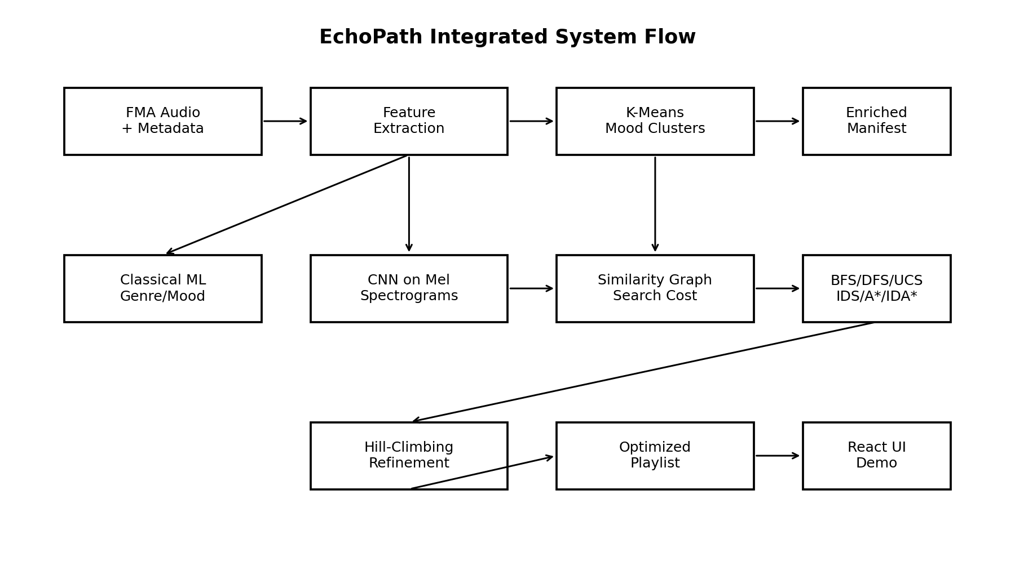
Figure 1: EchoPath integrated module flowchart.
The uploaded project synopsis also describes a similar modular flow with data preprocessing, playlist generation via search, CNN genre/mood classification, preference modeling, mood clustering, and optimized playlist output.
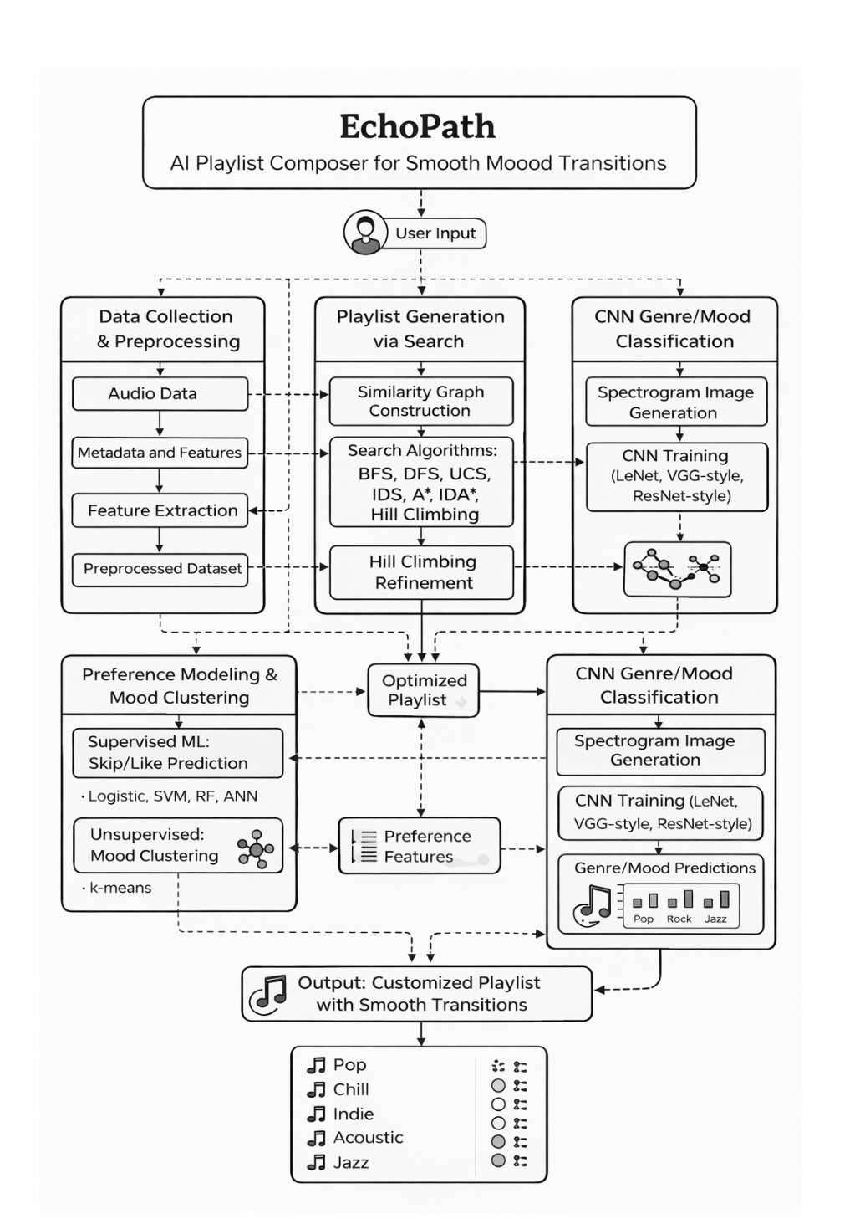
Figure 2: Original EchoPath module diagram from the project synopsis.

5. Dataset and Preprocessing
The implementation uses the FMA small dataset, which contains approximately 8000 audio files organized in numbered folders. A 4000-track subset was used for the main training and search experiments. The FMA metadata file tracks.csv was used to attach genre labels and metadata to audio files.
Item | Description
Dataset | FMA small audio files and tracks.csv metadata
Main experiment size | 4000 tracks
Audio loading | Mono conversion using librosa
Feature extraction duration | 30 seconds per track for CPU-feasible processing
Output manifest | data/library/tracks.json and enriched tracks_enriched.json
Feature table | artifacts/features.csv

5.1 Extracted Features
- Tempo: estimated beats per minute for tempo progression and similarity cost.
- Energy: RMS-based signal intensity, normalized for transition analysis.
- Valence proxy: spectral-centroid-based brightness estimate.
- MFCC statistics: compact timbral descriptors for classical ML models.
- Chroma features: harmonic content representation.
- Spectral contrast and zero-crossing rate: additional texture and brightness cues.
- Mel-spectrograms: image-like representations used as CNN inputs.

6. Main Modules and Algorithms

6.1 Data Collection and Feature Extraction
The ingest command scans audio files, reads metadata, loads each track with librosa, extracts audio features, and writes a backend-compatible manifest. The features are also stored in a CSV file for ML experiments.

6.2 Mood Clustering
K-means clustering groups tracks into mood clusters based on audio features. Each cluster is summarized using tempo, energy, valence, and anchor genres. The cluster ID is used as both a target type and as a mood checkpoint for playlist generation.

6.3 Similarity Graph Construction
Songs are treated as graph nodes. Transition cost is computed from tempo difference, energy difference, valence difference, genre transition, cluster transition, and tempo-policy penalties. The backend ranks nearby tracks as graph neighbors for search expansion.

6.4 Search Algorithms
The backend implements BFS, DFS, UCS, IDS, A*, and IDA*. BFS and DFS represent uninformed search. UCS minimizes path cost. A* and IDA* use heuristic target penalties and ML/CNN signal penalties to guide the path toward the target efficiently.

6.5 Hill-Climbing Refinement
After initial search, a hill-climbing pass attempts local replacement of non-seed tracks. A candidate replacement is accepted only if it lowers total path cost while preserving constraints and target validity.

6.6 Classical ML Module
Logistic Regression, SVM, Random Forest, Extra Trees, and MLP are trained on extracted audio features. Experiments include balanced top-5 genre classification and mood-cluster classification.

6.7 CNN Spectrogram Module
Audio is converted to mel-spectrograms. LeNet-style, VGG-style, and ResNet-style CNN variants are supported. The CNN pipeline outputs accuracy, macro-F1, weighted-F1, classification reports, and model artifacts.

6.8 Upload and Analyze Module
The web app can accept a random downloaded song. The backend extracts features, generates a spectrogram, assigns the closest mood cluster, estimates genre from nearest library neighbors, and inserts the uploaded track into the graph for the current session.

6.9 Cost Function Overview
The transition cost combines audio smoothness, genre/cluster continuity, tempo policy, preference score, mood-fit score, and CNN/proxy target alignment. This gives the search algorithm a measurable way to prefer coherent and target-aware playlists.

7. Relevant AI & ML Topics Used
Topic | Usage in EchoPath
Graph Search | BFS, DFS, UCS, IDS, A*, and IDA* are used to search for playlist paths.
Heuristic Search | A* and IDA* use target penalties and signal penalties as heuristics.
Unsupervised Learning | K-means discovers mood clusters from audio features.
Classical Supervised ML | Logistic Regression, SVM, Random Forest, Extra Trees, and MLP classify genres or clusters.
Deep Learning | CNNs classify genre/mood from mel-spectrogram inputs.
Audio Signal Processing | librosa extracts spectral, rhythmic, harmonic, and timbral features.
Evaluation Metrics | Accuracy, macro-F1, weighted-F1, runtime, nodes expanded, path cost, diversity, and constraint satisfaction.

8. Experimental Results and Evaluation

8.1 Classical ML - Balanced Top-5 Genre Classification
A balanced top-5 genre setup was used to reduce class imbalance and create a cleaner genre classification experiment. The selected classes were Hip-Hop, International, Pop, Experimental, and Folk, each with 513 tracks.
Model | Accuracy | Balanced Accuracy | Macro-F1 | Weighted-F1
Extra Trees | 0.612 | 0.612 | 0.609 | 0.609
SVM RBF | 0.612 | 0.612 | 0.608 | 0.608
Random Forest | 0.587 | 0.587 | 0.583 | 0.583
MLP | 0.564 | 0.564 | 0.562 | 0.562
Logistic Regression | 0.503 | 0.503 | 0.495 | 0.495
Linear SVM | 0.492 | 0.493 | 0.478 | 0.477

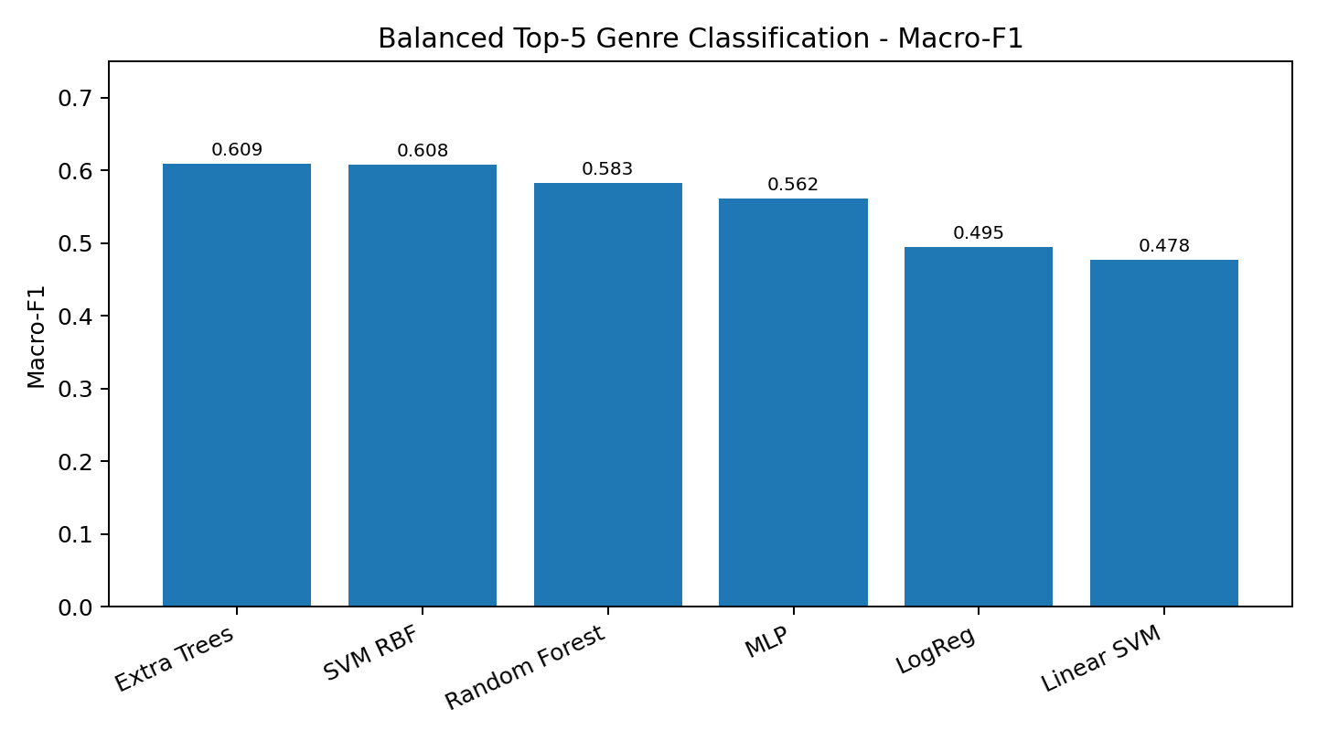
Figure 3: Macro-F1 comparison for balanced top-5 genre classification.

8.2 Classical ML - Mood-Cluster Classification
Mood-cluster classification performed strongly because cluster labels were derived from the audio feature space. This task is directly aligned with EchoPath’s goal of smooth mood-transition playlist construction.
Model | Accuracy | Balanced Accuracy | Macro-F1 | Weighted-F1
Logistic Regression | 0.965 | 0.969 | 0.966 | 0.965
MLP | 0.951 | 0.951 | 0.951 | 0.951
SVM RBF | 0.937 | 0.940 | 0.933 | 0.937
Extra Trees | 0.906 | 0.915 | 0.908 | 0.905
Random Forest | 0.884 | 0.874 | 0.882 | 0.884
Linear SVM | 0.832 | 0.845 | 0.837 | 0.831

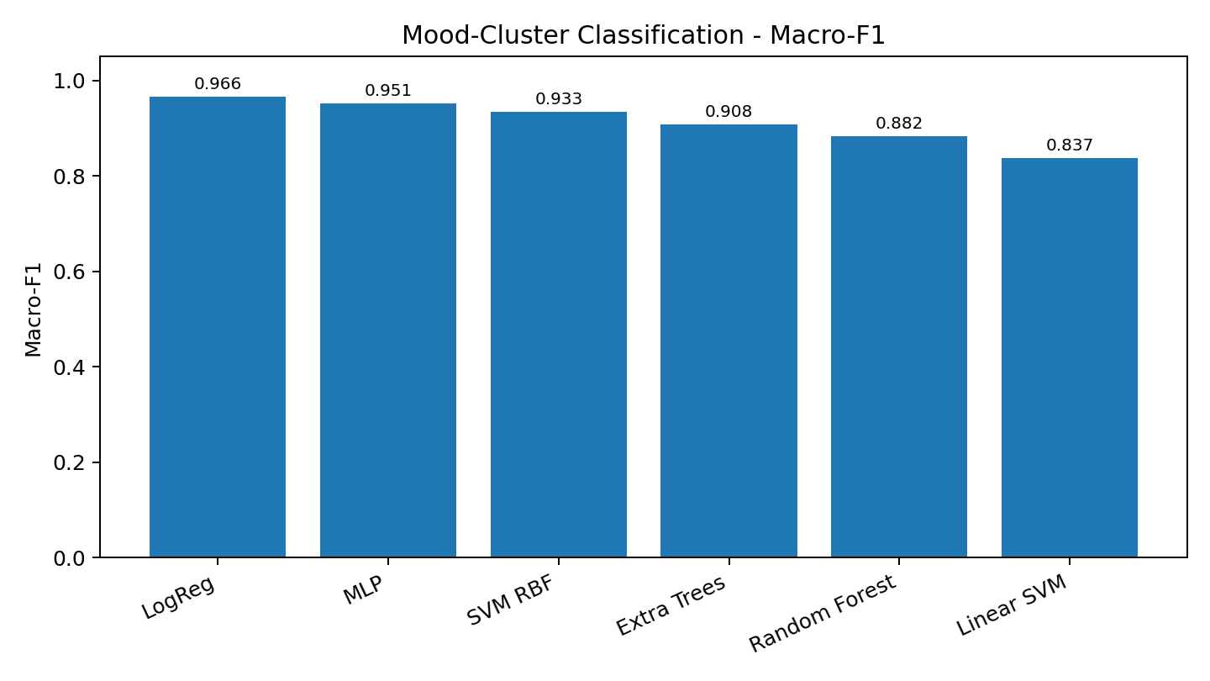
Figure 4: Macro-F1 comparison for mood-cluster classification.

8.3 Search Algorithm Benchmark
The benchmark compared BFS, DFS, UCS, IDS, A*, and IDA* on representative seed tracks from the 4000-track FMA manifest. Each seed was tested against genre and mood-cluster targets. All algorithms achieved a 100% target-hit rate in this benchmark.
Algorithm | Avg Runtime (ms) | Avg Nodes Expanded | Avg Cost | Hit Rate
A* | 38.85 | 4.0 | 0.228 | 100%
IDA* | 39.41 | 4.0 | 0.228 | 100%
DFS | 40.54 | 4.0 | 0.228 | 100%
UCS | 417.47 | 42.5 | 0.215 | 100%
IDS | 534.58 | 55.0 | 0.228 | 100%
BFS | 2670.85 | 259.0 | 0.228 | 100%

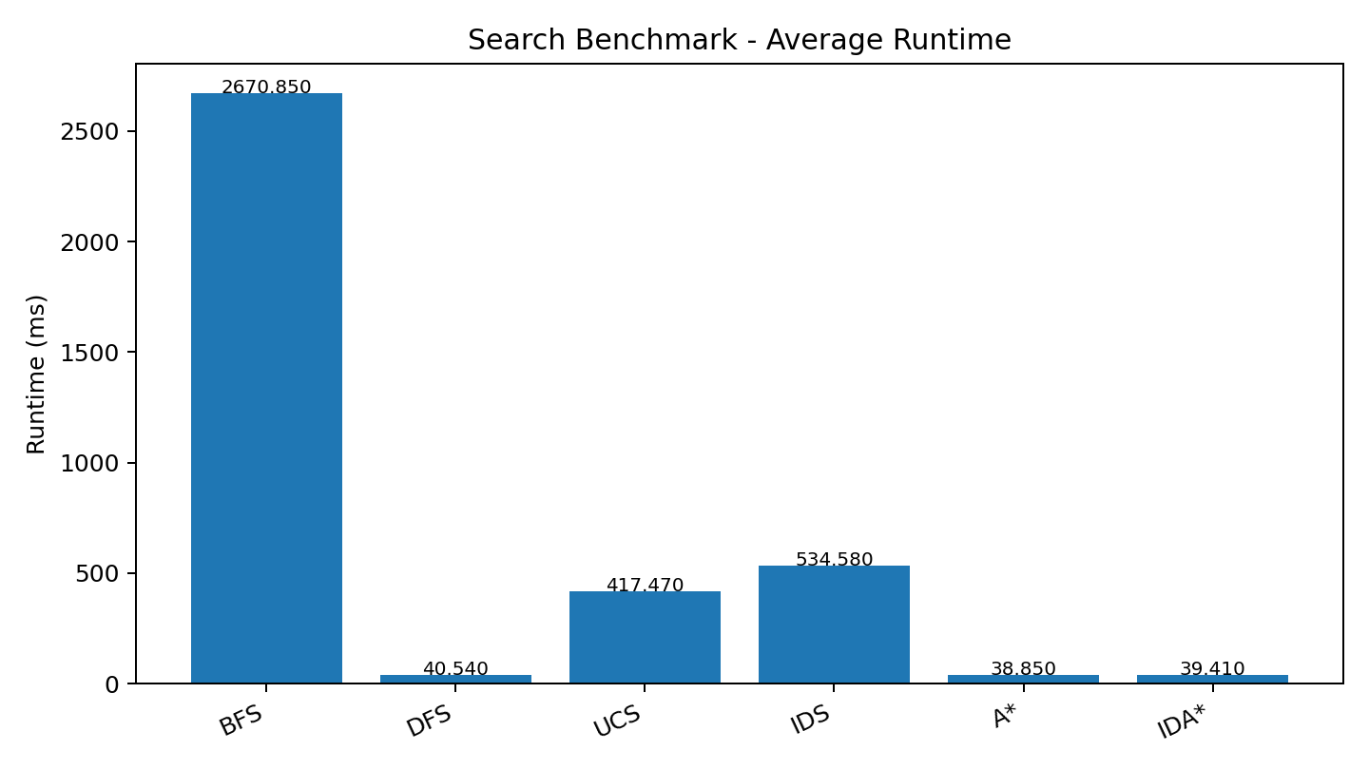
Figure 5: Average runtime comparison for search algorithms.
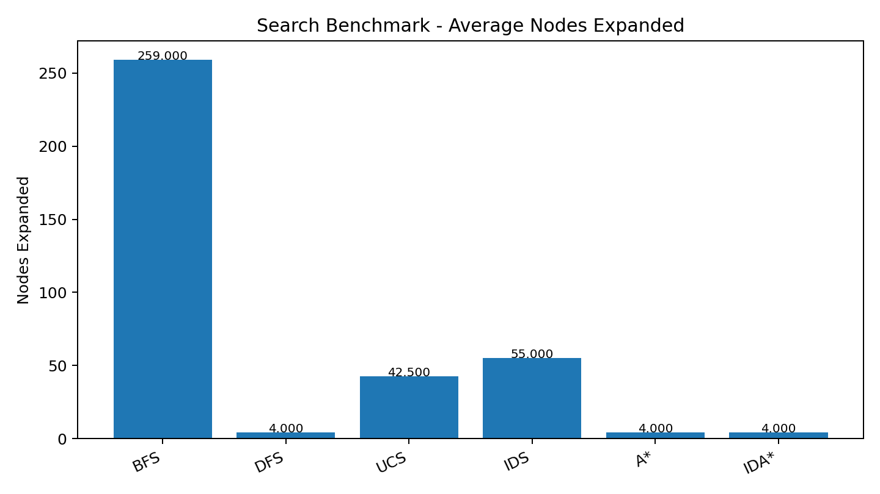
Figure 6: Average node expansion comparison for search algorithms.

8.4 CNN Mel-Spectrogram Classification
The CNN baseline was trained on a balanced top-5 genre subset using mel-spectrogram inputs. The CPU-feasible experiment used 5 epochs and batch size 8. The LeNet-style baseline achieved 53.2% accuracy and 0.497 macro-F1. The implementation also supports VGG-style and ResNet-style CNN variants for final architecture comparison.
Class | Precision | Recall | F1-Score | Support
Experimental | 0.58 | 0.62 | 0.60 | 103
Folk | 0.48 | 0.70 | 0.57 | 102
Hip-Hop | 0.59 | 0.75 | 0.66 | 103
International | 0.55 | 0.50 | 0.53 | 103
Pop | 0.33 | 0.09 | 0.14 | 102
Overall Accuracy | - | - | 0.532 | 513
Macro Avg | 0.50 | 0.53 | 0.50 | 513

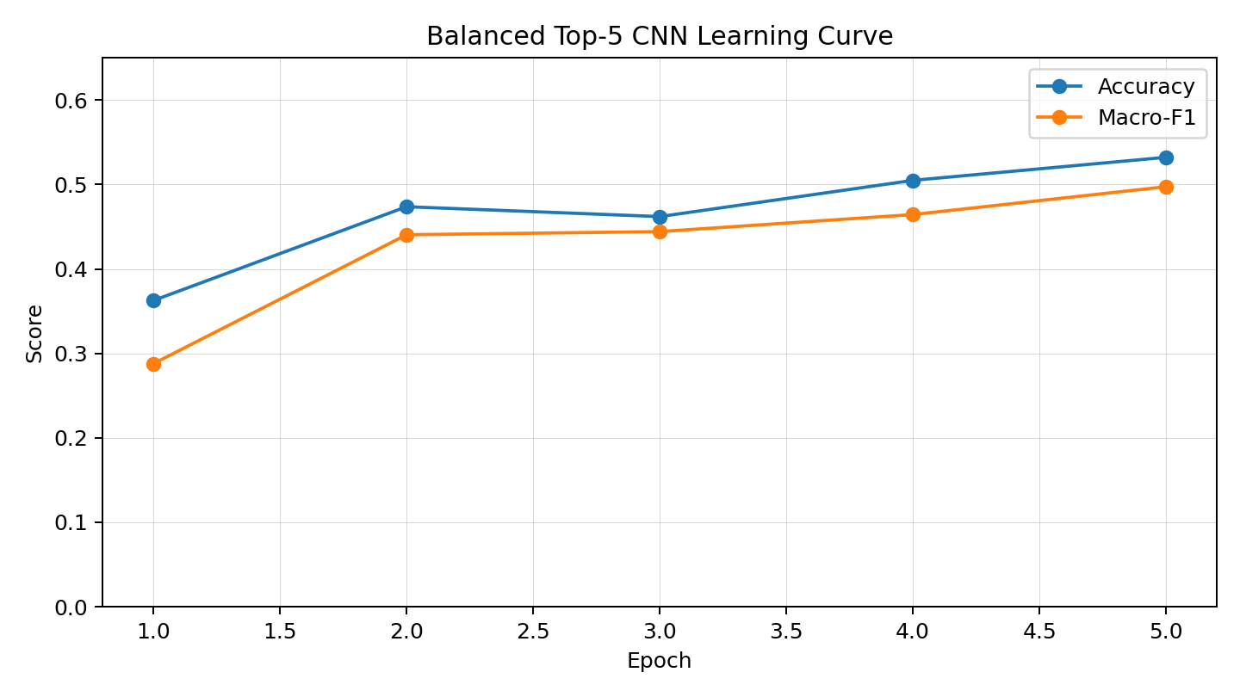
Figure 7: CNN learning curve across 5 epochs.
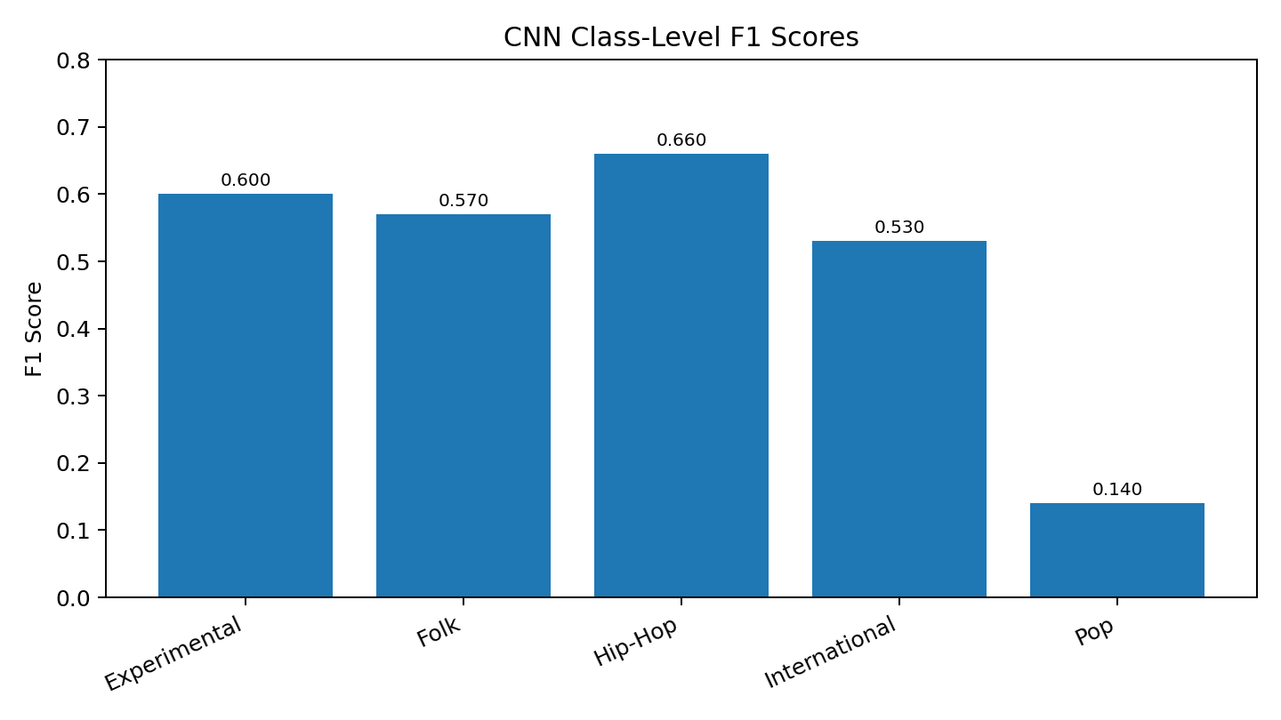
Figure 8: CNN class-level F1 scores.

8.5 CNN Architecture Comparison Procedure
The final training command supports LeNet-style, VGG-style, and ResNet-style architectures. The comparison produces a CSV file with accuracy, macro-F1, weighted-F1, and test loss for each architecture. The exact metrics should be updated after running the architecture comparison command on the final machine.
echopath train-cnn ^
--manifest ..\data\library\tracks_cnn_top5_balanced.json ^
--architecture all ^
--epochs 5 ^
--batch-size 4 ^
--output-dir ..\artifacts\models\cnn_arch_compare

Architecture | Description | Status
LeNet-style | Two convolutional blocks and compact classifier; CPU baseline. | Trained: 0.532 accuracy, 0.497 macro-F1
VGG-style | Deeper stacked 3x3 convolution blocks with pooling and dropout. | Implemented, final run command available
ResNet-style | Residual blocks with shortcut connections and adaptive pooling. | Implemented, final run command available

9. Output Screenshots and Figure Explanations
The following screenshots and figures should be included in the final submission. The generated charts already document the algorithm and model outputs. Live UI screenshots should be captured from the frontend after running the backend with tracks_enriched.json.
Figure/Screenshot | What it Showcases
Backend /health endpoint | Confirms FastAPI backend is running and real enriched manifest is loaded with using_sample_data=false.
Library page | Shows FMA tracks loaded from the backend and searchable in the UI.
Builder page | Shows seed selection, upload analysis, target type, target value, algorithm, playlist length, and constraints.
Results page | Shows generated playlist, runtime, nodes expanded, total cost, target hit, quality metrics, and transition explanations.
Analytics page | Shows mood clusters, model status, and search algorithm readiness.
Training terminal outputs | Shows classical ML results, CNN results, and benchmark output used in evaluation.

10. Work Division Between Group Members
Member | Enrollment Number | Primary Contributions
Harsh Jha | 2401030141 | Backend API, graph search integration, playlist generation logic, evaluation interpretation, report coordination.
Jaydeep Singh | 2401030133 | Dataset preparation, feature extraction, k-means clustering, classical ML experiments, benchmark logging.
Arnav Tyagi | 2401030139 | Frontend UI, CNN spectrogram training workflow, upload/analyze UI support, screenshots and demo preparation.

11. Conclusion and Discussion
EchoPath demonstrates an integrated AI/ML music recommendation pipeline that goes beyond random playlist generation. It uses audio feature extraction, mood clustering, graph search, supervised learning, CNN spectrogram classification, hill-climbing refinement, and a full-stack web interface. The strongest classical ML result was achieved on mood-cluster classification, where Logistic Regression reached 96.5% accuracy and 0.966 macro-F1. The balanced top-5 genre classification achieved 61.2% accuracy and 0.609 macro-F1 using Extra Trees. The CNN baseline achieved 53.2% accuracy on a balanced top-5 subset, proving that the spectrogram-based deep learning component is functional.
Search benchmarking showed that A* and IDA* were the most efficient algorithms for live demo usage, while UCS achieved slightly lower path cost at higher computational expense. BFS was much slower and is best kept as a benchmark comparison rather than a live demo choice on a 4000-track graph.

11.1 Limitations
- CNN performance is limited by CPU-only training, class imbalance, and short training duration.
- Uploaded-song prediction currently uses nearest-neighbor/library-based estimation unless exported CNN inference is attached.
- BFS and IDS are slow for large graphs and long playlist lengths.
- Genre labels in FMA can overlap acoustically, making genre classification harder than mood-cluster classification.

11.2 Future Enhancements
- Train CNN architecture comparison on GPU for more epochs.
- Export real CNN per-track probability predictions and feed them into A* heuristics.
- Add real user feedback data for skip/like preference modeling.
- Persist uploaded-song analysis into a user-specific library.
- Add interactive visualizations for graph paths and cluster transitions.

Appendix I - Implementation Code
The full implementation is submitted as a softcopy of code. The following excerpts summarize the key implementation modules and algorithms.
File / Module | Purpose
backend/app/repository.py | Core playlist generation engine: search algorithms, cost function, hill climbing, metrics.
backend/app/audio_analysis.py | Uploaded-song analysis: feature extraction, spectrogram, nearest cluster, genre estimate.
backend/app/routers/tracks.py | Track listing, streaming, spectrogram, and upload analysis endpoints.
training/echopath/commands/ingest.py | FMA scanning, feature extraction, manifest generation, k-means clustering.
training/echopath/commands/train_classical.py | Classical ML training and evaluation.
training/echopath/commands/train_cnn.py | LeNet/VGG/ResNet-style CNN training and comparison.
frontend/src/pages/BuilderPage.tsx | React UI for upload analysis and playlist generation.
frontend/src/pages/ResultsPage.tsx | React UI for playlist results, transition explanations, and optimization metrics.

References
- FMA: A Dataset For Music Analysis - https://github.com/mdeff/fma
- Scikit-learn Documentation - https://scikit-learn.org/stable/
- librosa Documentation - https://librosa.org/doc/latest/index.html
- PyTorch Documentation - https://pytorch.org/docs/stable/index.html
- FastAPI Documentation - https://fastapi.tiangolo.com/
- React Documentation - https://react.dev/

