## Introduction

Blah blah blah

## Overview

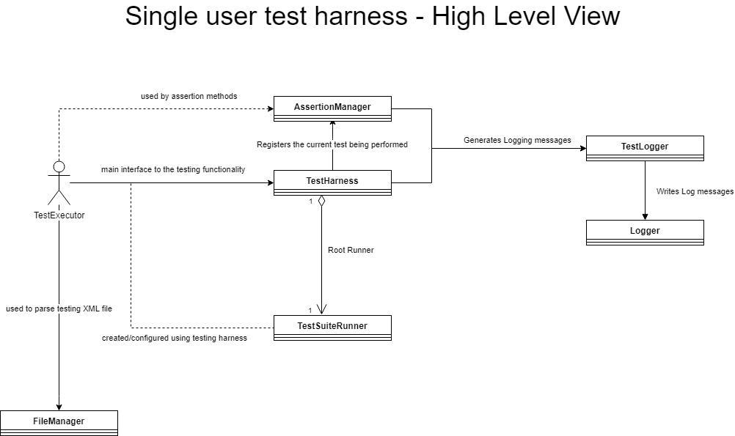

Figure - High level view

A high level view of the Single User Testing Harness is shown above in Figure 1 - High level view.

The test executor will first read the test XML file using the FileManager, to configure the TestingSuiteRunner used by the Testingharness, and then configure the logging using the TestingHarness help methods, and then ask the Testing Harness to run the tests.

