代码：

原代码位置 VideoWallDataOp --🡪 320行

HCNetSDK.INT_ARRAY pInt = **new** HCNetSDK.INT_ARRAY(1);

Pointer lpInt = pInt.getPointer();

pInt.intValue[0] = -1;

pInt.write();

HCNetSDK.WinNo strWinNo = **new** HCNetSDK.WinNo();

Pointer lpStrWinNo = strWinNo.getPointer();

strWinNo.winNo = 1 << 24 | 0 << 16 | 0;

HCNetSDK.RetWinNo strRetWinNo = **new** HCNetSDK.RetWinNo();

Pointer lpRetStrWinNo = strWinNo.getPointer();

HCNetSDK.NET_DVR_VIDEOWALLWINDOWPOSITION struWindowPos = **new** HCNetSDK.NET_DVR_VIDEOWALLWINDOWPOSITION();

Pointer LpStruWindowPos = struWindowPos.getPointer();

struWindowPos.dwSize = struWindowPos.size();

struWindowPos.byEnable = 1;

struWindowPos.dwWindowNo = 1 << 24;

struWindowPos.struRect.dwXCoordinate = 0;

struWindowPos.struRect.dwYCoordinate = 0;

struWindowPos.struRect.dwWidth = 1920;

struWindowPos.struRect.dwHeight = 1920;

HCNetSDK.NET_DVR_IN_PARAM struInputPapam = **new** HCNetSDK.NET_DVR_IN_PARAM();

HCNetSDK.NET_DVR_OUT_PARAM struOutputPapam = **new** HCNetSDK.NET_DVR_OUT_PARAM();

Pointer lpStruInputPapam = struInputPapam.getPointer();

Pointer lpStruOutputPapam = struOutputPapam.getPointer();

struInputPapam.struCondBuf.pBuf = lpStrWinNo;

struInputPapam.struCondBuf.nLen = 4;

struInputPapam.struInParamBuf.pBuf = LpStruWindowPos;

struInputPapam.struInParamBuf.nLen = 1 * (**new** HCNetSDK.NET_DVR_VIDEOWALLWINDOWPOSITION()).size();

struOutputPapam.lpStatusList = lpInt;

struOutputPapam.struOutBuf.pBuf = lpRetStrWinNo;

struOutputPapam.struOutBuf.nLen = 4;

struInputPapam.write();

struInputPapam.write();

pInt.write();

strWinNo.write();

strRetWinNo.write();

struWindowPos.write();

**boolean** op = hCNetSDK.NET_DVR_SetDeviceConfigEx(lUserID, HCNetSDK.***NET_DVR_SET_VIDEOWALLWINDOWPOSITION***, 1,

lpStruInputPapam, lpStruOutputPapam);

问题------------>

1. Winno定义



如果我们定义自己的winno应该怎么定义

1. dwWindowNo定义

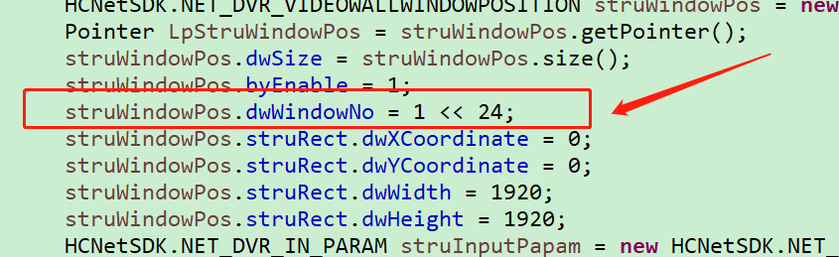

同1

1. 窗口信息

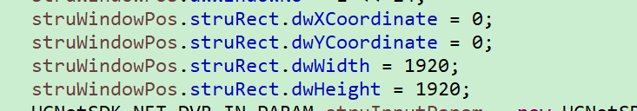

这是窗口坐标对吧？

1. 方法使用

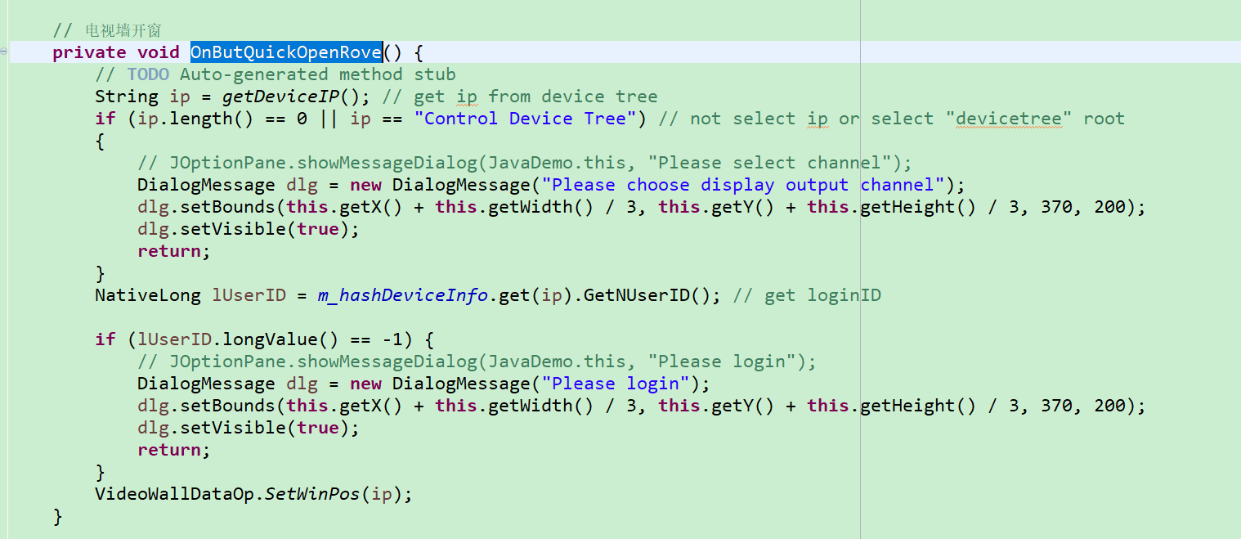

在demo中开窗使用了参数luserid，deviceIp 我们在具体编码中，是否登录之后，就可以直接开窗。