CIS Trade Hive — Master Design Specs (Portia Replacement)
System Design Document
Table of Contents

Master Design Specs — Portia Replacement

Sections 1–2
Companion to SDM_Sections_3_to_8.md, SDM_ER_Diagram.md, and SDM_Class_Diagram.md. Sourced from cis_trade_hive/docs/confluence/ (an 18-page internal architecture doc set already maintained in-repo) and cis_trade_hive/CLAUDE.md.

1 Introduction
CIS Trade Hive (CIS = Capital & Investment Services) is the system used to manage investment trades end-to-end — from trade entry, through compliance (maker-checker) approval, to settlement, position-keeping, and reporting.
The bank’s proprietary equities business was previously supported by the legacy IOS Portia platform, which had become obsolete and no longer met modern technology, integration, and reporting requirements. This replacement initiative leverages the existing Global Markets Platform (GMP) for products already approved by Global Markets — primarily listed equities — with CIS Trade Hive as the new front-to-back application layer, built on Apache Kudu (via Impala) hosted on the bank’s Cloudera CDP platform, replacing Portia’s data and processing layer.
At a glance: - A trader (maker) enters a trade or portfolio. - A checker reviews and approves it — no one may approve their own work (Four-Eyes / maker-checker principle). - The system automatically calculates each portfolio’s position (Average Price Position — AVP: quantity held, weighted average cost). - Market data (FX rates, equity prices, reference data) flows in daily from the upstream GMP system. - Every action is written to an immutable audit log. - The application is browser-based — no client install required.

Modules in Scope
Module | What it manages
Portfolio | Investment portfolios — create, approve, track
Trade | Buy/sell trades — enter, validate, settle
Position (AVP) | Automatic weighted-average-cost position per portfolio/security
Market Data | Daily FX rates and equity prices from GMP
Securities | Security master data (ISIN, currency, type)
Counterparties | Brokers and counterparties used in trades
Corporate Actions | Dividends, splits, rights issues affecting positions
Cash Flow | Cash movements linked to trades and corporate actions
UDF | User-defined custom fields on trades and portfolios
File Upload | Bulk data ingestion (CSV/Parquet/Excel)
Audit Log | Complete, immutable change history
RBAC | Role-based access control

1.1 Assumptions, Constraints and Dependencies
Assumptions - Products in initial scope are limited to those already approved by Global Markets — primarily listed equities. - Users authenticate via the bank’s existing LDAP/Active Directory infrastructure, consistent with other Cloudera CML-hosted applications. - GMP remains the upstream source-of-truth for market data (FX rates, equity prices) and select reference data; CIS does not originate this data itself.
Constraints - No relational-DB/ORM option for business data: all trade, portfolio, position, and reference data must be modelled and queried as Kudu/Impala tables — there is no fallback to a conventional RDBMS for business entities (Django’s own DB is used only for framework concerns: auth, sessions, contenttypes). - Kudu is append/UPSERT-only: there is no native row-level UPDATE semantics beyond UPSERT-on-primary-key; versioned entities (positions, trade history) are modelled as new rows rather than in-place mutation. This constrains schema design and increases storage growth over time (see Section 7.8, Archive and Purge). - No end-user direct cluster access: per the bank’s CDP/Ranger security model, all Impala/Hive/HDFS access is routed through two shared Linux service accounts (own_cis_svc write, un_cis_svc read-only) — Ranger enforces access at the service-account level, not per individual CIS user. CIS’s own RBAC (Section 5.1) is therefore a separate, additional access-control layer on top of Ranger, not a replacement for it. - A Python 3.6-compatible fork exists (edge_jobs_py36/) for select batch scripts that must run on an older cluster runtime component; any fix to a script with a counterpart in this fork must be mirrored, or the two copies silently drift.
Dependencies - GMP (Global Markets Platform): upstream source for FX rates, equity prices, and select reference data, fed daily (~6:00 AM) into Hive external tables that CIS reads but never writes to. - Cloudera CDP platform (Kudu, Impala, Hive, HDFS, Ranger, CML): CIS is hosted as a Cloudera CML Application, not a standalone server — CML injects the listening port at runtime and the app has no independent hosting path outside this platform. - Kerberos (GSSAPI) ticket-based authentication for all non-LOCAL environments — CIS cannot reach its own data in SIT/UAT/PROD/DR without a valid service-account Kerberos ticket. - AMS/AMSICEQ upstream feed for certain position/holdings data (Excel upload path — see upload_amsiceq_positions.py), a secondary data-ingestion dependency alongside GMP.

2 Architecture Design

2.1 Application Interaction Diagram
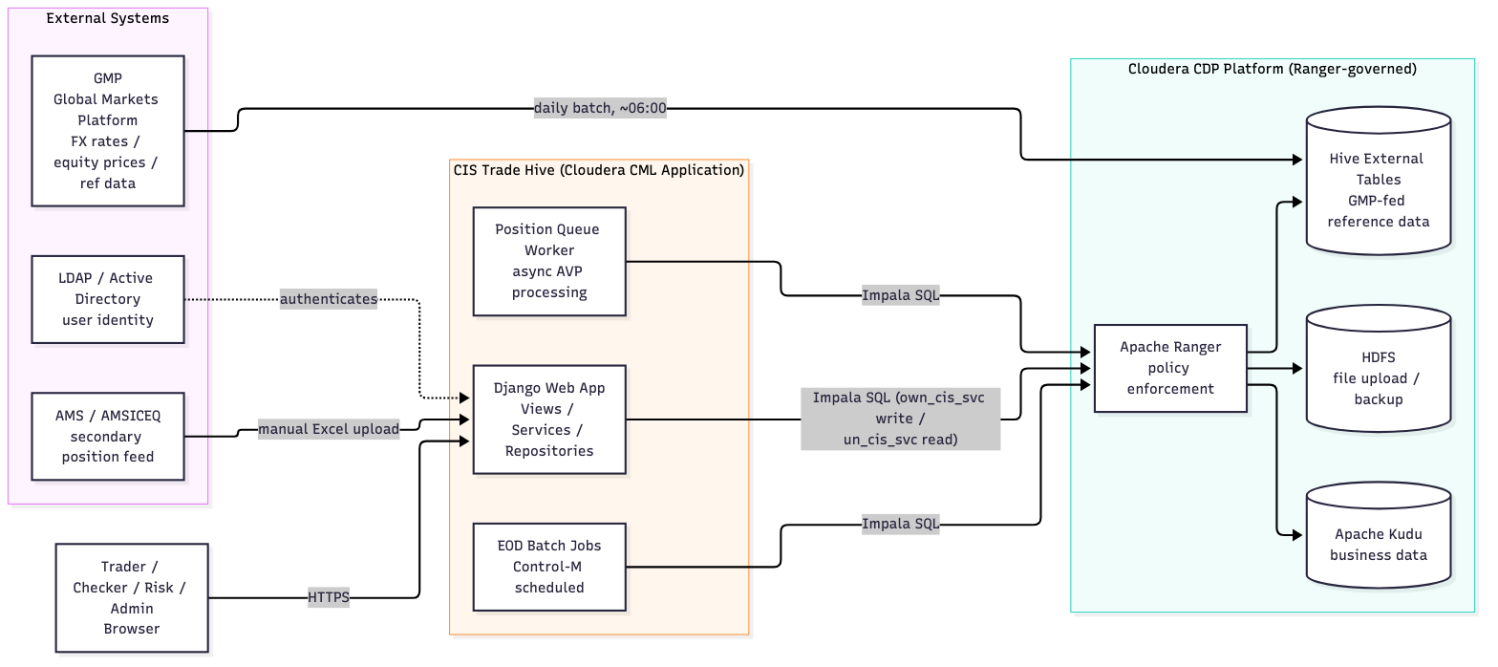
s12_0.png

2.2 Application Architecture Diagram
Strict layered architecture — every layer has exactly one job:
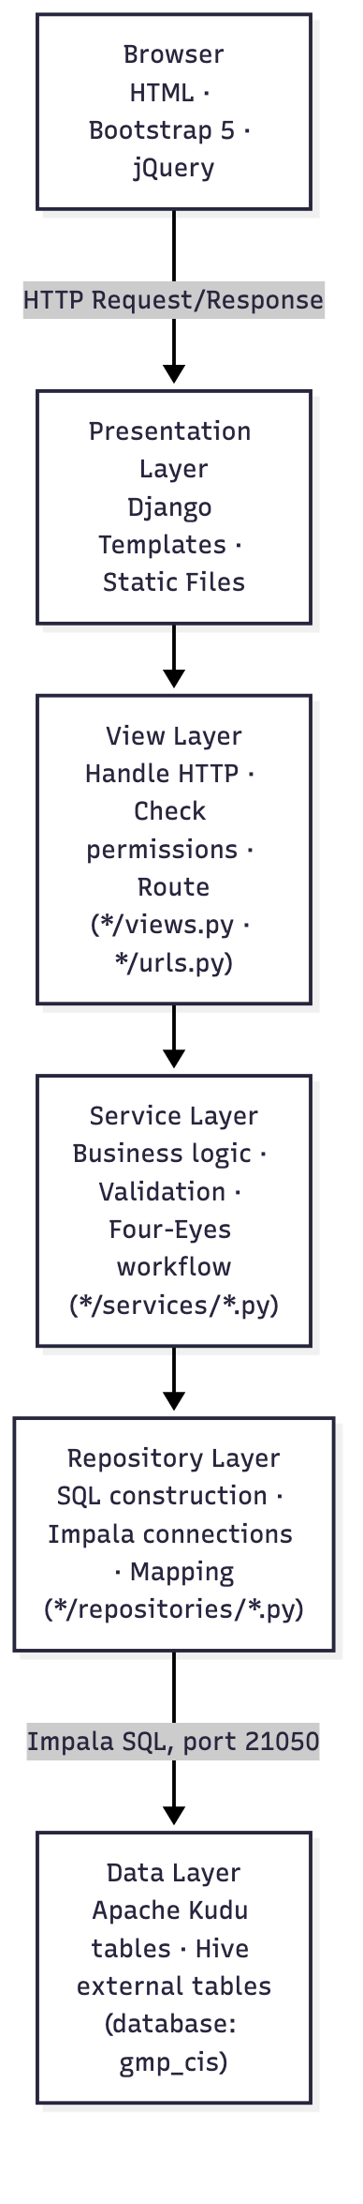
s12_1.png
Request lifecycle example — creating a trade:
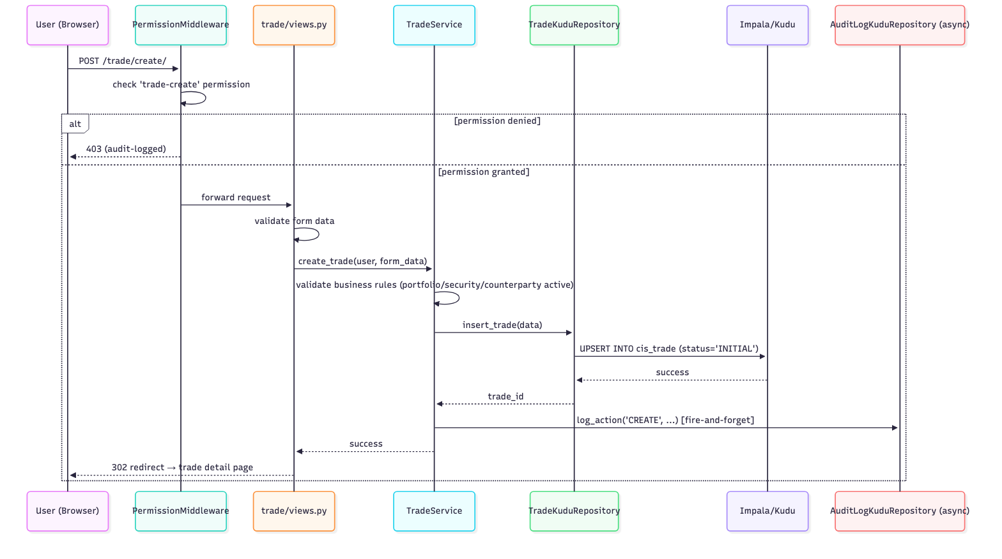
s12_2.png

2.3 Component Description
Component (Django App) | Purpose | Key Tables
core | Auth, audit, ACL, middleware, Impala connection pool | cis_audit_log, cis_user*, cis_group*
portfolio | Portfolio management + maker-checker | cis_portfolio, cis_portfolio_history
trade | Trade lifecycle, AVP position engine, settlement, position queue | cis_trade, cis_trade_history, cis_trade_position, cis_position_queue
market_data | FX rates, equity prices (read from GMP) | gmp_cis_sta_dly_fx_rates, gmp_cis_sta_dly_equity_price
reference_data | Currency, country, calendar, corporate actions | gmp_cis_sta_dly_currency/country/calendar, cis_corporate_actions
security | Security master data | cis_security, cis_security_history
udf | User-defined custom fields | cis_udf_definition, cis_udf_value, cis_udf_option
upload | File upload and Hive external table creation | cis_file_upload
lookup | Lookup/dropdown tables (broker, GL codes, etc.) | cis_trade_charge_lut
Full class-level detail: SDM_Class_Diagram.md. Full table-level detail: SDM_ER_Diagram.md.

2.4 Application Structure
cis_trade_hive/
├── config/ # Django settings, URLs, WSGI, per-env config
│ ├── settings.py
│ ├── urls.py
│ ├── environments.py # Per-environment Impala/Hive connection config
│ └── cml_app.py # Cloudera CML-specific bootstrap (port injection, etc.)
│
├── core/ # Foundation — used by every app
│ ├── audit/ # Kudu-based async audit logging
│ ├── repositories/
│ │ ├── impala_connection.py # Connection pool (primary read/write path)
│ │ ├── hive_connection.py # Hive ACID writes (managed tables)
│ │ ├── hybrid_connection.py # Routes Kudu→Impala, Hive-managed→Hive
│ │ ├── acl_repository.py # RBAC v1
│ │ └── acl_repository_v2.py # RBAC v2 (multi-group)
│ ├── services/
│ │ ├── acl_service.py
│ │ └── system_date_service.py
│ └── middleware/
│ ├── permission_middleware.py # URL-level permission enforcement
│ ├── performance_middleware.py
│ └── audit_middleware.py
│
├── portfolio/ / security/ / reference_data/ / market_data/ / udf/ / upload/ / lookup/
│ └── (each: repositories/, services/, views.py, urls.py, models.py)
│
├── trade/ # Largest app — trade + position + cash flow
│ ├── repositories/ (trade_kudu_repository.py, position_repository.py, cash_flow_repository.py)
│ ├── services/ (position_service.py, settlement_service.py, position_queue_service.py, cash_flow_service.py)
│ ├── management/commands/ (process_settlements.py, refresh_positions.py, run_trade_event_worker.py, ...)
│ └── views.py / views_position.py / views_cash_flow.py
│
├── edge_jobs_py36/ # Python 3.6-compatible fork of select batch scripts
├── templates/ # All HTML templates
├── static/ # CSS, JS, images — no CDN, all served locally
├── sql/ddl/ # Kudu/Hive DDL scripts (numbered sequence, 108 files)
└── scripts/ # PySpark migration + backup/restore + CML startup scripts
Hosting model: CIS runs as a Cloudera CML Application (scripts/cml_startup.sh starts two processes together on the CML-injected port: the Django server and the Position Queue Worker background thread pool). This is a single-instance-per-environment hosting model, not a load-balanced multi-instance web farm — see Section 8.3 for the resiliency implication.

Companion documents: SDM_ER_Diagram.md (data model), SDM_Class_Diagram.md (class/service model), SDM_Sections_3_to_8.md (Sections 3–8).

Master Design Specs — Portia Replacement

Sections 3–8
Draft content sourced directly from the cis_trade_hive codebase. Items that cannot be evidenced in-repo are marked [TBC] rather than invented — confirm with the relevant owner (Infra/Security/Ops) before finalizing.

3 Application Design

3.1 Application Type – Object Oriented
CIS Trade Hive is a Django 5.2.9 monolith following a strict SOLID layered design:
Views (HTTP) → Services (business logic / Four-Eyes workflow)
→ Repositories (raw Impala SQL against Kudu)
→ ImpalaConnectionManager (pooled connections)
~33 repository files span trade/, portfolio/, security/, reference_data/, core/audit/, udf/, and lookup/. Repositories never call each other directly; cross-entity lookups go through a dedicated validation repository. Services may call sibling services (e.g. CorporateActionService → CACashFlowService) within the same request.
A parallel Django-free fork of the same Service/Repository pairs lives in edge_jobs_py36/ for scripts running on an older Python 3.6 cluster runtime (see cis_trade_hive/CLAUDE.md).

3.1.1 Class Diagram
See SDM_Class_Diagram.md (companion file) for the full Mermaid class diagram covering all layers and cross-service dependencies.

3.1.2 Event Sequence Diagram
The canonical multi-step sequence in the system is the EOD batch run (6 waves, each gated on the prior wave’s exit code — see docs/CONTROL_M_EOD_JOBS.md):
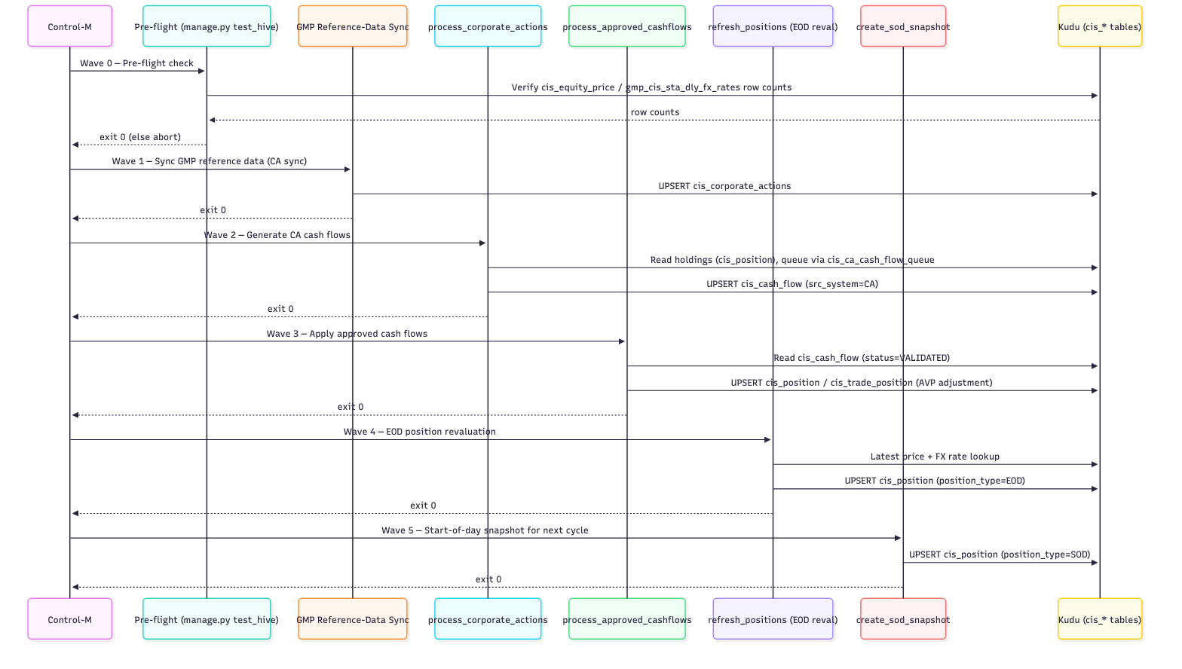
s38_0.png
See docs/EOD_SEQUENCE_DIAGRAM.md and docs/CONTROL_M_EOD_JOBS.md for the authoritative, fully-detailed version of this flow.

3.1.3 Component Design
Component boundaries follow the Django app structure:
Component (App) | Responsibility | Key Classes
core | Auth, ACL, audit, middleware, Impala connection pool | ImpalaConnectionManager, ACLService, AuditLogKuduRepository
portfolio | Portfolio master data, Four-Eyes workflow | PortfolioService, PortfolioHiveRepository
trade | Trade capture, AVP position engine, settlement, cash flow | TradeKuduRepository, PositionService, SettlementService, PositionQueueService, CashFlowService
security | Security master data | SecurityService, SecurityHiveRepository
reference_data | Currencies, countries, counterparties, corporate actions | CorporateActionService, CACashFlowService
udf | User-Defined Fields (generic entity extension) | UDFFieldService, UDFFieldRepository
market_data | FX rates, market data | MulticurrencyService
Full method-level detail is in SDM_Class_Diagram.md.

3.2 Application Type – Host Processing
The EOD/batch layer is implemented as Django management commands (manage.py <command>), scheduled by Control-M rather than run interactively — functionally equivalent to host/batch processing jobs, though the runtime is Python/Django, not a mainframe.

3.2.1 Data Flow
There are no flat-file interfaces in the batch layer — all data flow is Kudu table → Python business logic → Kudu table:
GMP source tables (gmp_cis_sta_dly_*)
│ (scheduled sync)
▼
cis_corporate_actions / cis_equity_price / gmp_cis_sta_dly_fx_rates
│
▼
process_corporate_actions.py ──► cis_ca_cash_flow_queue ──► cis_cash_flow
│
▼
process_approved_cashflows.py ──► cis_position / cis_trade_position (AVP adjust)
│
▼
refresh_positions.py (EOD reval) ──► cis_position (position_type=EOD)
│
▼
create_sod_snapshot.py ──► cis_position (position_type=SOD, next cycle's opening balance)

3.2.2 Program Flow
See docs/CONTROL_M_EOD_JOBS.md and docs/EOD_PROCESSING_GUIDE.md for the full program flow, retry/failure handling per wave, and job dependency chain. Each management command: 1. Validates pre-conditions (source data present for the processing date). 2. Executes idempotent UPSERT writes (safe to re-run a wave). 3. Logs progress and returns a non-zero exit code on failure, which halts the Control-M chain for that day.

3.3 Application Type – EAI
Not applicable. There is no ESB, message broker (Kafka/RabbitMQ/MQ), or integration-bus middleware in this codebase. Integration with upstream GMP/AMS systems is point-to-point batch data exchange — GMP/AMS feed land directly into shared Kudu/Hive tables (gmp_cis_sta_dly_*), which the Django app’s scheduled jobs read on a fixed cadence. No further EAI architecture/flow diagrams apply.

3.4 Application Type – Model Driven
Not applicable. Business logic is hand-written Python executing raw Impala SQL against Kudu tables (see repository layer, Section 3.1). Django’s ORM is used only for framework concerns (django.contrib.auth, sessions, contenttypes, messages) — it does not back any domain model, so there is no model-driven code-generation framework or application/grouping model definition to document here.

4 Data Design

4.1 Overview
All business data (trade, portfolio, position, security, cash flow, corporate action, reference data) is stored in Apache Kudu, accessed via Impala (PyHive 0.7.0 client). Django’s own database (used only for auth/sessions/contenttypes) is a separate, conventional RDBMS connection and out of scope for the business data model below.

4.1.1 Impact Assessment Considerations
- Kudu tables are append/UPSERT-only — there is no in-place row mutation for versioned entities; changes are modelled as new rows with a version_id/is_latest flag (cis_trade_position, cis_trade_history). Any schema change to these tables must account for existing historical versions.
- Dual-write pattern: every CIS-originated position change writes to both cis_trade_position (CIS-only working ledger) and cis_position (golden copy merging CIS/GMP/AMS_STREET/USER_UPLOAD). A schema or logic change to one side must be mirrored to the other, or the two will drift.
- The edge_jobs_py36/ fork duplicates several repository/service classes for the Python 3.6 cluster runtime — any DDL or business-logic change to a table touched by both the main app and a fork counterpart must be applied to both (see cis_trade_hive/CLAUDE.md).
- Known data-integrity risk: position_id for cis_position (PK = position_id alone) is generated two different ways in the codebase. Most paths compute it deterministically (MD5/fnv_hash of portfolio|security|basis|date|src_system), so a repeated write correctly UPDATEs the same row. Two code paths instead generate a fresh timestamp+UUID id with no natural-key lookup, producing a duplicate row instead of an update if re-run for the same position: upload_amsiceq_positions.py (Excel upload utility — live risk if re-run) and refresh_positions.py’s _insert_eod_position() (marked legacy/unused but not yet confirmed dead). A live duplicate was confirmed in cis_position for one portfolio/security/basis combination as of 2026-09-17; manual data cleanup was still outstanding at that time (docs/confluence/12_sre_support_handover.md §6).

4.1.2 Inventory of Physical/Logical Files
No flat-file interfaces exist in the current design (see 3.2.1) — all persistence is via Kudu tables, enumerated in Section 4.2.

4.2 Inventory of Tables/Views
DDL source of truth: cis_trade_hive/sql/ddl/ — 108 files, one numbered file per logical table group (NN_description.sql), e.g. 00_all_kudu_tables_docker.sql (full local-dev schema, all tables), 01_core_tables.sql, 02_portfolio_tables.sql, 05_acl_tables_kudu.sql, 06_trade_tables_kudu.sql, 13_avp_tables_kudu.sql, 14_corporate_actions_kudu.sql, 15_cash_flow_kudu.sql, 16_ca_cash_flow_queue.sql, 17_trade_event_queue_kudu.sql, 50_rbac_tables_kudu.sql, 51_security_udf_fields.sql, etc.

4.2.1 Key Tables
Table | Purpose
cis_portfolio | Portfolio master, Four-Eyes status
cis_security | Security master data
cis_party | Counterparty / broker / custodian master
cis_trade | Trade capture, Four-Eyes status
cis_trade_history | Trade audit trail (versioned)
cis_trade_position | Versioned AVP working ledger (CIS-only)
cis_position | Golden/consolidated position copy (all sources)
cis_position_queue / cis_settlement_queue | Async AVP calculation queues
cis_cash_flow | Dividend/interest/ROC/capital-distribution cash flows
cis_corporate_actions | CA master (dividends, splits, bonus, rights)
cis_ca_cash_flow_queue | Per-holding fan-out queue for CA→cash-flow generation
cis_udf_field | Generic key/value entity extension
cis_user / cis_user_group / cis_group_permissions | RBAC
cis_audit_log | Full audit trail (see Section 6.1)
Full column-level detail for each table: sql/ddl/<NN_*.sql>.

4.2.2 Physical Data Model
See SDM_ER_Diagram.md (companion file) for the full Mermaid ER diagram, including per-table column lists and cross-table relationships (logical only — Kudu does not enforce foreign keys).

4.2.3 Table/File/Record Definition
Representative record layout — cis_audit_log (full audit trail, see Section 6.1 for design rationale): audit_id, audit_timestamp, user_id, username, user_email, action_type, action_category, action_description, entity_type, entity_id, entity_name, field_name, old_value, new_value, request_method, request_path, request_params, status, status_code, error_message, error_traceback, session_id, ip_address (plus further columns — confirm exact full list against sql/ddl/ before sign-off).
Every other table’s definitive record layout is its DDL file under sql/ddl/; this document does not duplicate all 108 definitions inline.

4.2.4 Join Condition
Principal join keys (all logical, not FK-enforced by Kudu):
- cis_trade.portfolio_short_name = cis_portfolio.name
- cis_trade.security_label = cis_security.security_name
- cis_trade.counterparty = cis_party.party_short_name
- cis_trade_position.trade_id = cis_trade.trade_id
- cis_position / cis_trade_position keyed on (portfolio, security_label, position_basis, position_date) — the natural key hashed into a deterministic position_id (position_id_service.position_id())
- cis_cash_flow.ca_id = cis_corporate_actions.ca_id (nullable — only set when src_system = 'CA')
- cis_group_permissions.group_id = cis_group.group_id, cis_user_group.user_id = cis_user.user_id

5 Application Security Requirements

5.1 User Administration
RBAC model: cis_user → cis_user_group → cis_group → cis_group_permissions (Kudu tables, sql/ddl/50_rbac_tables_kudu.sql). Permission grants carry per-module can_view/can_create/can_edit/can_delete/can_approve flags, enforced by ACLService (core/services/acl_service.py, 300s per-user cache — see cis_trade_hive/CLAUDE.md). See docs/RBAC_MIGRATION_PLAN.md and docs/GRANULAR_PERMISSION_PLAN.md for migration history and the granular-permission design.

5.2 Authentication
Two independent authentication layers:
- Application login — django.contrib.auth, backed by Django’s own user store (separate from the Kudu-backed cis_user RBAC table).
- Data-layer authentication (Impala/Kudu) — environment-driven, set in config/environments.py:
  - LOCAL: NOSASL (no auth — Docker dev only)
  - SIT / UAT / PROD / DR: GSSAPI (Kerberos) against the Cloudera CML cluster, with SSL enabled.
- ⚠️ Open item to flag for security sign-off (documented internally as a critical known issue, docs/confluence/12_sre_support_handover.md §6): LoginView.post (core/views/auth_views.py) currently checks only whether the submitted LANID exists/is enabled — it does not verify a password. Because the app is a CML Application with users added as LDAP collaborators and LANIDs are visible internally, this allows logging in as another user if their LANID is known. A fix is agreed but not yet implemented: drop the free-text login form and trust CML’s own LDAP/SSO gate by reading the authenticated LANID from the trusted header CML’s proxy injects per request (blocked on live CML environment access to confirm the exact header name). This must be resolved and verified before Section 5.2 is represented as production-ready.

5.3 Session Management (Web based)
django.contrib.sessions with SessionMiddleware active (config/settings.py). No custom session hardening was found in settings.py — no SESSION_COOKIE_SECURE, SESSION_COOKIE_HTTPONLY override, SESSION_EXPIRE_AT_BROWSER_CLOSE, or SESSION_COOKIE_AGE override; Django framework defaults are in effect. [TBC] — confirm whether this is an intentional decision or a gap to close before go-live (recommend explicit SESSION_COOKIE_SECURE=True, SESSION_COOKIE_HTTPONLY=True, and an explicit idle-timeout for a banking application).

5.4 Access Controls
Centralized, deny-by-default URL-level enforcement via core/middleware/permission_middleware.py (PermissionMiddleware, last in the middleware chain, runs after SessionMiddleware), driven by core/permissions_map.py’s URL_PERMISSION_MAP / EXEMPT_URL_NAMES / DEFAULT_DENY. Decision flow:
- No URL resolver match → pass through.
- URL is in EXEMPT_URL_NAMES (e.g. login page) → pass through.
- User not authenticated → redirect to login.
- SKIP_PERMISSION_CHECKS=True (dev-only flag) → bypass.
- URL not present in the map → 403 if DEFAULT_DENY, else pass.
- Otherwise evaluate the mapped (permission, mode) tuple, or a per-HTTP-method permission dict.
- AJAX/API requests receive a JSON 403 (not an HTML redirect).
- Every denial is audit-logged (async) to cis_audit_log.

5.5 Access Controls (Application Privileges)
Privileges are module-scoped (Portfolio, Trade, Security, UDF, Corporate Action, Cash Flow, …) with five actions each: view/create/edit/delete/ approve. The approve privilege is distinct from create/edit to enforce the Four-Eyes (maker-checker) principle — the same user cannot both create/modify and approve the same record (enforced in code, e.g. TradeKuduRepository.validate_trade() raises on created_by == validated_by).

5.6 Access Controls (Web Application Technologies)
django.middleware.security.SecurityMiddleware and django.middleware.clickjacking.XFrameOptionsMiddleware are active (clickjacking protection, security headers). CSRF protection is enabled via CsrfViewMiddleware, with CSRF_COOKIE_SECURE = not DEBUG. Static assets are served via WhiteNoiseMiddleware (no separate CDN/reverse-proxy static tier documented).
RESOLVED: when DEBUG=False (config/settings.py), the following are explicitly set: SECURE_PROXY_SSL_HEADER = ('HTTP_X_FORWARDED_PROTO', 'https') (required because CML terminates TLS at its proxy and forwards plain HTTP to the app on loopback), SECURE_SSL_REDIRECT = True, SECURE_HSTS_SECONDS = 31536000 (1 year), SECURE_HSTS_INCLUDE_SUBDOMAINS = True, SECURE_HSTS_PRELOAD = True, SECURE_BROWSER_XSS_FILTER = True, SECURE_CONTENT_TYPE_NOSNIFF = True, X_FRAME_OPTIONS = 'DENY'.

5.7 Data Protection (Cryptography Control)
- Impala/Kudu connections to SIT/UAT/PROD/DR use SSL (USE_SSL=True per config/environments.py) with Kerberos (GSSAPI) authentication.
- CSRF_COOKIE_SECURE = not DEBUG is the only application-layer cryptography-adjacent setting found in settings.py.
- No field-level encryption-at-rest (e.g. for PII/account data) is configured in the application layer — this is a deliberate boundary, not a gap: the bank’s Cloudera CDP / Ranger platform is the enforcement point for cluster-level access and encryption-at-rest policy (docs/confluence/11_cdp_ranger_access_flow.md), and CIS never accesses Kudu/Hive/HDFS directly — all access is routed through two shared Linux service accounts (own_cis_svc write, un_cis_svc read-only, Kerberos-keytab authenticated), with Ranger policies governing exactly what each account may read/write per database/table/HDFS path. Encryption-at-rest is therefore an infrastructure/CDP-platform responsibility, outside this application’s own configuration surface.

5.8 Data Protection (Information Leakage)
Error responses in DEBUG=False (production) mode use Django’s standard generic error pages (no stack traces returned to the client). Audit log entries capture error_message/error_traceback server-side only (see Section 6.1) — never surfaced to the end user.

5.9 Data Protection (Exception Handling)
Repository/service methods follow a consistent pattern: catch exceptions, log via logger.error(...), and either raise a domain-specific ValueError/CommandError (surfaced to the UI as a validation message) or return a (success, message) tuple — raw exceptions/tracebacks are not propagated to the browser.

5.10 Data Protection (Web Based application)
Django’s built-in protections are relied upon: CSRF tokens on all state-changing forms, Django template auto-escaping (XSS protection), and the ORM/parameterization conventions for the Django-managed tables (auth, sessions). Note: business-data Impala queries are built via Python f-strings with manual escape_value()/_escape() helpers per repository (Impala’s C-style \' escaping, not parameterized queries, since PyHive’s driver does not support bound parameters for all statement types used here) — every repository consistently escapes single quotes and backslashes before interpolation. [TBC]: a dedicated SQL-injection review of the escaping helpers is recommended given this pattern is hand-rolled rather than using parameterized queries throughout.

5.11 Data Handling/Validation
Input validation occurs at two layers: Django forms/django-crispy-forms at the UI layer, and dedicated validation repositories (TradeValidationRepository, etc.) at the service layer before any Kudu write — e.g. validate_trade_data() checks required fields, quantity/price sign rules, and cross-currency FX-rate requirements before insert_trade() is permitted to proceed.

6 Audit Trail/Application log management

6.1 Audit Trail
Fully designed and implemented — see docs/AUDIT_LOGGING_PLAN.md (593 lines) for the complete design. Key mechanisms:
- Asynchronous, fire-and-forget writes: the triggering business operation returns to the user immediately; the audit write is queued to a background thread pool (AsyncAuditQueue, 4 workers, max queue depth
- 1000) so audit logging never blocks a user-facing request.
- Circuit breaker (core/audit/circuit_breaker.py): CLOSED / OPEN / HALF_OPEN states (failure_threshold=5, recovery_timeout=60s, success_threshold=2) — protects the application from cascading failures during known Kudu tablet leader-election/timeout events (60+ second stalls).
- File-based fallback (core/audit/file_audit_logger.py): when Kudu is unavailable, audit entries are written as JSON-lines to rotating files under logs/audit_fallback/audit_fallback_<YYYYMMDD>.jsonl (10MB rotation). This path is confirmed live — a real fallback file exists on disk from an actual run (logs/audit_fallback/audit_fallback_20260923.jsonl).
- Automatic HTTP-level capture: AuditMiddleware (core/middleware/audit_middleware.py) captures every POST/PUT/ PATCH/DELETE request plus /login///logout/, excluding /static/, /media/, /admin/jsi18n/, /__debug__/; gated by settings.AUDIT_LOG_ENABLED.
- Domain-level capture: every mutating service method (create/update/ approve/reject/delete/restore) also logs explicitly via AuditLogKuduRepository, recording action type, old/new values (JSON diff), user, IP, timestamp, and Four-Eyes approval status.
- Storage: cis_audit_log Kudu table — see Section 4.2.3 for the record layout.
- RESOLVED: two audit write paths exist historically — AuditMiddleware (core/middleware/audit_middleware.py) and the domain-service path via AuditLogKuduRepository (core/audit/audit_kudu_repository.py). Per docs/confluence/07_audit_logging.md, AuditMiddleware is explicitly marked legacy/deprecated — the canonical, queryable audit store for compliance reporting is the Kudu cis_audit_log table written via AuditLogKuduRepository’s async queue + worker pool.

6.2 Application Log Management Checklist (GSOC)
RESOLVED — data retention policy (docs/confluence/04_etl_and_data_flows.md, docs/confluence/07_audit_logging.md):
Data | Retention | Notes
Trades | 7 years | Regulatory requirement
Audit log | 7 years | All changes, all users; after 2 years, may be archived to cold HDFS storage but remains queryable
Positions | Forever | Needed for P&L history
Cash flows | 7 years | Regulatory
Market data | 10 years | Historical rates/prices
GMP trade ETL logs | 90 days | Operational logs only
Remaining checklist items — [TBC with Ops/GSOC team]:
- Whether the documented retention policy above is enforced by an automated purge/archive job, or is policy-only today (no such job was found in-repo — see Section 7.8).
- Audit fallback file (logs/audit_fallback/*.jsonl, 10MB rotation per file) retention/cleanup — not currently defined.
- Circuit-breaker state transitions (OPEN events) alerted to monitoring/GSOC — no external alerting integration found (see 8.2).
- Application (non-audit) log level, format, and destination for PROD — standard Python logging is used throughout (logger = logging.getLogger(__name__) per module); on CML, Django/worker logs land in /tmp/cis_django.log and /tmp/cis_position_worker.log per docs/confluence/12_sre_support_handover.md — centralized log shipping/aggregation target beyond these local files is [TBC].
- Log content review for sensitive-data leakage (PII, credentials) — not yet performed against this design.

7 Solution Design

7.1 Platform

7.1.1 Overview
Django 5.2.9 monolith. Two serving modes are supported by the dependency set: - WSGI (synchronous): gunicorn config.wsgi:application --bind 0.0.0.0:8000 --workers 4 --threads 4. - ASGI (async, for WebSocket-based real-time notifications): daphne/channels/channels-redis/uvicorn are present in requirements.txt.

7.1.2 Platform Component Diagrams
See SDM_Class_Diagram.md (application component/class view) and SDM_ER_Diagram.md (data component view) as the platform component diagrams for this submission. [TBC]: a physical deployment diagram (load balancer → app servers → Kudu/Impala cluster → Redis) is not yet produced — recommend adding one if required by the SDM template’s diagramming standard.

7.2 Infrastructure

7.2.1 System Environments Profile
Defined in config/environments.py, keyed by CIS_ENV env var (default LOCAL):
Environment | CIS_ENV | Impala/Hive Host | Auth | Notes
Local dev | LOCAL | localhost | NOSASL | Docker Kudu/Impala container, dev only
SIT | SIT | lxmrwtsgyodt1.sg.uobnet.com | GSSAPI (Kerberos) | TST.UOBNET.COM domain
UAT | UAT | lxmrwtsgvqk2.sg.uobnet.com | GSSAPI (Kerberos) | SG.UOBNET.COM domain
PROD | PROD | lxmrwtsgvqk2.sg.uobnet.com | GSSAPI (Kerberos) | Same host as UAT — DB/schema separation only, not host separation; confirm this is intentional
DR | DR | lxmrwtsgvqk2.sg.uobnet.com | GSSAPI (Kerberos) | Disaster-recovery cluster
(Source: docs/confluence/12_sre_support_handover.md §4, config/environments.py.)
Impala DB defaults to gmp_cis; Hive DB defaults to mrw_ima (non-LOCAL) or gmp_cis (LOCAL). All values are env-var-overridable (IMPALA_HOST, IMPALA_PORT, IMPALA_DB, HIVE_HOST, etc.); the Impala DB name alone can also be retargeted without redeploying by editing config/database.txt on the gateway host. Pool size: 10 per environment config default, 35 in the connection-manager default (CLAUDE.md). Timeout: 60s. Connectivity check: python manage.py test_hive; Kerberos ticket check: klist.
Access path: no end user reaches Impala/Hive/HDFS directly. All access is routed through two shared Linux service accounts — own_cis_svc (write, Kerberos keytab) and un_cis_svc (read-only, Kerberos keytab) — with Apache Ranger enforcing per-account access policy at the database/table/HDFS-path level (docs/confluence/11_cdp_ranger_access_flow.md). CIS’s own RBAC (Section 5.1) is a separate, additional layer on top of this — Ranger only sees the shared service account, never the individual CIS user.

7.2.2 Environment PROD
[TBC] — pull current PROD sizing (CPU/RAM/node count for app servers and the Cloudera CML cluster) from the Infra team; not present in this repository.

7.2.3 Supporting Software
Pinned versions from requirements.txt:
Package | Version | Purpose
Django | 5.2.9 | Web framework
PyHive | 0.7.0 | Impala client
thrift / thrift-sasl | 0.16.0 / 0.4.3 | PyHive transport + Kerberos SASL
djangorestframework | 3.16.1 | REST API layer
django-filter | 25.2 | List filtering
django-crispy-forms / crispy-bootstrap5 | 2.5 / 2025.6 | Form rendering
channels / channels-redis / daphne / uvicorn | 4.2.0 / 4.2.1 / 4.1.2 / 0.30.6 | WebSocket real-time notifications
redis | 5.2.1 | Channel layer backend
gunicorn | 22.0.0 | WSGI application server
whitenoise | 6.7.0 | Static file serving
pyarrow | ≥14.0.0 | Parquet support (upload/ETL)
openpyxl | — | Excel upload parsing
pytest / pytest-django / pytest-cov | 8.3.4 / 4.11.1 / 7.0.0 | Test framework
python-dotenv | 1.0.1 | .env config loading

7.2.4 Tools
[TBC] — CI/CD tooling, source control workflow, and deployment pipeline are not documented in this repository; confirm with the DevOps owner.

7.3 System Operations

7.3.1 Batch Scheduling Architecture Components
EOD batch is orchestrated by Control-M, calling Django management commands as OS-level jobs — see docs/CONTROL_M_EOD_JOBS.md for the full 6-wave job chain (documented in Section 3.1.2/3.2.2 above) and docs/CONTROL_M_DR_SYNC_JOB.md for DR-sync scheduling.

7.3.2 Control M
Each wave is a distinct Control-M job with a hard dependency on the prior wave’s successful exit code; a non-zero exit halts the chain for that business date. [TBC] — exact job names/folder structure as registered in the live Control-M instance should be pulled from docs/CONTROL_M_EOD_JOBS.md verbatim for the final SDM (not reproduced here to avoid drift from the authoritative doc).

7.3.3 Report2Web/Datapost Printing
[TBC] — no Report2Web/Datapost integration found in this repository; confirm whether this system has a reporting/print-distribution requirement, or mark Not Applicable.

7.3.4 Technical Monitoring Architecture Components
[TBC] — no APM/infrastructure monitoring integration (e.g. Dynatrace, AppDynamics, Prometheus) found in-repo. Application-level health check exists as manage.py test_hive (Impala connectivity check), used as the EOD pre-flight gate (Wave 0). On the CML host, the running Django and Position Queue Worker processes log to /tmp/cis_django.log and /tmp/cis_position_worker.log respectively (docs/confluence/12_sre_support_handover.md §3/§7) — support engineers check both processes are alive there today; no automated process supervision/restart or external monitoring dashboard was found.

7.3.5 Service Monitoring Architecture Components
The audit-logging circuit breaker (Section 6.1) is the one explicit in-app resilience/health signal found; [TBC] whether its OPEN/CLOSED state is exposed to an external monitoring system. Known gap: no automated watchdog exists for stuck file uploads (upload app) — a stuck ETL_RUNNING status currently requires a manual DB check/reset (docs/confluence/12_sre_support_handover.md §7).

7.4 Network

7.4.1 Bandwidth/Sizing Requirement
[TBC] — not documented in-repo; pull from Infra/Network team.

7.4.2 LAN Requirement
[TBC] — Impala connections require line-of-sight to the Cloudera CML coordinator on port 21050 (per config/environments.py) from the application servers in each environment.

7.4.3 File Transfer
Not applicable in the current design — no flat-file interfaces (see Section 3.2.1); all integration is via shared Kudu/Hive tables.

7.5 Performance
Documented, implemented optimizations (docs/PERFORMANCE_OPTIMIZATIONS.md):
- Async writes — ImpalaConnectionManager.execute_write_async() (5-worker thread pool, automatic cleanup, synchronous fallback if the queue is full) used for history/audit writes, e.g. TradeKuduRepository.insert_trade_history(..., async_write=True).
- Query result caching — QueryCache class in impala_connection.py; dropdown endpoints (portfolios, securities, counterparties) cached with a 300s TTL; search/validation queries deliberately bypass the cache.
- Connection pooling — up to 35 pooled Impala connections (CLAUDE.md).
Per CLAUDE.md: tested at 500 concurrent users, <1000ms average response time.

7.6 Security
See Section 5 (Application Security Requirements) in full — this sub-section is not duplicated here per the template’s own cross-reference convention.

7.7 Backup and Restore
Fully documented in docs/Kudu_Backup_Restore_Guide.md, implemented via PySpark + kudu-backup.jar:
- Full backup: complete table snapshot.
- Incremental backup: timestamp-based, delta-only.
- Restore: full and incremental, including cross-cluster migration and checkpoint-resume; compression supported (Snappy/GZIP/LZ4).
- Real scripts: scripts/kudu_full_backup.py, scripts/kudu_full_restore.py, scripts/kudu_incremental_backup.py (fixed list of 21 cis_* tables), scripts/kudu_incremental_restore.py.
- A real DR restore drill was executed and documented (docs/KUDU_DR_RESTORE_DRILL.md, dated 2026-08-07), which found and fixed three bugs in kudu_full_restore.py (missing Hive/external-table restore, since fixed via DESCRIBE FORMATTED auto-detection).
- Known limitation (disclose honestly in the final SDM): incremental restore’s point-in-time recovery is currently a manual two-step process, not fully automated.

7.8 Archive and Purge
Retention policy is documented (Section 6.2 table: trades/audit log/cash flows 7 years, positions forever, market data 10 years, GMP ETL logs 90 days). [TBC — still open]: no automated archive/purge job implementing this policy was found for cis_* Kudu tables, or for the audit fallback JSONL files beyond their 10MB per-file rotation size. cis_audit_log and cis_trade_history grow unboundedly today under the append-only/versioned design until such a job exists — recommend building and scheduling one before citing the retention policy as enforced (as opposed to merely documented) in the final SDM.

7.9 Support
An operational runbook exists — docs/confluence/12_sre_support_handover.md — covering: hosting/CDP platform quick-reference, environment quick-reference, the scheduled/batch job list with per-job failure guidance, known open issues (Section 8 below cross-references the critical ones), and a symptom→first-check table for common incidents (app unreachable, Impala connection failure, permission denied, stuck upload, duplicate position rows). [TBC — still open]: the runbook’s own escalation section states “Contacts / escalation path: placeholder — fill in the actual on-call rotation, CDP platform team contact, and Ranger/GIPS contact before publishing” — this must be completed with the Ops/Support team before go-live; no formal L1/L2/L3 tiering was found documented.

8 Resiliency DESIGN

8.1 Design and Runtime Isolation
- The audit-logging subsystem is isolated from the main request/response path via async writes + circuit breaker (Section 6.1) — a Kudu outage on the audit path cannot block trade/position writes on the main path.
- edge_jobs_py36/ batch scripts run as separate OS processes from the Django web application, isolating batch failures from the live UI.

8.2 Detection and Monitoring
The circuit breaker’s CLOSED → OPEN transition (5 consecutive failures) is the primary in-app failure-detection signal currently implemented. [TBC] — no evidence of this being wired to an external alerting/paging system; recommend confirming with Ops.

8.3 Redundancy and Failover
- Data tier: Kudu’s native tablet replication provides redundancy at the storage layer (infrastructure-level, not application code).
- DR: a separate DR environment profile exists (config/environments.py), backed by the Kudu backup/restore tooling (Section 7.7) and docs/CONTROL_M_DR_SYNC_JOB.md for DR data synchronization scheduling.
- Application tier redundancy: CIS runs as a single Cloudera CML Application instance per environment (scripts/cml_startup.sh starts the Django server and the Position Queue Worker together on one CML-injected port) — this is not a load-balanced multi-instance web farm. [TBC — flag for Infra]: confirm whether CML provides any instance-level failover/restart for this single-instance model, or whether app-tier redundancy needs to be explicitly designed for production sign-off.

8.4 Recovery
Recovery procedure is defined and has been live-tested: see docs/KUDU_DR_RESTORE_DRILL.md for the executed PROD→DR backup/restore drill, including the known limitation that incremental point-in-time recovery is a manual, two-step process (Section 7.7). Recommend running a follow-up drill to validate the fixes made after the first drill before citing this as fully proven in the final SDM.

8.5 Housekeeping

8.5.1 (1) Database/File Maintenance
[TBC] — no scheduled Kudu compaction/maintenance job or DDL-driven retention policy found in-repo beyond the backup scripts themselves.

8.5.2 (2) Log Management
Only the audit fallback JSONL rotation (10MB per file, Section 6.1) is currently implemented. Application (non-audit) log rotation/retention policy for PROD is [TBC] — confirm with Ops.

Summary of Open Items Requiring Follow-Up Before Sign-Off
(Updated after a second research pass against docs/confluence/ — items marked RESOLVED are now evidenced in-repo; genuinely open items remain.)
# | Section | Item | Status
1 | 5.2 | CML/LDAP authentication accepts any known LANID with no password check (core/views/auth_views.py, LoginView.post) | STILL OPEN — fix agreed, not implemented; blocked on live CML access. Must be resolved and verified before sign-off.
2 | 5.3 | Session hardening (SESSION_COOKIE_SECURE, idle timeout) | STILL OPEN — no override found; confirm intentional or close gap
3 | 5.6 | SECURE_HSTS_SECONDS, SECURE_SSL_REDIRECT, X_FRAME_OPTIONS for PROD | RESOLVED — all explicitly set in config/settings.py when DEBUG=False
4 | 5.7 | Encryption-at-rest boundary (app vs. infra) | RESOLVED — explicitly an infrastructure/Ranger/CDP responsibility, not application-layer
5 | 5.10 | SQL-injection review of hand-rolled escape_value() helpers | STILL OPEN — recommend a dedicated review
6 | 6.1 | Reconcile the two audit-log write paths | RESOLVED — AuditMiddleware is documented legacy/deprecated; cis_audit_log via AuditLogKuduRepository is canonical
7 | 6.2 | Log/data retention policy | RESOLVED (policy) — 7yr/10yr/90-day table documented in docs/confluence/. STILL OPEN (enforcement) — no automated purge job found
8 | 7.2.2 | PROD environment sizing (CPU/RAM/node count) | STILL OPEN — pull from Infra
9 | 7.2.4 | CI/CD tooling | STILL OPEN — no CI/CD config file found anywhere in the repo; pull from DevOps
10 | 7.3.3–7.3.5 | Report2Web/Datapost, APM/technical monitoring | STILL OPEN — confirm applicability; only local log files + manual health checks found (docs/confluence/12_sre_support_handover.md)
11 | 7.4.1 | Network bandwidth/sizing | STILL OPEN — pull from Network team
12 | 7.8 | Archive/purge automation for unbounded-growth tables | STILL OPEN (enforcement) — retention policy documented (item 7) but no automated job found
13 | 7.9 | Support model / escalation contacts | STILL OPEN — runbook exists (docs/confluence/12_sre_support_handover.md) but its own escalation section is an explicit placeholder
14 | 8.2–8.3 | External alerting integration and app-tier redundancy | PARTIALLY RESOLVED — confirmed single-instance CML hosting model (no load-balanced farm); external alerting integration still STILL OPEN
15 | 8.3/4.1.1 | position_id dual-generation-algorithm data-integrity risk (upload_amsiceq_positions.py, refresh_positions.py._insert_eod_position()) | NEW — STILL OPEN — live duplicate row confirmed 2026-09-17, manual cleanup outstanding
16 | 5.2 (UAT) | Pending Settlement page blank in UAT despite matching data | NEW — STILL OPEN — two related bugs fixed, root cause not yet found (docs/confluence/12_sre_support_handover.md §6; also noted in cis_trade_hive/CLAUDE.md)
17 | 7.7/8.4 | DR sync tooling — full backup/restore verified; Hive dynamic-partition restore fix, --latest auto-discovery, multi-table restore, --auto-since incremental discovery not yet re-verified on real clusters | STILL OPEN — treat any issue in those specific features as new, not regression

CIS Trade Hive — Entity Relationship Diagram
System Design Document (SDM) artifact. Reflects the Kudu/Impala data model (see sql/ddl/*.sql). Kudu does not enforce foreign keys — relationships below are logical, enforced at the application layer.
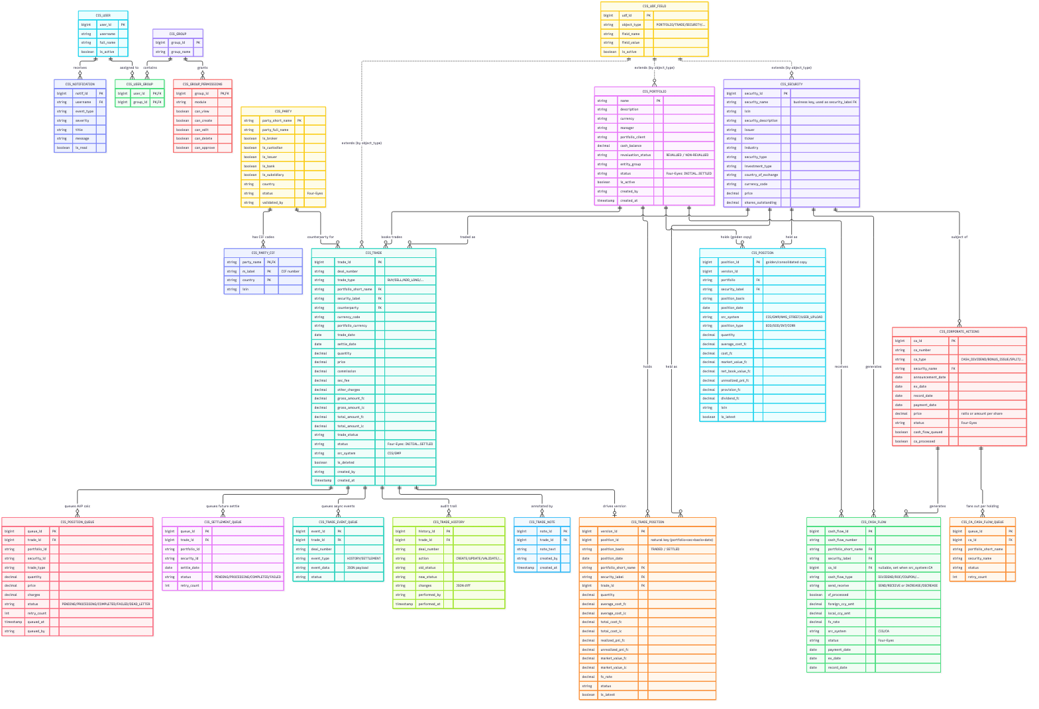
er_diagram.png

Notes for reviewers
- Versioned tables (cis_trade_position, cis_trade_history): Kudu is append/upsert-only, so these tables model change-over-time via a version_id/is_latest pattern rather than in-place UPDATE.
- Dual-write pattern: every CIS-originated position change lands in both cis_trade_position (versioned working ledger, CIS-only) and cis_position (golden/consolidated copy merging CIS, GMP, AMS_STREET and USER_UPLOAD sources) — the two are kept in sync by the service layer, not by the database.
- Four-Eyes status appears on cis_portfolio, cis_trade, cis_cash_flow, and cis_corporate_actions: INITIAL → MODIFIED → PENDING_VALIDATION → VALIDATED/CANCELLED → SETTLED.
- UDF (User-Defined Fields) is a generic key/value extension table keyed by object_type, not a physical foreign key — it can extend Portfolio, Trade, or Security records without schema changes.

CIS Trade Hive — Class Diagram
System Design Document (SDM) artifact. Reflects the SOLID layering used throughout cis_trade_hive/: Views → Services → Repositories → ImpalaConnectionManager (Kudu/Impala). Diagram groups classes by Django app; cross-app dependencies are shown explicitly.
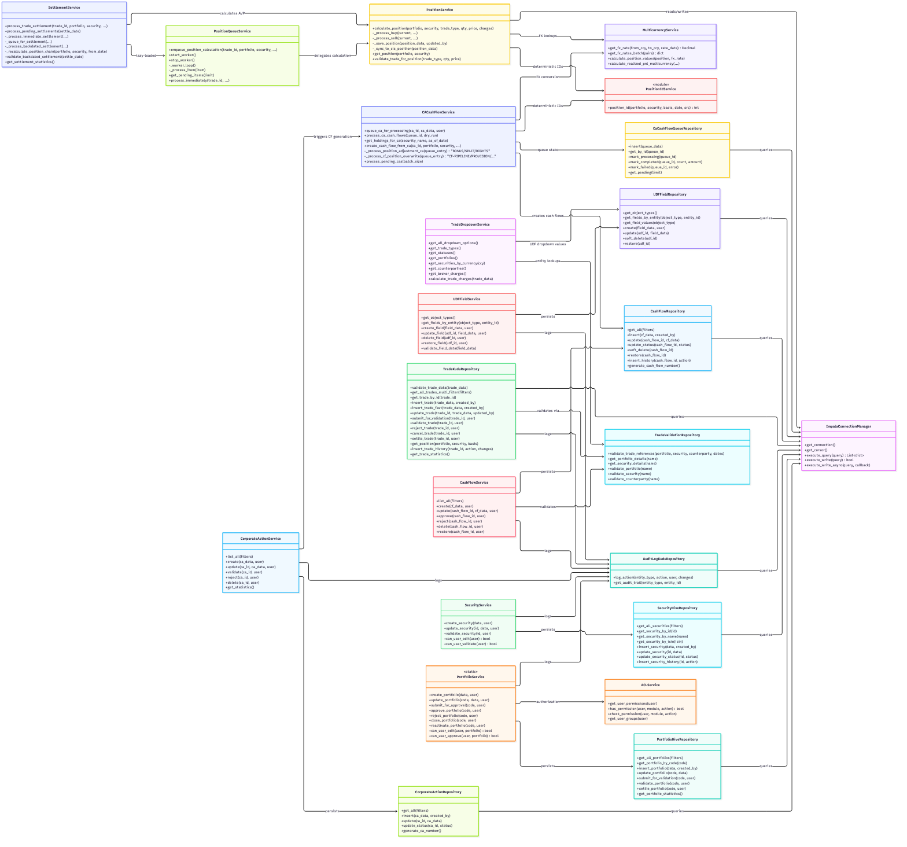
class_diagram.png

Layering conventions
Layer | Responsibility | Naming
Views (not shown) | HTTP request/response, form handling, template context | views.py
Services | Business logic, workflow rules (Four-Eyes), cross-entity orchestration | *_service.py
Repositories | Raw Kudu/Impala SQL construction and execution | *_kudu_repository.py / *_hive_repository.py
Connection Manager | Pooled Impala connections, query caching, async writes | core/repositories/impala_connection.py
- Repositories never call other repositories directly; cross-entity reads (e.g. TradeKuduRepository needing portfolio currency) go through TradeValidationRepository or a direct scoped query — kept intentionally thin.
- Services may call sibling services (e.g. CorporateActionService → CACashFlowService), but always within the same request/transaction boundary — there is no distributed transaction coordinator; Kudu writes are idempotent (UPSERT) by design to tolerate partial failure and retry.
- edge_jobs_py36/ (not shown above) is a parallel, Django-free fork of the Service/Repository classes with the same responsibilities, used by scripts running on an older Python 3.6 cluster runtime — see cis_trade_hive/CLAUDE.md.

