SVKM's NMIMS
Mukesh Patel School of Technology Management & Engineering
A Mini Project Report on
IoT-Enabled Distributed SCADA & Machine Learning-Based Predictive Anomaly Detection for Multi-Process Industrial Systems
Submitted for the subject
Supervisory Control and Data Acquisition (SCADA)
Submitted by
Eklavya Vaid (B117), B.Tech (Computer Engineering)
Arka Dhamani (A103), B.Tech (Information Technology)
Krishna Solanki (I075), MBA Tech (Information Technology)

Under the guidance of
Dr. Dattatray Sawant
Semester V | Academic Year 2026-2027

CERTIFICATE
This is to certify that the mini project entitled "IoT-Enabled Distributed SCADA & Machine Learning-Based Predictive Anomaly Detection for Multi-Process Industrial Systems" has been carried out by the following students of Semester V for the subject Supervisory Control and Data Acquisition (SCADA) at Mukesh Patel School of Technology Management & Engineering, SVKM's NMIMS, during the academic year 2026-2027, under my supervision.
- Eklavya Vaid (B117), B.Tech (Computer Engineering)
- Arka Dhamani (A103), B.Tech (Information Technology)
- Krishna Solanki (I075), MBA Tech (Information Technology)

Dr. Dattatray Sawant (Project Guide) | Head of Department
Signature: ____________________ | Signature: ____________________
[TO ADD] Date | [TO ADD] Date

ACKNOWLEDGEMENT
We express our sincere gratitude to our guide, Dr. Dattatray Sawant, for his guidance, encouragement and technical insight throughout this mini project. His feedback on industrial control practice shaped both the safety design and the scope of the system.
We thank the faculty and laboratory staff of Mukesh Patel School of Technology Management & Engineering for access to laboratory resources and LabVIEW, and our peers for their suggestions during reviews. Finally, we thank our families for their constant support.
[TO ADD] Add or edit any further acknowledgements.

ABSTRACT
Industrial process plants depend on Supervisory Control and Data Acquisition (SCADA) systems to monitor sensors, drive actuators and protect equipment. Conventional SCADA installations rely on fixed alarm thresholds, which react only after a limit is crossed and cannot recognise developing faults such as a pump running dry or a stuck relay while every individual reading is still in range.
This project designs and implements a four-layer, low-cost SCADA system for a water-tank process with gas and thermal hazards. An ESP32 edge node acquires tank level (HC-SR04), process temperature (DS18B20), combustible gas (MQ-2), pump current (ACS712), ambient conditions (BME280) and supply voltage, enforces fail-safe interlocks locally and exposes the plant over Modbus TCP. LabVIEW acts as the supervisory SCADA layer, and a Python FastAPI bridge validates telemetry, applies deterministic safety rules and hosts an advisory machine-learning engine. A React and Three.js web HMI provides a 3D digital twin of the rig, live predictions and alert notifications.
The machine-learning layer combines a per-mode robust covariance envelope with an Isolation Forest for anomaly detection, a Random Forest that classifies nine operating conditions, a Gradient Boosting regressor for pump health, a temperature- and humidity-compensated MQ-2 calibration model and a linear trend forecaster. Because no public dataset matches the rig, the models are trained on a datasheet-grounded plant simulator. On held-out simulated episodes the fault classifier reaches 96.0% accuracy (96.3% for the physical-rig profile), and gas compensation reduces the MQ-2 concentration error from 33.7% to 5.9%. All detections raise debounced alerts that are logged and displayed, while actuator control remains purely rule-based. The software stack and firmware are complete and tested; final hardware wiring and on-rig validation are in progress.
Keywords: SCADA, ESP32, Modbus TCP, LabVIEW, digital twin, anomaly detection, Isolation Forest, Random Forest, predictive maintenance, Industry 4.0.

TABLE OF CONTENTS
1. Introduction 7
1.1 Background 7
1.2 Problem Statement 7
1.3 Aim and Objectives 7
1.4 Scope 8
1.5 Organisation of the Report 8
2. Literature Review and Technology Background 9
2.1 SCADA Architecture 9
2.2 Modbus TCP 9
2.3 LabVIEW for Supervisory Control 9
2.4 Machine Learning for Condition Monitoring 9
2.5 Gas Sensor Calibration 10
2.6 Digital Twins 10
3. System Architecture 11
3.1 Data Flow 11
3.2 Safety Philosophy 12
4. Hardware Design 13
4.1 Components 13
4.2 ESP32 Pin Allocation 14
4.3 Power Distribution and Signal Conditioning 15
4.4 Wiring Status 15
4.5 Pending Final Configuration 16
5. Firmware Design 18
5.1 Overview 18
5.2 Sensor Processing 18
5.3 Modbus Register Map 18
5.4 Interlocks 19
5.5 Build Results 19
6. Supervisory Layer: LabVIEW and Python Bridge 20
6.1 LabVIEW SCADA Application 20
6.2 Python FastAPI Bridge 21
7. Predictive Analytics and Machine Learning 22
7.1 Design Principles 22
7.2 Training Data 22
7.3 Models 22
7.4 Alerting and Logging 23
8. Web HMI and Digital Twin 24
9. Testing and Results 26
9.1 Software Verification 26
9.2 Model Evaluation 26
9.3 End-to-End Test with the LabVIEW Feeder Simulator 29
9.4 Hardware Validation 29
10. Conclusion and Future Scope 31
10.1 Conclusion 31
10.2 Future Scope 31
References 32
Appendix A: Team Contributions 33
Appendix B: Running the System 34

1. Introduction

1.1 Background
Supervisory Control and Data Acquisition (SCADA) systems sit above the field instrumentation of a plant: remote terminal units (RTUs) or programmable controllers read sensors and drive actuators, while a supervisory station collects data, raises alarms and lets operators issue commands. Industry 4.0 extends this model with low-cost networked edge devices, open protocols, web-based human-machine interfaces (HMIs) and data-driven analytics that predict failures instead of only reacting to them.
Most alarm logic in small and medium plants is still a set of fixed thresholds. Thresholds are essential for safety, because they are deterministic and easy to verify, but they are blind to faults that develop while every reading is still within limits. A pump that loses prime keeps drawing current while the tank stops filling; a relay that welds shut keeps a pump running after it was commanded off. Detecting such conditions early requires models that understand how the plant normally behaves.

1.2 Problem Statement
To design a low-cost, distributed SCADA system for a multi-hazard process (liquid level, temperature, combustible gas and pump drive) that (i) keeps the plant safe through deterministic, verifiable interlocks at both the edge and the supervisory level, and (ii) adds an advisory machine-learning layer that detects anomalies, diagnoses faults, estimates pump health and forecasts limit violations before they occur, without ever giving the models direct control of actuators.

1.3 Aim and Objectives
The aim of the project is to build and validate an Industry 4.0 SCADA testbed that combines an ESP32 edge node, LabVIEW supervision, a Python intelligence layer and a web-based digital twin. The objectives are:
- Implement an ESP32 edge node that acquires six sensor channels, drives three actuators and serves its data over Modbus TCP.
- Enforce fail-safe safety interlocks locally on the ESP32 and again in the supervisory bridge.
- Develop a LabVIEW supervisory application that polls the node, scales the data and forwards it to the intelligence layer.
- Develop a FastAPI bridge that validates telemetry, applies rule-based safety states and runs advisory ML models.
- Train models for anomaly detection, fault classification, pump health and gas-sensor calibration, and evaluate them quantitatively.
- Provide a web HMI with a 3D digital twin, predictive analytics and alert notifications, and log every detection.

1.4 Scope
The original proposal envisaged three wireless ESP32 nodes (process plant, gas and fire safety, and electrical load). During implementation the design was consolidated into a single, fully instrumented process node so that every layer could be completed and tested end to end; the software architecture supports additional nodes without change. The physical rig uses a dual half-breadboard chassis, a submersible pump, a normally closed drain solenoid valve and an exhaust fan.

1.5 Organisation of the Report
Chapter 2 reviews the underlying technologies. Chapter 3 presents the system architecture. Chapters 4 and 5 describe the hardware and the ESP32 firmware. Chapter 6 covers the LabVIEW supervisory layer and the Python bridge, and Chapter 7 the machine-learning layer. Chapter 8 describes the web HMI and digital twin. Chapter 9 reports test results, and Chapter 10 concludes with future work.

2. Literature Review and Technology Background

2.1 SCADA Architecture
A SCADA system is commonly described in layers: field devices (sensors and actuators), controllers (RTUs or PLCs) that execute local logic, a communication network, and a supervisory layer with HMI, alarm management and historian functions. Guidance for operational-technology systems such as NIST SP 800-82 emphasises that safety functions must remain deterministic and independent of higher-level software, which motivates keeping interlocks in the controller and treating analytics as advisory.

2.2 Modbus TCP
Modbus is an open, request-response application protocol that exposes coils (single-bit read/write values) and holding registers (16-bit values). Modbus TCP carries the same protocol data units over Ethernet or Wi-Fi on TCP port 502. Its simplicity and broad support in LabVIEW, PLCs and HMI software make it a natural choice for a low-cost edge node.

2.3 LabVIEW for Supervisory Control
NI LabVIEW is a graphical programming environment widely used for data acquisition and control. Its front panel forms the operator interface, while the block diagram implements polling loops, scaling, alarm logic and communication. The NI Modbus library provides Modbus TCP master functions, and the built-in HTTP client and JSON functions allow LabVIEW to exchange data with web services.

2.4 Machine Learning for Condition Monitoring
Anomaly detection learns the normal operating region from healthy data and flags departures from it. The Isolation Forest isolates observations with random axis-aligned splits; anomalies need fewer splits and therefore receive shorter average path lengths. Robust covariance (minimum covariance determinant) estimators instead fit an elliptical envelope and score observations by Mahalanobis distance. For supervised diagnosis, Random Forests (ensembles of decision trees on bootstrapped samples) are robust to noisy features and give class probabilities, and Gradient Boosting builds additive regression trees that suit smooth targets such as a health index.

2.5 Gas Sensor Calibration
The MQ-2 is a tin-dioxide (SnO2) semiconductor sensor whose resistance Rs falls as the concentration of combustible gas rises. Concentration is estimated from the ratio Rs/R0, where R0 is the resistance in clean air, using the log-log sensitivity curve in the Hanwei datasheet. The same datasheet shows that Rs also depends on temperature and humidity, so readings drift with ambient conditions unless they are compensated.

2.6 Digital Twins
A digital twin is a software model of a physical asset that mirrors its state and can be used to test control logic and analytics before deployment. In this project a 3D web workbench reproduces the rig, its wiring and its firmware behaviour, and a plant simulator generates labelled training data for the machine-learning models.

3. System Architecture
The system is organised in four layers, shown in the figure below. Each layer can be developed and tested in isolation: the ESP32 can be simulated in Wokwi, LabVIEW can be replaced by a feeder simulator, and the web HMI includes a full digital twin of the rig.
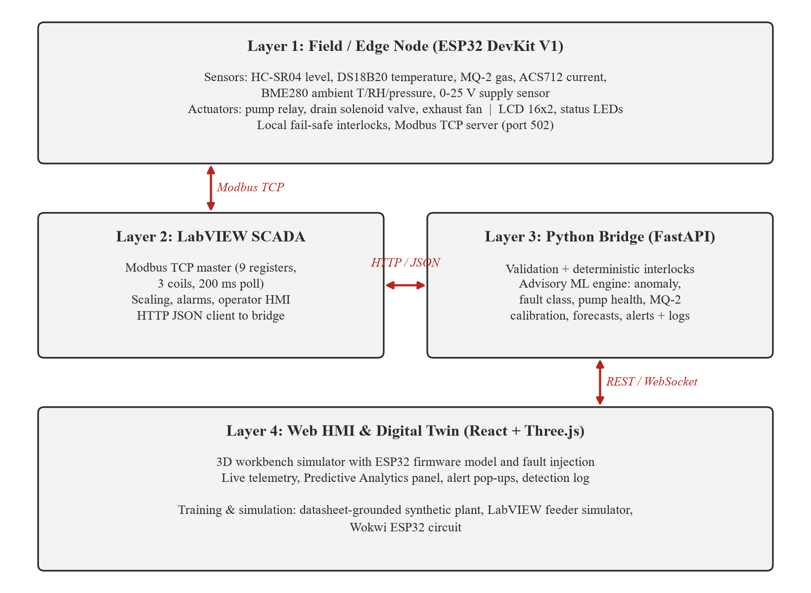
Figure 1: Four-layer system architecture

3.1 Data Flow
- The ESP32 samples every sensor, applies local interlocks and updates nine Modbus holding registers and three coils.
- LabVIEW polls the registers over Modbus TCP, converts them to engineering units and posts a JSON telemetry packet to the bridge.
- The bridge validates the packet, computes the rule-based safety state, runs the advisory ML engine, logs the sample and returns actuator commands with any interlock overrides.
- LabVIEW writes the returned actuator commands to the ESP32 coils; the ESP32 still applies its own interlocks before driving outputs.
- The web HMI polls the bridge for predictions and alerts and shows them to the operator.

3.2 Safety Philosophy
Safety is enforced in two independent places, the ESP32 firmware and the bridge, using identical fixed thresholds. Machine-learning outputs are advisory only: they raise alerts and append advice to the operator message but are never connected to an actuator. If a model is wrong, missing or untrained, the plant remains protected by the deterministic rules.

4. Hardware Design

4.1 Components
The table below lists the components of the as-built rig, and the figure after it shows the actual parts used.
Table 1: Bill of materials of the as-built rig
Component | Specification | Interface | Role
ESP32 DevKit V1 | 30-pin ESP-WROOM-32, dual core, Wi-Fi | 5 V VIN, 3.3 V logic | Edge controller, Modbus TCP server
HC-SR04 | Ultrasonic ranging, 2-400 cm | TRIG GPIO 25, ECHO GPIO 34 via 1 k/1.5 k divider | Tank level
DS18B20 | Waterproof probe, -55 to 125 °C, 12-bit | 1-Wire GPIO 4, 4.7 kΩ pull-up | Process temperature
MQ-2 | SnO2 combustible gas / smoke sensor | AO to GPIO 32 via divider | Gas leak detection
ACS712-05B | Hall-effect current sensor, ±5 A, 185 mV/A | OUT to GPIO 33 | Pump current, motor health
GY-BME280 | Temperature, humidity, pressure | I2C SDA 21 / SCL 22 | Ambient conditions, gas compensation
Voltage sensor | 0-25 V resistive divider module (5:1) | S to GPIO 35 | Supply voltage monitoring
Relay module | 5 V, opto-isolated, 10 A contacts | IN GPIO 26 | Pump switching
Submersible pump | 12 V / 5 V DC mini centrifugal | Relay contacts | Tank inflow
Solenoid valve | 12 V DC, normally closed | Driver on GPIO 27 | Emergency drain
Exhaust fan | 12 V DC, 40 × 40 × 10 mm | Driver on GPIO 14 | Gas dispersion, cooling
LCD 16 × 2 | HD44780 with PCF8574 I2C backpack (0x27) | I2C SDA 21 / SCL 22 | Local operator display
Status LEDs | Green and red 5 mm with series resistors | GPIO 23 / GPIO 13 | Healthy / alarm indication
Power supplies | 5 V 2 A (logic) and 12 V 2-3 A (actuators) | Separate rails, common ground | Power distribution

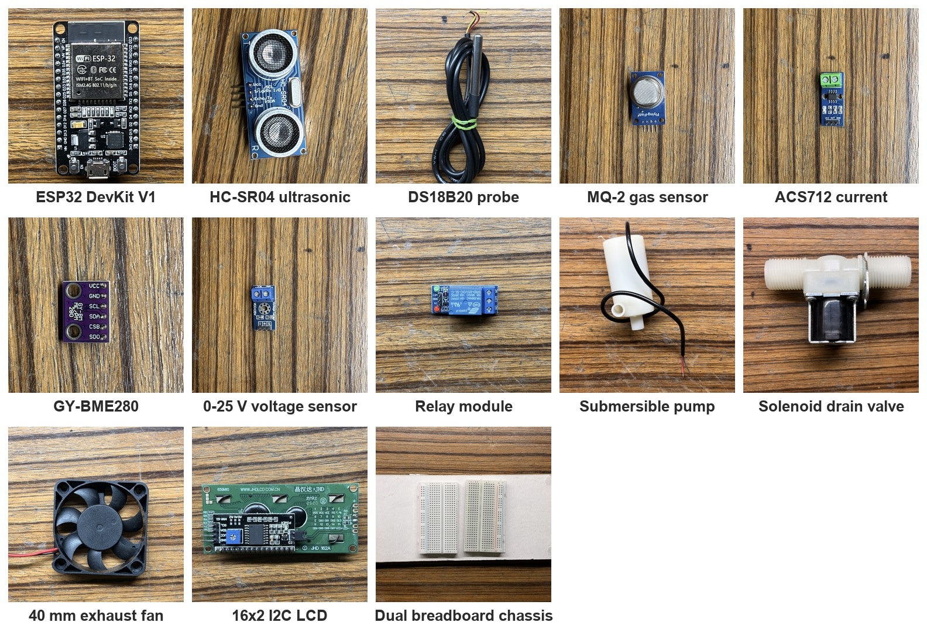
Figure 2: Components used in the hardware

4.2 ESP32 Pin Allocation
The ESP32 is mounted across two half-size breadboards. Boot-strapping pins (GPIO 2, 12 and 15) and the UART0 programming pins are deliberately left unconnected to avoid boot failures; the status LEDs were moved to GPIO 23 and GPIO 13 for this reason. Input-only pins (GPIO 34, 35) are used for the echo and voltage inputs.
Table 2: ESP32 pin allocation
GPIO | Direction | Connected to | Notes
34 | Input | HC-SR04 ECHO | Through 1.0 kΩ / 1.5 kΩ divider (5 V to 3.0 V)
25 | Output | HC-SR04 TRIG | 10 µs trigger pulse
4 | Bidirectional | DS18B20 DATA | 4.7 kΩ pull-up to 3.3 V
32 | Analog in (ADC1) | MQ-2 AO | Through resistive divider
33 | Analog in (ADC1) | ACS712 OUT | Zero offset calibrated at boot
35 | Analog in (ADC1) | 0-25 V sensor S | 5:1 module ratio
21 / 22 | I2C | LCD and BME280 | Shared bus, addresses 0x27 and 0x76/0x77
26 | Output | Pump relay IN | Relay channel 1
27 | Output | Drain valve driver | Normally closed solenoid
14 | Output | Exhaust fan driver | 12 V fan
23 / 13 | Output | Green / red LED | Healthy / alarm
2, 12, 15, TX0, RX0 | Not used | Protected | Boot strapping and USB programming

4.3 Power Distribution and Signal Conditioning
The rig uses two supplies with a common ground: a 5 V rail (ESP32 VIN, HC-SR04, MQ-2 heater, ACS712, relay and LCD) and a 12 V actuator rail for the pump, solenoid valve and fan, so that inductive loads cannot brown out the controller. The 3.3 V regulator output of the ESP32 feeds the BME280 and DS18B20. Every 5 V signal that reaches an ESP32 pin passes through a resistive divider, and flyback diodes clamp the inductive kick of the valve and fan coils.

4.4 Wiring Status
The table below summarises the current state of the physical wiring, taken from the project hardware tracker.
Table 3: Hardware wiring status
Subsystem | Status
5 V, 3.3 V and ground rails, 12 V barrel jack | Verified
HC-SR04 ultrasonic sensor and echo divider | Verified
MQ-2 gas sensor and divider | Verified
GY-BME280 (I2C) | Verified
0-25 V voltage sensor | Verified
16 × 2 I2C LCD | Verified
ACS712 current sensor | Verified
Pump relay (channel 1) and status LEDs | Verified
DS18B20 probe | Soldered, ready to plug in; 4.7 kΩ pull-up pending
Drain valve and exhaust fan drivers | Pins allocated; final wiring pending

[TO ADD] Insert photograph of the fully assembled hardware rig
Figure 3: Assembled hardware rig
[TO ADD] Insert close-up photograph of the ESP32 breadboard wiring
Figure 4: ESP32 and breadboard wiring

4.5 Pending Final Configuration
The following items must be completed and recorded before on-rig validation. They are marked here so that the measured values can be added to this report.
Table 4: Final configuration checklist
Item | Action required | Value / result
DS18B20 pull-up | Insert the 4.7 kΩ resistor between GPIO 4 and 3.3 V | [TO ADD] Done / date
Valve and fan drivers | Confirm relay channel or MOSFET module and wire IN2 / IN3 | [TO ADD] Driver used
MQ-2 divider ratio | Confirm resistor values and set MQ2_DIVIDER_RATIO | [TO ADD] Ratio
ACS712 output divider | Confirm whether a divider is fitted and set ACS712_DIVIDER_RATIO | [TO ADD] Ratio
MQ-2 load resistor | Read the module resistor (102 = 1 kΩ) and set MQ2_RL_KOHM | [TO ADD] RL (kΩ)
MQ-2 clean-air R0 | Copy the serial "R0 estimate" after warm-up into MQ2_R0_KOHM | [TO ADD] R0 (kΩ)
Tank depth | Measure sensor face to empty-tank bottom and set TANK_DEPTH_CM | [TO ADD] Depth (cm)
BME280 chip | Confirm BME280 (not BMP280) from the serial boot log | [TO ADD] Chip ID
Wi-Fi | Create src/secrets.h with the plant network credentials | [TO ADD] Node IP address

5. Firmware Design

5.1 Overview
The ESP32 firmware is written in C++ on the Arduino framework and built with PlatformIO. A separate Wokwi build replaces the current sensor with a potentiometer and skips the gas-sensor warm-up so that the same code runs in the Wokwi simulator. The main loop services Modbus requests, acquires all sensors, evaluates the interlocks, drives the outputs, updates the Modbus image and refreshes the LCD every 500 ms.

5.2 Sensor Processing
- Level: HC-SR04 echo time is converted to distance (0.0343 cm/µs ÷ 2) and then to percentage of tank depth; an echo timeout is reported as a sensor fault rather than an empty tank.
- Temperature: DS18B20 conversions run non-blocking (750 ms at 12 bit), so Modbus requests are answered while a conversion is in progress.
- Current: ACS712 output is converted as (V - V0) / 185 mV/A, where the zero offset V0 is measured at boot with the pump relay open. An output below 1.5 V indicates a disconnected sensor.
- Gas: MQ-2 output gives Rs = RL·(Vc - Vout)/Vout; concentration follows the datasheet LPG curve ppm = 574.25·(Rs/R0)^-2.222. Readings are treated as invalid during a 2-minute heater warm-up.
- Ambient and supply: the BME280 is detected automatically at 0x76 or 0x77 (a BMP280 is reported on the serial log), and the supply voltage is read through the 5:1 module.

5.3 Modbus Register Map
Table 5: Modbus TCP map (port 502, unit ID 1)
Address | Type | Value | Scaling
40001 | Holding register | Tank level | ÷10 → %
40002 | Holding register (signed) | Process temperature | ÷10 → °C
40003 | Holding register | Gas concentration | ×1 → ppm
40004 | Holding register | Pump current | ÷100 → A
40005 | Holding register (signed) | Ambient temperature (BME280) | ÷10 → °C
40006 | Holding register | Relative humidity (BME280) | ÷10 → %RH
40007 | Holding register | Pressure (BME280) | ÷10 → hPa
40008 | Holding register | Supply voltage | ÷100 → V
40009 | Holding register | MQ-2 output at sensor | ×1 → mV
00001-00003 | Coils | Pump, drain valve, exhaust fan | Boolean

A register value of 32767 (0x7FFF) is written whenever its sensor is faulty, missing or warming up. The value lies outside every engineering range for both signed and unsigned reads, so the bridge rejects it instead of mistaking it for a real reading.

5.4 Interlocks
Table 6: Firmware safety interlocks
Condition | Firmware action | Indication
Tank ≥ 88 %, gas ≥ 250 ppm, temperature ≥ 70 °C or current ≥ 3.8 A | Master trip: pump off; drain valve opened on overflow | Red LED strobes
Any core sensor faulty or MQ-2 warming up | Fail-safe: pump off; fan on while gas is unknown | Red LED solid
Gas > 80 ppm | Exhaust fan on (off again below 45 ppm) | LCD shows gas
Tank ≤ 25 % with all sensors healthy | Auto refill: pump on, valve closed | Green LED

5.5 Build Results
Both PlatformIO environments (physical board and Wokwi) compile without warnings from the project source. The physical-board image uses 14.9 % of RAM (48.9 kB of 327.7 kB) and 81.7 % of flash (1.07 MB of 1.31 MB).
[TO ADD] Add the serial monitor boot log from the physical board (Wi-Fi IP, ACS712 zero offset, BME280 detection, MQ-2 R0 estimate).

6. Supervisory Layer: LabVIEW and Python Bridge

6.1 LabVIEW SCADA Application
LabVIEW acts as the Modbus TCP master. In each cycle (200 ms recommended) it reads nine holding registers and three coils, converts the raw values to engineering units (reading registers 40002 and 40005 as signed integers), bundles them into a telemetry cluster, flattens the cluster to JSON and posts it to the bridge. The returned actuator commands are written back to the ESP32 coils.
Table 7: VIs used in the LabVIEW application
VI / toolkit | Used for
NI Modbus Library | Modbus TCP master session; read holding registers and coils, write coils
LabVIEW HTTP Client (POST) | Sends the JSON telemetry packet to the bridge and receives commands
Flatten / Unflatten From JSON | Converts the telemetry cluster to JSON and parses the bridge response
JKI Flat UI Controls | Modern front-panel indicators, gauges and switches
Waveform charts and Boolean indicators | Live trends, alarm lamps and actuator state on the front panel

[TO ADD] Confirm or edit the VI list against the final SCADA_Master_Controller.vi.
[TO ADD] Insert screenshot of the LabVIEW front panel
Figure 5: LabVIEW front panel
[TO ADD] Insert screenshot of the LabVIEW block diagram
Figure 6: LabVIEW block diagram

6.2 Python FastAPI Bridge
The bridge accepts telemetry from LabVIEW over HTTP or WebSocket. It rejects malformed packets, unknown fields and out-of-range readings; invalid telemetry immediately sets the state to UNKNOWN, which inhibits the pump and runs the exhaust fan. Valid telemetry is classified as HEALTHY, WARNING or CRITICAL TRIP using the same thresholds as the firmware, and interlocks override any conflicting operator command. Optional auxiliary readings (BME280, supply voltage, raw MQ-2 output) feed the ML layer only, so a missing ambient sensor never invalidates the plant data.
Table 8: Bridge API
Endpoint | Purpose
POST /api/telemetry | Ingest a telemetry packet from LabVIEW; returns health state and actuator commands
GET /api/telemetry | Latest plant state including predictions and active alerts
POST /api/control | Operator actuator command, subject to interlocks
GET /api/predictions | Current ML predictions, active alerts and model status
GET /api/alerts | Active alerts and the recent detection event history
WS /ws/telemetry | Bidirectional telemetry stream for live clients

The response returned to LabVIEW keeps a fixed schema (status class, health label, recommendation, data-valid flag and actuator commands), so the LabVIEW VI does not need to change when models are added. ML advice is appended to the recommendation text.

7. Predictive Analytics and Machine Learning

7.1 Design Principles
- Advisory only: no model output reaches an actuator; safety remains rule-based.
- Works without models: forecasts and datasheet gas compensation run even before any training.
- Every detection is debounced, alerted and logged so that operators and the report have an audit trail.

7.2 Training Data
No public dataset matches this rig, so the models are trained on a plant simulator whose physics and noise come from the component datasheets: ACS712-05B sensitivity and noise, DS18B20 resolution, HC-SR04 ranging accuracy, the MQ-2 sensitivity curve and its temperature/humidity dependence (an approximate reading of the datasheet figure). Each simulated episode runs the fill/drain control loop with randomised plant parameters, optional pump wear and one of eight injected faults. A fault changes the physics only in the operating mode where it is physically observable (for example a dry run only while the pump runs), and samples are labelled accordingly.
Two plant profiles are trained. The sim profile matches the 3D digital twin and the LabVIEW feeder simulator (about 1.6 A pump current); the rig profile matches the physical bill of materials, whose mini centrifugal pump draws about 0.1-0.5 A. Logged telemetry from the real rig can be added to the training set to adapt the models to the actual tank and pump.

7.3 Models
Table 9: Machine-learning models
Function | Algorithm | Inputs | Output
Anomaly detection | Robust covariance envelope per operating mode + Isolation Forest | Pump current and smoothed tank/temperature rates; all eight process signals | Anomaly scores and flag
Fault classification | Random Forest (150 trees) | Statistics of a 24-sample window (means, slopes, current ripple, actuator duty) | One of nine classes with confidence
Pump health | Gradient Boosting regressor | Current mean and ripple, fill rate, fill per ampere, supply voltage | Health index 0-100
MQ-2 calibration | Gradient Boosting regressor (datasheet fallback) | log(Rs/R0), ambient temperature, humidity | Compensated ppm
Forecasting | Least-squares linear trend | Last ~60 samples of level, temperature and gas | Value in 60 s, time to warning/trip limits

The Isolation Forest was evaluated first as the sole anomaly detector but missed most faults: its random splits are bounded by the training data, so a reading far beyond the normal range (for example pump current with the pump commanded off) is not isolated faster than an extreme normal reading. The per-mode envelope measures distance from normal behaviour in each mode and detects these faults reliably, so the two are combined: the envelope catches out-of-range dynamics, and the forest acts as a second opinion on unusual combinations of in-range readings.

7.4 Alerting and Logging
Each detection becomes an alert after four consecutive positive samples (immediately for safety trips and invalid telemetry) and clears after eight negative samples, which suppresses single noisy readings. Alert sources are: anomalies, fault classes with at least 60 % confidence, pump health below 40 %, forecast trip times under 120 s once a warning limit is crossed, rule-based warnings and trips, and invalid telemetry. Every raise and clear event is written to an event log (events.csv), every sample with its predictions to a telemetry history (telemetry_log.csv), and alerts are shown in the web HMI and appended to the message returned to LabVIEW.

8. Web HMI and Digital Twin
The web HMI is a React single-page application built with Vite and Three.js. Its 3D workbench reproduces the rig from CAD models of each component, including breadboard wiring with validation of every required connection, an ESP32 firmware model with a serial monitor, actuator effects and fault-injection controls (gas leak, overheating, cavitation and overflow). When the simulation runs, the workbench streams its telemetry to the bridge exactly as LabVIEW does.
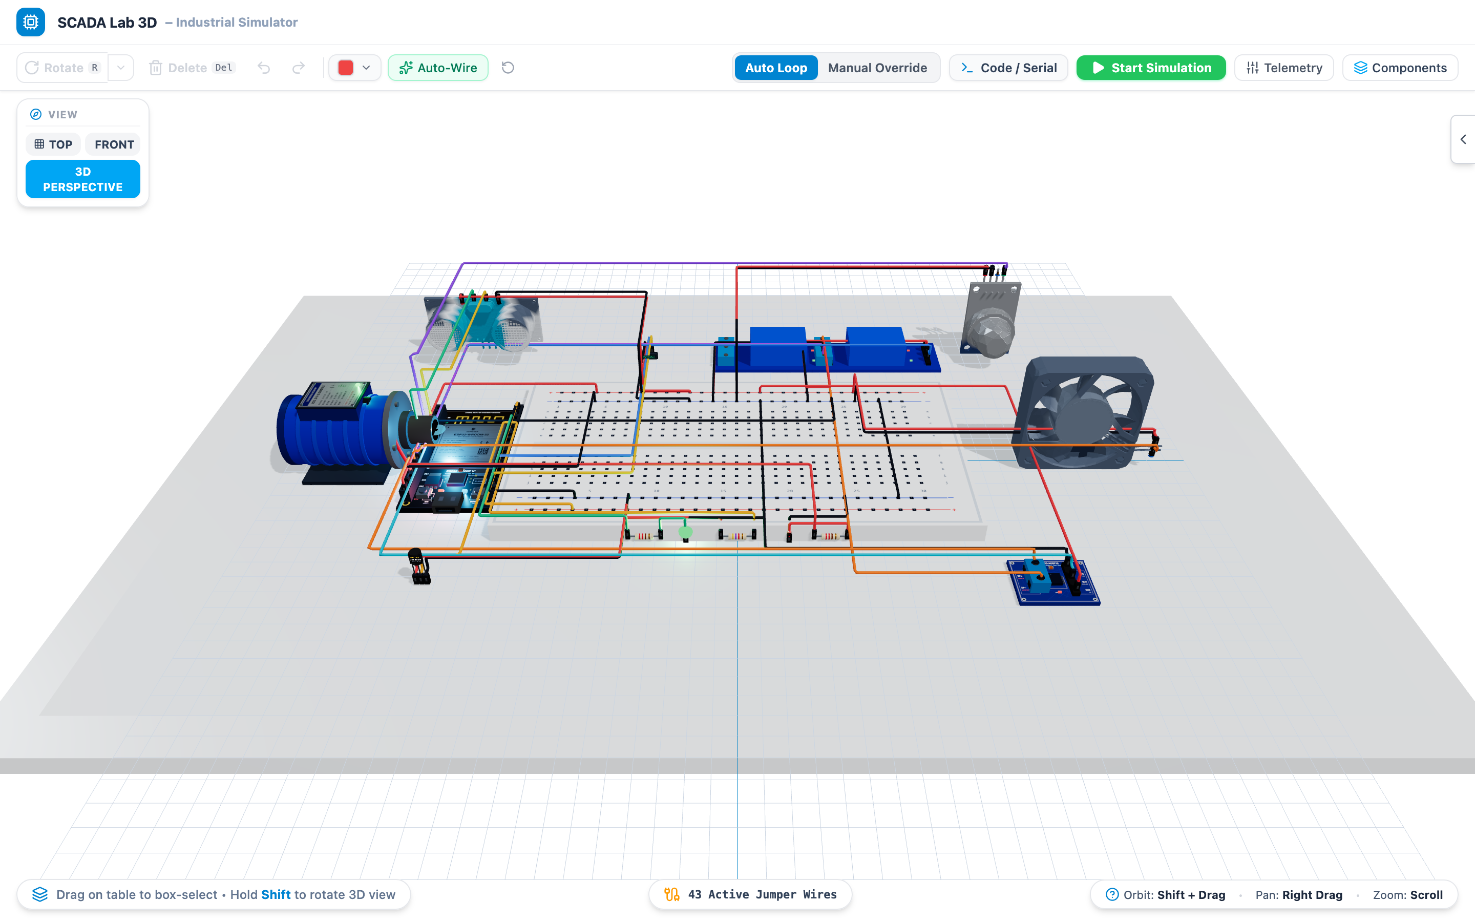
Figure 7: 3D digital twin of the SCADA rig
The Predict panel shows the live ML output: active alerts, anomaly scores from both detectors, the fault diagnosis with its top three probabilities, the pump health index, raw and compensated gas concentration, a 60-second forecast table with time-to-trip, and the detection log. New alerts also appear as pop-up notifications regardless of which panel is open, and the toolbar shows the number of active alerts.
[TO ADD] Insert screenshot of the Predict panel during a fault (e.g. feeder sim --fault dry_run)
Figure 8: Predictive Analytics panel

9. Testing and Results

9.1 Software Verification
Table 10: Software verification
Test | Result
Backend unit and integration tests (bridge, interlocks, ML engine, alerts, logging) | 15 / 15 passed
Frontend unit tests (circuit validator, safety controller, component dimensions) | 15 / 15 passed
Frontend production build and TypeScript type check | Passed
ESP32 firmware build, physical board and Wokwi environments | Passed

9.2 Model Evaluation
All models were evaluated on episodes generated with a different random seed from the training data. The following table and figure show the share of samples flagged by each anomaly detector for the sim profile.
Table 11: Anomaly detection rate by scenario (sim profile)
Scenario | Envelope | Isolation Forest | Combined
Normal (false alarms) | 1.5% | 0.2% | 1.6%
Gas leak | 0.7% | 0.7% | 1.3%
Overheating | 40.5% | 4.7% | 41.8%
Dry run | 95.6% | 0.0% | 95.6%
Line blockage | 63.9% | 0.0% | 63.9%
Motor overload | 99.9% | 0.1% | 99.9%
Tank leak | 99.9% | 0.0% | 99.9%
Stuck relay | 100.0% | 0.4% | 100.0%
Valve stuck | 0.7% | 0.1% | 0.7%

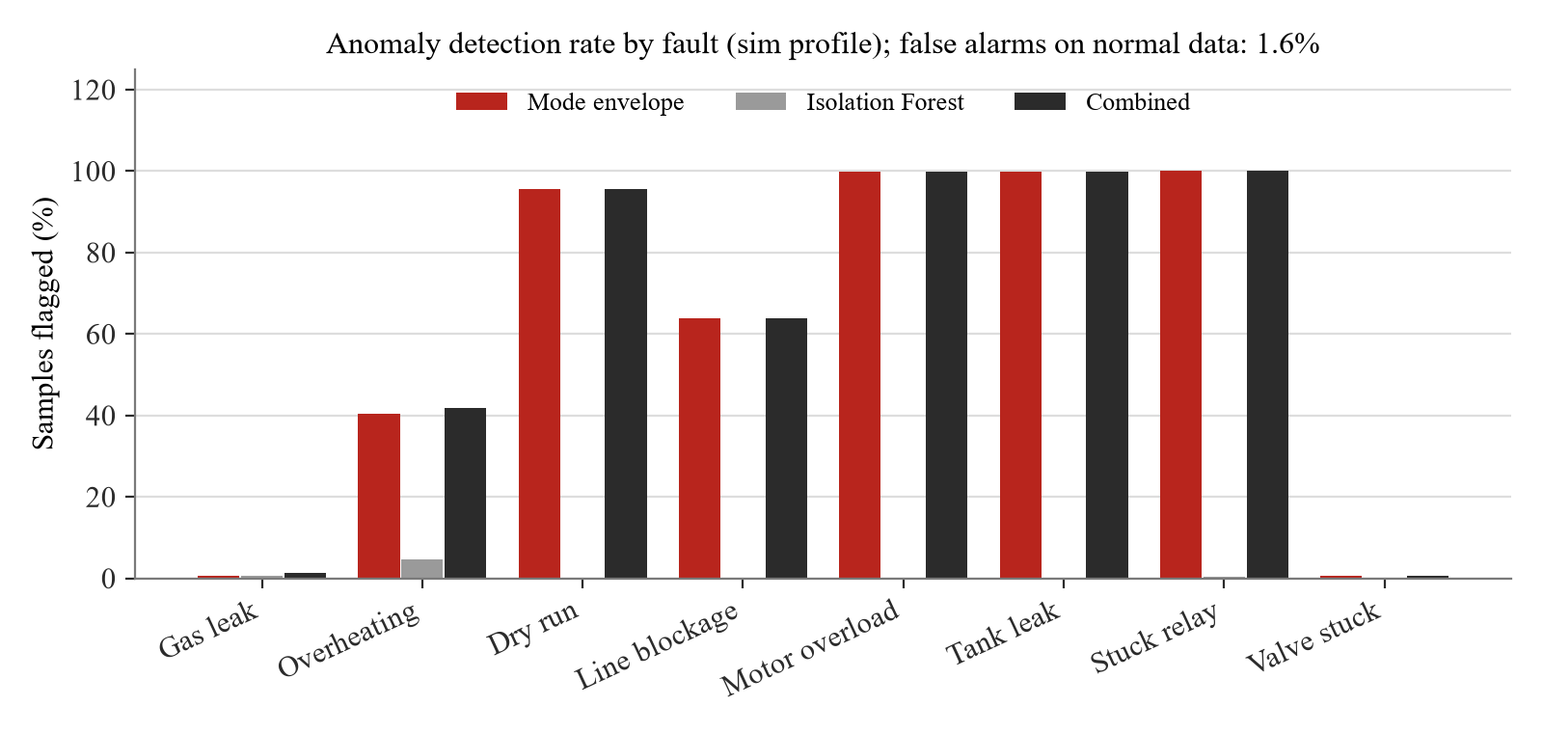
Figure 9: Anomaly detection rate by fault type
The envelope detects pump, relay and leak faults almost completely. Gas leaks and stuck drain valves are not visible in its features; they are covered by the fault classifier, the forecaster and the rule-based thresholds, which is why several complementary models are used.
Table 12: Fault classifier per-class results (accuracy: sim 96.0%, rig 96.3%)
Class | Sim precision | Sim recall | Rig precision | Rig recall
Normal | 0.95 | 0.98 | 0.96 | 0.99
Gas leak | 1.00 | 0.98 | 1.00 | 0.98
Overheating | 0.97 | 0.77 | 1.00 | 0.98
Dry run | 1.00 | 0.97 | 1.00 | 0.94
Line blockage | 0.96 | 0.94 | 0.92 | 0.91
Motor overload | 1.00 | 0.98 | 0.88 | 0.63
Tank leak | 0.84 | 0.91 | 0.92 | 0.96
Stuck relay | 1.00 | 0.99 | 1.00 | 0.98
Valve stuck | 0.98 | 0.97 | 0.94 | 0.92

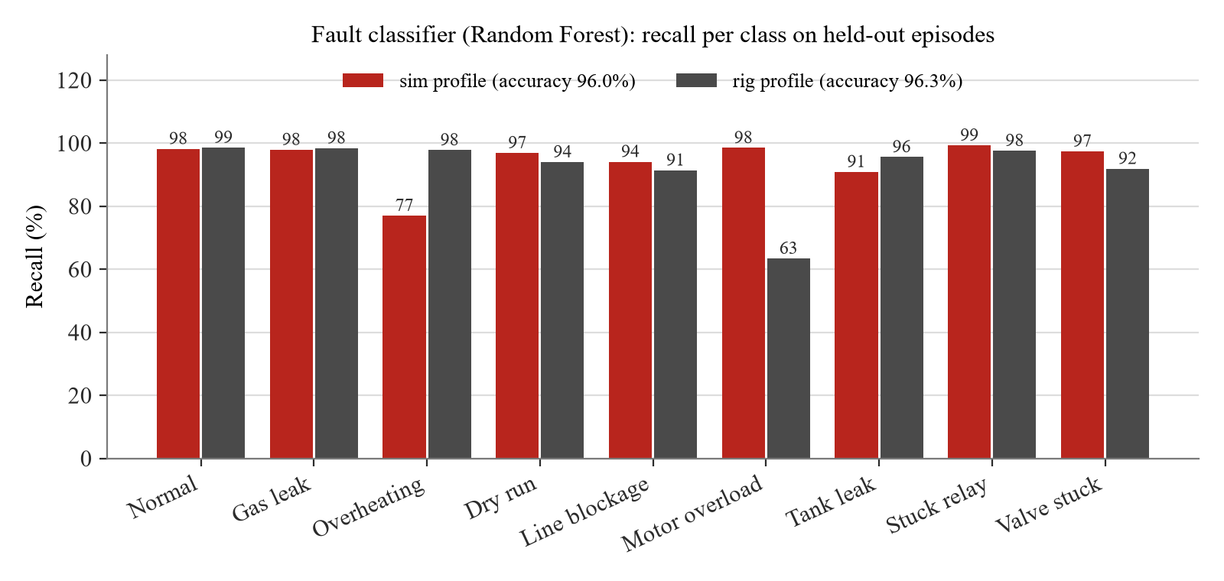
Figure 10: Fault classifier recall per class
Table 13: Pump health, false alarm and gas calibration results
Model | Metric | Sim | Rig
Pump health | Mean absolute error (health points, 0-100) | 11.6 | 19.3
Anomaly detection | False alarms per sample (combined) | 1.6% | 1.8%
MQ-2 calibration | Mean absolute % error, uncompensated → model | 33.7% → 5.9% | Same model

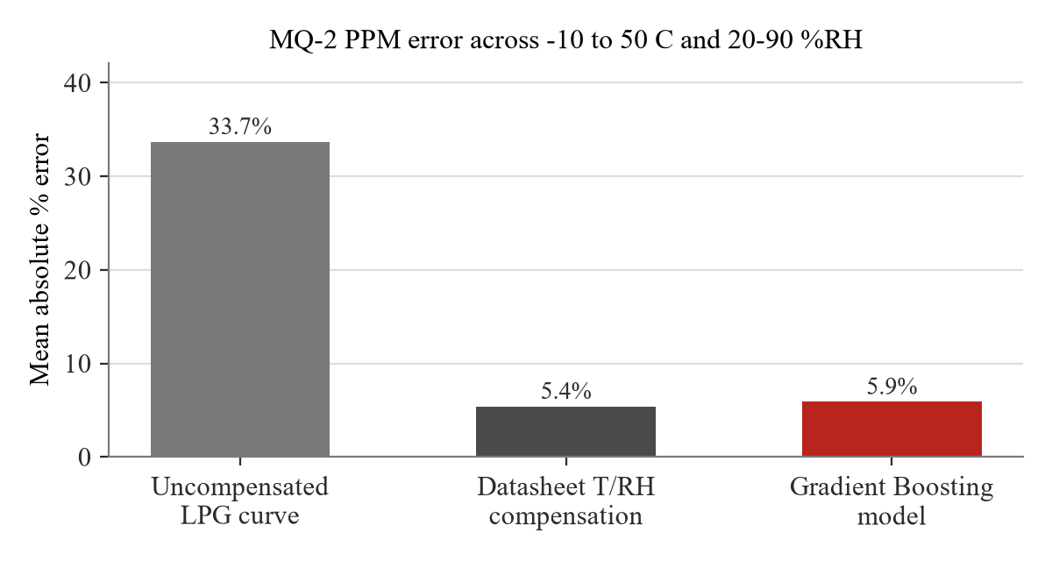
Figure 11: MQ-2 concentration error with and without compensation
Pump health is the least precise model (±12 points for sim, ±19 for rig) because a new weak pump and a worn strong pump can look alike without a plant-specific baseline. On the rig profile the envelope rarely flags dry runs because the unknown tank size forces wide training ranges; the classifier still detects them (94% recall). Both improve once the models are retrained on logged rig data. The learned gas model is marginally behind the analytic datasheet compensation (5.4%) because it has so far learned only that relationship; it becomes useful when trained on reference-meter readings.

9.3 End-to-End Test with the LabVIEW Feeder Simulator
The complete bridge was run with the LabVIEW feeder simulator, which streams telemetry at 4 Hz and injects faults on top of the normal fill/drain cycle.
Table 14: End-to-end results with the feeder simulator
Scenario | Detections raised | Outcome
Normal operation, 60 s | None | No false alerts
Dry run | Anomaly; fault: dry run (88 % confidence) | Detected
Gas leak | Forecast warning → rule warning → fault: gas leak (99 %) → safety trip | Detected before and at trip
Stuck relay | Fault: stuck relay; anomaly | Detected
Motor overload | Fault: motor overload; anomaly; pump health alert | Detected
Worn pump (90 % wear) | Pump health 12.9 %, SERVICE SOON | Detected (true health 10 %)

9.4 Hardware Validation
The following tests will be carried out on the physical rig once the final connections are complete.
[TO ADD] Fill in the measured values and status after hardware integration.
Table 15: Hardware validation plan
Test | Method | Expected | Measured | Status
Level accuracy | Compare HC-SR04 with a ruler at five levels | ±1 cm
Temperature accuracy | Compare DS18B20 with a reference thermometer | ±0.5 °C
Current reading | ACS712 zero offset and running pump current vs multimeter | ±0.05 A
Supply voltage | Voltage sensor vs multimeter | ±0.2 V
Modbus polling | LabVIEW cycle time and dropped frames over 10 min | 200 ms, 0 dropped
Overflow interlock | Raise level above 88 % | Pump off, valve open
Gas interlock | Expose MQ-2 to a lighter-gas source | Fan > 80 ppm, trip at 250 ppm
Sensor-fault fail-safe | Unplug the DS18B20 during operation | Pump inhibited, red LED solid
Alarm latency | Time from trip condition to web HMI alert | < 1 s
ML on rig | False alerts over normal fill/drain cycles after retraining | No sustained alerts

10. Conclusion and Future Scope

10.1 Conclusion
The project delivers a complete four-layer SCADA testbed: an ESP32 edge node with six sensor channels, three actuators and fail-safe interlocks; a Modbus TCP and HTTP integration path through LabVIEW; a FastAPI bridge that enforces deterministic safety states; an advisory machine-learning layer; and a web HMI with a 3D digital twin. The combination of rule-based protection with model-based diagnosis allows faults that never cross a threshold, such as dry running, line blockage, a stuck relay or a slow leak, to be detected and explained to the operator while keeping the safety function simple and verifiable.
On simulated data the fault classifier reaches 96.0% accuracy, the anomaly detectors catch most pump and relay faults with about 1.6% per-sample false alarms before debouncing, and temperature/humidity compensation cuts the MQ-2 error by a factor of about six. The firmware, bridge, models and HMI are complete and tested; the remaining work is the final hardware wiring and calibration described in Section 4.5, followed by on-rig validation and retraining.
[TO ADD] Add a sentence on the on-rig results once hardware validation is complete.

10.2 Future Scope
- Retrain all models on logged rig telemetry and on MQ-2 readings against a reference gas meter.
- Extend the system to the three-node architecture of the original proposal (gas/fire safety and electrical load nodes).
- Add a plant-specific pump baseline recorded at commissioning to improve the health estimate.
- Add secure communication (Modbus/TCP security or a VPN) and operator authentication on the HMI.
- Store telemetry in a time-series database and expose historical trends in the web HMI.

References
- Modbus Organization, "MODBUS Application Protocol Specification V1.1b3," 2012.
- Modbus Organization, "MODBUS Messaging on TCP/IP Implementation Guide V1.0b," 2006.
- K. Stouffer et al., "Guide to Operational Technology (OT) Security," NIST Special Publication 800-82 Rev. 3, 2023.
- F. T. Liu, K. M. Ting and Z.-H. Zhou, "Isolation Forest," in Proc. IEEE International Conference on Data Mining, 2008, pp. 413-422.
- L. Breiman, "Random Forests," Machine Learning, vol. 45, no. 1, pp. 5-32, 2001.
- P. J. Rousseeuw and K. Van Driessen, "A Fast Algorithm for the Minimum Covariance Determinant Estimator," Technometrics, vol. 41, no. 3, pp. 212-223, 1999.
- J. H. Friedman, "Greedy Function Approximation: A Gradient Boosting Machine," Annals of Statistics, vol. 29, no. 5, pp. 1189-1232, 2001.
- F. Pedregosa et al., "Scikit-learn: Machine Learning in Python," Journal of Machine Learning Research, vol. 12, pp. 2825-2830, 2011.
- Hanwei Electronics, "MQ-2 Semiconductor Sensor for Combustible Gas: Technical Data."
- M. Ruiz, "MQUnifiedsensor: Arduino library for MQ gas sensors," GitHub repository.
- Allegro MicroSystems, "ACS712: Fully Integrated, Hall-Effect-Based Linear Current Sensor IC," datasheet.
- Maxim Integrated, "DS18B20: Programmable Resolution 1-Wire Digital Thermometer," datasheet.
- Bosch Sensortec, "BME280: Combined Humidity and Pressure Sensor," datasheet.
- Espressif Systems, "ESP32 Series Datasheet."
- National Instruments, "LabVIEW Modbus API and NI Modbus Library" documentation.

Appendix A: Team Contributions
Table 16: Team contributions
Member | Roll No. | Program | Contribution
Eklavya Vaid | B117 | B.Tech (Computer Engineering) | [TO ADD] Contribution
Arka Dhamani | A103 | B.Tech (Information Technology) | [TO ADD] Contribution
Krishna Solanki | I075 | MBA Tech (Information Technology) | [TO ADD] Contribution

Appendix B: Running the System
Backend (from the backend folder):
- pip install -r requirements.txt
- python train_models.py (trains the sim and rig profiles; about 6 minutes)
- python -m uvicorn server:app --port 8000 (set SCADA_PLANT_PROFILE=rig for the physical rig)
Web HMI (from the frontend folder): pnpm install, then pnpm dev, and open http://localhost:5173.
Simulation without hardware: python labview_feeder_sim.py --fault {gas, temp, tank, dry_run, blockage, overload, leak, stuck_relay, valve_stuck} [--wear 0.8].
Firmware (from wokwi_edge_node): copy src/secrets.example.h to src/secrets.h, then pio run -e esp32dev -t upload.

