Scanner3 Guide

Contents:

Installation 2

Downloading and setup 2

Obtaining API keys 2

Steam Web API 2

backpack.tf API 3

Entering your API keys into Scanner3 3

Usage 4

Basics 4

Output Guide 5

Options 6

Player Options 6

Item Options 7

Output Options 9

Technical Options 10

February 17, 2017

Installation

Downloading and setup:

The program can be downloaded at <https://github.com/warmar/Scanner3>. A link to the most recent distribution is in the README section. After downloading, extract all contents of the .zip file. The executable, Scanner3.exe, will not run if the config fie, ‘config.ini’, or the resources folder, ‘Resources/’, are not located in the same directory.

Obtaining API Keys:

Before running the program, you must supply your own API keys for the Steam Web API and the backpack.tf API.

Steam Web API:

1. Navigate to <https://steamcommunity.com/dev>.
2. Log in to your steam account

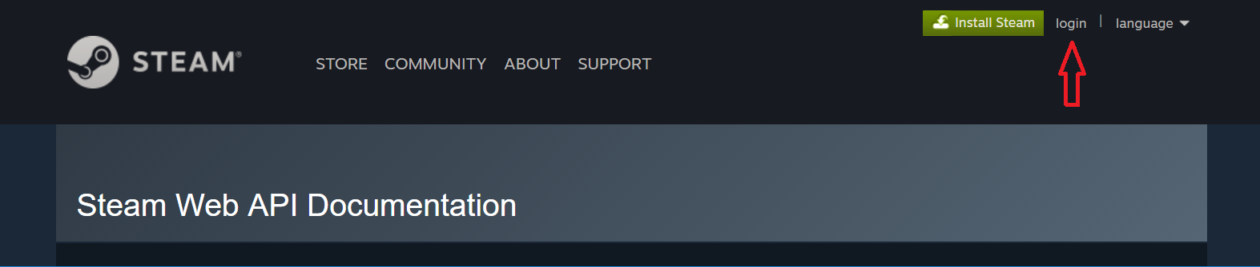

1. Go to the registration page

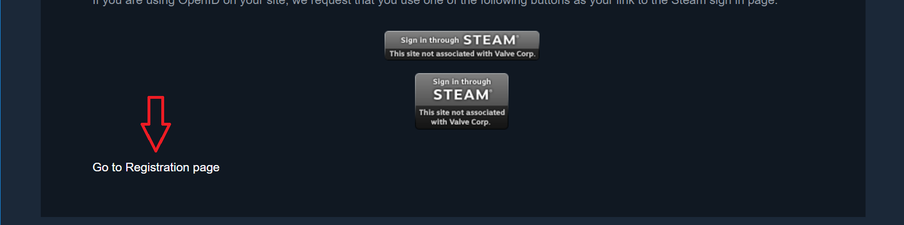

1. Type in your domain name. This can be any website. If you’re unsure, use either the GitHub Scanner3 page, <https://github.com/warmar/Scanner3>, or <https://google.com>.
2. Agree to the Steam Web API Terms of Use
3. Click Register

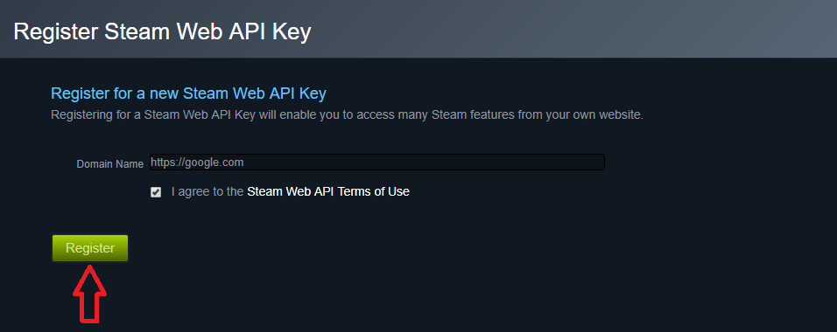

backpack.tf API:

backpack.tf has changed their process for obtaining API keys. This section will be updated in the future.

Entering your keys into Scanner3:

Once you have your API keys, you have to put them in the scanner’s config file, config.ini.

1. Navigate to the directory where you extracted the scanner files.
2. Open config.ini
3. Paste your Steam Web API key on the line that reads, “steam_api_key = “. It should look like this:

steam_api_key = XXXXXXXXXXXXXXXXXXXXXXXXXXXXXXXX

1. Paste your backpack.tf API key on the line that reads, “backpack_tf_api_key”. It should look like this:

backpack_tf_api_key = xxxxxxxxxxxxxxxxxxxxxxxx

Usage

Basics:

Using the scanner is simple. Launch it by opening Scanner3.exe. You will be greeted with a splash screen. Before displaying the main screen, the scanner will check for updates, update the item schema, update the community price list, update the market price list, download any missing item images, and load the item images.

Once everything is loaded, the main screen will appear:

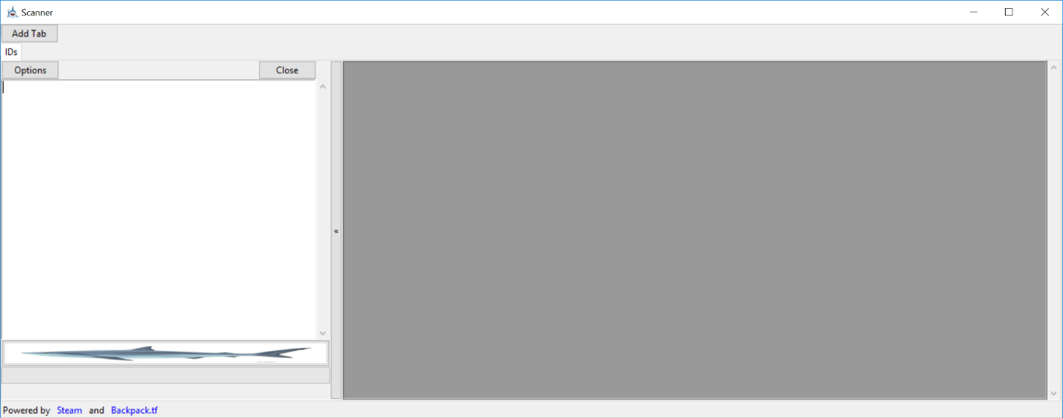

IDs are entered in the text box on the left; The scan button (shark image) starts a scan on any IDs entered in the input box; Players are displayed in the grey box on the right; And the scan’s progress is displayed below the scan button.

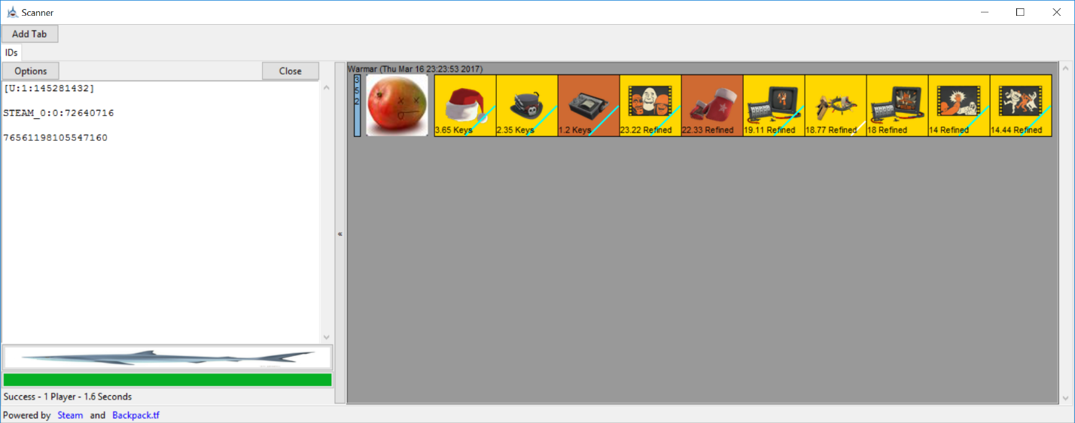

The “Add Tab” button creates a new, completely separate IDs tab. This feature allows you to run multiple scans at once, with individual options and separated outputs.

Output Guide:

The output has a number of features to help you quickly analyze and trade with players.

* Each player’s name is displayed at the top of their output
* Each player’s last online date is displayed to the right of their name.
* At the left of the output is the status box.
  + The color of the status box indicates whether a player is offline, online, or in-game.
  + The number inside the status box indicates how many hours that player has in TF2.
  + Click the status box to remove that player from the output.
* To the right of the status box is the player’s avatar.
  + Left click an avatar to go to that player’s steam profile.
  + Right click an avatar to go to add that player to your friends list.
* To the right of the player’s avatar is their items, sorted from most valuable to least valuable.
  + The color of the item box indicates the item’s quality.

See <https://wiki.teamfortress.com/wiki/Item_quality>.

* + The item’s price is displayed at the bottom of the box.
  + A red line in the top left corner indicates that the item is untradable.
  + A cyan line in the bottom right corner indicates that the player traded for that item.
  + A white line in the bottom right corner indicates that the item is uncraftable.
  + Click on an item to display the item description
  + Click on an item description to hide it
* Middle clicking anywhere on the output to clear all players

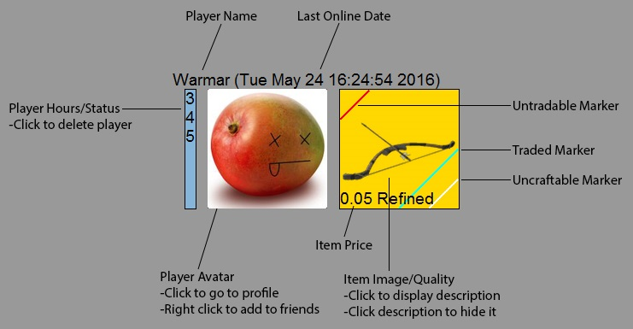

Options

Player Options:

Display Players:

Controls whether players are displayed in the output.

Collect Hours:

Controls whether players’ hours are collected from the Steam Web API. Disabling this will increase scan speed, but hours will no longer be displayed in players’ status boxes.

F2P:

Controls whether free to play players are displayed.

Status:

Controls the minimum status that a player must have to be displayed.

Offline: All players are displayed

Semi-Online: Players are displayed if they are not offline.

Online: Players must be Online or In-Game, not Away or Snooze, to be displayed.

In-Game: Players must be in-game to be displayed.

Max Hours:

Players who have more than the maximum number of hours will not be displayed. Leave blank for no maximum.

Max Refined:

Players who have more than the maximum amount of refined metal will not be displayed. Leave blank for no maximum

Last Online Date:

Players must have been online at or before the last online date. Format is MM-DD-YY. For example 01-05-17 is January 5th, 2017. Leave blank for no last online date.

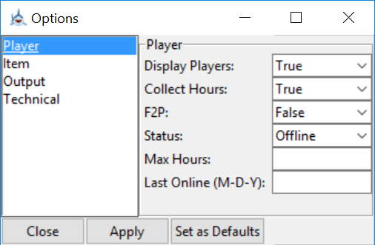

Item Options:

Players must have AT LEAST ONE item that satisfies ALL item requirements.

Min Item Value:

The item must be more valuable than the specified minimum item value.

Quality:

The item must have the specified quality. This option takes the integer index of the quality.

|  |  |  |  |  |  |  |  |  |  |  |  |
| --- | --- | --- | --- | --- | --- | --- | --- | --- | --- | --- | --- |
| Normal | Genuine | Vintage | Unusual | Unique | Community | Valve | Self-Made | Strange | Haunted | Collector’s | Decorated Weapon |
| 0 | 1 | 3 | 5 | 6 | 7 | 8 | 9 | 11 | 13 | 15 | 15 |

Price Index:

The item must have the specified price index.

From backpack.tf/api/docs/IGetPrices:

The priceindex is an attribute that is applied to priced items that share the same definition index and quality. For most items, it is zero. Otherwise, the use varies by context:

#### **Particle effects**

For items with particle effects, the priceindex corresponds to the ID of the particle as documented in the web API.

#### **Dual qualities**

Dual quality IDs are bit shifted by 16.

#### **Crates**

The priceindex corresponds to the crate series.

#### **Strangifiers**

The priceindex of a Strangifier corresponds to the definition index of the item it can be used on.

#### **Chemistry Sets**

The priceindex of a Chemistry Set is a hyphen-delimited string of two numbers; the definition index and the quality of the item. 1086-14 is the priceindex for a Collector's Festive Wrangler.

Level:

The item must have the specified level.

Craftable:

The item must have the specified craftability.

Tradable:

The item must have the specified tradability.

Traded:

The item must match with the specified traded requirement.

Item Slot:

The item must be used in the specified item slot.

Wear:

The item must have the specified wear. If wear is not set to “Any,” only decorated weapons will satisfy the requirement.

Australium:

The item must match with the specified Australium requirement.

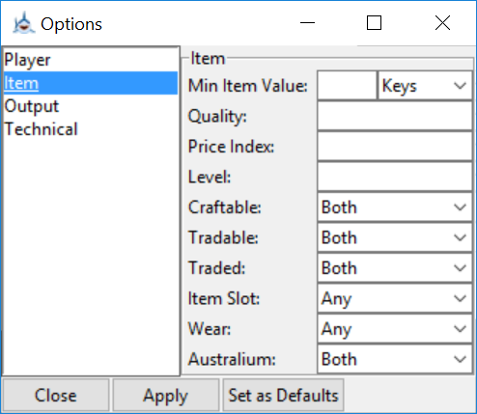

Output Options:

Currency:

The currency with which to display each item’s price. Default will give the price given by backpack.tf.

Min Displayed Item Value:

Only items more valuable than the specified minimum will be displayed. If a player has no items more valuable than the minimum, he/she will not be displayed.

Displayed Items:

The number of items to display for each player.

Items Per Line:

The number of items per player to display on each line, or row, of the output. If Displayed Items is greater than Items Per Line, multiple lines will be displayed for each player.

Image Size:

The size of the displayed output images, in pixels.

Font Size:

The size of the displayed output text. For best looking output, use approximately one tenth of the image size.

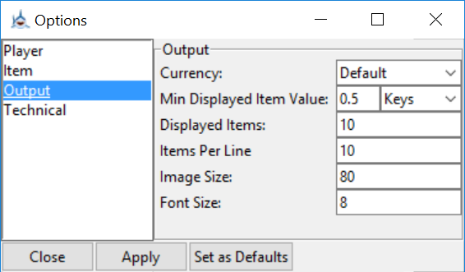

Technical Options:

Display Avatars:

Controls whether to display player avatars. Turning this off will slightly increase scan speed.

Limit Requests, Request Period, and Requests Per Period:

The Steam Web API limits the number of requests made to 100,000 per day. If you make requests too quickly, it will block you out and the scanner will stop working. If you are only doing 1 or 2 scans, you can disable request limiting. If not, leave it on to avoid a temporary block from the API.

I recommend leaving Request Period at 1 second and Requests Per Period at 3 requests. This will give you very good scan speed, while being slow enough that you will not be blocked from the API.

Simultaneous Scans:

The number of player scans to do at once. To ensure that no request opportunities go unused, this number should be larger than Requests Per Period. Increasing Simultaneous Scans a lot will not increase scan speed if request limiting is on, as the scanner will still be limited by the number of requests that it can make.

