RBI MPC In Silico
A Validated Multi-Agent Simulation of India's Monetary Policy Committee with Bounded Counterfactual Attribution
Research Proposal

1. Introduction
Monetary policy committees translate a stream of economic data into one of a small number of discrete decisions, and that decision propagates through an entire economy. Understanding not only what a committee decided, but how it reached that decision and how much any single voice within it mattered, is both a genuine open question in economics and one that artificial intelligence is now, for the first time, technically positioned to help answer directly.
Kazinnik and Sinclair (2025) introduced “FOMC In Silico,” a multi-agent framework that builds a large language model (LLM) agent for each member of the US Federal Open Market Committee (FOMC), grounded in that member’s real, documented views, and runs the resulting committee through the same private stance-formation, deliberation, and voting process a real FOMC meeting follows. Alongside this behavioral track, the authors run a parallel Monte Carlo implementation of a rational, game-theoretic voting model over identical data, so the two tracks can be directly compared. In a baseline simulation of the July 2025 FOMC meeting, both tracks converged unanimously on a rate near the real committee’s actual decision (4.42% LLM, 4.38% Monte Carlo), with no dissents recorded in either track. A single-member dissent pattern emerged only once the framework layered on a political-pressure treatment modeling public pressure on the Chair, under which the simulated Waller dissented in 88% of LLM runs. The authors describe the resulting system as an “in silico environment for counterfactual evaluation in monetary policy,” allowing researchers to vary factors such as disclosure rules, dissent penalties, or coalition dynamics and observe the effect on committee outcomes directly.
This proposal adapts that framework to a structurally different institution: the Reserve Bank of India’s (RBI) six-member Monetary Policy Committee (MPC). The RBI MPC differs from the FOMC in ways that are not cosmetic. It has an even number of voting members, which makes an exact tie a live structural possibility rather than an edge case, and Indian law resolves that tie with a specific, named mechanism — the Governor’s statutory casting vote. It also operates under an unusually strong individual-disclosure requirement: every member, not only the Chair, must publish a signed, first-person statement explaining their vote within 14 days of each meeting. And it sets policy for a large, monsoon-exposed, oil-importing emerging economy whose capital flows are directly sensitive to US Federal Reserve decisions — a materially different shock environment from the one the original framework was built around.
Beyond this adaptation, the proposal adds one further, deliberately bounded contribution. The original framework reports what a simulated committee decided, and, through broad scenario-level counterfactuals such as a “political pressure” condition, how a shift in the overall environment changes that decision. It does not report how much any one interaction — one member persuading another, or one institutional rule such as the casting vote — contributed to the outcome. This proposal closes that gap for a small, fixed set of interactions, drawing on attribution techniques adapted from a separate, fast-growing area of multi-agent-systems research, rather than presenting attribution itself as a new invention.

2. Literature Review

2.1 LLM-Based Multi-Agent Institutional Simulation
The direct foundation for this project is Kazinnik and Sinclair (2025), whose FOMC In Silico framework established that a dual-track LLM/rational-baseline simulation, given real-time macroeconomic data and member profiles, can approximate a real central bank committee’s decision and dissent pattern well enough to be useful as a counterfactual research tool. Their scenario analyses — a political-pressure condition and a negative labor-market data-revision condition — show that the behavioral (LLM) and rational (Monte Carlo) tracks respond to the same shock with small but systematic differences in the implied rate and in how often a member dissents. This dual-track design, and the broader idea of grounding an LLM agent’s behavior in a real individual’s documented history to produce a believable simulated participant, is the direct methodological starting point for the present proposal.

2.2 Classical Committee-Voting Theory and Central Bank Committees
Long before LLMs, economists and political scientists studied how a committee turns individually held information and preferences into one collective decision. Foundational work on information aggregation, including the Condorcet Jury Theorem literature revisited by Austen-Smith and Banks (1996), establishes the baseline logic of when a group’s collective judgment is more or less reliable than any individual member’s. Applied to real monetary policy committees, Riboni and Ruge-Murcia (2008) model how heterogeneous member preferences shape committee-level outcomes, while empirical studies of the Bank of England’s Monetary Policy Committee document individual members’ voting records and a tendency toward gradualism and inertia (Spencer, 2006; Groth & Wheeler, 2008). A related theoretical and empirical literature models the reputational incentives individual members face and how the transparency of individual votes changes their incentive to dissent (Sibert, 2003; Meade, 2005; Meade & Stasavage, 2008). Together, this literature establishes that a credible committee simulation needs to represent more than an aggregation rule — it needs member-level incentives, and it needs to take seriously how visible and individually attributable a member’s vote is.

2.3 Empirical Studies of RBI MPC Voting and Dissent
Since its creation in 2016, the RBI MPC’s own voting record has become a subject of direct empirical study. Sil, Kurup, Goyal, Singh, and Paramanik (2024) construct dissent measures directly from the text of RBI MPC minutes using sentiment analysis, and find that discordance among members is associated with improved accuracy of the committee’s implied growth and inflation forecasts, rather than simply signaling dysfunction — a finding that argues against treating a simulated dissent as a modeling failure. This body of work confirms two properties of the RBI MPC that make it an unusually strong candidate for LLM-based persona simulation: every member’s individual reasoning is a matter of public record, and individual-level dissent is already known to carry real economic information, giving a simulation something economically meaningful to try to reproduce.

2.4 Counterfactual and Attribution Methods for Multi-Agent LLM Systems
Separately from the monetary-policy literature, a fast-growing body of 2025–2026 machine-learning research has developed methods for attributing a multi-agent LLM system’s output to specific agents or interactions. These include leave-one-out and Shapley-value-based credit assignment adapted from cooperative game theory to LLM agent teams, of which recent removal-based attribution frameworks such as “Agents that Matter” (2026) are representative, and causal, replay-based failure-attribution methods that intervene on one step of a multi-agent transcript and observe the counterfactual effect on the outcome, such as “Causal Agent Replay” and hierarchical causal-graph approaches including “CHIEF” (2026). This literature has so far been applied almost exclusively to task-performance and failure-diagnosis settings — coding, mathematics, and negotiation benchmarks — and consistently finds that an agent’s own introspective, self-reported account of its importance is not a reliable substitute for actually re-running the system with that agent or interaction removed. None of this work has yet been applied to a real institutional policy-decision context.

3. Summary of Literature Review
- The FOMC In Silico framework (Kazinnik & Sinclair, 2025) established that a dual LLM-behavioral / mathematical-rational simulation can closely track a real central bank committee’s decision and dissent pattern, but has so far only been applied to the US Federal Reserve.
- Decades of committee-voting theory — the Condorcet Jury Theorem tradition and preference-heterogeneity models of central bank committees — show that a credible committee model must capture individual incentives and gradualism, not just an aggregation rule.
- The RBI MPC is unusually well documented for this purpose: every member publishes an individually signed rationale within 14 days of each meeting, and existing empirical work has already built dissent measures directly from this text.
- Existing RBI-specific research finds that MPC dissent is economically informative — associated with improved forecast accuracy rather than merely signaling instability.
- A separate, fast-growing 2025–2026 machine-learning literature has developed leave-one-out and Shapley-based methods for attributing multi-agent LLM outcomes to specific agents or interactions, but has not yet been applied to institutional economic policy decisions.
- No existing framework combines an emerging-market central bank’s structurally distinct voting mechanism (even-numbered committee, statutory casting vote) with interaction-level counterfactual attribution validated against real historical votes.

4. Research Gaps
- Institutional gap: FOMC In Silico-style simulation has not been extended to a central bank with an even-numbered committee and a statutory tie-breaking mechanism, a structurally distinct decision rule from the FOMC’s median-voter dynamics.
- Validation gap: existing LLM-committee-simulation work validates against a single illustrative meeting; no framework has been systematically backtested against a held-out panel of multiple real historical votes using a pre-registered calibration/holdout split.
- Granularity gap: existing counterfactual scenarios in this literature (e.g., political pressure, data revision) operate at the level of a broad condition change, not at the level of a specific member interaction or institutional rule — so the literature cannot currently answer how much one argument, or one rule, changed the outcome.
- Cross-domain gap: leave-one-out and Shapley-based multi-agent LLM attribution methods, actively developed in 2025–2026 machine-learning research, have not been applied to institutional or economic policy-decision simulations.
- Data-source gap: prior persona-construction approaches for committee simulation typically rely on speeches and indirect sources; the RBI’s individually-signed-statement disclosure requirement offers a more direct calibration signal that has not yet been exploited for this purpose.

5. Problem Definition
Despite the demonstrated ability of dual-track LLM/rational-baseline simulations to approximate real central bank committee decisions, no existing framework (a) has been adapted to a central bank with a structurally distinct, even-numbered voting body and a statutory casting-vote rule, (b) has been validated against a systematic, held-out panel of real historical votes rather than a single illustrative meeting, or (c) can attribute a simulated committee’s decision to a specific member interaction or institutional rule rather than only to a broad scenario condition. This proposal addresses these three limitations by designing, building, and validating a six-agent simulation of the RBI Monetary Policy Committee, and by extending that validated simulation with a small, bounded set of interaction-level counterfactual attribution experiments.

6. Objectives
- Design and implement a dual-track (LLM-behavioral and Monte Carlo-rational) six-agent simulation of the RBI MPC, incorporating its statutory majority-voting and Governor’s-casting-vote tie-break rule, with agent personas calibrated from each member’s individually signed MPC minutes statements.
- Validate the simulation’s directional accuracy and dissent-detection accuracy against a held-out panel of real historical RBI MPC meetings, using a pre-registered calibration/holdout split.
- Extend the validated simulation with two India-specific, historically-grounded counterfactual scenarios — a monsoon/food-inflation shock and a US Federal Reserve spillover shock — and quantify the behavioral-versus-rational wedge under each.
- Implement a bounded, leave-one-out counterfactual attribution layer, limited to three pre-specified experiments, that quantifies the marginal contribution of a single member interaction, institutional rule, or macroeconomic input to the simulated committee’s final decision.

7. Methodology
The methodology follows a single linear pipeline with one validation gate, illustrated in Figure 1 below. The overall three-stage architecture — data and persona preparation, dual-track simulation, and a final synthesis of outputs — adapts the pipeline structure set out in Kazinnik and Sinclair (2025), extended here with an institution rule engine, a validation gate, and the bounded attribution layer described below. The pipeline is deliberately sequential: the attribution layer and the counterfactual scenarios are only run once the validation gate has been passed, so that any attribution result is being computed on top of a baseline the project has already shown to be reasonably trustworthy, rather than on top of an unvalidated one.
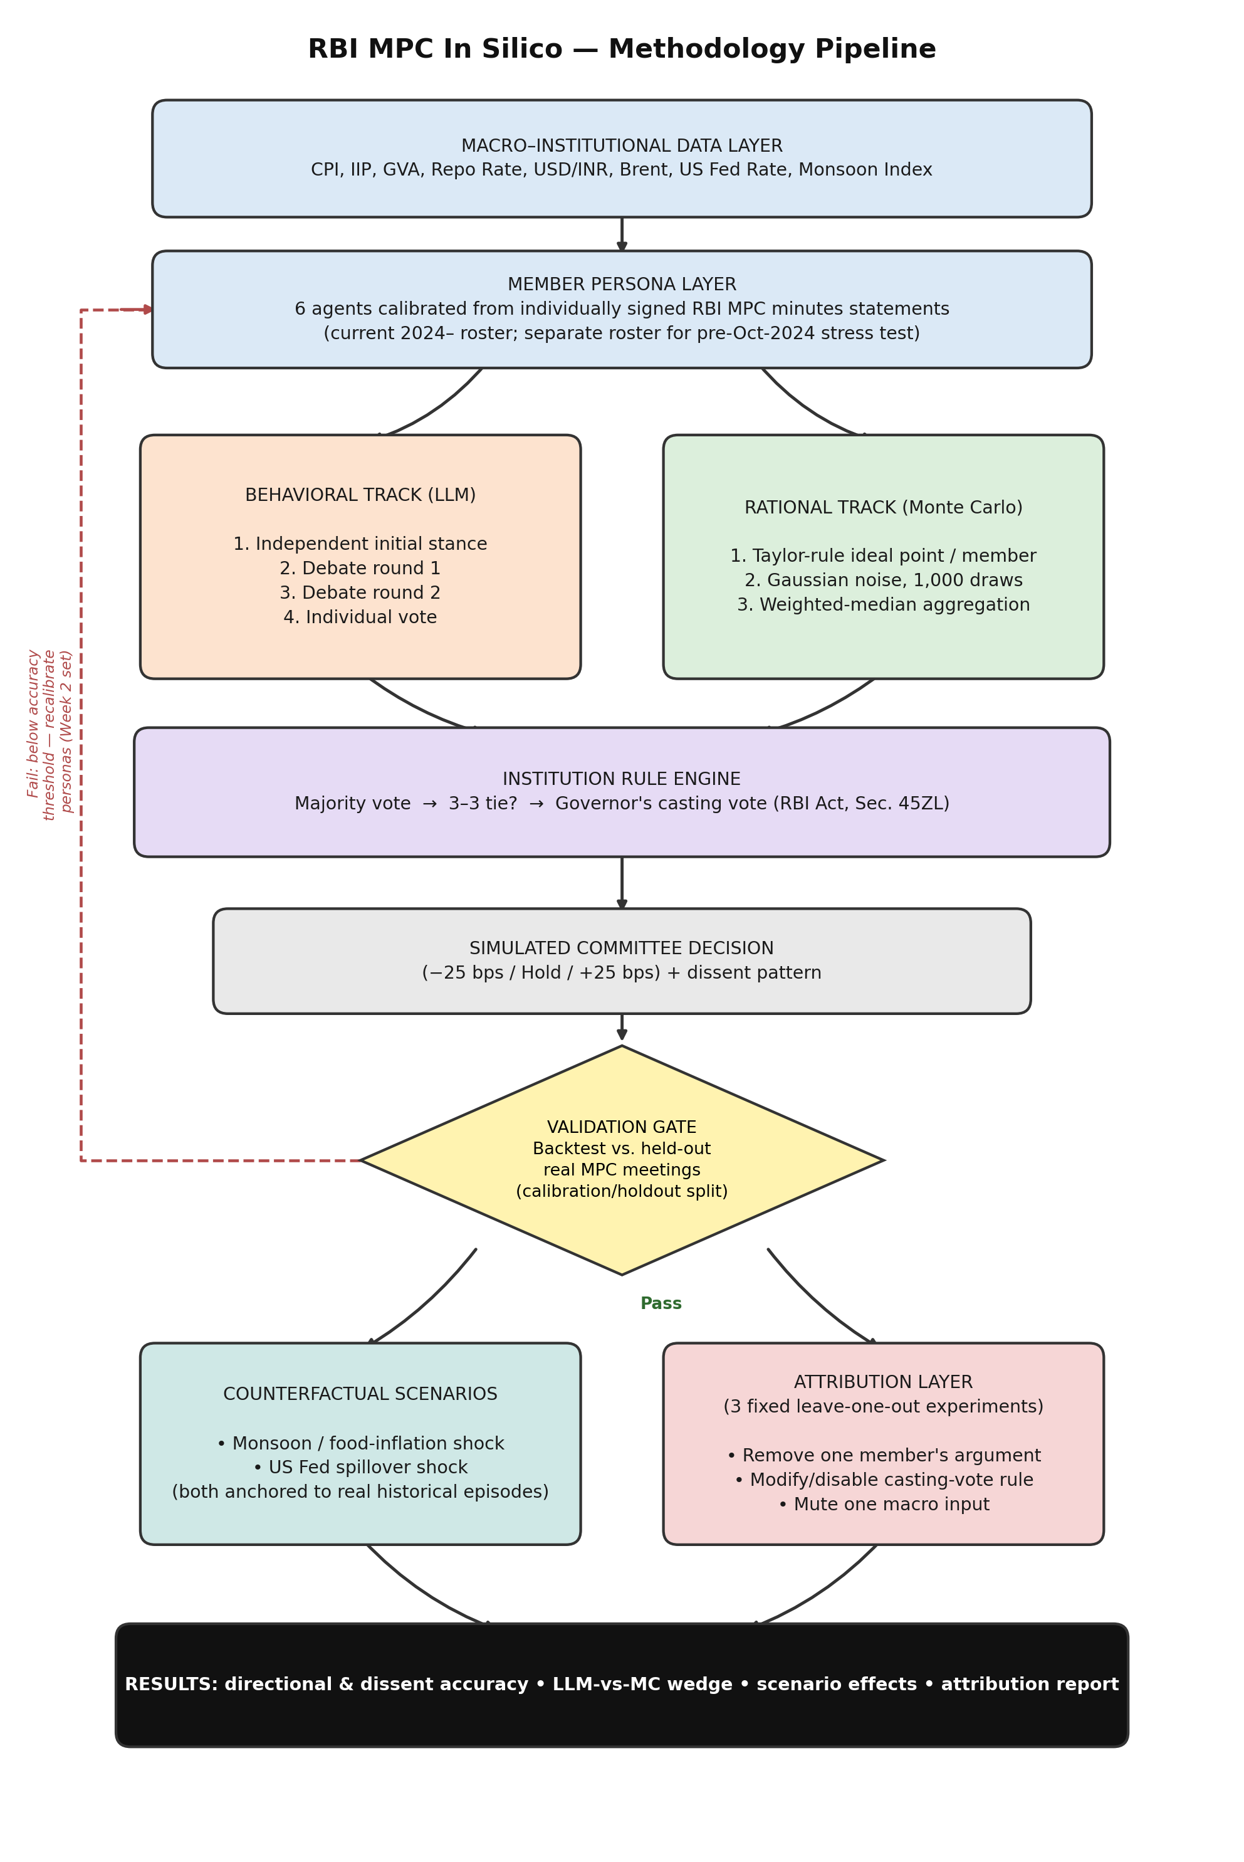
Figure 1. RBI MPC In Silico methodology pipeline, adapted from the simulation framework in Kazinnik and Sinclair (2025), from macro-institutional data through the dual behavioral/rational tracks, the institution rule engine, the validation gate, and the bounded counterfactual and attribution layers.

7.1 Data and Persona Layer
The pipeline begins with a frozen, versioned dataset of national macroeconomic indicators (CPI-Combined, core CPI, IIP, GVA growth, the repo rate history, system liquidity, USD/INR, Brent crude, the US Fed funds rate, and monsoon rainfall departure from the Long Period Average), compiled from primary sources such as the RBI Database on Indian Economy and MOSPI. In parallel, six member personas are constructed directly from each committee member’s individually signed statement in the official MPC minutes archive, which is read as a system prompt template capturing that member’s documented growth/inflation weighting and characteristic reasoning style. Because the external-member roster changed in October 2024, meetings are mapped to the roster that was actually in place at the time, and a separate persona set is maintained for any pre-October-2024 meetings used in a generalizability stress test.

7.2 Dual-Track Simulation
Given an identical macroeconomic snapshot, the behavioral track runs six LLM agents through an independent initial-stance step, two rounds of structured debate — adapting the multi-round deliberation format of Kazinnik and Sinclair (2025) — in which agents see and may be persuaded by one another’s positions, and a final individual vote. In parallel, the rational track computes each member’s implied ideal policy rate from a Taylor-rule-style function of the inflation and output gaps, with member-specific parameters calibrated from historical dissent direction, and aggregates 1,000 noisy Monte Carlo draws via weighted-median voting. Both tracks pass through the same institution rule engine: majority aggregation determines the outcome unless the vote splits 3–3, in which case the Governor’s statutory casting vote (RBI Act, Section 45ZL) resolves the tie.

7.3 Validation Gate
Before any counterfactual or attribution work is run, the simulation is backtested against a held-out panel of real historical RBI MPC meetings. Meetings are split in advance into a calibration set, used while writing and tuning persona prompts, and a holdout set, on which persona prompts are frozen and never revisited. Directional accuracy (did the simulated modal decision match the real outcome) and dissent-detection accuracy (did the simulation identify which specific member(s) dissented) are computed only on the holdout set. If holdout accuracy falls below a pre-agreed threshold, the pipeline loops back to persona recalibration rather than proceeding to the counterfactual and attribution stages, as shown by the feedback path in Figure 1.

7.4 Counterfactual Scenarios and the Attribution Layer
Once validated, the framework is used for two purposes. First, two India-specific counterfactual scenarios — a monsoon/food-inflation shock and a US Federal Reserve spillover shock — are constructed by anchoring the shock magnitude to a real historical episode (for example, the 2023 vegetable-price-driven CPI spike) rather than an assumed round number, and rerun through both tracks. Second, a bounded attribution layer runs exactly three pre-specified leave-one-out experiments: removing one member’s debate-round argument, modifying or disabling the casting-vote rule, and muting one macroeconomic input. Each experiment reruns the affected stage of the pipeline with everything else held fixed and compares the resulting trajectory and outcome against the validated baseline, following the removal-based attribution methodology established in the recent multi-agent-LLM-attribution literature (Section 2.4) rather than a bespoke causal-inference framework built from scratch. The final output layer aggregates all of this into a single results report: directional and dissent accuracy, the LLM-versus-Monte-Carlo wedge, the two scenario effects, and the three attribution values.

References
Austen-Smith, D., & Banks, J. S. (1996). Information aggregation, rationality, and the Condorcet jury theorem. American Political Science Review, 90(1), 34–45.
Groth, C., & Wheeler, T. (2008). The behaviour of the MPC: Gradualism, inaction and individual voting patterns (Discussion Paper No. 21). Bank of England, Monetary Policy Committee Unit.
Kazinnik, S., & Sinclair, T. M. (2025). FOMC in silico: A multi-agent system for monetary policy decision modeling (Working Paper No. 2025-005). H. O. Stekler Research Program on Forecasting, George Washington University.
Meade, E. E. (2005). The FOMC: Preferences, voting, and consensus. Federal Reserve Bank of St. Louis Review, 87(2), 93–101.
Meade, E. E., & Stasavage, D. (2008). Publicity of debate and the incentive to dissent: Evidence from the US Federal Reserve. The Economic Journal, 118(528), 695–717.
Riboni, A., & Ruge-Murcia, F. J. (2008). Preference heterogeneity in monetary policy committees. International Journal of Central Banking, 4(1), 213–233.
Sibert, A. (2003). Monetary policy committees: Individual and collective reputations. The Review of Economic Studies, 70(3), 649–665.
Sil, R., Kurup, U., Goyal, A., Singh, A., & Paramanik, R. N. (2024). Chorus in the cacophony: Dissent and policy communication of India’s Monetary Policy Committee. Applied Economics Letters, 31(18), 1900–1906.
Spencer, C. (2006). The dissent voting behaviour of Bank of England MPC members (Discussion Paper 0306). School of Economics, University of Surrey.
Recent (2026) preprints on removal-based and causal attribution for multi-agent LLM systems — including “Agents that Matter: Optimizing Multi-Agent LLMs via Removal-Based Attribution,” “Causal Agent Replay: Counterfactual Attribution for LLM-Agent Failures,” and “From Flat Logs to Causal Graphs” (CHIEF) — are cited by title in Section 2.4; full author lists should be confirmed and added during the formal literature review stage.

