Week 4: Machine Learning Model Development and Evaluation
A reproducible classification workflow using Python and scikit-learn

1. Introduction and Objective
This project demonstrates a complete basic machine-learning workflow: selecting a public dataset, preparing the data, choosing a model, training it, evaluating performance on held-out data, visualizing results, and discussing limitations and improvements.

2. Dataset and Target
The Breast Cancer Wisconsin (Diagnostic) dataset bundled with scikit-learn is used as an educational classification dataset. It contains numeric features computed from digitized images of breast-mass samples. For this project, the target is recoded as malignant=1 (positive class) and benign=0. The dataset is used only to demonstrate machine-learning evaluation; this model is not suitable for medical diagnosis or clinical decisions.

3. Data Preparation
The data were divided into training and test sets using an 80/20 stratified split with random_state=42. This gives 455 training samples and 114 test samples. Stratification helps preserve the class proportions in both sets. A scikit-learn pipeline applies median imputation, standard scaling, and logistic regression. Fitting preprocessing inside the pipeline prevents test-set information from leaking into training.

4. Model Selection and Justification
Logistic regression was selected because it is a widely used, interpretable baseline for binary classification and produces probabilities that can be evaluated with an ROC curve. Feature standardization helps logistic regression because the input measurements are on different scales. A majority-class DummyClassifier is used as a simple baseline for comparison.

5. Evaluation Metrics
Accuracy is the proportion of all predictions that are correct. Precision for the malignant class is the proportion of predicted malignant cases that are actually malignant. Recall is the proportion of actual malignant cases correctly identified. F1 is the harmonic mean of precision and recall. The confusion matrix separates true negatives, false positives, false negatives, and true positives. ROC-AUC summarizes discrimination across classification thresholds; it does not select a clinically appropriate threshold.

6. Results
Metric | Logistic regression | Majority baseline
Accuracy | 0.965 | 0.632
Precision | 0.975 | 0.000
Recall | 0.929 | 0.000
F1 score | 0.951 | 0.000
ROC-AUC | 0.996 | N/A
Logistic regression test accuracy was 0.965, precision 0.975, recall 0.929, F1 0.951, and ROC-AUC 0.996. The majority-class baseline accuracy was 0.632.

7. Visualizations

Figure 1. Confusion matrix
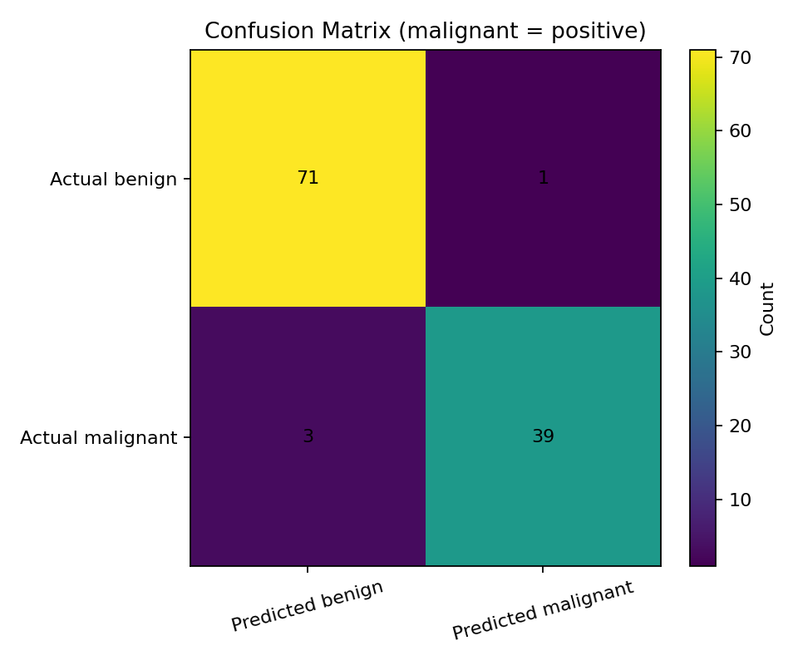
This plot compares actual and predicted classes. False negatives are malignant samples predicted as benign; false positives are benign samples predicted as malignant. Both error types matter, and their importance depends on the application.

Figure 2. ROC curve
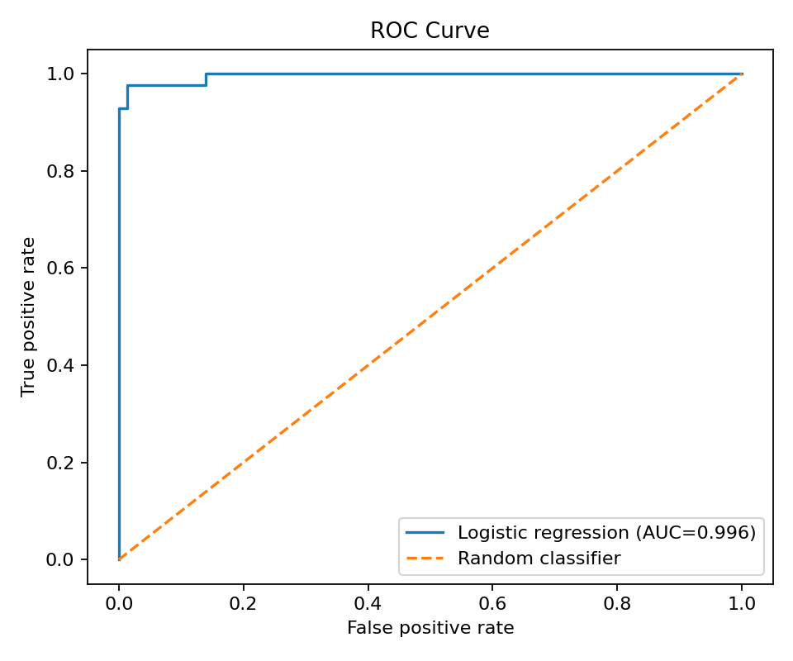
The ROC curve shows the trade-off between true-positive and false-positive rates at different thresholds. The AUC summarizes ranking performance over these thresholds.

Figure 3. Model metrics versus baseline
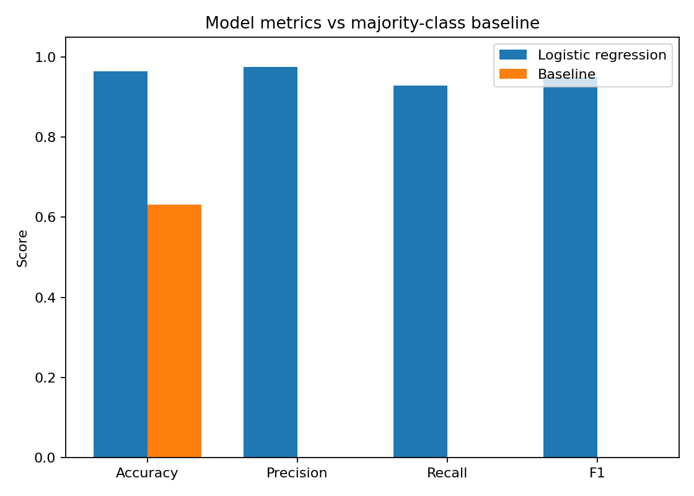
This chart compares the logistic regression scores with a majority-class baseline. Accuracy alone can be misleading when classes are imbalanced, so precision, recall, F1, and ROC-AUC are also reported.

Figure 4. Largest standardized logistic-regression coefficients
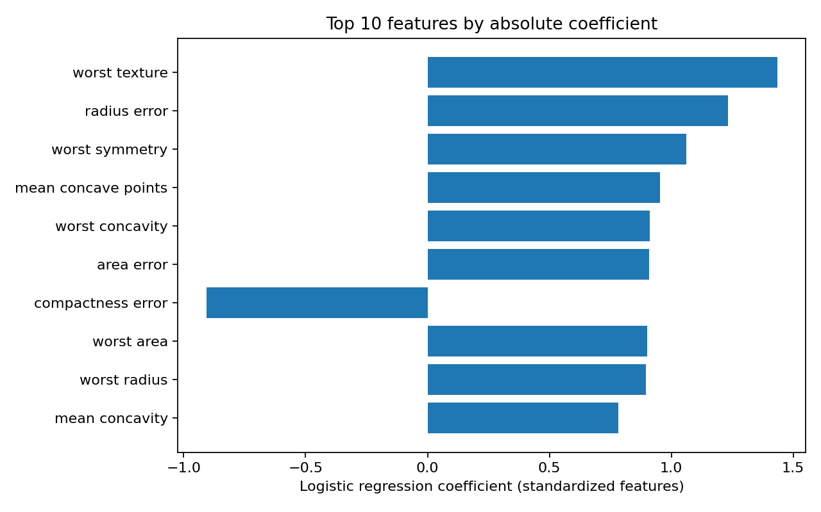
The signed coefficients show how standardized features contribute to the fitted logistic-regression score. Correlated features can make individual coefficients unstable, so this plot should not be interpreted as causal or medical importance.

Figure 5. Class distribution
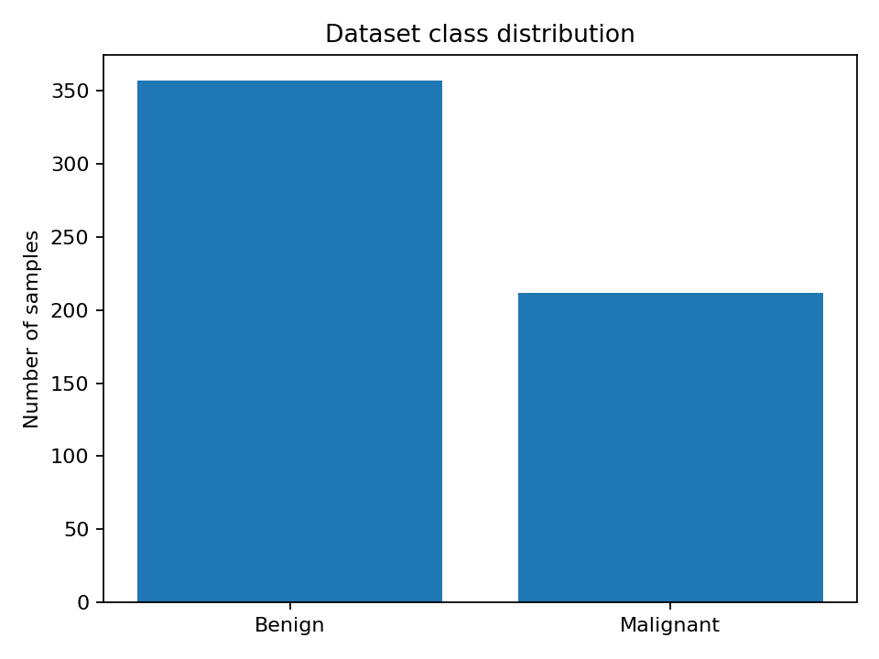
This chart shows the number of benign and malignant samples. It helps explain why a baseline and multiple metrics are useful.

8. Error Analysis and Limitations
- The dataset is a curated educational dataset and may not represent real-world populations or clinical settings.
- A single train/test split can produce variable estimates; cross-validation would provide a more stable evaluation.
- Logistic regression is a simple model; nonlinear models may capture more complex patterns but can be harder to interpret.
- Feature correlations can affect coefficient stability.
- Threshold selection should reflect application-specific costs of false positives and false negatives. No threshold here is clinically validated.
- The model must not be used to diagnose, screen, or guide treatment.

9. Potential Improvements
Future work could use stratified cross-validation, tune regularization strength within a training-only cross-validation procedure, examine calibration, compare additional models, assess subgroup performance where appropriate, and report uncertainty around evaluation metrics. Any high-stakes application would require independent validation, governance, and expert oversight.

10. Conclusion
This project demonstrates data preparation, logistic-regression training, held-out evaluation, baseline comparison, and visual communication of model performance. Using several complementary metrics gives a more complete picture than accuracy alone. Results apply only to this educational dataset and split; they do not establish clinical usefulness.

11. Reproducibility
Install dependencies: pip install pandas numpy matplotlib scikit-learn
Run: python analysis.py
The accompanying files include the Python script, dataset CSV, metric table, results text, README, and five visualizations.

