Week 1 Project Report
Data Acquisition, Data Cleaning, and Exploratory Data Analysis (EDA) Using Python

1. Objective
The objective of this project is to acquire a dataset, inspect its structure and quality, apply basic data-cleaning methods, and perform exploratory data analysis (EDA) with Python. The analysis uses descriptive statistics and visualizations to identify patterns and relationships.

2. Dataset Description and Acquisition
The classic Iris dataset was loaded from scikit-learn's bundled copy of the public Iris dataset (originally associated with the UCI Machine Learning Repository).
The dataset contains 150 records and 4 numeric measurement columns plus one categorical target column, species. The numeric features are sepal length, sepal width, petal length, and petal width, measured in centimetres. The species column identifies setosa, versicolor, or virginica.
Dataset file included: iris_dataset.csv

3. Tools and Libraries
Python 3, Pandas, NumPy, and Matplotlib. Pandas is used for loading, inspecting, cleaning, and summarizing data. NumPy supports numeric operations, and Matplotlib is used to create charts.

4. Data Inspection and Cleaning
The dataset has 150 rows and 5 columns before cleaning. The initial quality checks found 0 missing cells and 1 exact duplicate row in the supplied dataset. The analysis script includes reusable handling for missing values and duplicate rows: numeric missing values are filled with the column median, categorical missing values with the most frequent category, and exact duplicate rows are removed. In this dataset, the duplicate check removes one repeated record, leaving 149 rows for the cleaned analysis.
Data types were checked to ensure measurement columns are numeric and species is categorical. Extreme values should be investigated using domain knowledge and boxplots rather than removed automatically; an unusual measurement is not necessarily an error.

5. Exploratory Data Analysis
The following visualizations are generated by the included Python script:
- Species count bar chart: checks that the dataset is balanced across the three species.
- Histograms: show the distribution and spread of each measurement.
- Petal-length boxplot by species: compares typical values and variability between species.
- Correlation heatmap: summarizes linear relationships between numeric measurements.

6. Results and Key Findings
Species counts: setosa: 50, versicolor: 50, virginica: 50.
The supplied dataset contains 150 observations before cleaning, with 50 examples for each species. One exact duplicate row is removed during cleaning, leaving 149 unique records. Petal length and petal width show a strong positive relationship, meaning flowers with longer petals generally also have wider petals. Petal measurements separate the species more clearly than sepal measurements, especially for setosa compared with versicolor and virginica. The feature histograms show that measurements have different ranges and distributions, so feature-specific scales should be considered in later modeling.
Mean measurements (cm): sepal length = 5.84, sepal width = 3.06, petal length = 3.76, petal width = 1.20.

7. Limitations
The Iris dataset is small and represents only three flower species. Findings from this dataset should not be generalized to all plant species. Correlation describes association and does not prove causation. This project focuses on descriptive analysis and does not train a predictive model.

8. Conclusion
This project demonstrates a repeatable workflow for data acquisition, inspection, cleaning, and EDA using Python. The dataset was checked for missing values, duplicate records, data types, and basic statistical properties. Visualizations helped reveal differences among species and relationships between measurements. The included code and dataset make the analysis reproducible.

9. How to Run the Code
- Install Python 3 if it is not already installed.
- Install dependencies using: pip install pandas numpy matplotlib
- Keep analysis.py and iris_dataset.csv in the same folder.
- Run: python analysis.py
- Review the charts folder, iris_cleaned.csv, and correlation_matrix.csv.

10. Project Files
analysis.py — full, runnable Python analysis script.
iris_dataset.csv — dataset used in the report.
charts/ — generated plots used for EDA.
iris_cleaned.csv and correlation_matrix.csv — generated when the script runs.

Figure 1. Sample count by species
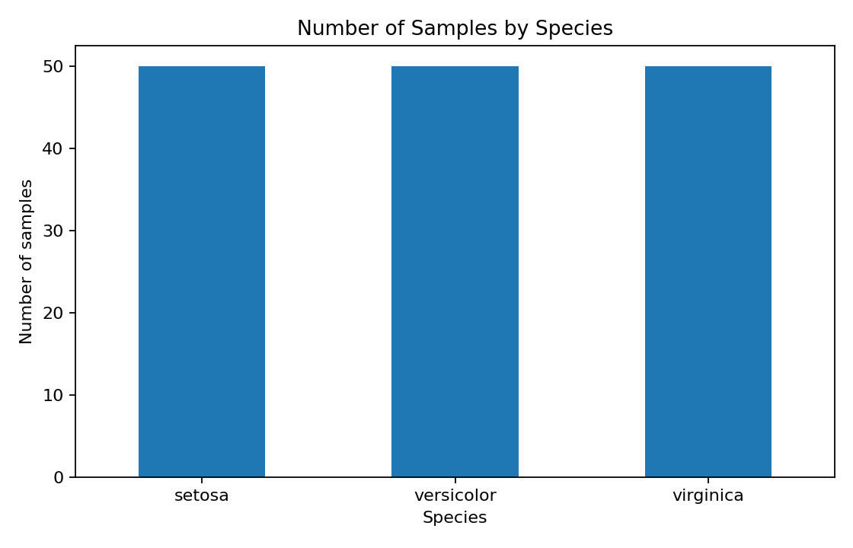

Figure 2. Measurement distributions
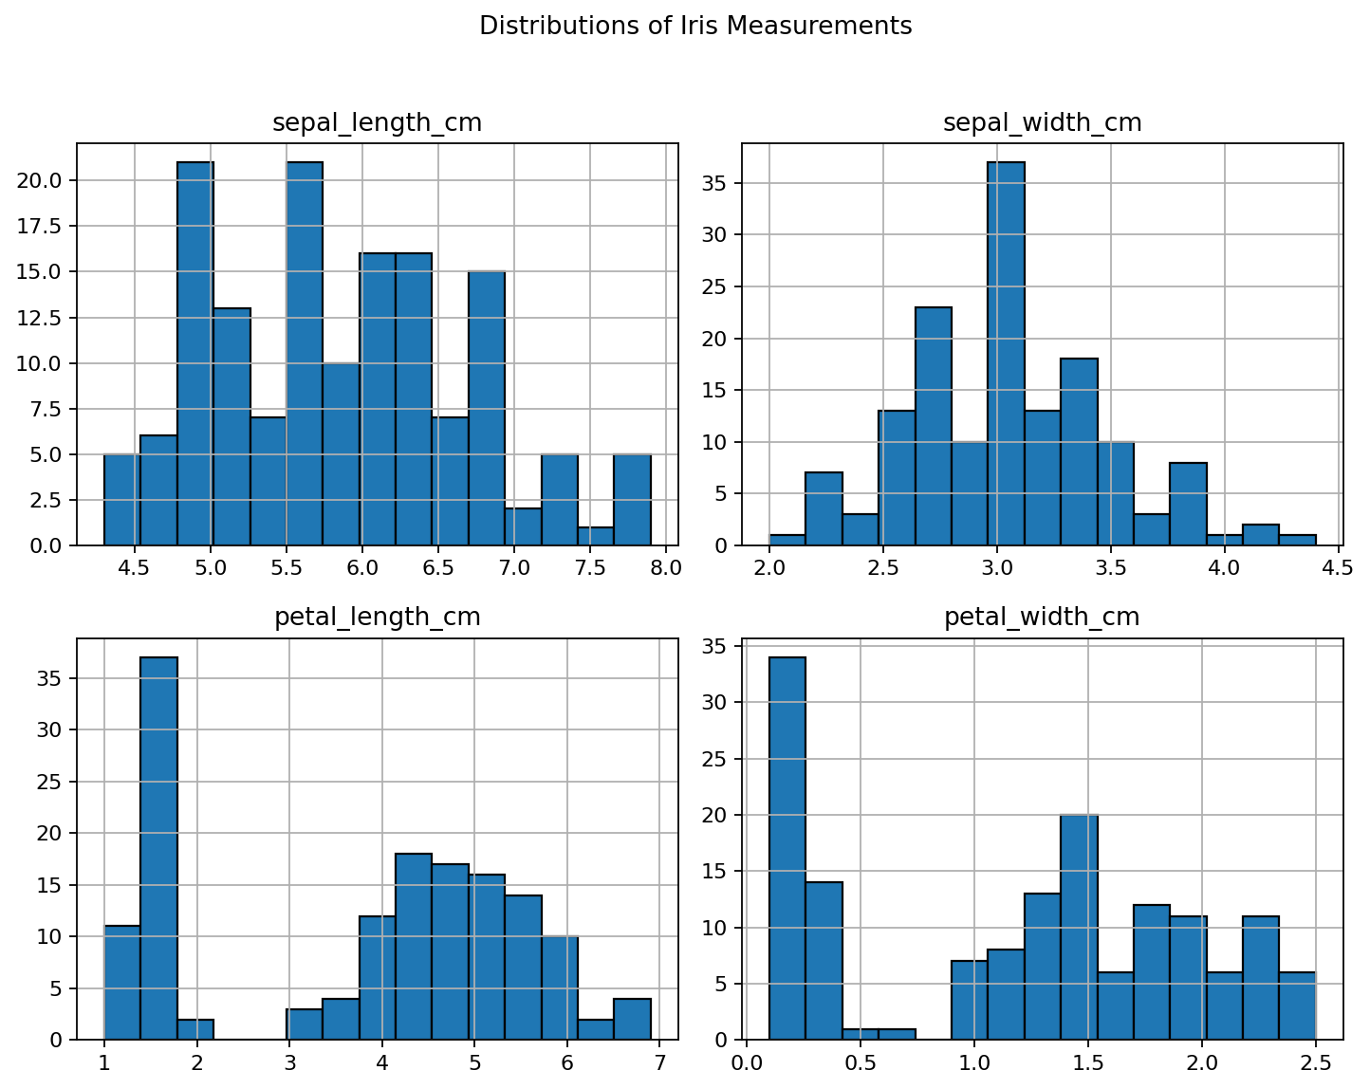

Figure 3. Petal length by species
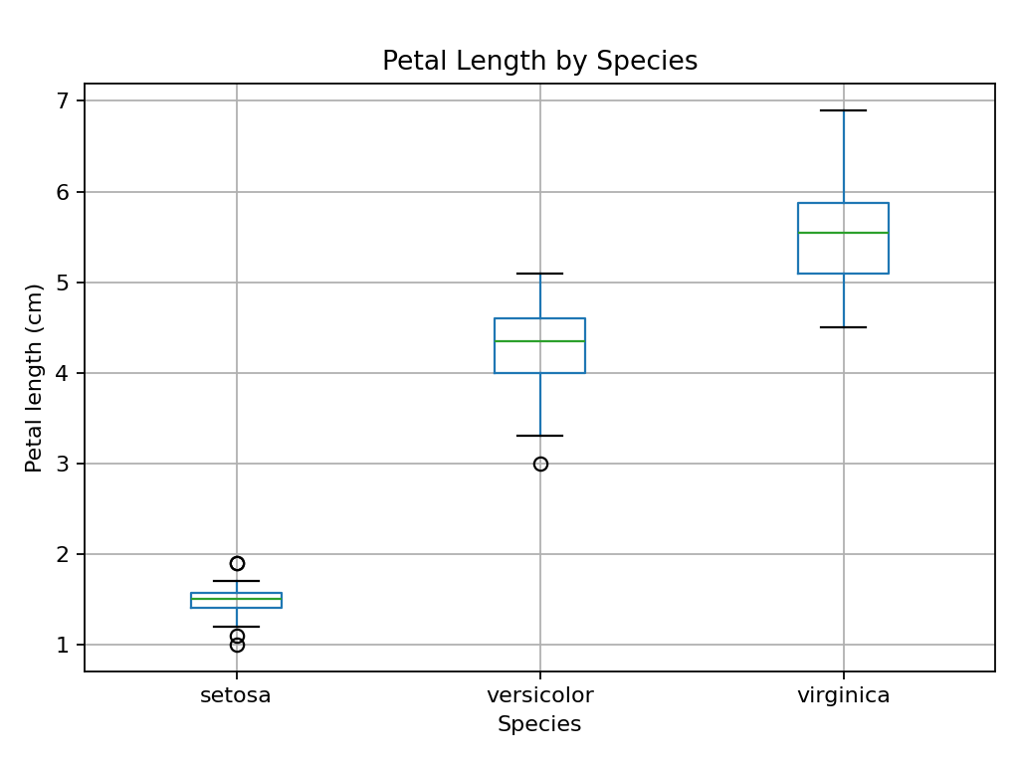

Figure 4. Correlation between measurements
