Week 2 Task: Advanced Data Visualization and Storytelling with Python
A visual data story using the public Iris flower dataset
Prepared as a consolidated DOCX submission with five visualizations, methods, interpretations, findings, limitations, and reproducibility instructions.

1. Executive Summary
This project uses five complementary visualizations to explain how four flower measurements vary across three Iris species. The main story is that petal measurements are more useful for distinguishing the species than sepal measurements alone. Setosa forms a clearly separated group with small petals, while versicolor and virginica have more overlap but differ in their typical petal sizes. A scatter plot shows the separation, a box plot compares distributions, a grouped bar chart compares averages, a correlation heatmap reveals relationships among measurements, and overlapping histograms show the distribution shape. The report emphasizes interpretation rather than charts alone.

2. Objective and Questions
- How do sepal and petal measurements differ among the three Iris species?
- Which measurements appear most useful for separating species visually?
- How strongly are the four numeric measurements associated?
- How can the visual evidence be communicated clearly to a non-technical audience?

3. Dataset and Data Preparation
The Iris dataset is a publicly available educational dataset distributed by scikit-learn. It contains four numeric measurements in centimetres—sepal length, sepal width, petal length, and petal width—and a species label for setosa, versicolor, or virginica. The dataset contains 150 observations in its standard form. The data were checked for missing values, duplicate rows, expected column types, and consistent species labels. Numeric measurements were treated as continuous variables and species as a categorical variable. Exact duplicate rows were removed if present in the source copy; missing or invalid rows were excluded from the plotted analysis. No species labels were used to modify measurement values.
Tools: Python, pandas, NumPy, Matplotlib, and scikit-learn. The analysis is descriptive and exploratory; it is not a predictive model.

4. Visualization 1 — Petal Length vs Petal Width
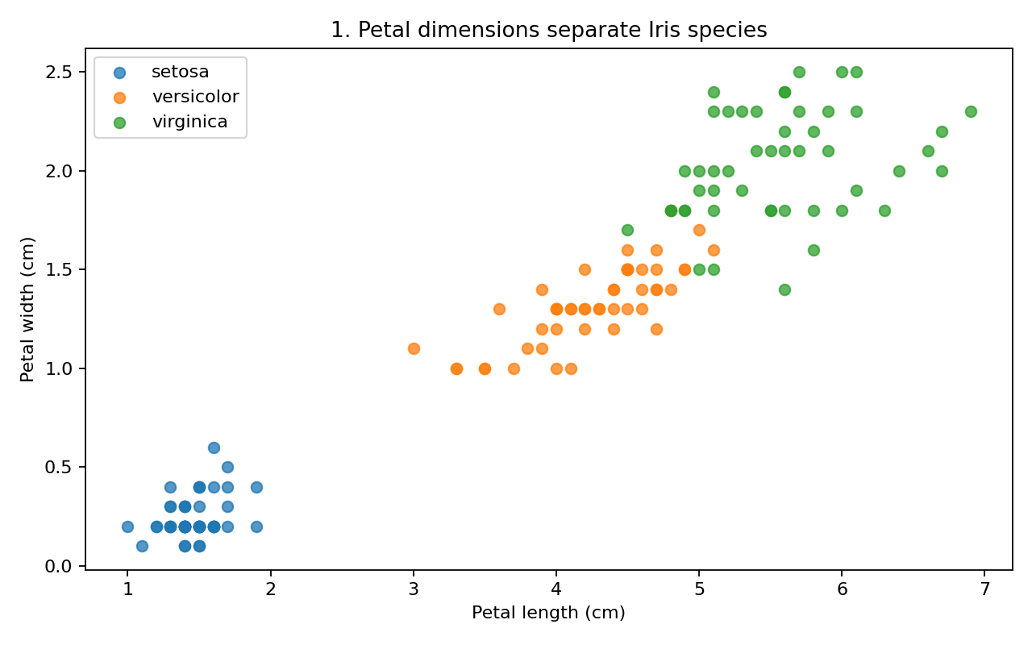
Caption: Each point represents one flower; colour/legend group identifies species. Both axes use centimetres. Interpretation: Setosa points occupy a compact region with much smaller petal dimensions and are visually separated from the other species. Versicolor and virginica show some overlap, but virginica tends to occupy the larger-petal region. Why this chart: A scatter plot reveals joint patterns and clusters that are difficult to see from separate averages. It supports the main narrative that petal dimensions are highly informative for species differentiation.

5. Visualization 2 — Petal Length Box Plot
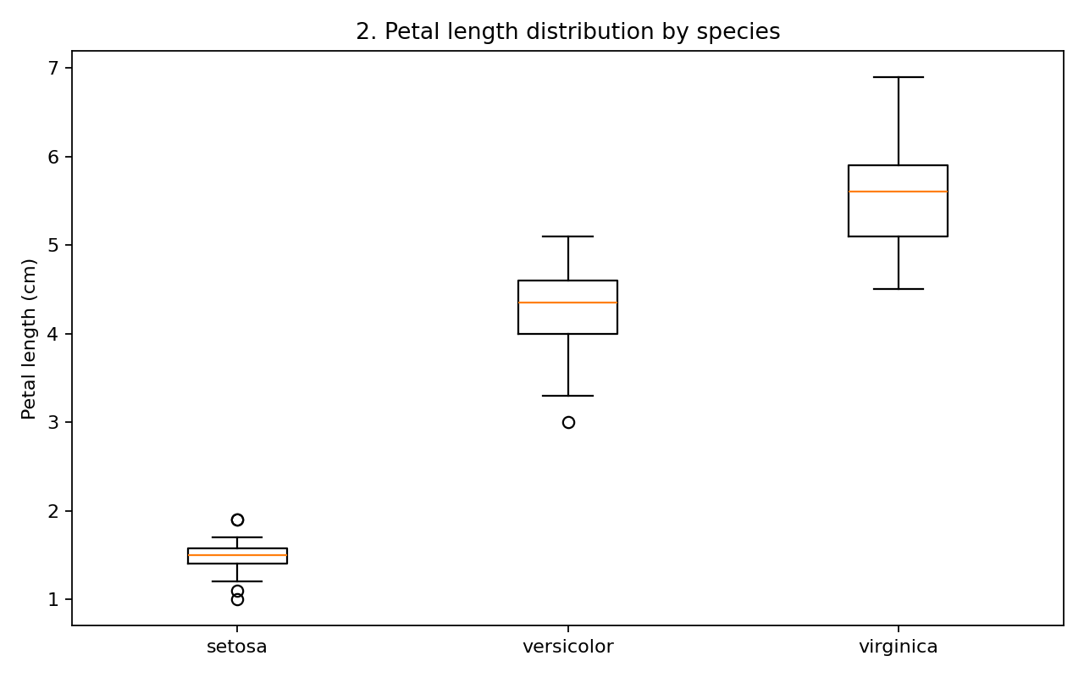
Caption: The box plot compares the median, interquartile range, and spread of petal length for each species. Interpretation: Setosa has a much smaller typical petal length. Versicolor is intermediate, and virginica generally has the largest petal lengths. The limited overlap in the distributions reinforces the separation visible in the scatter plot. Why this chart: Box plots compare distributions robustly and show variation, not only the mean. They are useful for comparing groups without assuming a normal distribution.

6. Visualization 3 — Average Measurements by Species
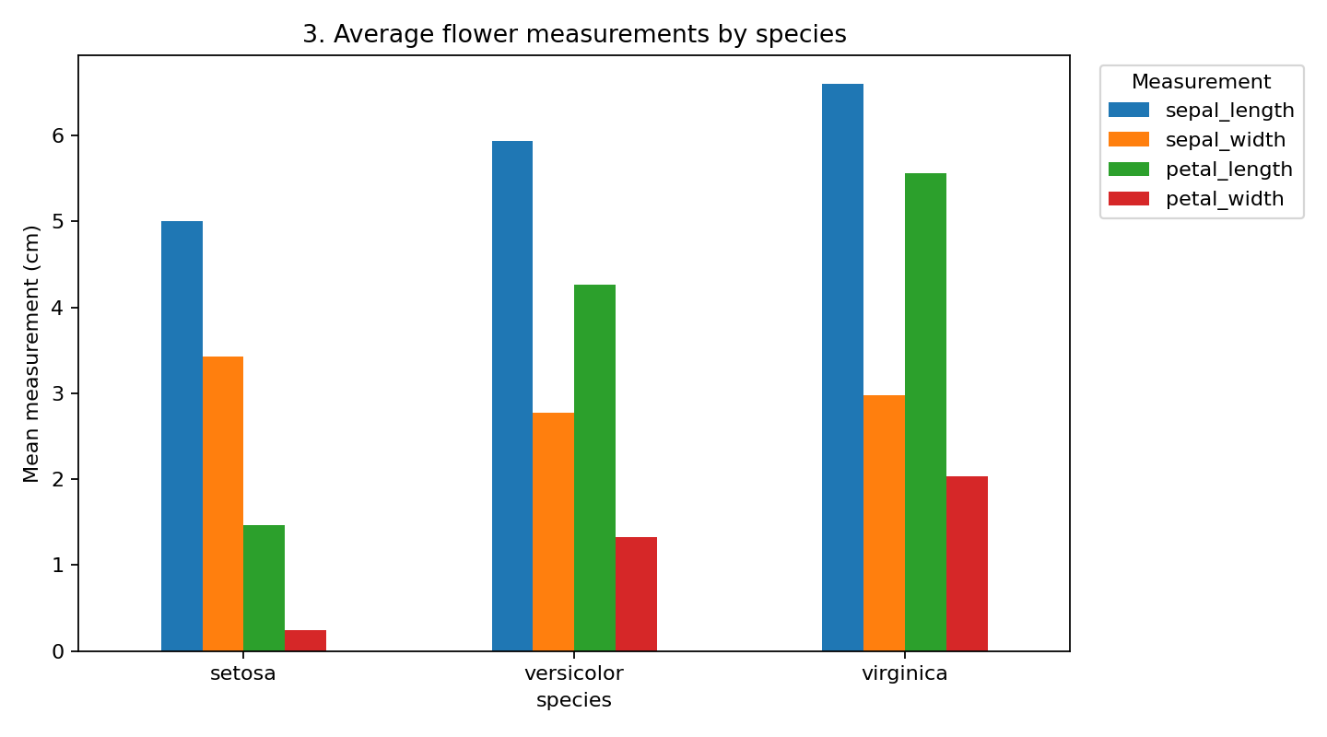
Caption: Grouped bars compare mean sepal length, sepal width, petal length, and petal width for each species. Interpretation: Petal measurements show a stronger visual gradient across species than sepal measurements. Virginica has the largest average petal dimensions, setosa the smallest, and versicolor is generally between them. Why this chart: The grouped bar chart provides a quick summary for an audience that wants to compare typical measurements. Since bars summarize means, the box plot should be used alongside it to understand within-species variability.

7. Visualization 4 — Correlation Heatmap
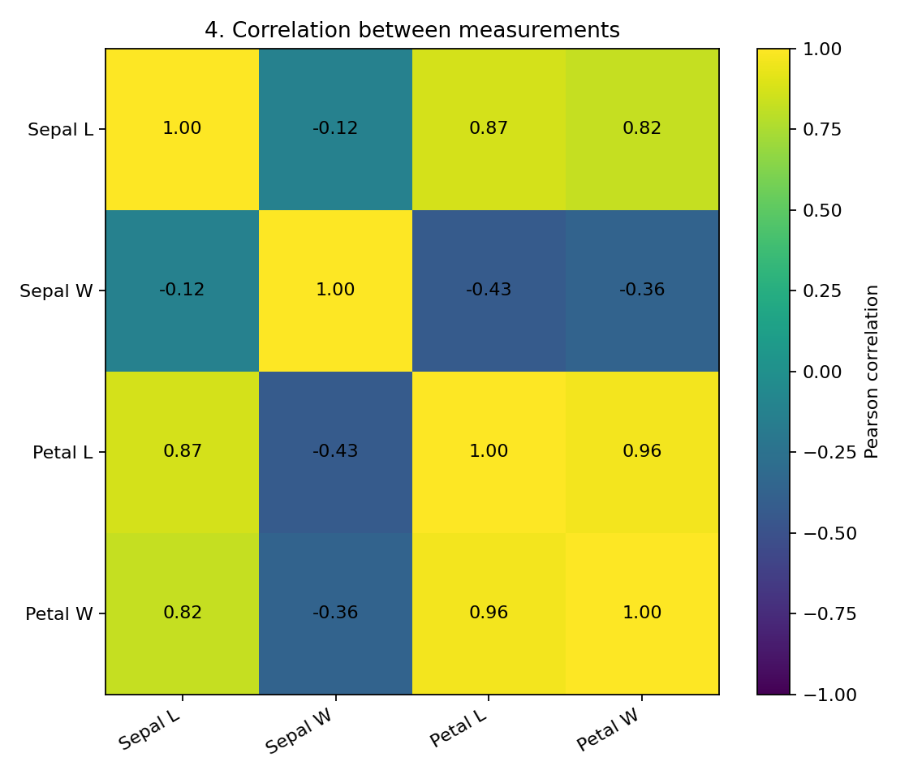
Caption: Each cell displays the Pearson correlation coefficient between two numeric measurements, ranging from -1 to +1. Interpretation: Petal length and petal width have a strong positive association in the Iris dataset: flowers with longer petals tend to have wider petals. Sepal measurements have weaker or more mixed relationships with other features. Why this chart: A heatmap summarizes several pairwise relationships in one compact view. Correlation describes association, not causation, and it does not by itself establish a reliable classification rule.

8. Visualization 5 — Petal Length Frequency
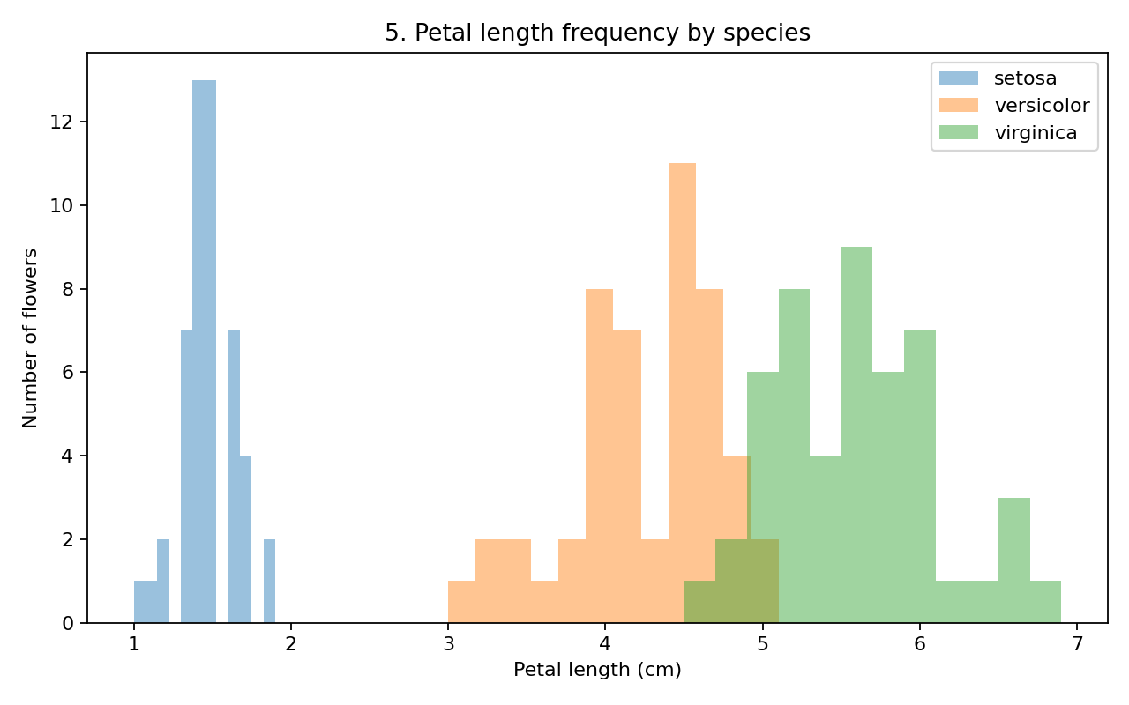
Caption: Overlapping histograms show the frequency distribution of petal length for each species. Interpretation: Setosa forms a distribution at the lower end of petal length, while versicolor and virginica appear at higher ranges. The overlap between the latter two groups explains why a single petal-length threshold may not perfectly separate every flower. Why this chart: Histograms reveal the shape and overlap of distributions. Transparency makes the three groups easier to compare, though overlap can make counts harder to read precisely.

9. Combined Data Story
The visualizations tell a consistent story from different angles. The scatter plot shows that petal length and width create visible species clusters. The box plot confirms that typical petal length differs substantially by species and shows the amount of spread within each group. The average-measurement chart makes the species differences easy to summarize, while the heatmap explains why petal length and width often move together. Finally, the histograms make distribution overlap explicit. Together, these charts suggest that petal dimensions are more useful than sepal dimensions for visually distinguishing the species in this dataset. For a general audience, the practical takeaway is simple: measurements should be considered together, and no single chart tells the full story.

10. Potential Scientific Implications
The analysis demonstrates how exploratory visualization can help researchers identify candidate features for a later classification study. Petal dimensions could be prioritized for further evaluation, while sepal measurements may provide supplementary information. A next step would be to train and test a classification model using a held-out dataset and report accuracy, precision, recall, and a confusion matrix. Any such model should be evaluated carefully rather than assuming the visual separation guarantees perfect predictions.

11. Limitations and Responsible Interpretation
- Iris is a small, classic teaching dataset and may not represent the diversity of flowers encountered in real field research.
- The plots describe patterns and associations; they do not prove that one measurement causes a species difference.
- Two species show some overlap, so a simple visual boundary will not classify every observation perfectly.
- The analysis is exploratory and does not include a separate test set or a predictive model.

12. Reproducibility and How to Run
Install Python 3, then install dependencies:
pip install pandas numpy matplotlib scikit-learn
Run the script:
python analysis.py
The script loads the Iris dataset from scikit-learn and creates a folder named week2_outputs containing the cleaned CSV, correlation matrix, descriptive statistics, and five PNG charts. The charts embedded in this document are the generated report visuals.

13. Conclusion
Five complementary visualizations reveal a clear and consistent pattern: petal measurements, especially petal length and width, provide strong visual separation among the Iris species in this dataset. Setosa is distinct, while versicolor and virginica overlap more but differ in their typical petal sizes. Combining distribution plots, relationship plots, group summaries, and correlation analysis produces a more complete narrative than relying on one visualization. The work provides a reproducible foundation for a future classification exercise while keeping the conclusions appropriately limited to this dataset.

Appendix A — Key Summary Statistics
Species | Sepal length | Sepal width | Petal length | Petal width
Setosa | 5.01 | 3.43 | 1.46 | 0.25
Versicolor | 5.94 | 2.77 | 4.26 | 1.33
Virginica | 6.60 | 2.98 | 5.56 | 2.03

Appendix B — Deliverable Files
This report is the primary DOCX submission. The ZIP accompanying it contains the Python script, cleaned dataset, correlation matrix, descriptive statistics, README, and chart PNGs.

