Week 5: Comprehensive Data Science Project Reporting and Strategic Recommendations

Executive Summary
This project explores the public diabetes progression dataset and trains a Ridge regression model. On a held-out test split, results were MAE=42.81, RMSE=53.78, and R-squared=0.454. A simple training-mean baseline achieved MAE=64.01. This report covers data preparation, exploratory analysis, modelling, evaluation, visual findings, recommendations, and limitations. The dataset and model are for education only, not medical use.

1. Introduction and Objectives
The goal is to integrate data acquisition, cleaning, exploratory data analysis, machine learning, evaluation, visualization, and actionable recommendations into one report. The work aims to communicate technical findings clearly for a non-technical audience.

2. Dataset and Preparation
The scikit-learn diabetes dataset contains 442 observations, ten standardized baseline features, and a quantitative progression target. Data were checked through descriptive statistics and correlation analysis. The target was separated from predictors and the data split into 80% training and 20% testing using random_state=42. Median imputation and standardization are included in a pipeline fitted on training data to reduce data leakage.

3. Methodology and Model Selection
Ridge regression was selected as a regularized linear model. Its L2 penalty can help stabilize estimates when predictors are correlated. A simple baseline predicts the training-set mean for every test record. The baseline allows us to assess whether the model improves on a simple reference.

4. Evaluation Metrics and Results
Mean Absolute Error (MAE) is the average absolute prediction error; lower is better. Root Mean Squared Error (RMSE) penalizes larger errors; lower is better. R-squared measures fit relative to a mean-based reference and can be negative. All model scores below are calculated on the held-out test set.
Model | MAE | RMSE | R-squared
Mean baseline | 64.01 | 73.22 | -0.012
Ridge regression | 42.81 | 53.78 | 0.454

5. Visualizations and Interpretation

Figure 1. Target distribution
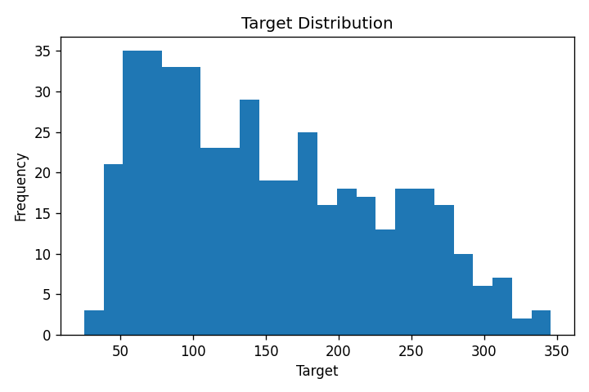
Shows the range and frequency of target values.

Figure 2. Actual versus predicted
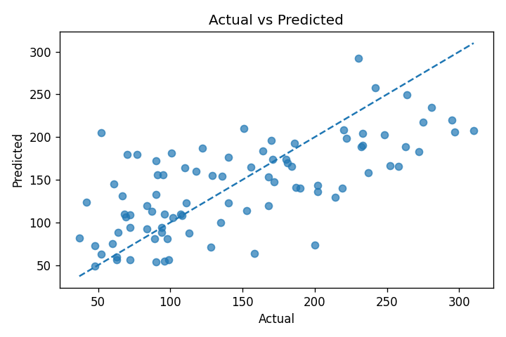
Points closer to the diagonal indicate more accurate predictions; deviations indicate prediction errors.

Figure 3. Residual analysis
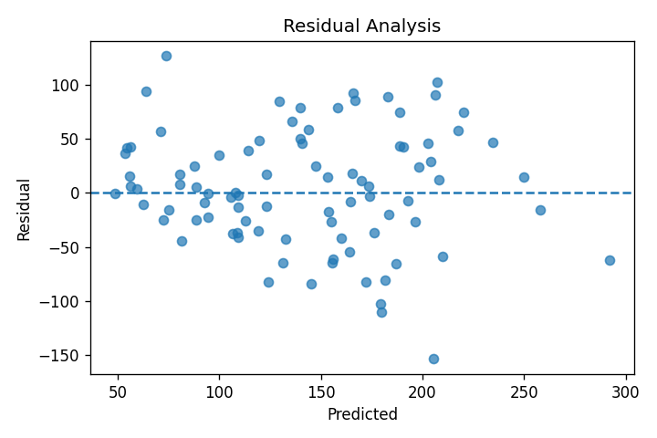
Residuals are actual minus predicted. Patterns may indicate model limitations.

Figure 4. Model comparison
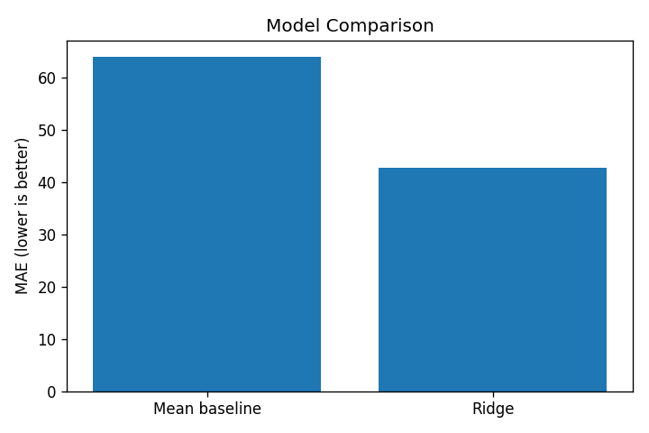
Compares average absolute error for the baseline and Ridge model; lower MAE is better.

Figure 5. Feature-target correlations
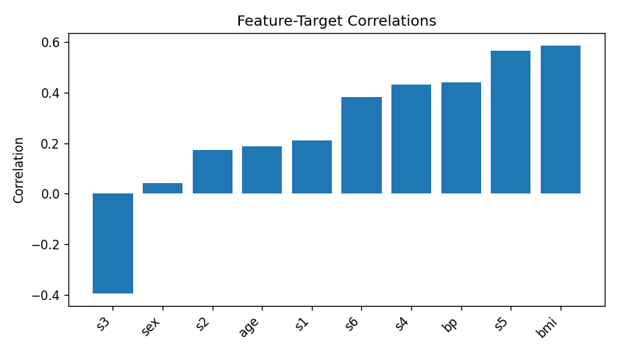
Shows linear associations between predictors and target; correlation does not establish causation.

6. Strategic Recommendations
- Use a documented data-quality checklist for missing values, duplicates, types, and unusual observations.
- Keep preprocessing in a pipeline and fit it only on training data to reduce data leakage.
- Compare models with a simple baseline and use several metrics rather than accuracy or one score alone.
- Use cross-validation and tune the Ridge alpha parameter on training data before final model selection.
- Explain uncertainty and limitations to stakeholders; do not treat correlation as causation.
- Do not use this educational dataset or model for diagnosis or treatment decisions.

7. Limitations and Future Improvements
The dataset is small and reflects the original study population. One train-test split may give variable estimates, and a linear model may not capture nonlinear relationships. Future work could use cross-validation, tune model parameters, compare alternative regressors, and validate on independent data. Any real-world health application would require rigorous external validation and qualified oversight.

8. Conclusion
The project demonstrates an end-to-end workflow from data preparation and EDA to model evaluation and recommendations. Ridge regression was compared with a simple baseline using MAE, RMSE, and R-squared. Visualizations explain the target distribution, prediction errors, model comparison, and feature relationships. Findings are educational and should not be generalized without further validation.

9. Reproducibility
Install dependencies: pip install pandas numpy matplotlib scikit-learn. Run analysis.py. Included project files: Python code, dataset CSV, descriptive statistics, feature correlations, model metrics, test predictions, README, and five charts.

