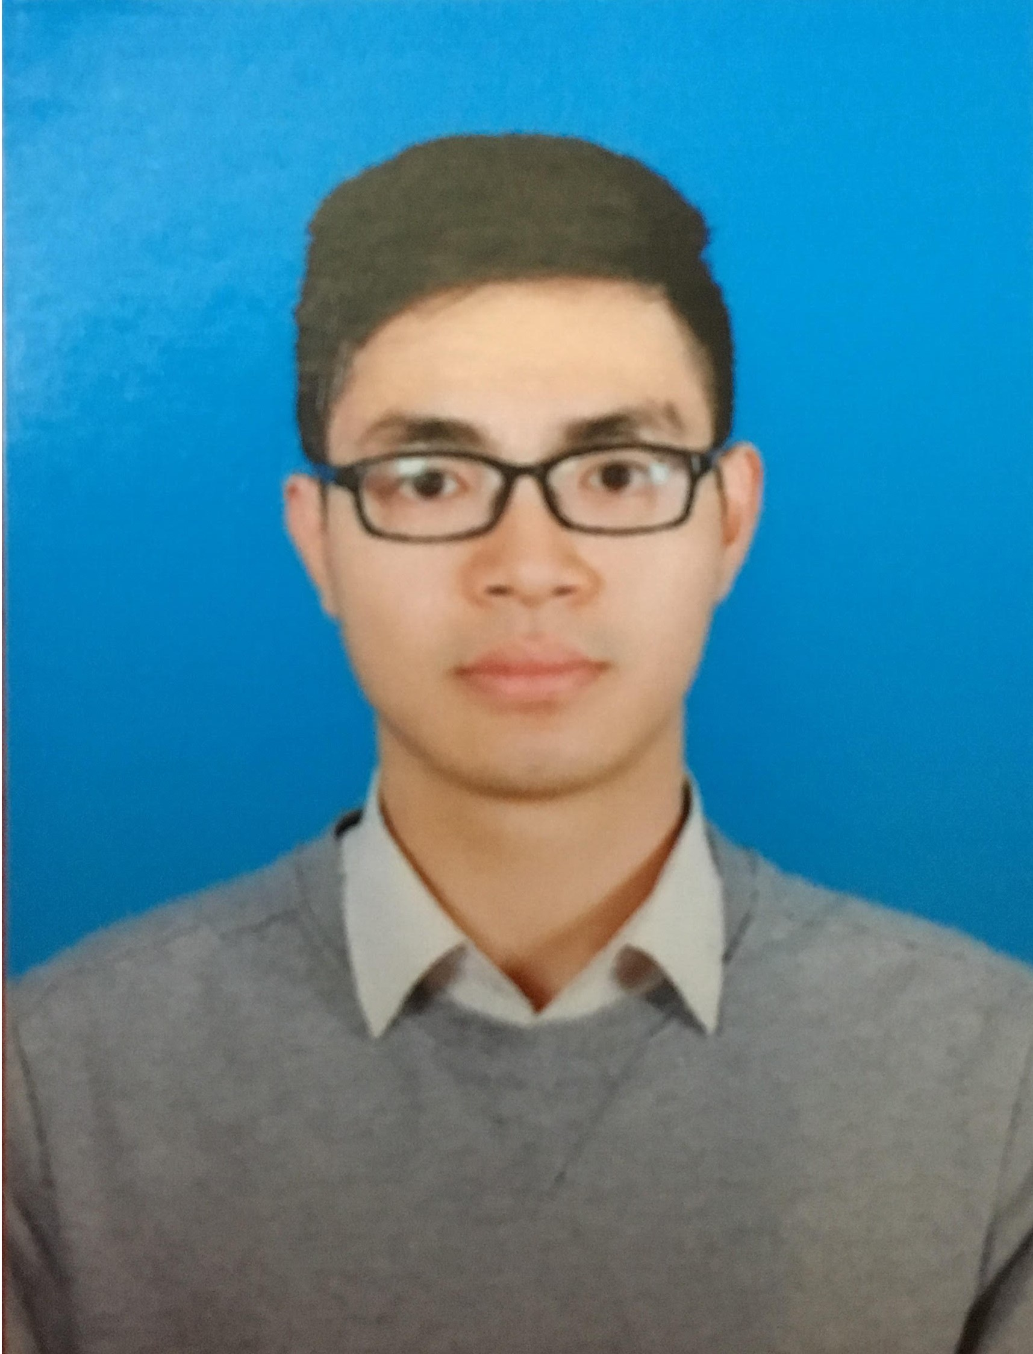 | CURRICULUM VITAE  Position apply: Product Specialist  Salary: Negotiate  Available for new job:

I. PERSONAL INFORMATION
Full name: Hoang Khac Quang |  | Gender: Male
Birthday: 25/09/1992 | Born: Thanh Hoa | Home town: Hoang Dao, Hoang Hoa, Thanh Hoa
ID: 038092008266 | Date: 27/11/2017 | Issued in: Thanh Hoa
Height: 175 cm | Weight: 65 kg | Health status: Type A
Marital status: Married | Ethnic: Kinh | Religion: No
Address: 1520 HH03 2.1 B Thanh Ha, Thanh Oai, Ha Noi
Phone: 0964088855 | Email: hoangkhacquang259@gmail.com | Facebook: https://www.facebook.com/khac.quang.5
II. Family Information

Name | Relationship | Birhday | Job | Address
Đào Thị Yến | Wife | 18/06/1994 | Architech | 1520 HH03 2.1 B Thanh Ha, Thanh Oai, Ha Noi
Hoàng Yến Ánh Dương | Daughter | 19/12/2019 | New Born | 1520 HH03 2.1 B Thanh Ha, Thanh Oai, Ha Noi

III. MY GOAL IN MY LIFE
Become a Senior Executive, contributing value to the company, family, society.

IV: STRENGTH:
- Many years experience in the pharmaceutical business
- Experience in the field of product development, training, presentation and professional management
- Experience developing new product, new hospital
- High motivation, help colleages in work and life
- Compassion, high expertise, strong spirit, logical thinking, enthusiasm.

V: WEAKNESS
- Experience and knowledge are still limited
- Sometimes not assertive at work
- Sometimes not careful on the paperwork
- Loving life so sometimes have puzzle situation
- Living upright, it’s hard to be with the liar.
VI: HOBBIES
- Research for the new application, new thinking, new ideas, new product
- Reading books, watching TED talk and Steve Job’s presentation
- Do charity and join clubs and unions
- Travel, swimming, running, play football.

VII: TRAINING PROCESS

From 2010-2015
- Graduated Regular at Hanoi University of Pharmacy
Type of education: Regular
Deagree: Good (GPA: 7,89)

- Other certificate
- English (communication)
- Applied informatics

VIII: WORK PROCESS

From 2015-2016 | From 2016 – April 2019 | From April 2019 - Now | Other Part time Work
SOHACO GROUP  Address: 11th floor, Hapulico, 1 Nguyen Huy Tuong street, Thanh Xuan, Ha Noi  Position:  Product manager  Line Manager: Hoàng Thị Diệu Huyền, Head of R&D department  Phone: 0982.210.018  Web: http://sohacogroup.com.vn/  Main job:  Responsible for professional management of product line. Training marketing team, sales team and pharmacy staff. Market analysis, search for new product to import or manufacture  Scale of work:  -Quantity of product management: 10  -Turnover of 10 billion/year  Reason for leave  Not fully promoted. | ASTRAZENECA VIET NAM  Address: 4 Da Tuong street, Hoan Kiem, Ha Noi  Position:  Medical Representitive  Line Manager: Ha Bich Thuy, Head of Oncology Ha Noi  Phone: 0988.922.782  Web: www.astrazeneca.com  Main job:  1. Develop neurological branch at specialized and general hospitals:  High sales volume (7/8 quarter) with area growth over 50%  Develop maximum representation skills:  Leadership skill: level C  Presentation skill: level C  Territory Action Plan: level B+  2. Launching new cancer products name “Tagrisso” for Non-small cell lung cancer patient. Gain patient from KEEs Doctor: Pham Cam Phuong, Vu Huu Khiem, Dang Van Khiem, Le Thi Khanh Tam… with fast sale growth  Cancer fields in hospitals: Bach Mai, Lung Central, Huu Nghi, Medicine hospital Hanoi Cancer, Hong Ngoc hospital...  - Reason for leave  Not fully promoted. | VINACARE JOIN STOCK COM.  Address: No 18 lane 19/15 Kim Dong Street, Hoang Mai, Ha Noi  Position:  Area Manager  Line Manager: Trần Quốc Hưng, Regional Manager North Province  Phone: 0977.903.388  Web: www.vinacare.vn  Main job:  - Manager Employee:  - Manager 2 employees, recruitement, traning and support them in field  - Monitor and evaluate employees monthly  - Manager customer  - Maximum 2 months get contact and face to face customer with Rep together  - Complete and make sure achieved target.  Reason for leave  Not achieved income | Participate in teaching specialies of Pharmacy College.  Join and develop the Couchsurfing, Sysdo and Spotlight English club

IX: HIGHLIGHTS ACHIEVEMENT
- After 2 years of development on the field of neuroscience in specialized and general hospitals, growth over 50%/year, sales increase 1000% in National Geriatric hospital and Friendship hospital.
- Launching successful “Tagrisso”, product treatment Non-Small Cell Lung Cancer.
- After 2 years of working at AstraZeneca, winning many awards: Exellent Pharmacist (2017), MRs exellent skill (level C). Promoted Senior Medical Representative in just 2 years working in AZ.
X: COMMITMENT
Ha Noi: Date 01 Month 02 Year 2020
Hoang Khac Quang
I declare that the information provided above is true. I agree to let the company investigate what I have stated. I am entirely responsible if the information is false. I sincerely thank!

