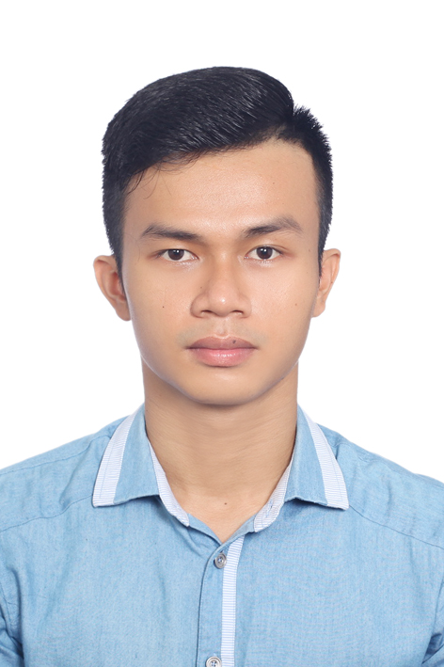

CURRICULUM VITAE

PERSONAL INFORMATION
Full name: DAO DUC MINH
Date of birth: 01/05/1994
Place of birth: Phu Yen Province
Class: D2012B – Faculty of Pharmacy
University of Medicine and Pharmacy, Ho Chi Minh City
Contact address: 115/98A Le Van Sy Street, Ward 13, Phu Nhuan District, Ho Chi Minh City
Contact number: +84.165.989.1145
Email address: ducminhd12@gmail.com
Marial status: Single
EDUCATION
- October 2012–July 2017: Student in Faculty of Pharmacy, University of Medicine and Pharmacy at Ho Chi Minh City
- July 2017– Now: Medical Affair Executive in Allergan Vietnam. Key responsibilities
  - Support Medical department in clinical facilitation, anatomical training and internal research.
  - Logistic arrangement for Advisory Board Meeting, Hospital Director discussion
  - Development Medical affairs activities, training tools.
  - Working with speakers, training centers to set up workshop, meeting
  - Medical affairs document archiving (translation, interpret clinical trials, prepare slide deck)
CAREER OBJECTIVES
- Work in a professional and dynamic environment
- Expand social and work relationships.
- Improve crucial working skills: teamwork, communication, presentation, leadership…
- Have good knowledge of clinical research.
PERSONAL QUALITIES
• Strengths
- Hard-working, willingness of learning and broadening my knowledge.
- Good performance in both group and individual tasks.
- Good time management in dealing with deadlines and high pressure job.
- Highly adaptable to new working environment.
- Weakness
- Not have enough experiences.
HOBBIES
- Playing sports (e.g., go swimming, playing football, playing table-tennis…).
- Reading books, newspapers; listening to the music and watching movies.
- Travelling and exploration.
ACHIEVEMENTS
- December 2015: Poster Presenter in The 1st International Conference on Pharmacy Education and Research Network of ASEAN (ASEAN PharmNET1) held in Bangkok, Thailand.
- August 2016: First Author of a study called “A literature review on influenza treatment costing studies” published on International Research Journal of Pharmacy.
- December 2016: Get into semifinal on English Speaking Contest hold by Pharmacy English Club.
- November 2017: Being an interpreter for Situational Leadership Workshop (2 days).
- December 2017: First Author of a research called “Socioeconomic burden of community-acquired pneumonia associated hospitalizations among Vietnamese patients: a prospective, incidence-based study” published on ClinicoEconomics and Outcome Research
ACTIVITIES
- February 2013: Participant in charity activity called “White Blouse Volunteer”.
- March 2014: Participant in an English competition called “Raising the spirit”
- 2014-2015: Participant in many charity works namely “Blood Donation”, “Running for Social health”, “Distribution Christmas for the poor and homeless people”.
- July 2015: Joining Healthcare Management Research Group.
- March 2016: Participant in Traditional camping 26/3/2016, a member of “Funding group”, “Drama group” and “Planning group”.
SKILLS
• Language Skill
- Proficient communication in English
- Able to do presentation in English
- Able to read, understand and write English documents
- IELTS 7.0 (All skills above 6.0) – Test day: September 21st 2017.
- Computer Skill
- Proficiency in MS Word, MS Excel, MS Power Point, Internet and Email
- Proficiency in using Skype, MS Outlook.
- Communication Skill
- Developed from extracurricular activities and group working.

