CURICULUM VITAE

Updated on: Feb 28, 2018

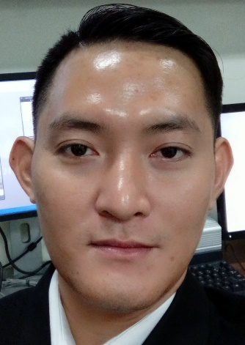
PERSONAL DETAILS

Full name : QUAN DINH CHANH
Gender : Male
Date of Birth : 22 July, 1984
Place of Birth : Dong Nai Province
Marital Status : Single
Nationality : Vietnamese
Hand-phone number : +84 983 675 004
Email : quandinhchanh@gmail.com
Address : 14, Calmette Street, Ward 4, District 1, Ho Chi Minh City

WORKING EXPERIENCE
From May 2016 up to now: GENTIS JOINT STOCK COMPANY
Position: Area Sales Supervisor
Main duties:
- Make business plans to promote company’s services and achieve target
- Deploy marketing campaigns to wide range of people and potential customers (organize mini talk-show at hospitals, deliver brochures and leaflets at public places, coffee shops,…)
- Introduce company’s services to partners and potential customers.
- Work with hospitals, doctors, testing labs, clinics,… to persuade them to be our agent/partner in introducing and selling services to end customers.
- Directly support doctors by consulting company’s service to end customers.
- Regularly visit company’s agents to take good care of them and maintain good relationship.

From Sep 2014 to May 2016: IN CON PHARMA CO., LTD
Position: Medical Representative
Main duties:
- Promote and sell company's products to Cho Ray Hospital, Binh Dan Hospital, District 4 Hospital, Minh Anh Hospital,...
- Closely work with doctors, nurses and pharmacists.
- Increase product awareness, answer queries, provide advice and introduce new products.
- Complete sales task given by company within specific deadline.
- Aware the market changes and provide the market/working feedback to the company
- Brief the current products as well as introduce new/upcoming products to customers
- Make phone calls, visit, make presentation about products to current and potential customers.

From May 2012 to August 2014: STELLA HEARING CENTER CO., LTD
Position: Sales & Consulting Specialist
Main duties:
- Interview patients to know their symptoms and medical histories;
- Conduct screenings and tests to determine the severity and type of hearing impairment;
- Carry out basic hearing test such as bone conduction, air conduction, speech audiometry tests, etc.;
- Analyze test findings to make diagnoses, then discuss possible solutions with patients;
- Recommend and dispense assistive listening devices;
- Take measurements and make ear molds to ensure that hearing aids fit properly;
- Guide patients how to use and maintain the devices, providing demonstrations and information;
- Assist audiologists with nonsurgical procedures designed to treat hearing disorders;
- Modify devices that have already been placed in patients’ ears, to make them function properly or fit better;
- Make repairs and replace defective parts;
- Teach patients aural rehabilitation techniques;
- Create and maintain customer computer files;
- Train other staffers, if required by the employer;
EDUCATION
From 2012 to 2016 University of Medicine and Pharmacy. Major: Pharmacy.
From 2005 to 2010 University of Natural Sciences. Major: Bio-technology.
SKILLS
- Logical thinking
- Good communication skills (English and Vietnamese)
- High learning ability, can grasp new job in short time
- High adaptability, easily adapt with new working environment
- Proficient Computer (Microsoft Word, Excel, Outlook Express, Power Point)
INTERESTS
- Reading books, Meeting people, Traveling, Watching movies, Music, Learning English, Searching web, playing video games.
OTHER ACTIVITIES
- Part-time job as car-driving Teacher.

