COVER LETTER

Dear Ms./ Mr of Human Resource Dept’s,

I’m glad to know Regulatory Affairs position in Rohto Metholatum company which is posted on website. Looking in information due to your company, I’m really excited about not only is modern working environment but also significantly developing direction in the future. As I know, your department requires the staffs who is professional, hard-working, friendly and so on. It is helpful chalenge to me for improving my skills if I have opportunity to work in that position at one of your company. Therefore, I have written this letter to introduce myself for applying in this job.

With my interested background knowledge, I believe that I have completed factors to be one of the most appropriate candidates for this position. First of all, I had graduated in International University, Viet Nam University, HCMC, so I can use fluently English in my job. Secondly, I had graduated the Pharmacist major in Medical and Pharmacy University, HCMC, from this school, I was understood generaly about testing drugs, standards for expertising drugs and i know what is the manufacturing process and how to validate it and so on that are helpful for my job. Espectially, I have work on RA staff position at An Phat company about one year so I absorbed many experiences of new registration, registration for changed or suplement dossier. Moreover, I am not only a person that easily adapt to new and high pressure environment , but also a man who is enthusiastic, open minded, caring and resourceful, studious to give my whole mind on work, especially on teamwork. If I have opportunity to work in your company I will try mybest to give over all my energy and my knowwlegde to serve patient and to contribute in development of your company.
Thank you for considering my application. If you would like to consider me as a right candidate and need more information, please feel free to contact me via email address vyvythitran@gmail.com or phone number 0989485172. I would very appreciate the opportunity of working for you.
Sincerely,

Tran Thi Vy Vy.
CURRICULUM VITAE


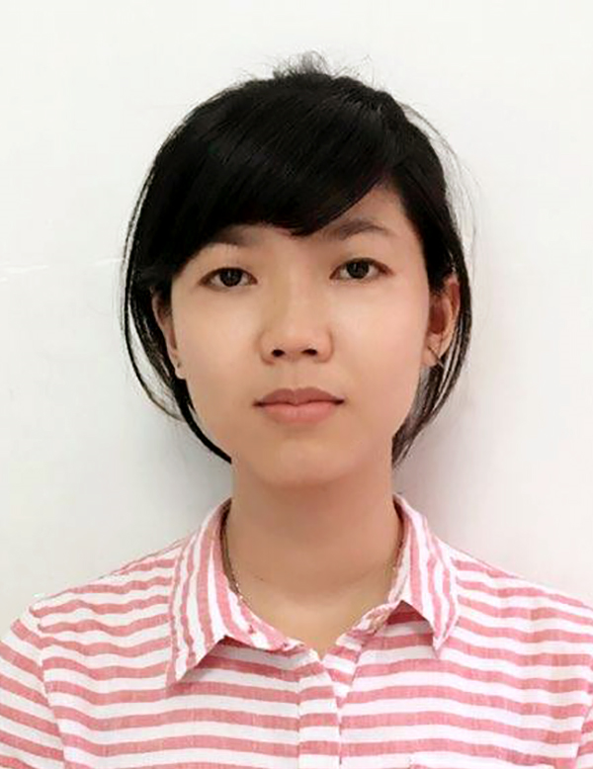
Name: TRAN THI VY VY |  | Female
Date of birth: 20 March, 1988 |  | Nationality: Viet Nam
Home town : Dong Nai |  | Phone number: 0989485172
Resdential address: 280/110, Bui Huu Nghia Street, Binh  Thanh district. |  | Email: vyvythitran@gmail.com
Identity card: 271902975 | Date range :  04/08/2004 | Nationality: Viet Nam
2. EDUCATIONAL PROCESS
Name of shool | Major |  | Durtion
Nguyen Huu Cau High School , District 12 |  |  | 2003 – 2006
International University- National university-HCM city | Biotechnology |  | 2007 – 2012
Medical and Pharmacy University, HCMC | Pharmacist |  | 2013-2017

3. FOREIN LANGUAGE
Type of language | - Required level of International University  - IELTS from British Coucil
English
4. OTHER SKIL
 |  | Very good | good | normal | bad | Strong points | Weak points
translating |  |  | x |  |  | Strong points | Weak points
Typing |  | x |  |  |  | • Having reponsibility  • Hard working  • Enthusiastic  • Open minded  • Caring  • Resourceful  • Studious | Laking experiment in restaurant
MS Word |  | x |  |  |  |  | Laking experiment in restaurant
MS Excel |  |  | x |  |  |  | Laking experiment in restaurant
Others |  | • Good in working group  • Good in time organization  • Good in communication |  |  |  |  | Laking experiment in restaurant
5. IMPLOYMENT HISTORY
Name of Company |  |  |  | Duration |  | Position
Auntie anne Cooke Bakery in  Bitexco centre |  |  |  | 04/20011 –05/2012 |  | Saler  Accumulated experiment:  - Improved communicated skill by English with foreiner.  - Learned basic skill of sale  - Learned the good way to approach

International University- HCM city | 1/2013 – 1/2016 |  | Lab management:  - Arranging doccuments and file related lab  - Organizing and arranging eqiupment and chemical in Lab room  - Helping student for science research  - Arranging time table for using Lab room  Accumulated experiment:  - Developed skill of job arrangement  - Making good communicating with boss and student.
An Phat Company | Now |  | Preparing, filing and register drug dossier from exporting country to DAV for getting visa number.
6. EXTRACURRICULAR ACTION
Type of action |  | time |  | Posision | Achivement
English club at University and  Binh Thanh district |  | Now |  | member
Art and fashion contest |  | During studous time |  | model
Joining in show Run For Poor people |  | During studious time |  | member
7. TARGET
Orientation : I want to work in a pharmaceutical company where have good environment for me to get more expirement and to become a good RA in the future.
Job Target: trying to finish my work, learing and getting more expirement to build the steady basic for
larger target.

HCM city, 03/06/2018
Candidate
Vy Vy

