Curriculum Vitae

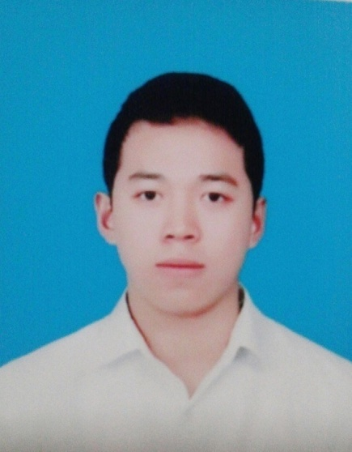 | Personal contact information  Name :TRAN XUAN THAI  Date of birth: 21/02/1991  Address: No. 25 Lane 4, Cuong Ngo Village, Tu Hiep Ward, Thanh Tri District, Ha Noi City, Vietnam Country.  Phone number: 01656145723  Email: tranxuanthai1991@gmail.com

APPLICATION POSITION

MEDICAL REPRESENTATIVE

EDUCATION

2012-2014 | - Studied at Ha Dong Medical College  - Majors: College pharmacist  - Degree Classification: Good
JOB EXPERIENCES

1/2012 - 6/2014 | - Working at: Tan A Pharmaceutical Company  - Job description: Packing workers and support other parts
1/2015 - 6/2015 | - Working at: AD distribution company  - Job description: Medical representative  - Replace old employee for 6 months
7/2015 - 7/2018 | - Working at: Zuellig pharmaceutical Company  - Job description: Sales consultant  - Worked in 3 districts : Hoan Kiem, Hoang Mai, Thanh Xuan, cover 200 pharmacies
SKILLS

- Enthusiastic, responsible and can work under high pressure.
- Good computer skill: can use Word, Excel, Power Point and searching information via Internet.
- Abitity of finding, analysing and summarising information of specialist.
- Open-minded and friendly in communication.

HOBBIES

- Reading books: economic books. education books
- Surfing Internet for information and maintaining friendship.
- Watching Television, listening to music.
- Playing sports: Jogging, playing badminton.

The Applicant

TRAN XUAN THAI

