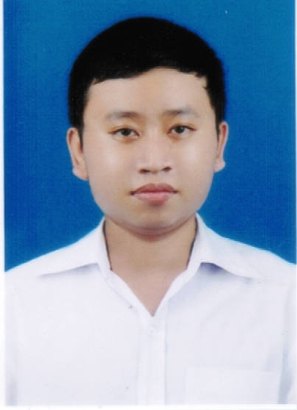
CURRICULUM VITAE

PERSONAL INFORMATION
Full name: NGUYEN LUONG HUY |  | Sex: Male
Date of birth: 07/10/1994 |  | Place of birth: Lam Dong
Nationality: Vietnam |  | Marital status: Single
Permanent address: 6/57 Nguyen Luong Bang street, Truong Luu, Truong Dong, Hoa Thanh, Tay Ninh
Current address: 416/6/17 Lac Long Quan, Ward 5, District 11, Ho Chi Minh City
Hand phone: 0977 430 845
Email: nguyenluonghuy71094@gmail.com

CAREER OBJECTIVE
- Short-term goal: Take advantages of saless kills and experiences, understand of market to become a professional Medical Representative and bring a lot value to customers. From that,I will contribute to increase sales of company and promote the company's brand.
- Long-term goal: Make a long-term contribution to my company, become a Sales Manager within ten years.
EDUCATION
2009-2012  2012-2017 | Hoang Le Kha High School  - Major: Biology  Can Tho University of Medicine and Pharmacy  - Major: Pharmacy  - Grade: Good  - GPA: 7.1/10
WORKING EXPERIENCE
September 2017 - March 2018  April 2018 - Present | Medical Representative in HOCOMED COMPANY  Main responsibilities:  - Provide information of product for doctor.  - Expand locality.  - Evaluate, classify, and identify precise target customers. Prioritize potential territories.  - Establish & maintain close relationship with key accounts  - Monitor market trends and competitor activity in assigned territory.  Workplace  - Department of Otolaryngology - Hospital: An Binh, Nguyen Tri Phuong, Trieu An, Cho Ray, Thong Nhat, 115, District 4, District 11.  Achievements and skills gained:  - Achieve target.  - Improve communication skill.  - Have good relationship to doctors.  - Learn how to live and work under pressure.  Medical Representative in DKSH Vietnam Co., Ltd.  Main responsibilities:  - Product: Cardiology – Respiratory of MSD: Cozaar, Hyzaar, Singulair, Aerius  - Provide information of product for doctor.  - Expand locality.  - Evaluate, classify, and identify precise target customers. Prioritize potential territories.  - Establish & maintain close relationship with key accounts  - Monitor market trends and competitor activity in assigned territory.  Workplace  - Hospital: FV, Tam Duc, Gia Dinh, District 8, District 7, District 4.
SKILLS AND PERSONALITY
- English: general communication
- Computer proficient (Microsoft Word, Excel, PowerPoint )
- Good at communication and convivial person.
- Ability to work independently as well as within a team
- Enthusiastic, optimistic.
- Responsible for self-actions and hard- working
- Eager to learn new knowledge and skills
- Ability to adapt to changing work enviroment.
- Abilities to work well under pressure and deadlines

I, the undersigned, certify that, to the best of my knowledge and belief, this CV correctly describes my qualifications and my experience. I understand that any willful misstatement described herein may lead to my disqualification or dismissal.

NGUYEN LUONG HUY

