Curriculum Vitae
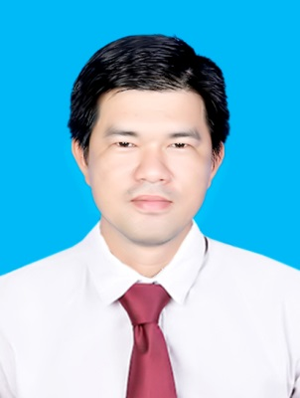

HO SI TAN

CAREER Objective:

SALES

PERSONAL DETAIL

Date of birth: August 05th ,1987 Place of birth: Dong Thap
Address: Dist. Binh Tan, HCMC.
Mobile: 0907.887.068
Email: hotands0508@gmail.com
Health: Good
Marital Status: Single

EDUCATION

- 2007 – 2011
+ Degree: Chemical bachelors
+ Major : organic chemistry – University of Industry, HCMC
- 2012 – 2017
+ Degree: pharmacist – University of Medicine and Pharmacy, HCMC

WORK EXPERIENCE

- June 2016 – may 2018 : QUEISSER PHARMA
+ Position: Sales
MasterTran Corporation was established in 2010, mainly engaged in the import of medicines and medicine materials. Since 2013, the company is the exclusive representative in Vietnam of Queisser Pharma Germany. The company is distributing Doppelherz branded products with a history of more than 100 years of development and is claimed to be the No.1 quality in Germany and Europe.
+ Key Achievement:
- Expanding market, establish relationships with Customer
- Receiving and dealing with customer feedback on products.
- Maintaining former key products, expanding new key products
- Attending the company's training courses to improve communication skills, presentation, sales skills.
- Always achieving target > 95 %/quarter.
- June 2018 – Oct 2018: BESINS_HEALTHCARE
+ Position: Sales
Besins Healthcare is a multinational pharmaceutical company founded in 1885 in the Kingdom of Belgium - the European Community. With a history of more than 100 years, Besins has its main manufacturing plant in France and is expanding its business. Globalize more than 90 countries. Besins Healthcare specializes in the development and production of reproductive health pharmaceuticals, improving the quality of life for male and female obstetricians and gynecologists and is also thriving in the areas of assisted reproductive health. men, cerebral edema, food supplement.
+ Key Achievement:
- Expanding market, establish relationships with Customer
- Receiving and dealing with customer feedback on products.
- Maintaining former key products, expanding new key products
  - Attending the company's training courses to improve communication skills, presentation, sales skills.

OTHER SKILLS

Computing | Soft Skill | Foreign Language | Sale – Marketing knowledge
Microsoft Office (Word, Excel, Power Point) | + Time management  + Problem solving  + Presentation | English:  + Communication: pretty  + Write: pretty good | Marketing:  + Customer marketing organization.  + Integrated construction plan  Trade:  + customer care  + Point of sale expertise  + Expanding leads

SOCIAL ACTIVITIES

+ join members

+ participate in charitable activities

HOBBIES AND INTERESTS

- Having inquiring, creative and humorous mind & love to join social activities & community.
- Dynamic, enthusiasm, enterprising and having sense of responsibility
- Work hard and team work.
- Strong analytical thinking.

STRENGTH AND WEAKNESS

- Strengths: Good in data screening, opportunity finding and problem solving.
- Weakness: Straight communication.

REFERENCES

- sporting
- creative
- photograph
- traveling, volunteer...

