Cover letter
Pham Hong Nhung
460 Khuong Dinh, Thanh Xuan, Ha Noi
Tel: (+84) 979 625 835
Email: Nhungpham90hup@gmail.com .
APPLICATION FOR MEDICAL REPRESENTATIVE
DKSH Pharmaceuticals, Hanoi City
Attn: Human Resources Management.
Re: Medical representative position.

Dear Sirs/Madams,
I would like to apply for the Medical Representative position which has been recently posted. DKSH Pharmaceuticals is internationally recognized as a leading pharmaceutical company with professional staff, dynamic and creative working environment. Having the chance to work and dedicate for the company will be a great journey for me.
After having graduated from Hanoi University of Pharmacy in 2014, I worked in the pharmacy department of Son Duong General Hospital in one year as a pharmacy storekeeper. Thanks for this period, I have built up my skills and acquaintance in drug sales, medicine forcasting and pharmaceutical statistics. Now I am a Medical Representative at Tedis company, I have knowledges and experiences in selling skill and communicate, customer care skills.
Besides those experiences that I have gained during my study and my last job, I am also an active and enthusiastic person. Hardworking, socially confident and willing to take responsibilities are three major characteristics that help me work effectively. These strong points would inable me to fullfill the required tasks as a potentially successful Medical Representative.
I am ready for a detailed discussion about my abilities, your requirements and your offers. This would be a fruitful interview, I believe.
Ha Noi, March, 25th, 2018
Yours faithfully

Pham Hong Nhung
CURRICULUM VITAE

PERSONAL INFORMATION
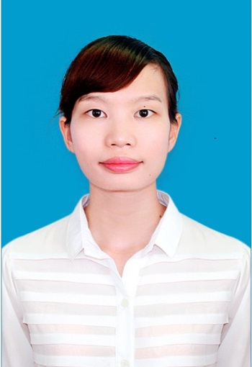
Fullname: Hong Nhung Pham
Gender: Female
Date of birth: 16th Aug 1990
Phone number: 0979.625.835
Email address :Nhungpham90hup@gmail.com
EDUCATION
- 2001-2005 : Tan Trao Secondary School (award for good colored painting competition which was organized by ethnic minority magazine in 2001, 3rd prize of Chemistry in the provincial competition in 2005, scholarship in July 2005 for good studying performance)
- 2005-2008 : Son Duong High School
- 2009-2014 : Hanoi University of Pharmacy

PROFESSIONAL EXPERIENCE
- 06/11/2017 – now : Medical representative at Tedis company.
- 01/05/2017 – 04/11/2017 : Medical representative at Ikamed company.
- Have experiences in selling skill and comunicating skill
- Have care customer skill and handling case
- 01/9/2014 – 30/10/2014: probation at pharmacy department of Son Duong General hospital.
01/11/2014 – 31/10/2015: Storekeeper at pharmacy department of Son Duong General hospital. Main responsibilities:
- Involved in drugs sale activities.
- Made medicine forecasting.
- Performed statistical calculations.
- Introduce product to doctors for sales: Collaborated with doctors in prescriptions and delivery medicines to patients.

OTHER EXPERIMENTS
- 03/2013 : Participant in Pharmacovigilance training course delivered by a French Expertise.
- 2009 : Completion of 02 courses of ‘Effective Communication Skill’ and ‘Convincing Representation Skill’ organized by Tam Viet Organization.
- 2010 : Member of Newvision club organized by Student Union – Hanoi University of Pharmacy. Completion of ‘Time Management’ course organized by the Culb in coperation with Tam Viet organization.
- 03-2014 : Completion of ten-hour course of ‘Real experiment in professional working environment’ organized by Eduhub group.
OTHER SKILLS
- Good communication.
- Good computer skills.
- Ability to work independently, being active and enthusiastic.
- Well co-operation in group working.
HOBBIES
- Singing, playing basketball, listening to music and travelling.
I undertake that all the details above are true and I’m looking forward to have an interview so you can find how ambitious I’m.

