CURRICULUM VITAE

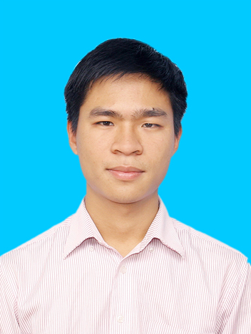 | Full name: Pham Quoc Hoan  Gender: Male  Date of birth: 28th November, 1990  Email: Hoanpharm@gmai.com  Mobile: 0918.196.626  Permanent place of residence: Xuat Hoa, Lac Son, Hoa Binh  Current address: P9.14 – CT4 EcoGreen City Dept, Tan Trieu, Thanh Tri, Ha Noi  Marital status: Married

EDUCATION QUALIFICATIONS
2008-2013: Ha Noi University of Pharmacy.
Major at Clinical of Pharmacology. Graduate at good.
2005-2008: Hoang Van Thu gifted high School, Hoa Binh province.
Graduate at good.

WORKING EXPERIENCE
- Medical Representative at AstraZeneca from 05 January 2015.
Responsibilities:
- Represent Oncology products: Faslodex, Zoladex, Arimidex, Casodex at K1, K2, K3 Duc Giang, Vinmec, Da Khoa Ha Noi, YHPX QD, 103, DK Ha Dong Hospts.
- Deep knowledge in actual sales, the rest of quota, tender process and Doctor’s adoption. Monitor KAM, TAP monthly and make change promptly.
- Building Customer Relationship, especially KEE. Make plan clearly
- Make a long-term and short-term plan. Do the priority action
- Looking for prescription barriers and resolve them.

My Experiences and achievements
- To be a Trainee of First line Manager in October 2017, Have been trained Coaching Skill in April 2018. Control Team’s Activities Plan.
- To be a Senior Med Rep and Best Med Rep in February 2017. Have a good performance in 2017: Achi 134%, Grow 27%.
- To be a leader of self-training for Onco HN2 team
- Leader Ship Selling skill high lever at the audit in November 2016; Territory Action Plan high level
- Tender Listing Oncology products, Follow up tender process, support KA team.
- K hosp win Tender 2017: Zoladex 5.500 boxes (Growth 22%), Arimidex 50.000 Tabs (Grow 233%, National Tender), Casodex 10.000 tabs, Faslodex 250 boxes.
Persuade KEEs offer Faslodex to Insurance Payment list.
- YHPX: Listing Zoladex 150boxes
- Duc Giang: Listing Zoladex 50 boxes.
- Da khoa Ha Dong: Listing Zoladex 130 boxes, Arimidex 600 tabs
- 103 Hospitals: Clear Quota, build new quota 2018: Zoladex 30boxes, Arimidex: 70 boxes.

- Sales and Tender at VIETMEC (Vietnam Medical Plant Joint Stock Company) from March, 2014 to December, 2014
Responsibilities:
- Tender listing: Cefoxitin (Group 2 & 5), Ampiciclin+ Sulbactam (Group 5), Ceftrixon (Group 5), Moxifloxacin (Group 2) at Vĩnh Phúc, Thai Nguyen, Phu Tho, Hai Phong, Thanh Hoa Health Department.
- Prepare tender documents for Thai Nguyen, Phu Tho, Hai Phong, Hung Yen Health Department

- To be a pharmacist at Dr Binh Clinic from August, 2013 to March, 2014
Responsibilities:
- Prepare Documents, equipment to expertise the pharmacy
- Build up Drug list, Control the Pharmacy
- Sales and consulting Drug to patients

SKILLS & ABILITY
- Territory action Plan skill, KAM (Key Account Management), Coaching skill. Build Customer Relationship skill.
- English: Good at communication English (TOIEC: 640)
- Computer skills: good at Microsoft Word, Excel and Power point.
- Good at persuading, communicating, presenting before the crowd.
- Ability to work in team or individual.

HOBBIES/INTERESTS
- Play football, basketball.
- Go out with friends for picnic, karaoke.
- Travelling and adventuring fantastic places, Listen to Rock, country music.

I certify that the information provided in this CV is true and correct and I will bear the full responsibility for them.

Applicant,

Pham Quoc Hoan

