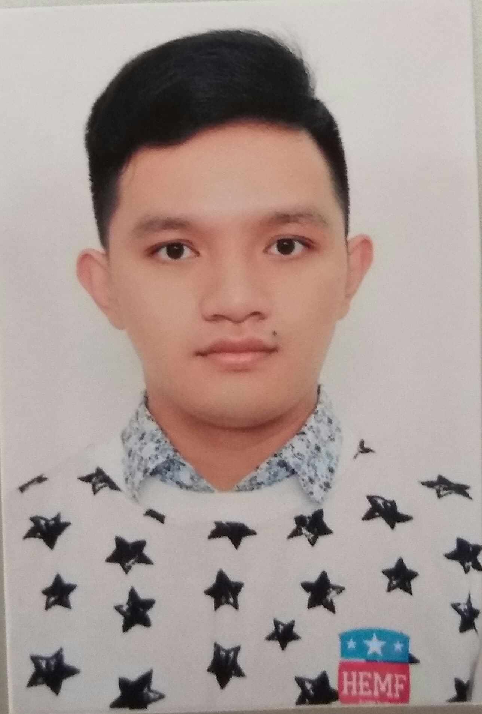
Trương Công Khánh
Gender: Male
Date of birth: 20/01/1995
Address: Tran Huy Lieu, Dist. Phu Nhuan, HCMC
Phone number: 037 8131 749
E-mail: congkhanh0120@gmail.com

OBJECTIVE:
In short term, I want to improve my soft skills such as communication, cooperation, team - building, presentation, … by means of devoting myself in jobs relating to sale or representative. Along with professional knowledge in Pharmacy and Healthcare, I would like to help our customers to know more about our products and bring them finest values within our ability.
In long term, I want to learn and practice more in business administration, contribute to company’s attempts in building up the market, approaching wider customer ranges and improving brand awareness in Vietnam’s drug and healthcare market.
EDUCATION:
Fresh graduate student, Faculty of Pharmacy, HCMC University of Medicine and Pharmacy
GPA: 7.10
EXPERIENCE:
Internship (2 months) in company Ki Ta Pi Da, which deal in stents, guild-wires, catheter balloons and other devices used in coronary angioplasty.
ACTIVITIES:
National University Entrance Exam Support Campaign (2014)
Blood Donation (2014)
Green Sunday (2015)
SKILLS:
Languages: English (reading, listening, writing and speaking)
Japanese (JLPT N3)
Computing: MS Word, Excel, PowerPoint
Self - learning, communication, reasonable arrangement and organization of works, high concentration in tasks, working under high pressure, good in analytical skills, careful, have a high sense of responsibility, take the initiative in work.

