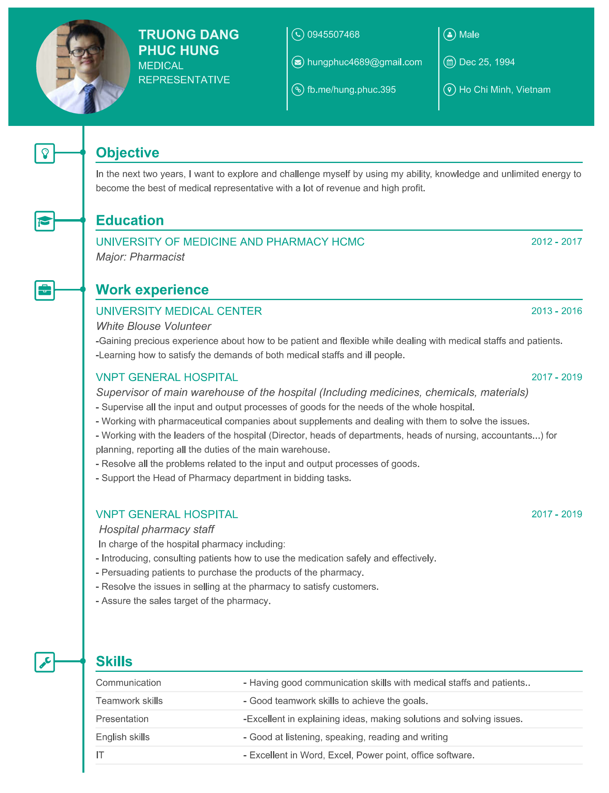
JOB APPLICATION

Respectfully addressed to the Personnel Department of VinMec International Hospital.
My name is Truong Dang Phuc Hung. I am a Pharmacist, graduated from the University of Medicine and Pharmacy, Faculty of Pharmacy in 2017.
I have learned that you are recruiting Medical Representative in Ho Chi Minh City, so I find it very interesting to apply for that position.
Please consider me an applicant for the vacancy. I have enough enthusiasm and abilities to work as your Medical Representative because I am hard working, active, patient, and honest. Moreover, I have necessary skills because I used to work as a Staff of the warehouse and the pharmacy of Vnpt General Hospital for nearly two years. Though the task is very challenging, I would try my best to accomplish it.
I would like to start working in your company, and I would be delighted to attend an interview at your convenience.
Thank you very much for your kind attention to my application.
I am looking forward to hearing from you soon.
Yours faithfully,

Truong Dang Phuc Hung.

