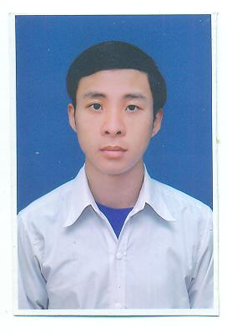
CURRICULUM VITAE

A. PERSONAL DETAIL
1. Name | Nguyen Huu The
2. Phone number | 0986 132 242
3. Email | Huuthe122@gmail.com
4. Permanent address | Nghe An province
5. Present address | District 9, Ho Chi Minh city
6. Date of birth | 20/10/1990
7. Sex | Male
8. Major | Pharmacist

B. OBJECTIVES
Being a good pharmacist in pharmaceutical R&D area.

C. CAREER AIMS
SHORT TERM | - Join the company, one of the best reputable local pharmaceutical firms in Vietnam, and try to devote the best for the development of the company.  - Obtain the Ielts certificate 7.0
LONG TERM | - A position at the company that would help me to develop my skills and increase my knowledge, as long as contributing to the development of company.  - Try to complete the assigned tasks, and seek opportunity for promotion at work.

D. EDUCATION
COURSE | - From 2008 – 2013: Student of Hanoi University of Pharmacy.
ACHIEVEMENTS | - In 2008: get 27,5 marks after the university entrance examination in 2008 and receive offer letter from Hanoi University of Pharmacy.  - From 2013: graduate from Hanoi University of Pharmacy in 06/2013 with point 7.39.

E. PERSONAl SKILLS AND STRONG POINTS
SKILLS | - Deep knowledge of specialized pharmacy: GMP, New drugs development, Pharmacology, Legal….  - Language:  - Fluent at 4 basic skills of English: Reading, writing, listening, and speaking.  - English certificate: IELTS – 6.0  - Computer skills: use proficiently microsoft office, photoshop...  - Good communication and presentation skills.
STRONG POINTS | - Intensive concentration and great memory.  - Ability of independence and teamwork, standing in hingh pressure.  - Hardworking, careful, and patient.

F. WORKING EXPERIENCE
10/2013 – 06/2015 | - From 10/2013 - 06/2015: work at R&D department of Nghe An pharmaceutical and medical equipment.  - Position: R&D staff.  - My work included:  - Develop formulas for new drugs and functional food.  - Preparae registration dossier for medical products and functional food.  - Control manufacturing process of drugs at production area.
08/2015 – 02/2016 | - From 08/2015 - 02/2016: work at R&D department of Korea United Pharm. Int’l.  - Position: R&D staff.  - My work included:  - Prepare formulas and manufaturing process for new drugs.  - Prepare samples and pharmaceutical development file of new drugs for registration.  - Support QA to preapre some documents related to production: Batch production records, production SOPs, process validation protocol.
04/2016 - Now | - From 04/2016 - Now: work at R&D department of Glomed pharmaceutical company.  - Position: R&D executive.  - My work included:  - Development of new drugs: find the academic information, select API and excipients resources, make trials, and sacle up to pilot and commercial batches.  - Improvement of quality of current products.  - Prepare pharmaceutical development file and manufacturing process for registration.  - Support QA to preapre some documents related to production: batch production records, master formula, process validation protocol, process validation report.  - Co-operate with QA and production to investigate and handle the problems occuring in manufaturing process.

G. INTERESTS
Fishing, walking, and reading books.

