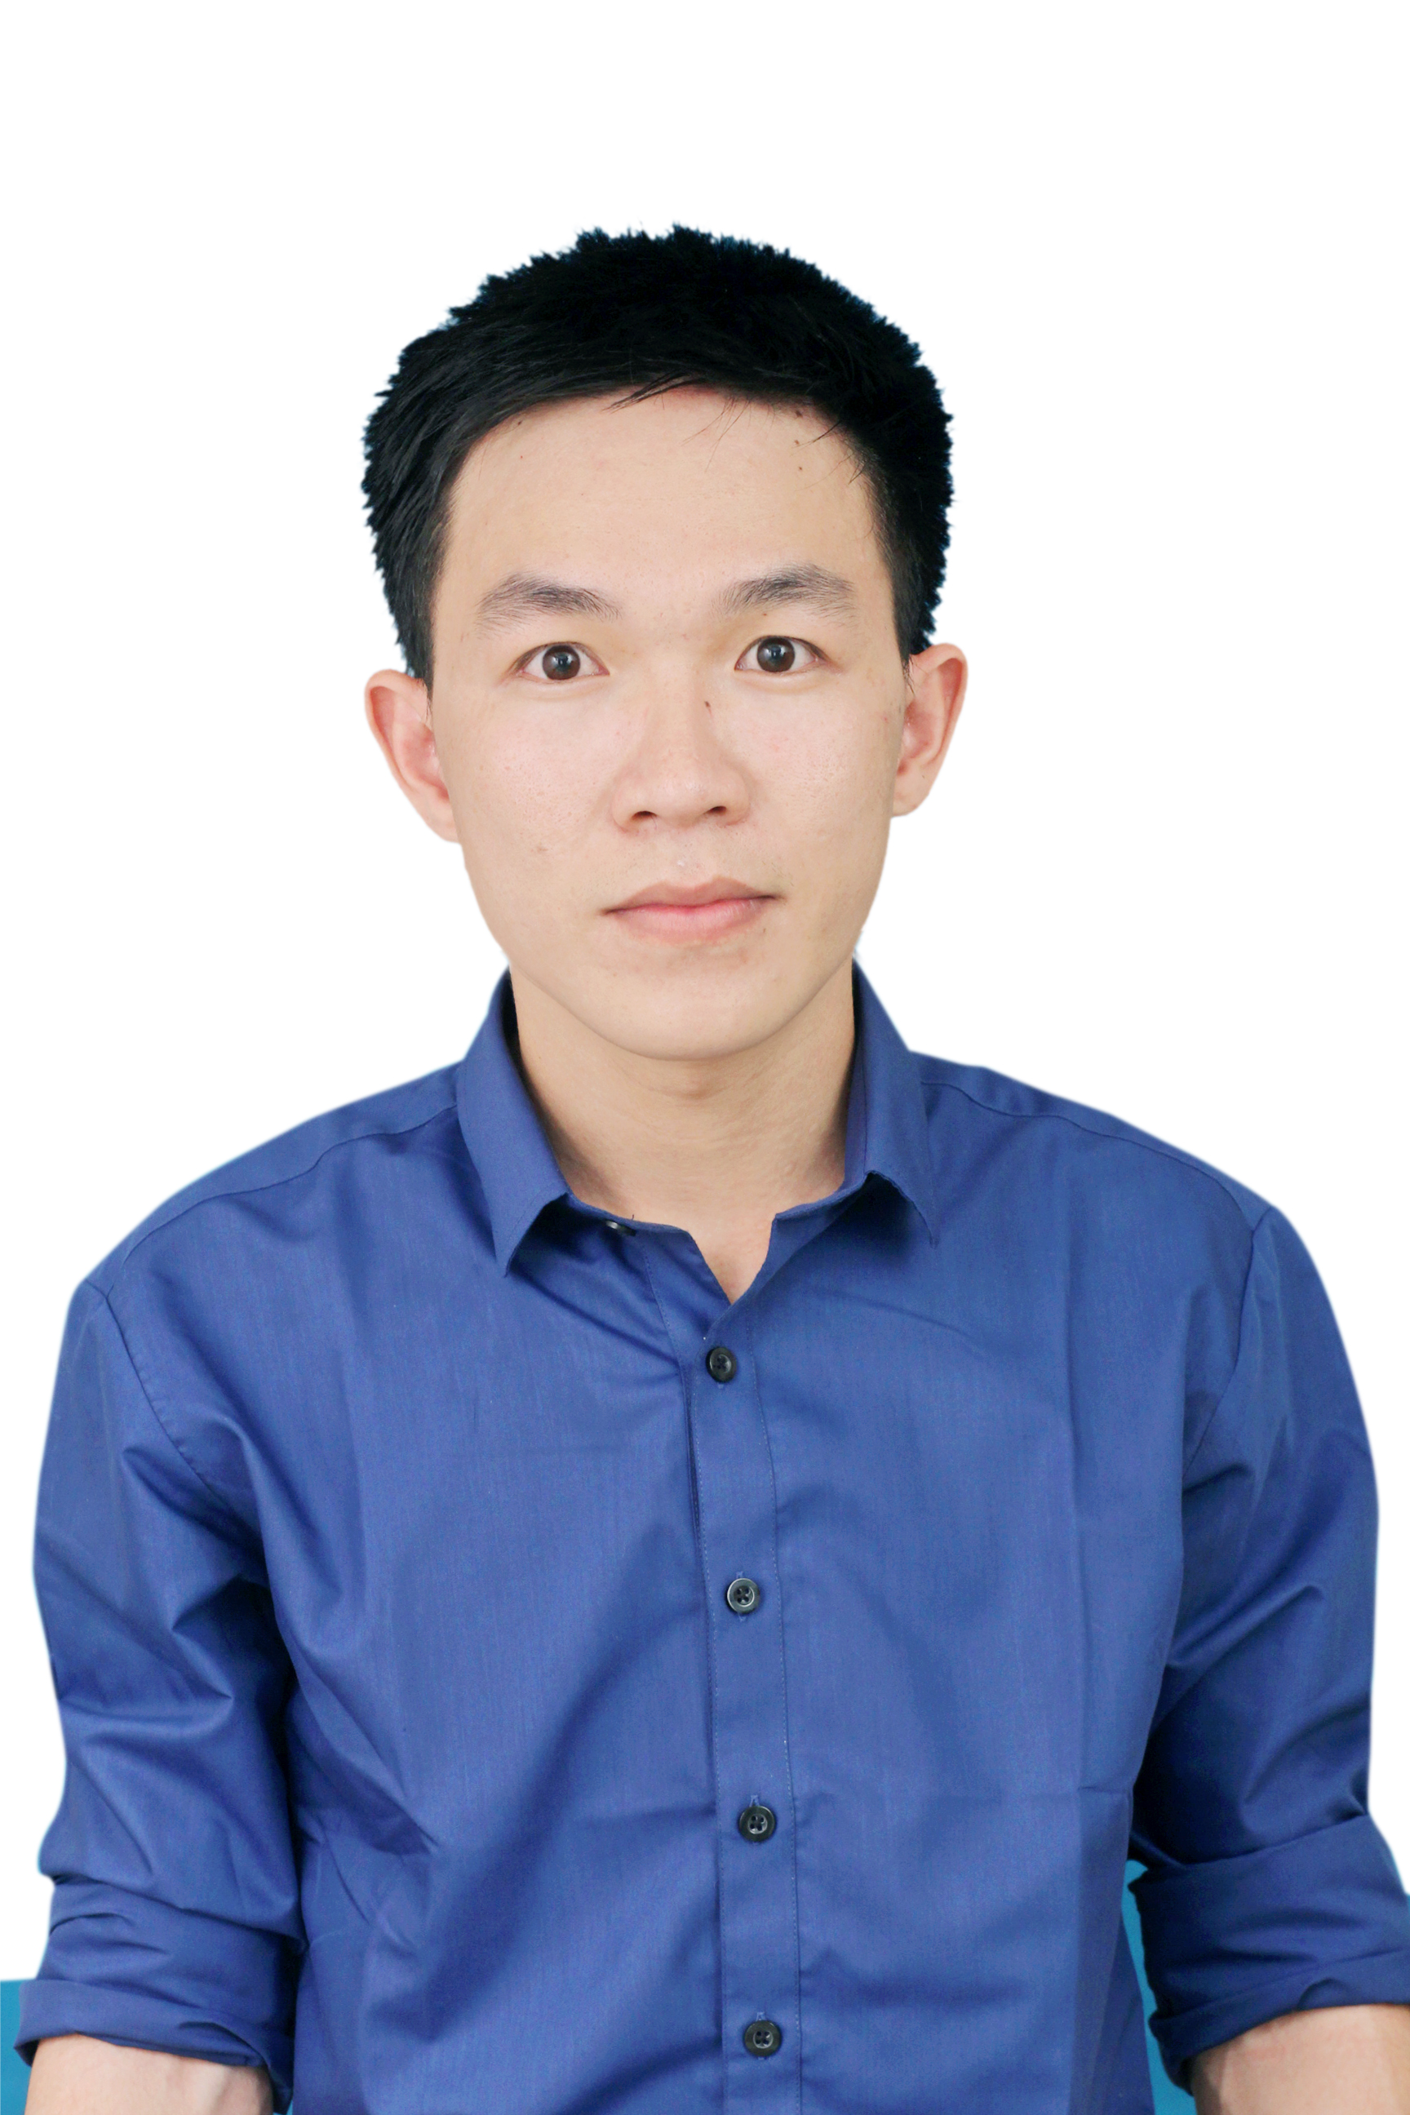
LÊ QUANG TRỌNG
Professional Pharmacist
PROFILE  CAREER GOAL  SKILLS  INTEREST  - Reading English books  - Singing Vietnamse songs  Date of Birth: 07/05/1994  Gender: Male  Mobile: 01265226383  Email: lequangtrong47@gmail.com  Address: 50 Dat Thanh street, Tan Binh district, HCMC  - Short term: Become a professional Pharmacist (2 years)  - Long term: Become a Product Manager in next 10 years  - Microsoft Office  - Teamwork  - Presentation  - English  - Sales | WORK EXPERIENCE  2017-Now  ONLINE SALES  - Advertise Dietary Supplement, Cosmetics, etc. through forum and Facebook  - Answer customer’s questions and make a recommendation  2015-2016  PRIVATE TUTOR  - Teach, give homework to students and test scores, assess student learning through questions  - Seek a tutor who temporarily replaces me when I’m busy for semester exam  EDUCATION  Bachelor –Pharmacy  University of Medicine & Pharmacy, Ho Chi Minh City – 2013 to 2018  Major: Pharmacy Administration and Distribution  GPA: 7.47  ACTIVITIES  - 26/3 Pharmacy Camp (2/2017)  Give ideals, manage my group to jump Flashmob, design uniform for team and make camp gate suitable for my classs’theme  - The Spring Campaign Volunteering (15/1 – 15/2/2016)  Distribute gifts to the homeless and help them decorate their house for preparing Tet holiday  - Exam Season Supporting (6/2014 – 7/2014)  Help students and their parents find homestay at a resonable price, answer the inquiries about the entrance examination to university  ABOUT ME  - I can work well both in a team as well as on my own as I like to set myself goals which I will achieve  - I have a creative mind and am always up for new challenges; besides, I am well organized and always plan ahead to make sure I manage my time well  - I am a punctual and motivated individual who is able to work in a busy environment and produce high standards of work  AWARDS  ACHIEVEMENT  -TOEIC certificate with score 860  -The Apply Of Information Technology (MS Office) - Basic Level with ‘Excellent’ band; Advanced Level with ‘Excellent’ band  - Second Prize in the Reproductive Health for Students’YDS in 2017  - Scholarship for well-performed students in the 2nd semester of 2016 & 2017

