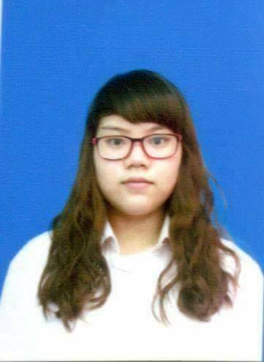**DUONG BICH CHAU**

Email: [strawberrygirl1711@gmail.com](mailto:strawberrygirl1711@gmail.com)

Date of birth : 17/11/1994

Phone number : 01293759358

Address : Binh Thuy distict , Can Tho city

**TARGET:**

I can worked professionally in the field of pharmacy and will become an excellent employee within 1 year.

**PROCESS OF STUDYING:**

2012-2017: Tay Do University

                    Bachelor of Pharmacy

3 / 2016-4 / 2016: I had an internship at Can Tho Children's Hospital

                           Learned the process of drug distribution in the parcels, retail and drug distribution in the health insurance department

 2 / 2017-3 / 2017:I had an internship at Can Tho Central General Hospital

                             Learned about prescription drug analysis based on drug interaction (clinical pharmacology) in neurology department

3 / 2017-4 / 2017: I had an internship at Can Tho medicine quality control Center

                            Understanded the process and methods of testing drugs in the chemo laboratory and biological laboratory

4 / 2017- 5/2017: I had an internship in Hau Giang Pharmaceutical Joint Stock Company in Can Tho city

                           Learned the process of producing pills, liquid drugs and packaging process at the company

**SOCIAL ACTIVITIES**:

2013-2016: A member of the board of blood donation club at Tay Do University

2/2015: Joined the program which is colaborated between Motana university in US and

Can Tho university for environmental project in mekong delta

3/2016: Being a receptionist for Hiền guesthouse in Can Tho city

12 / 2016- 7/2017: Worked as a freelance tour guide in Can Tho city

4/2017: Worked as an freelance interpreter

5/2017: Worked as a teaching assistant at Esmart English Center in Can Tho City

9 / 2017-10 / 2017: I had an internship at the pharmacy store number 7 Ho Chi Minh City

10 / 2017- 12/2017:I had an internship at Thien An Pharmacy in HCMC

8/2017 – 3/2018 : Work as a sales admin for medcomtech joint stock company

* Office skills : Made contract, work with emails and customer feedback, made order for out retail form , keep tracking product from the warehouse and made daily report.
* Worked with hospital , deal with hospital demand and also being the interpreter for supplier who worked with doctors at the hospital.

3/2018 – 11/2019: Being a consultant at THANN Santuary Spa

* Sales and introduce spa products , welcome guest ,consults spa treaments and received booking from the customers
* Handled guest complaint and company targets
* Made daily revenue report and made order for new products

**SKILL**

- Ability to communicate well, teamwork skills, sales skills

- Microsoft word processing, excel, access

- Comunicate well in English

**CERTIFICATE**

- Certificate of B in English, Certificate of 5.5 IELTS by AMA English Language Center

- Certificate B of infomation technology

- Soft skills certificate

- Sales skills certificate

**HOBBIES**

- Sports, listening to music, participating in social activities.