**CURRICULUM VITAE**

***PERSONAL INFORMATIONS:***

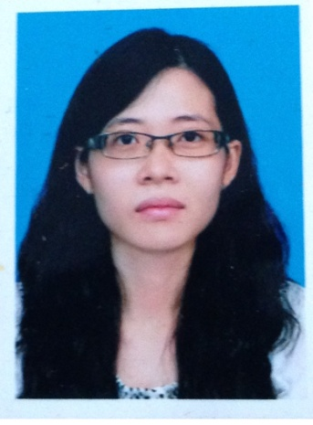Full name :Cao Phuong Anh, common name : Phuong Anh

Sexual : female

Birthday : 06/06/1986

Cell-phone : 0937 698 032

E-mail : caophuonganh1986@gmail.com

Permanent address : 216, Cai Be town, Tien Giang province

People : Kinh. Religion : none.

Wish working place: TP HCM.

***PERSONAL HISTORY :***

* 1992 - 1998 : study in Cai Be Primary school, learning capacity : good
* 1998 - 2001 : study in Cai Be Junior high school, learning capacity : good
* 2001 - 2004 : study in Cai Be High school, learning capacity : good
* 2004 - 2007 : study in University of Medicine and Pharmacy of Ho chi Minh city, college, learning capacity : moderately good.
* 2008 : working at Vphano company
* 2008 - 2012 : working at Mebiphar company, laboratory staff
* 2012 - August,2016 : study in University of Medicine and Pharmacy of Ho chi Minh city, learning capacity : average good.
* 2013 – 2015: working at pharmacy Khanh
* March- May,2017: working at Hoang Loc company,medical respesentatve
* October – today: working at Samedco company, medical respesentative

***CERTIFICATES:***

Level A certificate of Informatics

***SKILLS:***

* Thoughtful; diligent; enthusiastic
* Be familiar with the pressure of work
* Have ability to work independently also in team, firendly
* Have experience in trading
* Excellent in communication and convincing skill

***INTEREST:***

* Shopping
* Travelling
* Watching television
* Listening music
* Reading

TPHCM, Dec 05 2017

Candidate

Cao Phương Anh