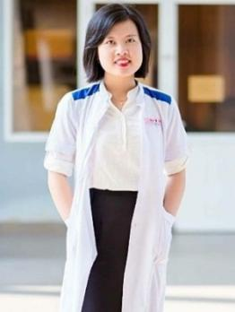

# OBJECTIVE

**NGUYEN THI HOAI LINH**

Pharmacist

**Date of birth:** Dec 30, 1994

**Gender:** Female

**Phone:** 0965709990

**Email:** [linhnth3012@gmail.com](mailto:linhnth3012@gmail.com)

**Address:** Dienban, Quangnam, Vietnam

**Website:** https://[www.facebook.com/linhnth3012](http://www.facebook.com/linhnth3012)

Take knowledge and skills of pharmacy to become a pharmacist, besides I will contribute to the development of our company.

# EDUCATION

Aug 2013 - Aug 2018 **Duy Tan University** Major: Pharmacy GPA: 3.08

# WORK EXPERIENCE

Jan 2017 - Jun 2017 **Cam Le Pharmacy**

Trainee

* Sell medicines, medical supplies, functional foods
* Advise customers

Jun 2018 - Sep 2018 **Hanh Thai Functional foods Company**

Sales Staff

* Introduce and sell products
* Advise customers

# SKILLS

**Specialize** Pharmacy, Pharmaceutical Science & Administration

**Language** English communication, Reading, Speaking

**Computer** Microsoft office

**Soft skills** Seminar, Communication, Presentation

# ACTIVITIES

Jul 2014 - Now **Danang Astronomy Club**

Member

Stargazing tour guide, sells the tickets to the travelers at Bana Hills

Mar 2015 - Mar 2015 **Earth Hour**

Volunteer

Flashmob, cycling

Nov 2015 - Jan 2017 **Danang Guitar Club**

Member

Play the guitar, sing

Aug 2016 - Aug 2016 **The largest ASEAN map by LED**

Volunteer

Created the map by LED

Nov 2016 - Nov 2016 **Dance for Kindness**

Volunteer Flashmob

# INTERESTS

Book

Music, guitar Badminton Photograph

# ADDITIONAL INFORMATION

Honest, reliable, clever