**CIRRICULUM VITAE**

APPLIED POSITION: MEDICAL REPRESENTATIVE

**(Ho Chi Minh city)**

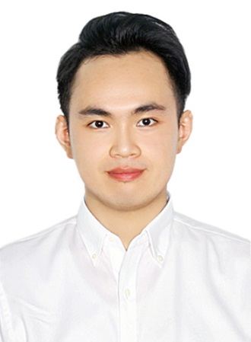I am Ly Minh. My detailed information is presented as

following:

**PERSONAL INFORMATION:**

* Full Name: Ly Minh
* D.O.B: June 16, 1993
* P.O.B: Ca Mau City
* Address: 418 Le Van Quoi street, Binh Tan district, Ho Chi Minh city.
* Hand phone: 0946006716
* E-mail: stevenminh0616@gmail.com

**EDUCATION:**

*Name and Address of School - Degree/Diploma - Graduation Date:*

*1)* 2011-2016: studied at Vo Truong Toan university, major Pharmacy

2) 2008-2011: studied at Phan Ngoc Hien high school for the gifted (Chemistry).

**EXPERIENCES:**

* Work at Allegen - YMed Pharmaceutical in Ho Chi Minh city
* Worked at Medic Ca Mau hospital.
* I have a chance to surfere with medical representative environment in university. I have accumulated a lot of experiences such as communication skills, good selling skills and presentation skills that a professional Medical Representative needs.
* Intership at Nhut Quang Pharmacy Can Tho city.
* Intership at Pharmacy department, Hau Giang general hospital.
* Intership at Phung Hiep general hospital.

**SKILLS AND QUALIFICATIONS**

* Toeic certificate
* I have already studied IELTS 6.5
* English certificate level B
* Informatics Certificate Level B
* Confident and representative with customer, friendly and trustly to other people
* Being able to build customer relationship.
* Ability to work under pressure.
* Presentation skills with fluency and confidence
* Ability to perform tasks/multitask in fast-paced environment and work independently.
* Team work.

**PERSONALITY AND HOBBIES:**

* Responsibility.
* Dynamic, confident.
* Friendly and open-minded.
* Computer skills with proficiency in MS Word, Excel, Ms Access, Power Point and various software applications.
* Very friendly and enthusiastic in work.
* Surf the web, social networks (Facebook, Twitter, Yahoo, Zing).
* Being able to learn and explore new knowledge. Being able to work under pressure and high intensity.

**ACTIVITIES:**

* Activity at university: inter-chapter party secretary
* Volunteer, blood donation,…

**CAREER OBJECTIVES**

I belive that I'm able to Medical representative in **Glaxo smith kline viet nam** . I will complete my work by all my best, deal to the development of company. This is also a great opportunity for me to improve myself of working in a great environment. I understand that being an employee of your company may help me to take more challenging tasks, improve my qualification and broaden knowledge. I believe that this is an excellence opportunity to develop my knowledge and career experience.

Finally, I extremly want to have an opportunity to working in your company.

Sincerely.