**EDUCATION**

* **09/2012-09/2017**

**University Of Medicine and Pharmacy, Ho Chi Minh City**

**Major: Pharmacist**

**03/2017: Hassan – Dermapharm Factory (Internship)  
Study: GMP, GSP, GLP, GDP**

**Research and Development of medicine, QC, QA**

**Regulatory affairs, project management, commercial business development, and marketing and sales**

**03/2017: Medicine and Pharmacy University Hospital (Internship)   
Clinical pharmacist in hospital, prepared and supervised the dispensing of medicines**

**The Faculty Pharmacy in hospital: duty, function, responsibility**

* **09/2009-09/2012**

**Quoc Hoc Hue High School For The Gifted**

**Major in Mathematics**

**WORK EXPERIENCE**

* **10/2017-2/2018: Pharmacist in Vitabella**

**Responsible for preparing seminars  
Finding informations of the products: Mechanism of action, clinical evidences ...  
Introducing the products to the doctor, pharmacist on the conference organizing in Hospital of Demato Venerelogy in Ho Chi Minh City**

**Homeshopping: Epitomizing and presenting usages, side effects, precautions, interactions... to telesales people.**

**Resolve complaints from the customers.**

**Finding informations of the competitors and partners.**

* **Thesis: Method development and quantitative analysis of rutin in**

***flosstyphnolobii immaturus* by UPLC-PDA with ThS Huynh Loi**

* **03/2017-06/2017: Tutor**

**Inter-college transfer**

* **Telesales person in Besins Healthcare Viet Nam**

**ACTIVITIES IN UNIVERSITY**

* **Exam Season Supporting**

**Find guesthouses for student**

* **Green Summer Volunteer Campaign**

**Sale stuff for charity fundraising**

* **Blood Donation**

**STRENGTH**

* **Interested in people’s health**
* **Accurate and methodical**
* **Friendly, have a good sense of humor**
* **Working under pressure**
* **Adaptable to a new environment**

**WEAKNESSES**

* **Lack of experience**
* **Spent much time on the internet**

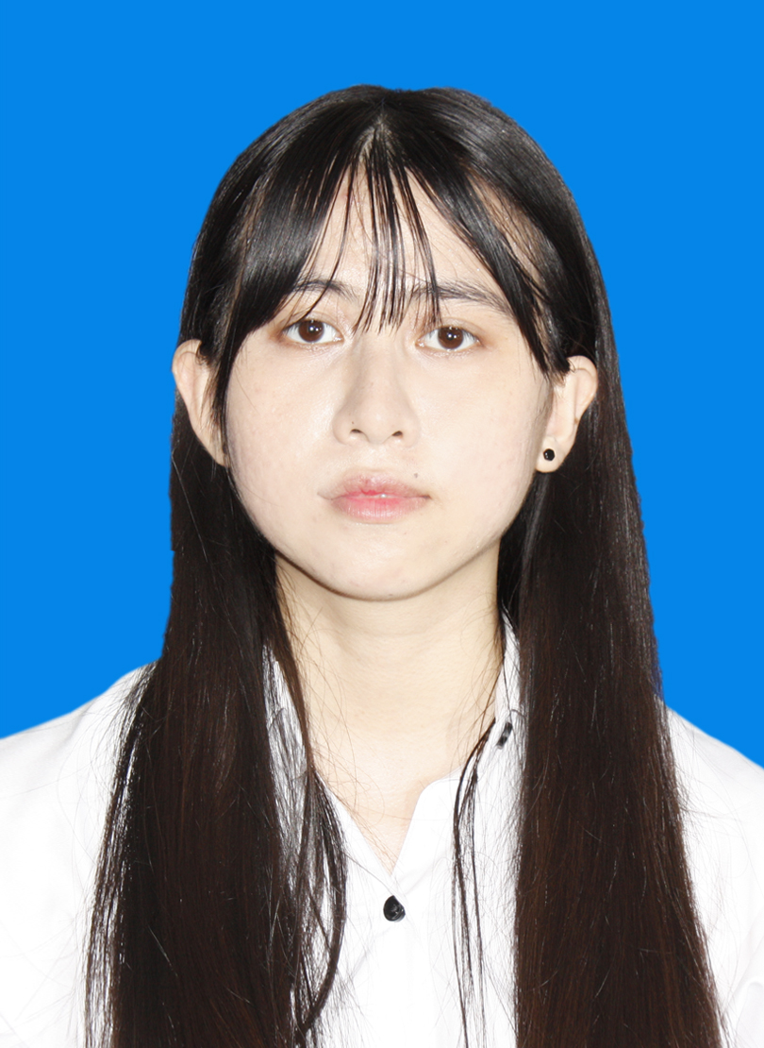

**LE NU HUYEN TRANG**

* **Date of birth: 21/09/1994**
* **Gender: Female**
* **Tel: 0165 267 1399**
* **Address: 269/17 Nguyen Thi Nho, Ward 16, District 11, Ho Chi Minh City**
* **Email: lenuhuyentrang@gmail.com**

**SKILLS**

* **Office:**

**Word, Excel, Power Point**

* **English:**

**Toeic: 600-700 (Try at home)**

* **Soft skills:**

**Communication**

**Presentation**

**Teamwork**

**INTERESTS**

* **Book**
* **Play chess, badminton**
* **Music**