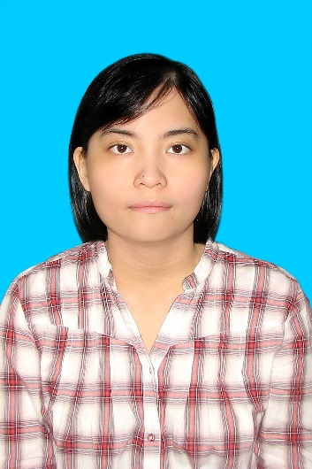**PERSONAL INFORMATION**

Surname: THUY AN NGO

Date of birth: 18/01/1991

Permanent address: 001 Block A Phan Van Tri Apartment Buildings, Ward 2, District 5, Ho Chi Minh city.

Telephone number: 0906783221

Email address: [thuyanngo91@gmail.com](mailto:thuyanngo91@gmail.com)

**EDUCATION**

2014 – 2017 University of Medicine and Pharmacy of Ho Chi Minh City

B.S. Pharmacy

2009 - 2013: University of Science - Vietnam National University, Ho Chi Minh City.

: B.S. Chemistry

Major : Organic Chemistry

**WORKING EXPERIENCE**

**7/2017 – present:**  Shine Pharma

Regulatory Affairs - Training Executive

***Job responsibilities:***

* Be the main in charge of preparing the complete registration dossier for products of company;
* Co-operate with relevant departments to compile the quality part of the dossier in compliance with CTD form (ACTD form for products registering in Vietnam and ECTD form for products registering abroad);
* Prepare all supporting document and forms other required legal document for company’s products;
* Follow up with DAV for all submitted dossier but not yet appraised; and for all new/changed regulations concerning to RA and also other fields that may affect to company’s products and activities;
* Undertake other tasks relating to RA when assigned.
* Identify critical capability areas and key competencies to be developed in alignment with the organisations desired future state for field force.
* Ensure quality development plans and targeted learning and development solutions are deployed to address areas for improvement for regional field force.
* Manage the smooth implementation of all Learning and Development Initiatives for regional workforce
* Proactively analyse and design appropriate learning and development interventions that support for field force performance improvement.
* Effectively maintain learning & development budget to ensure that resources are used in the most efficient manner.

**1/2015 – present:** Vinh An Drugstore

Pharmacist – Training Executive

***Job responsibilities:***

* Manage and control the purchasing, dispensing and stock of the medications and consumable on site.
* Ensure good record keeping of medication and materials - check expiry dates and prepare requisition when required or medical supplies
* Ensure cleanliness and good housekeeping of the pharmacy
* Internal training on his or her own specific tasks.

**1/2015 -6/2017**: The Institute of Drug Quality Control – Ho Chi Minh City

Pharmaceutical Analyst –Cosmetic Department

***Job responsibilities:***

* Conducting analytical tests on samples of Raw Material/Reference Standards/Finished products/Cosmetics/ Environmental/Plasma by HPLC, GC, GC-MS, UV-vis, AAS, Dissolution, and other analytical instruments, in accordance with the company and USP specifications
* Performing pharmacokinetic/bioequivalence studies of different designs
* Data entry, data processing and data audits in the experiments
* Documenting and reporting results as per established SOP
* Investigating new methods
* Development and validation of analytical procedures
* Establishment of a chemical secondary Reference Standard
* Performing preventative maintenance, calibration and troubleshooting of analytical instruments as required
* Assisting with request for ordering laboratory supplies
* Training other QC analysts in laboratory methods and procedures

**HONORS AND AWARDS**

2012 : Chemistry and I contest Bronze medal

**PROFESSIONAL SKILLS**

* Performing Lab test based on request and in accordance with existing standards, reports and distributes the results to the related parties.
* Excellent experience in biological equivalent studies
* Good knowledge of chemical analysis method and ability of working independently in accordance with current regulations
* Have knowledge and know how to use the modern laboratory equipments (GC, HPLC Instruments, UV Spectrometer, HPLC-MS…)
* Good knowledge on GLP, GCP with certification and high respect on GLP guidelines as well as current procedures in site
* Computer skills: Proficient user of Microsoft Office (Word, Excel, PowerPoint…), ChemDraw, HyperChem…
* Languages: Possess good communication skills, both written and spoken English and Vietnamese languages

**EXTRACURRICULAR ACTIVITIES**

2009 - present Tutor in Chemistry, Physic, Math