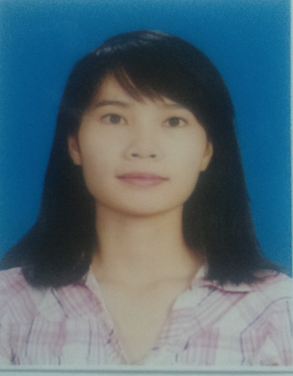

**CURRICULUM VITAE**

**I. PERSONAL INFORMATION**

Full Name: LÊ THỊ MAI

Date of birth: 23/01/1990

Gender: Female

Place of birth : Thach Ha , Ha Tinh province

Address: 7 Ngo Duc Ke, 12 ward, Binh Thanh Dist., HCMC

Mobile number: 0934 189 720

Email: [Lemaiphar@gmail.com](mailto:Lemaiphar@gmail.com)

**II. FAMILY (PARENTS, SPOUSE, CHILDRENT, BROTHER, SISTER)**

|  |  |  |  |  |
| --- | --- | --- | --- | --- |
| Full name | Relation | Age | Occupation | Adress |
| Le Huu Ngoc | Father | 1962 | Farmer | Dak Nong |
| Nguyen Thi Loan | Mother | 1964 | Farmer | Dak Nong |
| Le Thi Xuan | Sister | 1985 | Farmer | Dak Nong |
| Le Thi Nhung | Sister | 1991 | Student | Ho Chi Minh |
| Le Thi Hong | Sister | 1994 | Student | Ho Chi Minh |
| Le Thi Long | Sister | 1996 | Student | Ho Chi Minh |

**III. EDUCATION/TRAINING BACKGROUND**

|  |  |  |  |
| --- | --- | --- | --- |
| School Name/Training Center | Major Field/Course of Study | From – to - | Type of Degree/ Certificate |
| Master: Ho Chi Minh City University of Medicine and Phamarcy | Major: Clinical and pharmacology | 2014-2016 | Good |
| University/College: Ho Chi Minh City University of Medicine and Phamarcy | Major: Phamacist | 2008-2013 | Good |
| Ho Chi Minh City University of Natural Sciences | Certificate of Microsoft Office, Level B | 2012 | Very Good |
| Ho Chi Minh City University of Natural Sciences | Technical Graphic Design | 2014 | Good |
| Others | | | |
| Khoi Nghiep Tre Company | Success guiding | 2012 |  |
| Giant Company | Successful way and top comunication Art | 2012 |  |

**IV. SOCIAL ACTIVITIES**

|  |  |  |
| --- | --- | --- |
| Organizational unit | My roles | Time |
| Warm Hands Club by Khoi Nghiep Tre Company patronizing | Holding activities, newpapers and candy sale campaign for poor children | 4/2012-12/2012 |
| 26/3 camp | Singing, dancing, serving food and water, preparing equipments...ect. | 26/3/2012 |
| Social Works Club, Book Club | Taking part in social Works, collecting and lending books | 2008-2010 |
| Go through the semis in Best Phamarcist Finding Contest by Phamarcists Department, Ho Chi Minh City University of Medicine and Phamarcy | | |

**V. EMPLOYMENT HISTORY**

|  |  |  |
| --- | --- | --- |
| Company | My roles | Time |
| Hutech university | Lecturer | 4/2017- Now |
| Sanofi Aventis | Team Leader | 11/2017 |
| Sanofi Aventis | Medical Representation | 4/2015-10/2017 |
| GlaxoSmithKline Pte Ltd | Medical Communicate Profession | 6/2013-4/2015 |
| Khoi Nghiep Tre company | Sale group leader (part time) | 2012-2013 |
| Tutor | Grade 9 and grade 11 (part time) | 2009-2013 |
| Education equipment Joint-stock company | Worker (part time) | 9/2008-2/2009 |

**VI. WORK EXPERIMENT**

Locations in charges: University Medical Center HCMC co so 1, Gia Dinh hospital, 115 hospital, Ear Nose Throat Hospital HCMC, Saigon International Hospital, District 7 Hospital, District Phu Nhuan Hospital, …

Ability:

* + - * Call/visit and pursuade with doctors
      * Have ability to speak in front of group meeting which introduce products.
      * Support the company to implement the marketing strategy, conference…

Skill:

* Good communication.
* Hard working and responsible for job.
* Good in optimistic, enthusiastic, studious, careful, patient and enegertic.
* Teamwork skill: planning, organizing, motivating others to finish work.
* Capability of managing time and working under pressure.
* Use expertly Microsoft Office Solfware such as Word, Excel, Power Point...
* Excellent in negotiation and approaching market

**VII. PERFORMANCE**

**+ GlaxoSmithKline**

1. 2013 year end performance review: Successfully completely

* Achieved 120% target sale.
* Knowledge Products and Dieases: >=9/10
* Coaching Skill and Territory management: 4/5

2. 2014 year end performance review: Successfully completely

Outstanding: Knowledge Products and Dieases, Action Plan, Voice of customer, Skill, Territory management….

**+ Sanofi Aventis**

Sales performance:

2015: >120% target.

2016: Sanofi Hero award 2016

Knowledge Products and Diseases: 10/10, Rollplay: 98/100.