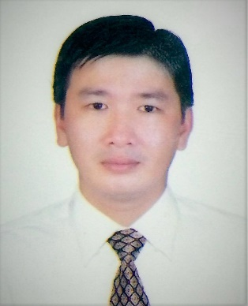 **PHAM VAN TINH**

**Date of Birth:** August 8th, 1988 **Place of Birth**: Bac Lieu

**Sex:** Male

**Permanent address:** Hamlet 8A, Phong Thanh Tay A, Phuoc Long, Bạc Lieu, Viet Nam.

**Temporary address:**03 Tạ Quang Buu St, Ward 06, Dist. 08, HCMC, Viet Nam

**Email:** [Tinh.pv8888@gmail.com](mailto:Tinh.pv8888@gmail.com)

**Cell phone:** 0942 153 156

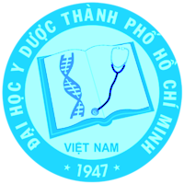**APPLICATION POSITION**

***Medical Sales Representative for ETC in HCM City.***

**CAREER OBJECTIVE**

I had four years of experience at University Medical Center Ho Chi Minh City, four years as a collaborator for TWI company, Thien Thang company and six months working at Hyphens company. I was trained and worked in a professional environment. Moreover, this job helped me get more expertise of medical career. Currently, I hope to work in a more dynamic environment, to improve my communication, presentment and persuasion.

**EDUCATION**

* 2006 - 2008: Bac Lieu Medical College – Pharmacy Vocational Diploma
* 2013 - 2017: University of Medicine and Pharmacy at HCM City – Pharmacy Bachelor Degree
* 2009 - 2013: Attending all training courses of Faculty of Pharmacy - University Medical Center HCMC
* 2008: Applied Informatics Certificate level “A”

**EXPERIENCE**

* From 06/2009 to 02/2013: University Medical Center HCMC
* From 2013-04/2017 Co-ordinator of drug introduction for TWI pharmaceutical company, Thien Thang company.
* From 09/2017-04/2018 working at Hyphens company.

**SKILLS**

* ****Good communication skill.
* Working alone and working in group
* High adaptation
* Resistance to difficulties in work.

**ACTIVITIES**

* 2006 – 2008: Member of the Executive Committee of HoChiMinh Communist Youth Union of the Class Medicine Vocation.
* 2010 – 2013: Member of the Standing Committee of HoChiMinh Communist Youth Union of University of Medicine and Pharmacy at HCM City.
  + - * + Secretary of HoChiMinh Communist Youth Union of the Faculty of Medicine, University of Medicine and Pharmacy at HCM City.
        + Joining charity programs of examination and medication organised by University of Medicine and Pharmacy at HCM City in: Quang Ngai, Binh Thuan, Dac Lac, Tay Ninh, Long An, Ca Mau, etc.
        + Joining competitions of elegance and beautiful voice, etc. organised by University of Medicine and Pharmacy at HCM City.
        + Joining traditional & root inclined camp site of University of Medicine and Pharmacy at HCM City.
* 2013 – 2017: Joining activities organised by class and Faculty of Pharmacy - University of Medicine and Pharmacy at HCM City.

**INTERESTS**

* Team-building activities
* Music, football, volley ball, …