**CURRICULUM VITAE**

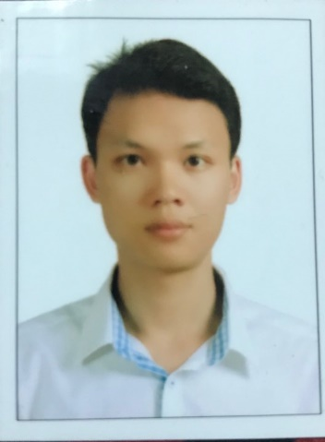**INFORMATION**

Name: TRAN TIEN DAT

Gender: Male

Marital status: Married

Nationality: Vietnamese

Email: ttd.pharma@gmail.com

Tel: Mobile – 0988879333

Address: 429/21A Hoang Van Thu street, Ward 1, Tan Binh district, Ho Chi Minh city.

**CAREER OBJECTIVES**

Applying experience in communication and sale skills, understanding the psychology and customer needs to become a professional staff, bring more value to customers.

During the period of 2-3 months, I make a lot of effort to have proffestional knowledge and independent activity. After three years, the goal will be to lead the team and gain trust in the company’s leadership team.

**EDUCATION**

**2013 – 2017**: Ho Chi Minh University of Medicine and Pharmacy

Bachelor of Pharmacy.

**2006 – 2011**: Ho Chi Minh University of Technology

Bachelor of Biotechnology.

**EXPERIENCE**

**8/2011:** Laboratory staff at Mekostem Bank (Stem cell bank).

Main responsibilities: Devise plan for stem cell processing and storage activities in the laboratory and and ensure everything follows the management procedures, the technical procedures, instructions, and forms issued by Mekostem.

**12/2011 – 9/2013**: Co-founder and manager of B.I.G company limited.

Website: <http://www.remoingay.com>. The group-buying, deal-centric business model in Vietnam.

### 12/2016-12/2017: Phuong Chi Pharmacy at Van Gia town, Van Ninh district, Khanh Hoa province.

### 2/2018:: I have been through training sessions at Zuellig Pharma Vietnam

**SKILLS**

Good teamwork skill and ability to work under pressure.

Well-organized time management skill and proven problem salving skills.

Ability to work on multiple tasks and meet tight deadlines.

Good computer skills: MS. Word, Excel, Power Point, Internet.

Language: English: fluent

Vietnamese: native.

Responsible, careful, active and flexible in work.

Honest, friendly and ready to learn new things.