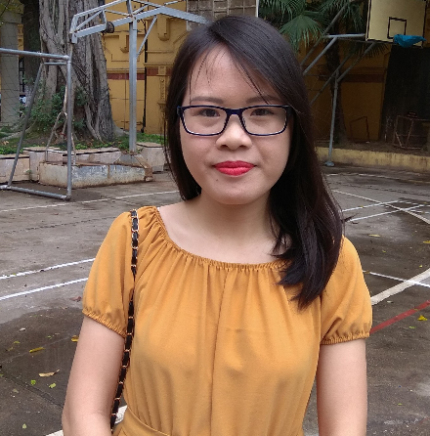🏍🕊

**TRAN THANH HIEN**

**Regulatory Affairs Assistant**

**Nhân viên Marketing**

**EDUCATION**

Final - year student at Ha Noi university of Pharmacy.

Pharmacetical Technology major, GPA 7,21.

**EXPERIENCES**

**👓 Personal management**:

✰Monitor at high school.

✰Group leader for 5 years at university.

✰Team leader of learning projects at university.

**👓 Science research at Department of Pharmaceutics:**

✰Planning to research.

✰Seeking, reading, translating english documents.

✰Thinking creatively to solve problems in research process.

**👓 Practicing in Pharmaceutical Company:**

✰ Marketing Contributor (product advertising for Thien Nguyen Company).

✰ Participated in Research and Development Department in Traphaco, IMC Company.

✰ Participated in drugs bidding project at Duc Giang hospital.

**👓 Home teaching:**

Practicing presentation skills and psychology understanding people.

**ACTIVITIVES**

**** Contributor in HUP Blood Club. 2014

**** Participated in Candidates Supporting activities. 2014

**** Participated in volunteer activities:

* Youth day 2015
* Blood donation 2013-present

**RECOGNITIONS**

* Schoolarships for excellent student at local district, province 2010 – 2013
* Schoolaship for excellent student at university 2015

**ABOUT ME**

**** Hard working  **👍** Positive

**🕊** Friendly **** High responsibility

**OBJECTIVE**

 Becoming a Regulatory Affairs Assistant of a multinational corporation.

 Improving professional and management skills to become Regulatory Affairs Director within 5 years.

**SKILLS**

Presentation

Communication

Team work

Office

**HOBBIES**

🕮 Reading  Seeking information ✈ Travel 🎧 Music

 28/12/1995

✆ 01652018042

🖂 [Hienduoc68@gmail.com](mailto:Hienduoc68@gmail.com)

🏞 1A Tho Lao, Hai Ba Trung, Ha Noi