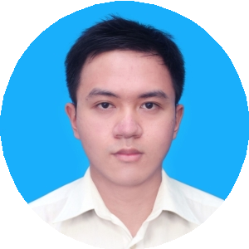

**NGUYEN TUNG QUAN**

**Medical representative**

**540 Ngo Gia Tu street, Ward 9, District 5.**

**Ho Chi Minh City**

[**nguyentungquan1011@gmail.com**](mailto:nguyentungquan1011@gmail.com)

**0969 341 670**

t

August 15, 2018

Apply to: Medical Representative ETC position.

Dear Sir/Madam,

With reference to your Recruitment posting, I hereby wish to apply for the position. I am honored to introduce myself to you as a graduate at University of Medicine and Pharmacy at Ho Chi Minh city. I strongly believe that interests and communication skills match with your requirements.

As shown in my enclose resume, I have participated in some hospital disease research. During these years, I have equipped myself with relevant pharmaceutical functions such as consulting the medical staffs about drugs and investigating the cost-effectiveness of medications.The job also helps me possess a strong aptitude with analyzing and presentation of my work. My career objective is to become a good medical representative in the future. Therefore, working for your company is a great opportunity for me to gain valuable working experience, to enhance my professional knowledge and to develop teamwork skills.

Being a student of University of Medicine anh Pharmacy at Ho Chi Minh city.I am conﬁdent that my conbination of practical work experience and solid education will enable to be productive. In addition, you will find me a positive, motivated and hard working person who is been to learn and contribute. Given the oportunity, I would apply myself with enthusiasm to all tasks, ensuring that I get the job done efficiently and inspire others to positive and productive.

As part of my application I have attached my resume for your considerasion. I would appreciate the opportunity to meet you at an interview and discuss how my qualifies wil be helpful to your firm.

Sincerely,

Nguyen Tung Quan

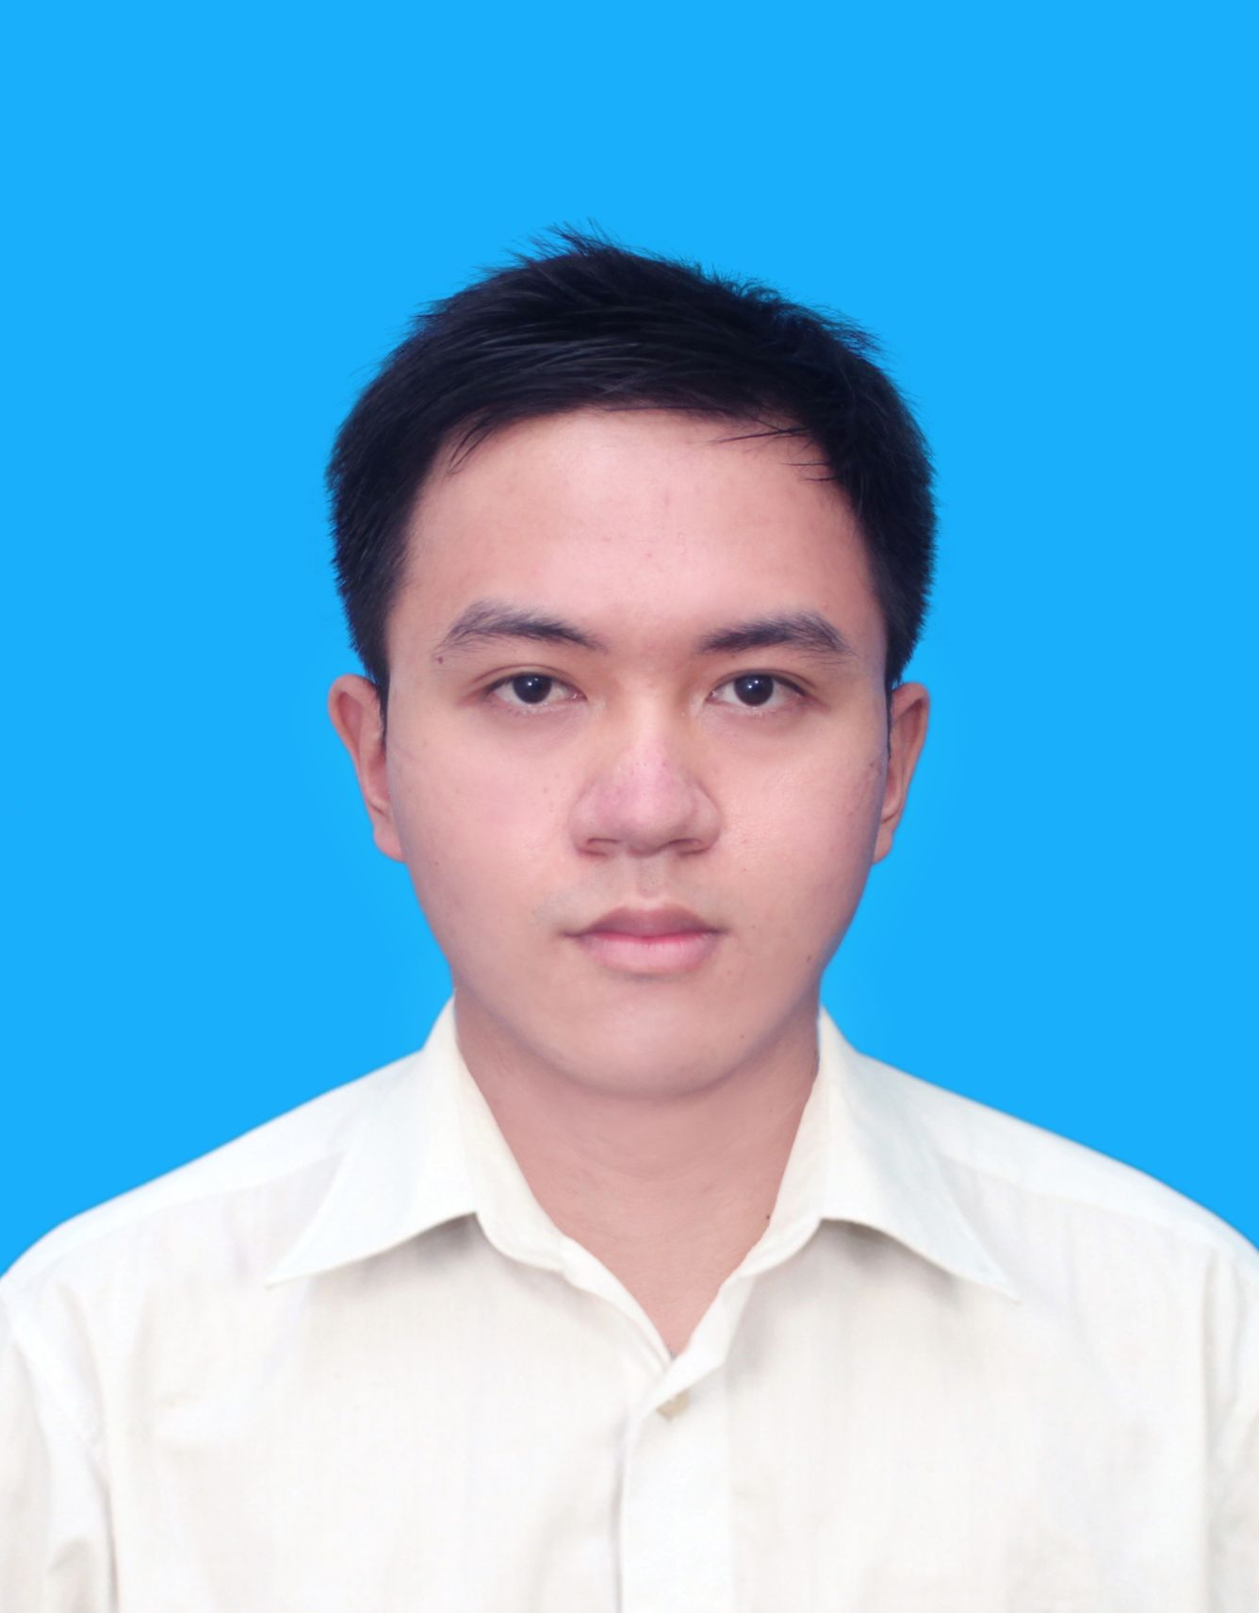

**Study Phamacy at University of Medicine and Pharmacy, Ho Chi Minh city**

**Average accumulated score 10 semesters 6.89 out of** 10

**SKILLS**

**HOBBIES**

**Interest in science.**

**Independent.**

**Self- confident.**

**PERSONALITY**

**OBJECTIVE**

**2013-2018**

**Attention to detail**

**Friendly**











**EDUCATION**

**PERSONAL DETAILS**

**Name**

**Date of birth**

**Gender**

**Phone**

**Address**

**Email**

**Email**

* **Become a good Medical Representative in the future.**
* **Expand social relationships and improve important working skills: teamwork, presentation, leadership…**

**Scholarships of University of Medicine and Pharmacy Ho Chi Minh City.**

**Participating in other extracurricular activities at university and outside: Social Club, Pharmacy English Club**

**Votunteer work at the University such as “Blood Donation”, “Running for Earth Hour”, “Spring Volunteer Campaign”.**

**WORKING EXPERIENCE**

**Tuitor in Math, Chemistry, Biology**

**Improve explaining and communicating skills**

**Adward**

**Activity**

**2013-present**

* **Excellent communication and presentation skills.**
* **Proficiency in Microsolf Office.**
* **Ability to negotiate, solve problems and make effective decisions.**
* **Able to comprehend English documents and to communicate and present in English.**
* **Reading books .**
* **Traveling.**
* **Whatching movie.**

**NGUYEN TUNG QUAN**

**10/11/1995**

**Male**

**0969 341 670**

**540 Ngo Gia Tu St, Wa rd 9 District 5, Ho Chi Minh City**

**nguyentungquan1011@gmail.com**