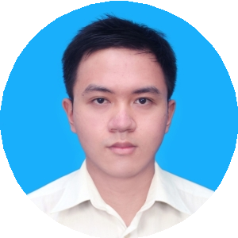

**NGUYEN TUNG QUAN**

**Medical representative**

**540 Ngo Gia Tu st, Ward 9, District 5. Ho**

**Chi Minh city**

[**nguyentungquan1011@gmail.com**](mailto:nguyentungquan1011@gmail.com)

**0969341670**

t

August 7, 2018

Human Resources Department

Ferring Private LTD Vietnam 20th Floor Flemington 182 Le Dai Hanh, Ward 15, District 11, Ho Chi Minh city.

Apply to: Medical Representative position.

Dear Sir/Madam,

With reference to your Recruitment posting, I hereby wish to apply for the position. I am honored to introduce myself to you as a senior at University of Medicine and Pharmacy at Ho Chi Minh city. I strongly believe that interests and communication skills in both private and public sectors match with your requirements.

As shown in my enclose resume, I have participated in some hospital disease research. During these years, I have equipped myself with relevant pharmaceutical functions such as consulting the medical staffs about drugs and investigating the cost-effectiveness of medications.The job also helps me possess a strong aptitude with analyzing and presentation of my work. My career objective is to become an medical representative in the future. Therefore, working for your company is a great opportunity for me to gain valuable working experience, to enhance my professional knowledge and to develop teamwork skills.

Being a student of University of Medicine anh Pharmacy at Ho Chi Minh city.I am conﬁdent that my conbination of practical work experience and solid education will enable to be productive. In adition,you will findme a posiive, motivated and hard working person who is been to learn and contribute. Given the oportunity, I would apply myself with enthusiasm to all tasks, ensuring that I get the job done efficiently and inspire others to positive and productive.

As part of my application I have attached my resume for your considerasion. I would appreciate the opportunity to meet you at an interview and discuss how my qualifies wil be helpful to your firm.

Sincerely

Nguyen Tung Quan.

**2013-present**

**Tuitor in Math, Chemistry, Biology**

**Improve explaining and communicating skills**

**SKILLS**

**HOBBIES**

**Logical thingking**

**Self-improvement & learning**

**Adward**

**Study Phamacy at University of Medicine and Pharmacy, Ho Chi Minh city**

**GPA: 6.89/10.**

**Modest, loyal, honest**

* **Improving skills and experience through learn & support for customers and other staffs.**
* **Become a manager and build next generation.**

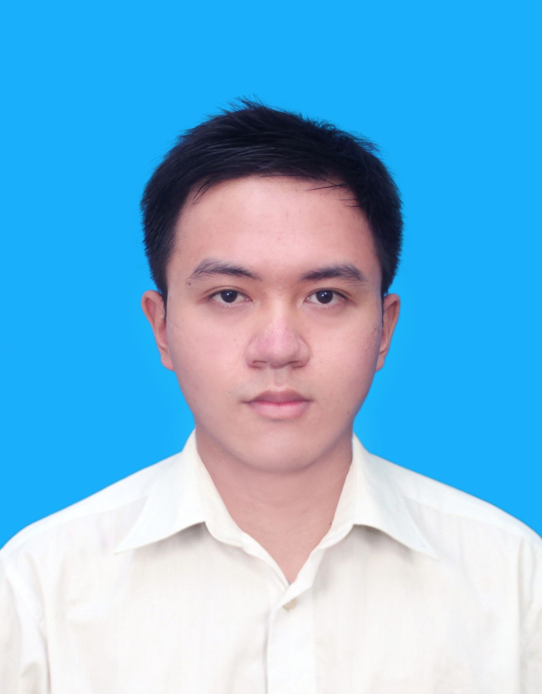

**PERSONALITY**

**OBJECTIVE**

**2013-2018**

**Attention to detail**

**Friendly**











**EDUCATION**

**PERSONAL DETAILS**

* **English in communication and translate.**
* **Strong &confident communicator over the phone or face to face.**
* **Exellent negotiating skill.**
* **Computer skills include MS Office, staticstics tools, searching information**
* **Planning and organizing**
* **Teamwork; supporting; independence working**
* **Exchanging knowledge and thinking with other people**
* **Reading books to improve skills: thinking, communicating and problem solving**
* **Making new things; changing myself**

**NGUYỄN TÙNG QUÂN**

**10/11/1995**

**Male**

**0969341670**

**540 Ngo Gia Tu St, District 5**

**Nguyentungquan1011@gmail.com**

**Name**

**Date of birth**

**Gender**

**Phone**

**Address**

**Email**

**Email**

**WORKING EXPERIENCE**

**Scholarship for good at study and votunteer work at the school**