**HO THI LE DIEM**

**MEDICAL SALE REPRESENTATIVE**

|  |  |
| --- | --- |
| Kết quả hình ảnh cho address icon | QUANG NAM, VIET NAM |
| Kết quả hình ảnh cho phone icon | +841633364376 |
| Kết quả hình ảnh cho Email icon | holediem266@gmail.com |
| DATE OF BIRTH  SEX | 07/07/1994  FEMAL |

EXPERIENCE

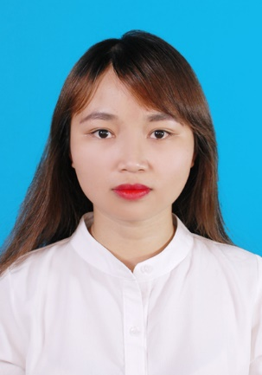

OBJECTIVE

To work in an organization, which could nurture my leadership qualities and where I get opportunities to grow and hence contribute to the development of the organization and self.

Become a regional manager after 3 years.

SKILLS AND COMPETENCES

Verbal and written communication

|  |  |  |  |  |  |
| --- | --- | --- | --- | --- | --- |
|  |  |  |  |  |  |

Leadership

|  |  |  |  |  |  |  |
| --- | --- | --- | --- | --- | --- | --- |
|  |  |  |  |  |  |  |

Sales

|  |  |  |  |  |  |
| --- | --- | --- | --- | --- | --- |
|  |  |  |  |  |  |

## Teamwork

|  |  |  |  |  |  |
| --- | --- | --- | --- | --- | --- |
|  |  |  |  |  |  |

INTEREST

- Reading/ Waching movie

**Quang nam hopitaL**

01/2018 -04/2018

Pharmacist intern

- Instruct patients on how and when to take a prescribed medicine and inform them about potential side effects from taking the medicine

- Check whether prescriptions will interact negatively with other drugs that a patient is taking or any medical conditions the patient has

- Work in drug store

CHAU VAN PHARMACY

QUANG NAM

07/2015- 10/2015

- Arrange dugs

- Learn how to sell drug and communicate with customer

SALE CLOTHES ONLINE

10/2014- 5/2015

-Consult and convince customers and built good relationship with them

EDUCATION

-Da Nang University of Medical Technology and Pharmacy - dhktyduocdn.edu.vn

-Major: Pharmacy

-October 2013 - June 2018

**CERITIFICATION**

* Test of English for International Communication :715

**ABOUT ME**

* I am an enthusiastic, self-motivated, reliable, responsible and hard working person. I am a mature team worker and adaptable to all challenging situations
* I have good convincing and negotiation skills. I have done five diferent sales work