­­­

* Major: Pharmacy
* Da Nang University of Medical Technology and Pharmacy - dhktyduocdn.edu.vn
* October 2013 - June 2018

**Quang nam hopital** 01/2018 -04/2018

Pharmacist intern

* Instruct patients on how and when to take a prescribed medicine and inform them about potential side effects from taking the medicine
* Check whether prescriptions will interact negatively with other drugs that a patient is taking or any medical conditions the patient has
* Work in drug store

**Sale clothes online** 10/2014 – 05/2015

* Consult and convince customers and built good relationship with them

Sex: Female

Date of birth: 07/07/1994

* Phiếm Ái 2 - Đại Nghĩa -Đại Lộc - Quảng Nam
* 01633364376
* holediem266@gmail.com

**HỒ THỊ LỆ DIỄM**

**MEDICAL REPRESENTATIVE**

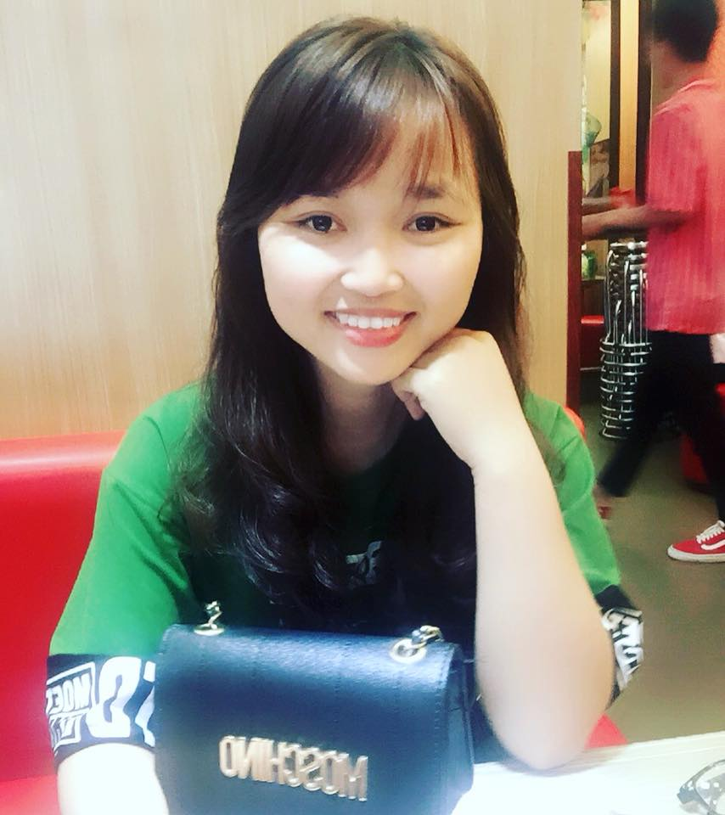

* To work in an organization, which could nurture my leadership qualities and where I get opportunities to grow and hence contribute to the development of the organization and self.
* Become a regional manager after 3 years.

**Skills**











* Test of English for International Communication :715

**Certification**

* Good convincing and negotiation skill
* Flexibility, result-oriented with good sales skills
* Good time management and organizational skills
* Having the necessary confidence, patience, initiative, motivation and reliability to succeed.

**Work experience**

**Education**

**Career goal**