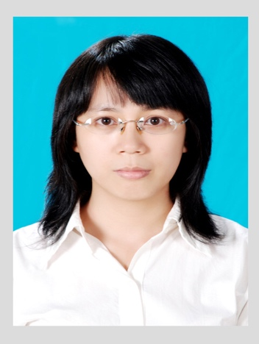

**CURRICULUM VITAE**

**PERSONAL INFORMATION**

**NGUYEN THI HONG VAN**

**Date of birth** : November, 11th, 1986

**Place of birth** : Da Nang City

**Gender** : Female

**Marital status** : Married

**ID No** : 201 529 380

**Issued place** : Da Nang City

**Permanent address** : 120 Groups, Thanh Khe Tay Ward, Thanh Khe District, Đa Nang City

**Present address** : B3-3-3 Le Thanh Apartment, An Duong Vuong Street, An Lac Ward, Binh Tan District, HCMC.

**Tel No** : 0983245137

**E-mail address** : hihongvanpharma@gmail.com

**EXPERIENCES**

**2012 – Present: Abbott Laboratories SA, HCMC.**

**Product Specialist, Sales Department.**

-Be charge in Women Health Products, epecially Duphaston in Mekong Hospital, Tu Du Hospital

- To create good relationship with Head of Pharmacy, Director, Vice Director of Hospital, so list new Product into pharmacy of hospital quickly

- To hold many activities in hospital to develop sale such as Hospital Meeting, Group Discussion, detaling to emphasize benefit of Products.

-Performance: 100% vs target.

**2010-2012**: **Servier Pharmaceutical Company, HCM**

**Medical Representative, Sales Department.**

-Be charge in Cardiovascular and Diabetes Products in Heart Institute, Nguyen Tri Phuong, An Sinh, Phu Nhuan such as Diamicron, Bi Preterax, Vastarel MR

-To support tender in listing, have many activities such as Hospital meeting, group discussion in order to detail key message to key doctor and unfavor doctor

-Performance: 100%vs Target

**2009-2010: Sanofi Synthelabo Pharmaceutical Company, HCMC.**

**Medical Representative, Sales Department.**

-Be charge in Nervous Products in Heart Institute, Nguyen Tri Phuong such as Dogmatil, Deparkin.

-To support tender in listing, have many activities such as Hospital meeting, group discussion in order to detail key message to key doctor and unfavor doctor.

-Performance: 100% vs Target

**EDUCATION**

**2004 - 2009** : Hue College of Medicine and pharmacy, HC

**2001 - 2004** : Phan Chau Trinh High School, DNC.

**1997 - 2001** : Nguyen Khuyen Secondary School, DNC.

**1992 - 1997** : Vo Thi Sau Primary School, DNC.

**QUALIFICATION**

**Hue College of medicine and pharmacy:**

Bachelor degree in Pharmacy 2009

**Cenlet** **Foreign Language Center, HC:**

Advanced Level 2008

**Hoa Mi** **Foreign Language Center, HC:**

Intermediated Level in Communication 2009

**Soft Developed Center, Da Nang College:**

Computer Technician Level 2008

**OTHERS**

**Abilities and skills** Organizational skill

Be able to work independently and do teamwork

Advanced English in communication

Advanced computing skills in Microsoft

Office and Internet.

**Health:** Excellent

**Interest and hobbies**: Pop Music, Karaoke, reading books and magazines.