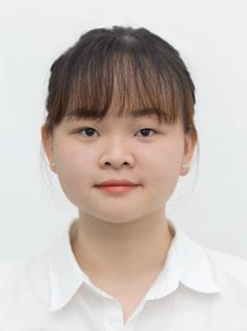

**Da Nang University of Medical Technology and Pharmacy 10/2013 – 06/2018**

Major: Pharmacy - GPA: 7.5/10

**Education**

**NGUYEN THI KIM PHUNG**

**Pharmacist**



**Work experience**

**RA Staff at Representative office of Euro Healthcare 10/2018 – 01/2019**

**-** Coordinate with the trademark consultants and manufacturer for the trademark registration and updating the process.

- Prepare declaration of trademark registration and supply to NOIP

- Follow up with DAV for all submitted dossier but not yet appraised; and for all new/changed regulations concerning to RA and also other fields that may affect to company’s products and activities.

- Coordinate with RA consultants and manufacturer for the RA and updating the process

- Prepare all supporting document and forms other required legal document for company’s products

**Retail pharmacist in Pharmacity Co., Ltd 8/2018 - 10/2018**

- Providing advice about health issues, symptoms and medications in response to customer enquiries

- Ordering and selling medicines and other stock

**Da Nang Hospital 1/2018 - 04/2018**

**Intership**

- Arranged products on shelves and maintain drug inventory in compliance with national regulations

- Dispensed prescribed medications to patients

- Compounds and dispenses medications as prescribed by doctors, by calculating, weighing, measuring, and mixing ingredients.



19/06/1994

79/35 A National Highway 13, Ward 26, Binh Thanh District

090.293.8801

[phungntk196@gmail.com](mailto:phungntk196@gmail.com)







**CAREER OBJECTIVE**

Short – term: Becoming a hard and good staff, I will try to learn as much as possible and do my best in order to complete my task

Long – term: Developing skills, proving myself and seeking good opportunities to get promotion in my job

**SKILLS**

Work skills: Be able to work independently and team work. Quickly adapt myself to the new enviroment work. Work well in high pressure.

English:

Informatics:





**Activities**

**Green Summer Campaign Jul 4th, 2016 – Jul 9th, 2016**

Took part in Green Summer Campaign at Tra My, Quang Nam province.

* Distributed drug to local people; took care of children living there, taught them and held some activities such as reading club or playing games

**Volunteering at the Vu Lan clinic Oct, 2017 – Apr, 2018**

Participated in free medical treatment for local people in Da Nang

**Interests:**

* Travelling
* Reading
* Boardgame
* Skincare